June 25, 2014

Steven V. King, Executive Director and Secretary

Utilities and Transportation Commission

1300 S. Evergreen Park Dr. SW

P.O. Box 47250

Olympia, WA 98504-7250

RE: *Washington Utilities and Transportation Commission v. Advance Relocation Expert, LLC*

Commission Staff’s Response to Application for Mitigation of Penalties TV-140936

Dear Mr. King:

On June 3, 2014, the Utilities and Transportation Commission issued a $1,000 Penalty Assessment in Docket TV-140936 against Advance Relocation Expert, LLC for 10 violations of Washington Administrative Code (WAC) 480-15-480, which requires household goods carrier companies to furnish annual reports to the commission no later than May 1 each year.1

On June 11, 2014, Advance Relocation Expert, LLC wrote the commission requesting mitigation of penalties (Mitigation Request).2 In its Mitigation Request, Advance Relocation Expert, LLC does not dispute that the violation occurred. The company states, “I have experienced a very difficult beginning of 2014 for my business along with having medical issues the first part of the year which kept me out for several months.” The company requests waiving the fee.

It is the company’s responsibility to ensure that the regulatory fee is paid and the annual report is filed by the May 1 deadline. On February 28, 2014, Annual Report packets were mailed to all regulated household goods companies. The instructions for annual report completion page of the annual report informed the regulated company that it must complete the annual report form, pay the regulatory fees, and return the materials by May 1, 2014, to avoid enforcement action.

On May 27, 2014, Corporate Moving Systems, Inc. filed the 2013 annual report and paid the required regulatory fees and late payment penalty. The company has been active since February 17, 2005. No previous violations of WAC 480-15-480 are on commission record. Staff supports

UTC Annual Reports

June 25, 2014

Page 2

the company’s request for mitigation as this is the company’s first delinquent filing. Staff recommends waiving the penalty due to the compelling circumstances provided in the written statement.

If you have any questions regarding this recommendation, please contact Amy Andrews, Regulatory Analyst, at (360) 664-1157, or [aandrews@utc.wa.gov](mailto:aandrews@utc.wa.gov).

Sincerely,

Sondra Walsh, Director

Administrative Services

ATTACHMENT A

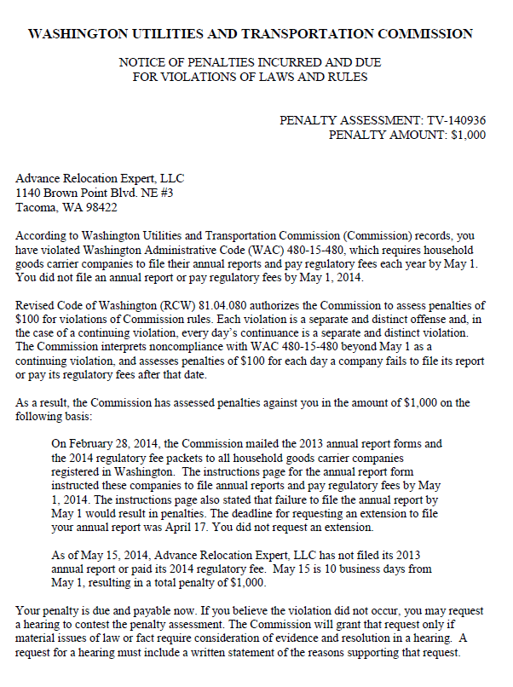

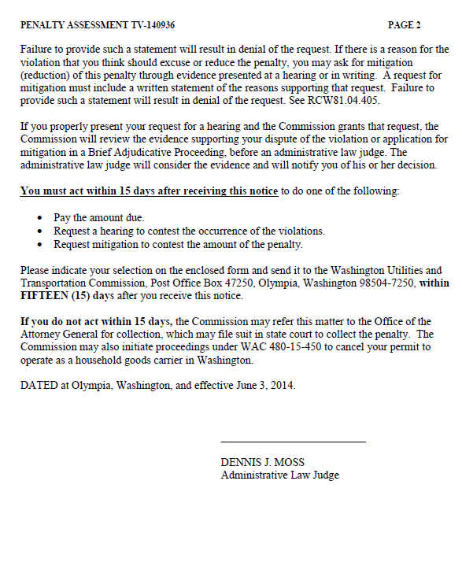

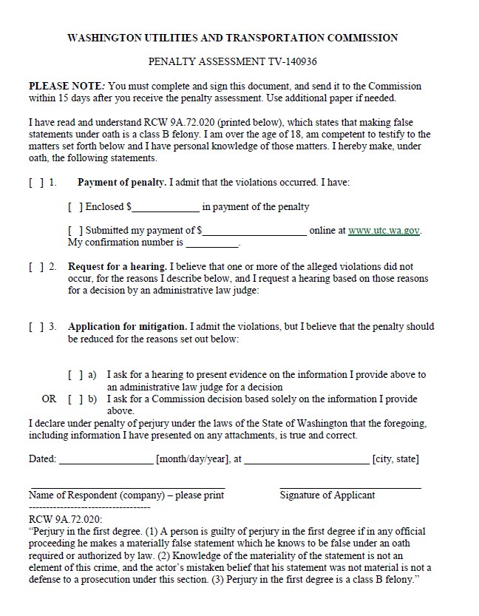

ATTACHMENT B

