**Bench Request No. 14:** Staff: With regard to Staff response to bench request No. 8, please reconcile the net operating income, rate base, and revenue requirement impacts provided in the response to the amounts shown in Mr. Hancock’s exhibits CSH-2 at page 10, column 4.01 and CSH-3 at page 9, column 4.01.

**Response:**

Mr. Hancock used column headings in the response to Bench Request 8 that are inconsistent with those in exhibits CSH-2 and CSH-3. He apologizes for this inconsistency. To clarify, the headings in the response to Bench Request 8 may be translated as:

1. “Rev – Exp” is net operating income;
2. “Rate Base impact” is the change in rate base; and
3. “NOI impact” is the sum of net operating income plus the return on the rate base. This sum may be considered as the amount required to yield the authorized rate of return.
4. “Revenue requirement impact” is the revenue requirement.

“Net Operating Income”, as used in CSH-2 and CSH-3, is revenue minus expenses, prior to accounting for the effects of rate base changes. “NOI impact”, as used in the response to Bench Request 8, does take into consideration the effects of rate base changes. This latter definition is useful because it produces the amount that is “grossed up” to determine the revenue requirement. The Commission typically uses the definition adopted in CSH-2 and CSH-3.

Bench Request 8 only requested the impacts of Staff’s proposed 14 capital additions. CSH-2 (Electric) Adjustment 4.01 consists of those fourteen capital projects plus two other items of relatively minor size: a reduction in rate base of $738,000 related to CDA Legal Costs;[1] and a tax expense titled Amortization ITC – Noxon.[2] Collectively, these amount to a $20,078 change in net operating income, CSH-2, page 10, line 30. When combined with the return on the reduction in rate base of $738,000, the result is an “NOI impact” of -$73,878.

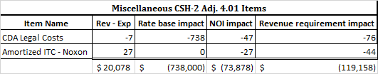

Bench Request 8 only displayed the impacts of the 14 capital additions, and not these two relatively minor items present in electric Adjustment 4.01. This explains the difference between the NET OPERATING INCOME figure on CSH-2, page 10, line 30, and the “Rev – Exp” column in the response to the Bench Request. This also explains the difference between the total “Rate base impact” figure in the response to Bench Request 8 and the figure provided in CSH-2, page 10, line 48 (titled “Total Rate Base”). Because the revenue requirement calculation is ultimately dependent on net operating income and rate base, a different revenue requirement figure resulted as well.

To reiterate, CSH-2, Adjustment 4.01 includes the 14 capital additions as well as these two minor items. Bench Request 8 addressed only the 14 capital additions.

The orange cells in the images below show the reader the $20,000 difference in “Rev – Exp” in the response to Bench Request 8, and CSH-2, page 10, line 30:

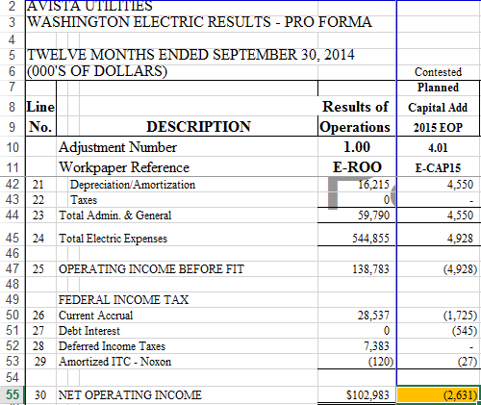  
*From CSH-2, page 10*

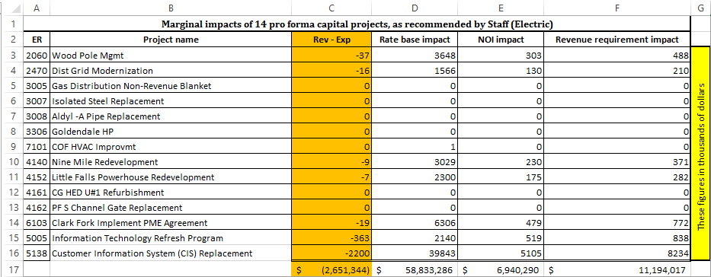*From Bench Request 8 response*

The image below reconciles the response to Bench Request 8 and CSH-2, page 10:



The image below reconciles the response to Bench Request 8 and CSH-3, page 9:



**Summary**

To summarize, the differences in the figures in the response to Bench Request 8 and those figures in exhibits CSH-2 and CSH-3 are due to the following:

* Bench Request 8 only addressed the 14 capital additions endorsed by Staff, whereas electric Adjustment 4.01 includes those 14 projects and two minor items;
* Two different formulations of the term net operating income were used, one of which included return on rate base effects.

1. See Bench Request 9 response, filename BR 9 WP - 1) CAP SUMMARY-WA – CSH.xlsx, worksheet E-CAP SUMMARY, cell W26.
2. See CSH-2, page 10, line 29.