

**STATE OF WASHINGTON**

WASHINGTON UTILITIES AND TRANSPORTATION COMMISSION

***1300 S. Evergreen Park Dr. S.W., P.O. Box 47250 ● Olympia, Washington 98504-7250***

***(360) 664-1160 ● TTY (360) 586-8203***

March 21, 2013

Steven V. King, Acting Executive Director and Secretary

Washington Utilities and Transportation Commission

1300 S. Evergreen Park Dr. SW

P. O. Box 47250

Olympia, Washington 98504-7250

RE: *Washington Utilities and Transportation Commission v. Dillard-Lewis, LLC*

Commission Staff’s Response to Application for Mitigation of Penalties

Docket TE-130195

Dear Mr. King:

On March 4, 2013, the Washington Utilities and Transportation Commission issued a $225 Penalty Assessment in Docket TE-130195 against Dillard-Lewis, LLC (Dillard-Lewis) for nine violations of WAC 480-30-071, which requires Charter and Excursion companies to file annual safety reports with the Commission by December 31 each year; and WAC 480-30-076, which requires such companies to pay regulatory fees annually on that date. [1]

On March 18, 2013, Dillard-Lewis responded to the commission, requesting mitigation of the penalty. In its Mitigation Request, Dillard-Lewis does not dispute that the violations occurred. The company states, “It is impossible to accurately complete your Safety Report and have it postmarked on December 31st. Our Company operates in 35 different states and in Puerto Rico. It takes our drivers up to two weeks to compile and submit their mileage reports and some of our vans are still on the road at 4:30pm [sic] on December 31 when the post office closes. I have called the Transportation Commission in the past with my concerns but no one was able to tell me how to file an accurate report on December 31st. I was told to do the best I could and then pay the 2% penalty and 1% interest, which I did. This year our computer system was infected by a work which caused our report to be a little later than usual. Please explain how this report and [sic] be accurately completed and mailed on December 31st.”[2]

It is the company’s responsibility to ensure that the regulatory fee is paid and the annual report is filed by the December 31 deadline. On November 15, 2012, the commission mailed 2012 Annual Safety Report forms and 2013 regulatory fee packets to Charter and Excursion companies registered in Washington state. A letter from the commission’s Assistant Director for Transportation Safety, David Pratt, instructed these companies to file annual reports and pay regulatory fees by December 31, 2012. The letter stated failure to file the annual report by December 31 would result in a penalty and possible cancellation of the company’s permit to operate in Washington. Those companies wishing to request an extension to file the annual report were asked to do so prior to December 31, providing a reason for the requested extension. No extension was requested.[3]

On January 7, 2013, the commission issued a notice to companies that had not yet filed their annual report and paid regulatory fees, informing these companies that they were subject to enforcement action, including the assessment of penalties beginning to accrue on that date. Companies that filed their annual reports and paid regulatory fees after January 7, 2013, but on or before January 18, 2013, are subject to penalties that the commission uses its discretion to mitigate to $25 per day if the company had not made these filings late in prior years. Companies that were late in prior years are subject to an additional $25 per day for each year in which they were late up to a total of $100 per day. For first time late-filers who filed their report after January 18, the commission will mitigate the penalties to 50 percent of the maximum permissible amount. No further mitigation will be granted unless the company provides new information that is unrelated to these factors. Mitigation will not be granted on the basis that a company was unaware a report must be filed.[4]

Dillard-Lewis filed its 2012 annual safety report and paid its 2013 regulatory fee on January 18, 2013. That date is nine business days past the January 7, 2013, notice date when penalties began to accrue, resulting in a potential penalty assessment of $900 ($100 per day times nine days). Dillard-Lewis is a first time late-filer and, therefore, received a mitigated penalty of $25 per day for the nine days to $225. The commission could have begun assessing penalties of $100 per business day, beginning January 2, which would have made the company responsible for a penalty of $1,300. The commission did not begin assessing penalties until January 7, 2013, so that companies would have time to complete their annual safety reports and pay regulatory fees without incurring a penalty. Companies that needed extra time to file their report were instructed to do so by requesting an extension. Dillard-Lewis did not request an extension.

Staff does not support mitigating the $225 penalty assessment further. The penalty was already administratively mitigated by 75 percent, from $900 to $225 and Dillard-Lewis provided no new information related to the factors above. Staff recommends denying the mitigation request.

If you have questions regarding this recommendation, please contact Mathew Perkinson, Compliance Investigator, at (360) 664-1320, or at mperkinson@utc.wa.gov.

Sincerely,

Sharon Wallace, Assistant Director

Consumer Protection and Communications

**Attachment A**

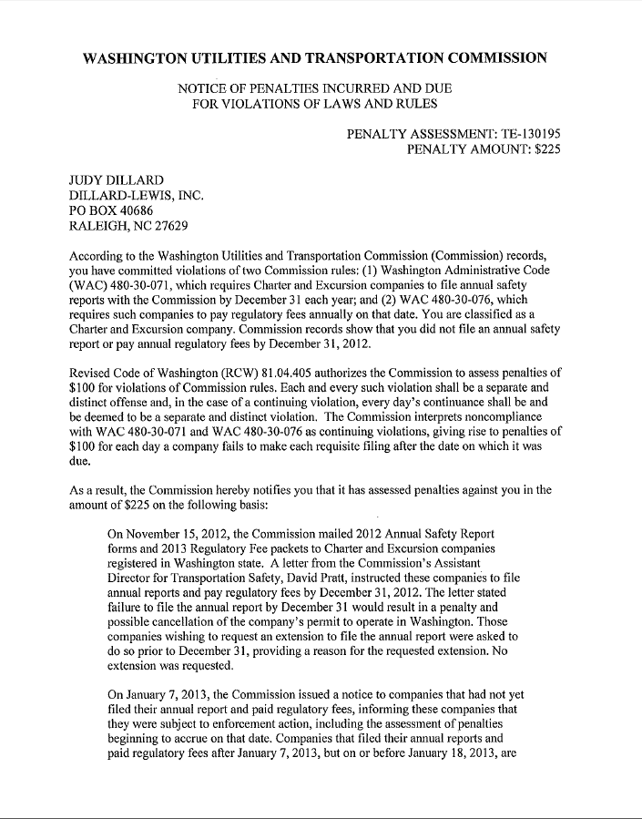

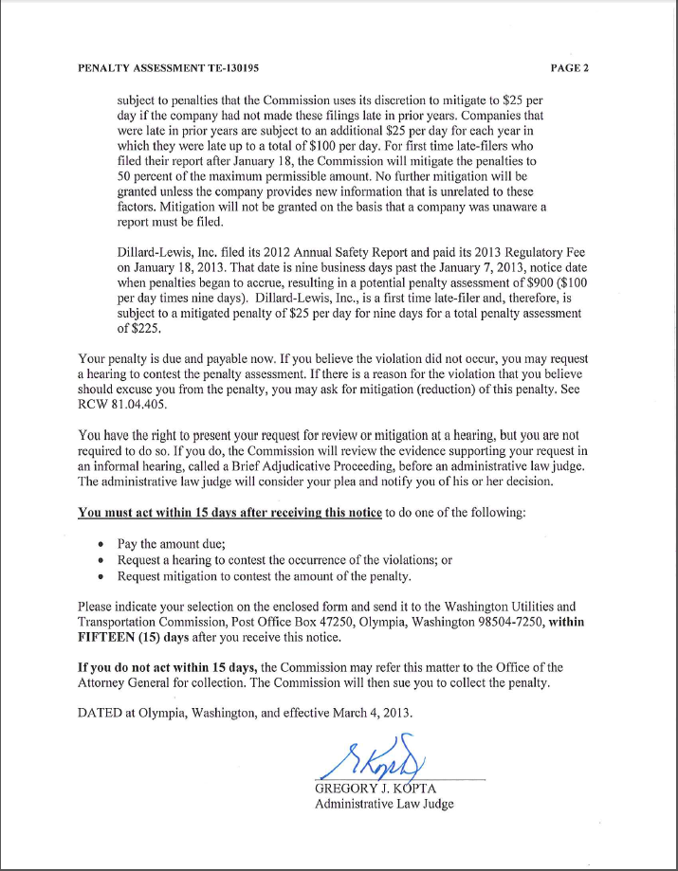

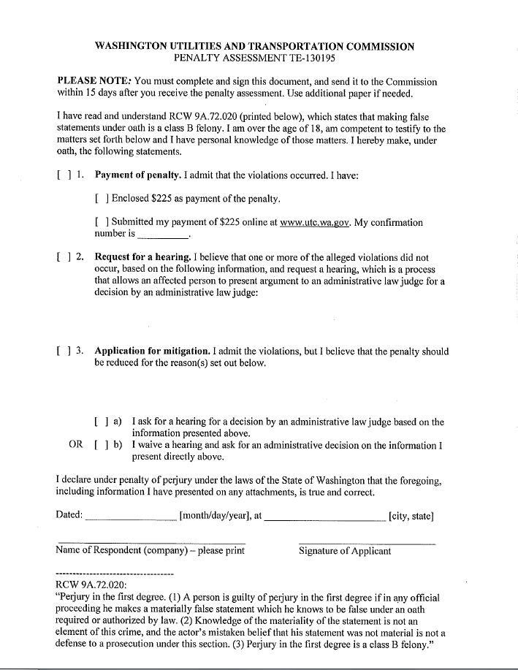

**Attachment B**

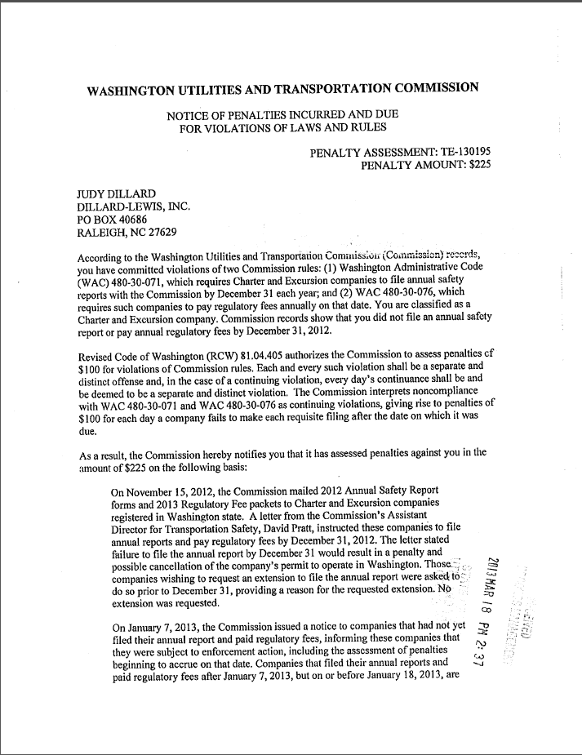

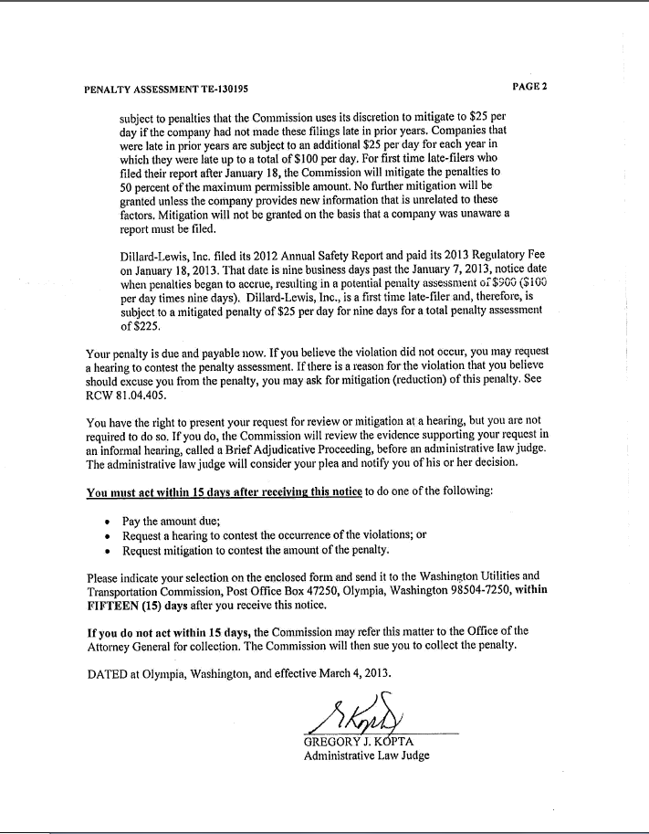

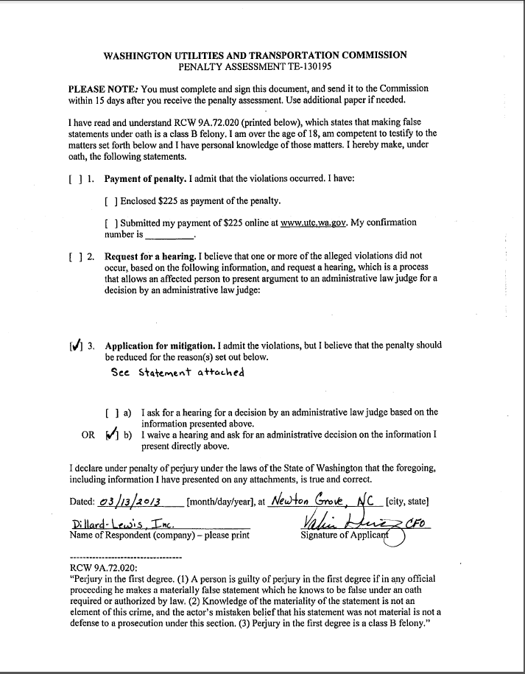

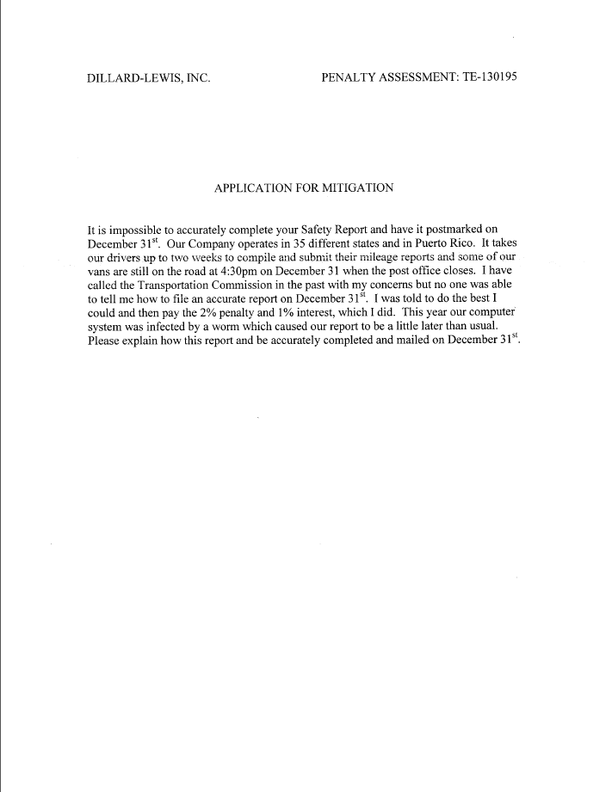

**Attachment C**

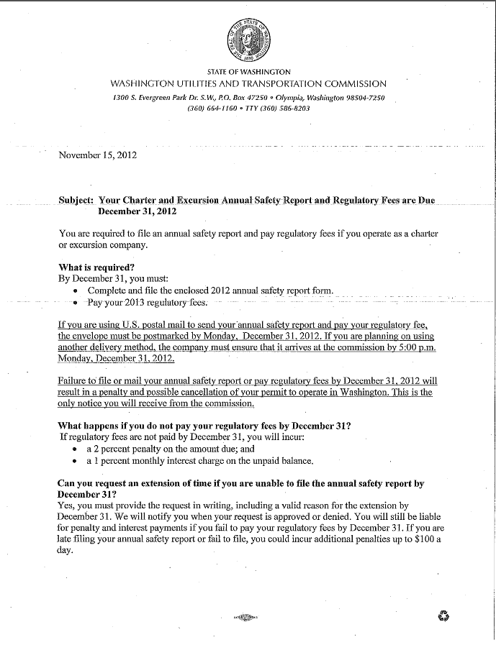

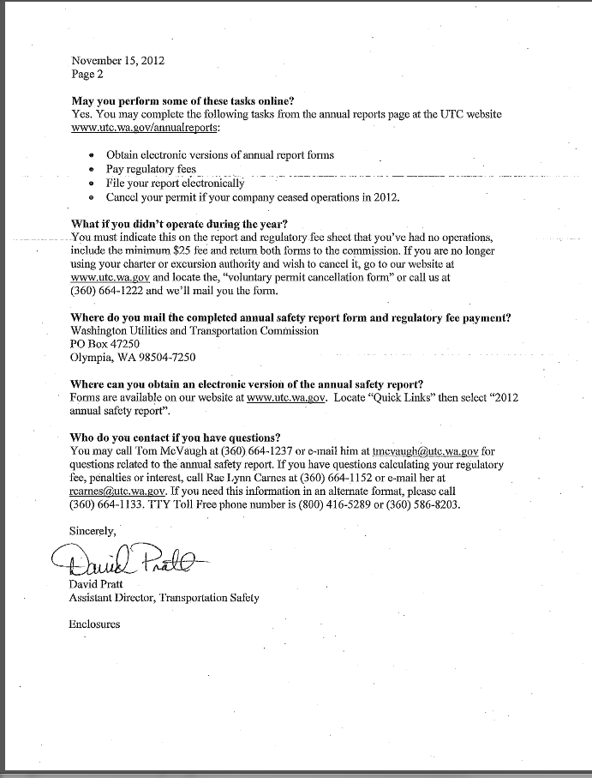

**Attachment D**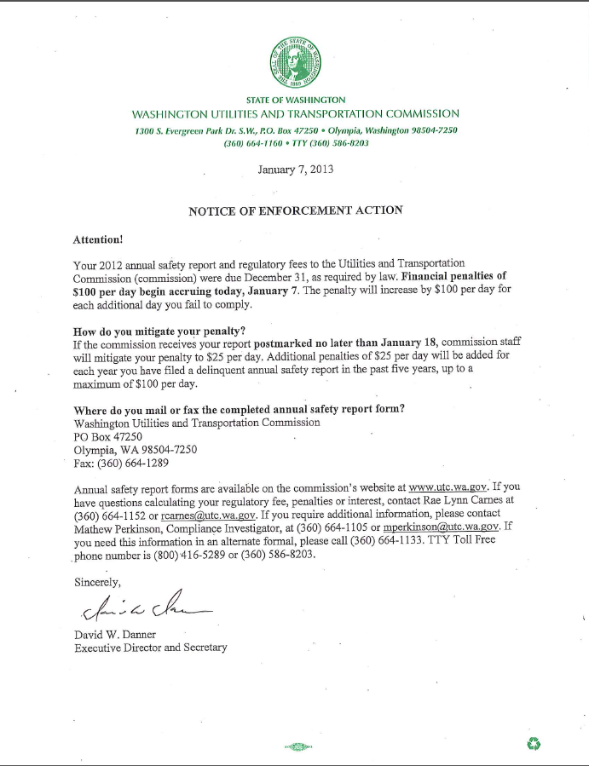

1. See Attachment A for a copy of the penalty assessment sent to Dillard-Lewis, LLC.
2. See Attachment B for a copy of the letter submitted by the company on March 18, 2013.
3. See Attachment C for a copy of the letter sent to all regulated companies on November 15, 2012.
4. See Attachment D for a copy of the Enforcement letter sent to all delinquent companies on January 7, 2013.