**PUGET SOUND ENERGY**

2015 INTEGRATED RESOURCE PLAN

UPDATED WORK PLAN

August 29, 2014

#### IRP WORK PLAN REQUIREMENTS

Section 480-90-238 (4) and 480-100-238 (4), the natural gas and electric Integrated Resource Plan (“IRP”) rules, specify requirements for the IRP Work Plan:

Not later than twelve months prior to the due date of a plan, the utility must provide a work plan for informal commission review. The work plan must outline the content of the integrated resource plan to be developed by the utility and the method for assessing potential resources.

Additionally, Section 480-90-238 (5) and 480-100-238 (5) of the WAC states:

(5) Public participation. Consultations with commission staff and public participation are essential to the development of an effective plan. The work plan must outline the timing and extent of public participation….

#### Purpose of the Integrated Resource Plan

PSE’s long-term resource planning process continues to inform and guide the Company’s resource acquisition processes, consistent with the letter and spirit of WAC 480-90-238 and WAC 480-100-238. PSE’s IRP analysis integrates demand-side and supply side resources in a manner so as to find the lowest reasonable cost set of resources to meet the growing energy needs of our customers.

**Section I: Public Participation Process and Anticipated Timing**

Input and feedback in PSE’s planning process from external stakeholders has been fundamental to the success of PSE’s IRP process. In response to feedback from stakeholders at the conclusion of the 2013 IRP process, the Company included the following item in that IRP’s Action Plan:

* Develop a robust work plan for the 2015 IRP to clarify the roles and expectations of the of the public participation process and to provide greater transparency regarding PSE’s analytical processes.

This section will describe the key elements of the public stakeholder process.

Purpose of the Stakeholder Process

Participation by external stakeholders *is* essential to the development of an effective resource plan. Dialogue with stakeholders provides PSE with broader perspectives about the future than PSE would have on its own. Additionally, the stakeholder process provides the opportunity to share technical information with other experts in the region, including other utilities, Northwest Power and Conservation Council staff, WUTC Staff, and advocacy groups. Additionally, the stakeholder process provides an opportunity to work through complex details on how PSE performs its portfolio analysis with those same groups of experts. Finally, the stakeholder process can also provide PSE an opportunity to work with stakeholders on what information to include in the IRP and how to best present that information, to support planning decisions. All these things help PSE develop more robust resource plans.

Consultative Stakeholder Process

PSE values the feedback, alternative views, and technical information received from stakeholders in prior IRP processes. We appreciate the advice from stakeholders and appreciate the time individuals take to provide such consultation, ideas, and advice, especially when stakeholders have no legal obligation to lend such assistance. The IRP stakeholder process is a consultative one, not a consensus process where majority voting will drive decisions. PSE bears full responsibility for filing an Integrated Resource Plan with the WUTC that complies with WAC 480-90-238 and WAC 480-100-238. Stakeholders need not be experts in compliance to provide helpful advice, but the IRP is ultimately a compliance filing for which PSE is responsible. Additionally, PSE bears the responsibility for demonstrating the prudence of its resource decisions that will be informed by the IRP; again, stakeholders need not be prudence experts to provide helpful advice in the IRP, but PSE will be required to demonstrate prudence in potentially highly contested cases in the future. Therefore, PSE will continue to use a consultative process, with enhancements to improve transparency and improve communication so all participants can derive greater value from PSE’s IRP process.

IRP Advisory Group

PSE will continue to rely on its IRP Advisory Group as the principle means for ensuring public participation in the planning process. This is the same process the Company has used since 2003. The Company anticipates full IRP Advisory Group meetings will continue to be open to the public. Lyn Wiltse, from PDSA consulting, has been retained to facilitate these large group meetings. Appendix A is the anticipated timeline for IRP Advisory Group meetings. Meeting dates are subject to change, based on stakeholders’ schedules and PSE’s progress, as meeting dates get closer. The Company will endeavor to inform stakeholders as far in advance as possible if meeting dates must change. Please note, this meeting schedule may be revised in the future, based on the timing needs of key stakeholders, changes in policy direction, and/or based on progress the Company makes in developing the plan.

In the first IRP Advisory Group meeting on March 18, 2014, certain ground rules and expectations were established, with assistance from facilitator Ms. Wiltse. Please find those summarized in Appendix B. PSE will update these ground rules and expectations throughout the process as the group gains experience with them, to ensure an efficient process.

While IRP Advisory Group meetings are productive ways for PSE to get feedback from stakeholders, the “IRP Advisory Group” is not synonymous with the meetings. PSE has found one-on-one discussions with IRP Advisory Group members extremely helpful in the past, as the dynamic of such dialogue is much more open. PSE will continue to engage in such discussions. Additionally, PSE will be formalizing a process for smaller group meetings to focus on highly technical material, in an effort to enhance transparency and facilitate more efficient communication with other technical experts.

Technical Advisory Groups (“TAGs”)

The quantity, depth, and complexity of both assumptions and analytical processes to perform IRP analysis is simply beyond the scope of non-technical experts in certain areas. PSE has a team of highly qualified analysts devoted to performing this kind of work full-time, with access to software, models, and resources commensurate with a utility that will be making significant investment decisions; e.g., the Lower Snake River wind facility cost upward of $800 million. In order to communicate with experts on detailed assumptions and better explain details of analytical processes to key stakeholders PSE has developed a set of Technical Advisory Groups. This will allow the Company to engage with specific sub-sets of the IRP Advisory Group in small group meetings. Small group meetings with specific stakeholders will provide a more efficient way to communicate highly technical information, resulting in a more effective resource plan. Attachment C provides an overview of the TAGs PSE has defined, along with the stakeholders that have been or will be invited to attend those discussions.

Feedback on Specific Information to Include in IRP Document

There are several areas in the IRP that stakeholders, including the Commission, wanted to see more information included in the document. To be responsive, in this IRP cycle, PSE will engage with stakeholders during IRPAG meetings to scope and discuss such information. The Integrated Resource Plan is a filing at the Commission. The emphasis of these discussions will be what information should be included in the document to help stakeholders understand the different elements of the resource plan.

PSE does not anticipate any information in the 2015 IRP will need to be treated as confidential. If it becomes necessary to share confidential information during IRP Advisory Group meetings or TAG meetings with stakeholders, the Company will work with stakeholders to address those concerns in a way that is consistent with the Company’s need to protect confidential information on behalf of our customers, information providers, and shareholders. The complexity of IRP models and frameworks, along with the magnitude of input and output data can create barriers to transparency—very little data is actually confidential. Therefore, focusing on specifically what information stakeholders believe would be helpful in the IRP document should address most of these issues, if they emerge during the process.

**SECTION II: METHODS FOR ASSESSING RESOURCES**

***Overview of Analytical Approach***

PSE’s demand-side and supply-side resource analyses are well integrated, as are the Company’s electric and gas resource planning efforts. Common assumptions are used and similar analytical approaches are used in our electric and gas planning efforts. Appendix D is a diagram that illustrates how PSE plans to perform the quantitative analysis for this 2015 IRP. Appendix D also includes a table summarizing the different parts of the Company that contribute to the IRP process.

Uncertainty will be addressed in two ways, consistent with PSE’s last six IRPs going back to 2003. Potential futures will be reflected in scenarios that will have different fuel prices, carbon costs, resource costs, environmental policies, etc.. Sensitivities will also be used. Sensitivities are similar to scenarios, but focus on impact of one variable; i.e., sensitivity analyses examine implications of key variables “all else equal” such as changing natural gas prices or the resource additions in a portfolio. Understanding how different potential futures and factors affect resource strategies, costs, emissions, and cost risks is the focus of this analysis.

Stochastic analysis will be used in addition to deterministic scenario and sensitivity analysis. Stochastic analysis is helpful to understand the impact on the risk and volatility of costs that different resource types may have on the Company’s long term portfolio.

**SECTION III: 2015 IRP-CONTENT OUTLINE**

The following is a draft outline of the 2015 IRP. This draft is based on PSE’s 2013 IRP, modified based on early discussions with stakeholders. Organizational structure of the final IRP may be revised based on results of analysis and feedback received through the planning process.

1. Executive Summary
   1. Electric Resource Plan
   2. Gas Sales Resource Plan
   3. Action Plans
2. Developing the Plan
   1. Electric Plan
   2. Electric: Results Across Scenarios/Sensitivities
   3. Other Considerations
   4. Gas Plan
   5. Gas Results Across Scenarios
3. Planning Environment
   1. Economic Environment
   2. Policy Requirements and Influences
   3. Resource Considerations
4. Key Analytical Assumptions
   1. Key Inputs
   2. Scenarios/Sensitivities
   3. Stochastic Assumptions
   4. Input Matrices
   5. Summary Table of Scenarios and Sensitivity Assumptions
5. Load Forecasts
   1. Overview
   2. Methodology: Electric and Gas, Energy and Peaks
   3. Key Assumptions
   4. Results: Load Forecasts
   5. Sensitivities to Normal Energy Forecasts Examined—Possible Impacts of Climate Change
6. Electric Analysis
   1. Resource Needs
   2. Resource Alternatives
   3. Analytic Methodologies
   4. Results
   5. Key Findings and Insights
7. Gas Analysis
   1. Gas Resource Needs
   2. Existing Resources
   3. Resource Alternatives
   4. Analytic Methodologies
   5. Results & Key Findings
8. Delivery System Infrastructure Planning
   1. System Overview
   2. Infrastructure Investment Drivers
   3. Planning Process
   4. 2013-2023 Infrastructure Plans
   5. Challenges and Opportunities

Appendices

1. Public Participation
2. Legal Requirements & Other Reports
3. Environmental and Related Regulatory Matters
4. Electric Resource Alternatives
5. Regional Transmission Resources
6. Financial Considerations
7. Operational Flexibility
8. Demand Forecasts
9. Regional Resource Adequacy
10. Colstrip
11. Electric Analysis
12. Gas Analysis
13. Electric-Gas Coordination
14. Demand-Side Resources

**PUGET SOUND ENERGY**

Updated 2015 IRP Work Plan

Appendix A

Anticipated Timing of IRP Advisory Group Meetings

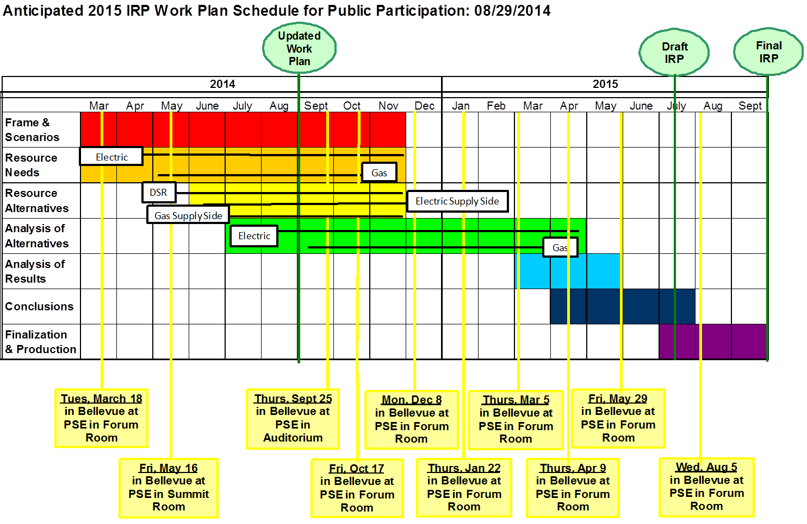

**PUGET SOUND ENERGY**

Updated 2015 IRP WORK PLAN

Appendix B

Initial Meeting Ground Rules

**Meeting / Process Ground Rules**

This list started off as meeting-specific norms and quickly expanded to ground rules at the first IRP Advisory Group meeting for PSE’s 2015 IRP that was held March 18, 2014. These represent the initial ground rules and may be revised as needed to enhance the overall efficiency of the process:

* Start and end on time (9:00–3:00 Monday–Thursday and 9:00–2:00 on Fridays).
* Be fully present.
* Open and inclusive participation and information sharing.
* Balance participation.
* Ask questions and listen to increase understanding.
* No side bars or interruptions.
* Cell phones on “stun”.
* Use Parking Lot to track issues to address at a later time.
* Have fun.
* Take a break approximately half way through the meeting (~15 min.).
* Be clear about next steps (who is doing what by when).
  + List Action Items at the top of the first page of the meeting notes.
* Email slides of presentations two days in advance. Note any last minute edits or additions on the day of the meeting.
* Use facilitator and provide “draft” meeting notes.
* PSE to provide written responses to all written questions.
  + Questions submitted need to be specifically related to the Integrated Resource Plan analytical process, assumptions, or conclusions, not broad policy questions or issues that require legal counsel. This is intended to help provide clarity, not to create a new discovery process for a regulatory filing that is still in development.
  + PSE will respond within two days. This may include a direct response, an estimate of when a direct response will be provided, or an explanation of why such response will not be forthcoming.
  + PSE will use a separate document to track questions and answers.
  + PSE will “make full use of existing provisions to manage confidential information” but that process is limited by the Commission’s statutory authority to protect information outside of a contested case. There is actually very little information that must be treated as confidential. If access to confidential information is necessary by some stakeholders for transparency, PSE will work with stakeholders to overcome the specific barriers, to the extent feasible.
  + Update this document and share at each meeting (as some questions will arise outside of these meetings).
  + We will all work with this process and modify it as we go.
* PSE to develop reasonable inputs and results.
* Facilitator to provide high-level meeting notes (capture general discussion and use attribution only by exception or if requested).
* Track requests that come up in the meeting through meeting notes.
* PSE to note when, how, and if responding to suggestions in Appendix A and B.
* Add Technical Groups to delve into complexities of analyses:
  + Tech Groups to meet between IRP AG meeting and share highlights / notes from those meetings during IRP AG meetings
  + Aim of Tech Groups is to get through detailed technical information with key people in an effective and efficient manner

**PUGET SOUND ENERGY**

Updated 2015 IRP WORK PLAN

Appendix C

Technical Advisory Groups

**Parties Invited to Participate in TAG Process**

**RESOURCE NEEDS**

* WUTC Staff & Policy Staff
* Public Counsel
* ICNU
* NWIGU
* NWPCC
* NWEC
* RNP
* Sierra Club

**RESOURCE ALTERNATIVES**

Demand-Side Resources: Subset of CRAG self-selected volunteers

Electric Supply-Side Resources

|  |  |
| --- | --- |
| * WUTC Staff & Policy Staff | * Public Council |
| * NW Power & Cons. Council | * ICNU |
| * NW Energy Coalition | * Sierra Club |
| * RNP | * GE |
| * Other Electric Utilities | * Open to Others |

Gas Supply-Side Resources

|  |  |
| --- | --- |
| * WUTC Staff & Policy Staff | * Public Council |
| * NWIGU | * NW Gas Association |
| * Northwest Pipeline | * TransCanda Pipeline |
| * NW Energy Coalition | * Other Gas Utilities |
| * Open to Others |  |

**ANALYSIS OF ALTERNATIVES**

|  |  |
| --- | --- |
| Electric | Gas |
| * WUTC Staff & Policy Staff * Public Counsel * ICNU * NW Power & Cons. Council * NW Energy Coalition * RNP * Sierra Club | * WUTC Staff & Policy Staff * Public Counsel * NWIGU * NW Energy Coalition |

**PUGET SOUND ENERGY**

Updated 2015 IRP WORK PLAN

Appendix D

Resource Planning Process



**Work Groups Contributing to the Integrated Resource Plan**

|  |  |
| --- | --- |
| **Work Group** | **Information Provided** |
| Resource Planning & Analysis | Resource needs and portfolio analysis to assess costs, cost risks, and least-cost combinations of resources. |
| Load Forecasting | Long-term customer, energy, and peak load forecasts for electric and gas retail customers. |
| Energy Efficiency | Review and feedback on electric and gas conservation supply curves, including costs, feasibility, and timing and review and feedback on results. |
| Resource Acquisitions and Emerging Resources | Costs, operational characteristics, and commercial availability of supply-side electric resources and review of inputs, outputs, and conclusions. |
| Customer Renewable Energy Programs | Cost forecasts for customer-owned generation, market penetration forecasts, and green power program information. |
| Natural Gas Resources | Costs, operational characteristics, and commercial availability of supply-side gas resources. |
| System Planning | Specific information on electric transmission and gas and electric distribution planning issues. |
| Energy Delivery | BPA transmission contract information and intra-hour resource flexibility analysis. |
| Transmission Contracts | PSE transmission capacities and constraints and regional transmission issues. |
| Power and Gas Supply Operations | Input on market issues and review of assumptions and results. |
| Thermal Resources | Operational and performance information on PSE’s existing thermal generation. |
| Hydro and Wind Resources | Operational and performance information on PSE’s existing hydro and wind generation. |
| Government Affairs | State and federal energy policy activity at legislative and executive branches. |
| Energy Resource Compliance | Emission information, emission accounting, and emission related policy trends. |
| State Regulatory Affairs | Regulatory compliance guidance. |
| Government Affairs | State and federal energy policy activity at legislative and executive branches. |