

**STATE OF WASHINGTON**

WASHINGTON UTILITIES AND TRANSPORTATION COMMISSION

***1300 S. Evergreen Park Dr. S.W., P.O. Box 47250 ● Olympia, Washington 98504-7250***

***(360) 664-1160 ● TTY (360) 586-8203***

March 20, 2013

Steven V. King, Acting Executive Director and Secretary

Washington Utilities and Transportation Commission

1300 S. Evergreen Park Dr. SW

P. O. Box 47250

Olympia, Washington 98504-7250

RE: *Washington Utilities and Transportation Commission v. Genie Service Company, Inc., d/b/a Genie Tours*

Commission Staff’s Response to Application for Mitigation of Penalties

Docket TE-130200

Dear Mr. King:

On March 4, 2013, the Washington Utilities and Transportation Commission issued a $100 Penalty Assessment in Docket TE-130200 against Genie Service Company, Inc., d/b/a Genie Tours (Genie) for four violations of WAC 480-30-071, which requires Charter and Excursion companies to file annual safety reports with the Commission by December 31 each year; and WAC 480-30-076, which requires such companies to pay regulatory fees annually on that date. [1]

On March 11, 2013, Genie responded to the commission, requesting mitigation of the penalty. In its Mitigation Request, Genie disputes that the violations occurred. The company states, “Please note attached report & check was submitted in December.” [2]

It is the company’s responsibility to ensure that the regulatory fee is paid and the annual report is filed by the December 31 deadline. On November 15, 2012, the commission mailed 2012 Annual Safety Report forms and 2013 Regulatory Fee packets to Charter and Excursion companies registered in Washington state. A letter from the commission’s Assistant Director for Transportation Safety, David Pratt, instructed these companies to file annual reports and pay regulatory fees by December 31, 2012. The letter stated failure to file the annual report by December 31 would result in a penalty and possible cancellation of the company’s permit to operate in Washington. Those companies wishing to request an extension to file the annual report were asked to do so prior to December 31, providing a reason for the requested extension. No extension was requested.[3]

On January 7, 2013, the commission issued a notice to companies that had not yet filed their annual report and paid regulatory fees, informing these companies that they were subject to enforcement action, including the assessment of penalties beginning to accrue on that date. Companies that filed their annual reports and paid regulatory fees after January 7, 2013, but on or before January 18, 2013, are subject to penalties that the commission uses its discretion to mitigate to $25 per day if the company had not made these filings late in prior years. Companies that were late in prior years are subject to an additional $25 per day for each year in which they were late up to a total of $100 per day. For first time late-filers who filed their report after January 18, the commission will mitigate the penalties to 50 percent of the maximum permissible amount. No further mitigation will be granted unless the company provides new information that is unrelated to these factors. Mitigation will not be granted on the basis that a company was unaware a report must be filed.[4]

Commission staff investigated the claims of Genie and found that the commission received Genie’s annual safety report on January 14, 2013. The envelope was postmarked January 11, 2013. The commission assessed an automatic late fee of two percent of the $200 regulatory fee or $4, per WAC 480-30-076(4). Commission staff records reflect payment of $204 on January 14, 2013.[5]

January 11, 2013, is four business days past the January 7, 2013, notice date when penalties began to accrue, resulting in a potential penalty assessment of $400 ($100 per day times four days). Genie is a first time late-filer and, therefore, received a mitigated penalty of $25 per day for four days for a total penalty assessment of $100.

Staff does not support mitigating the $100 penalty assessment further. The penalty was already administratively mitigated by 75 percent, from $400 to $100 and commission records show the annual safety report was delinquent and the regulatory fees were not paid timely. Staff recommends denying the mitigation request.

If you have questions regarding this recommendation, please contact Mathew Perkinson, Compliance Investigator, at (360) 664-1105, or at mperkinson@utc.wa.gov.

Sincerely,

Sharon Wallace, Assistant Director

Consumer Protection and Communications

**Attachment A**

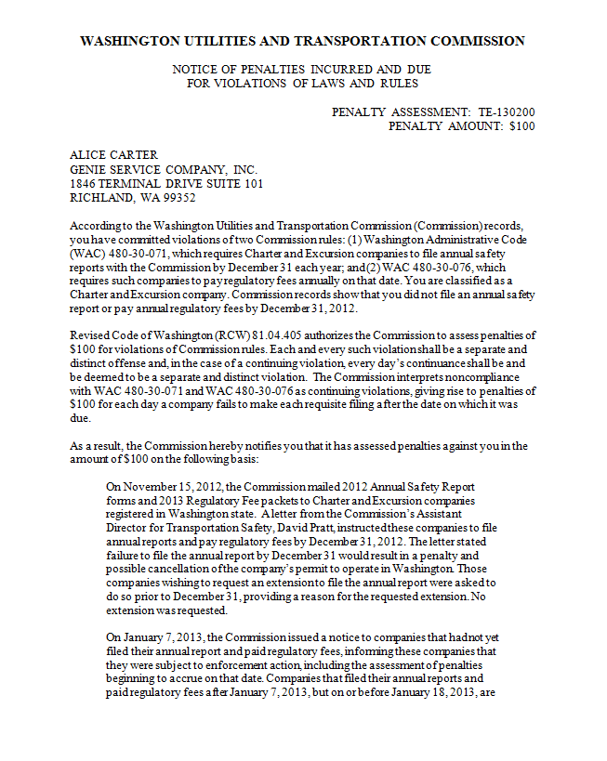

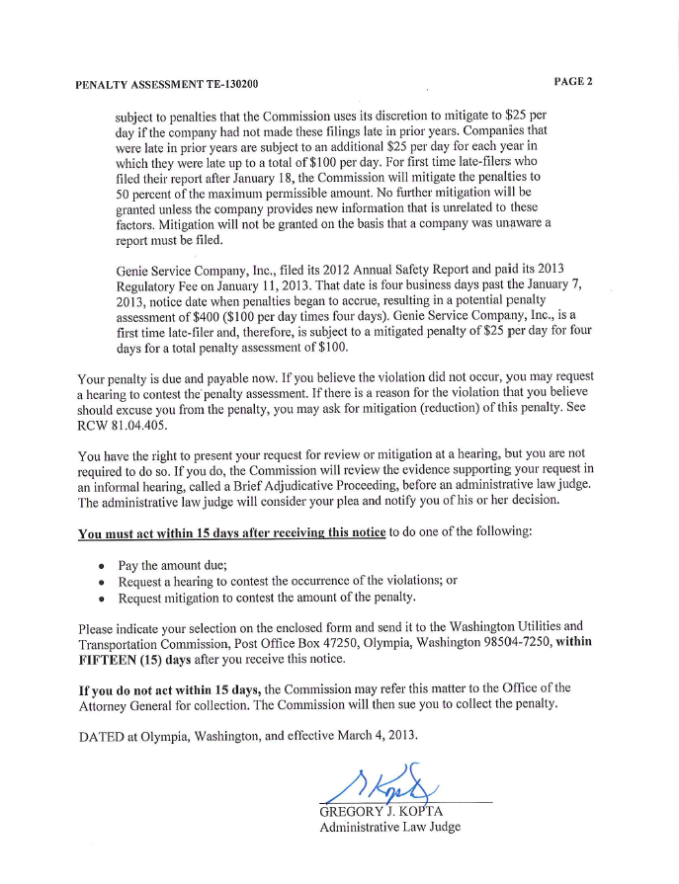

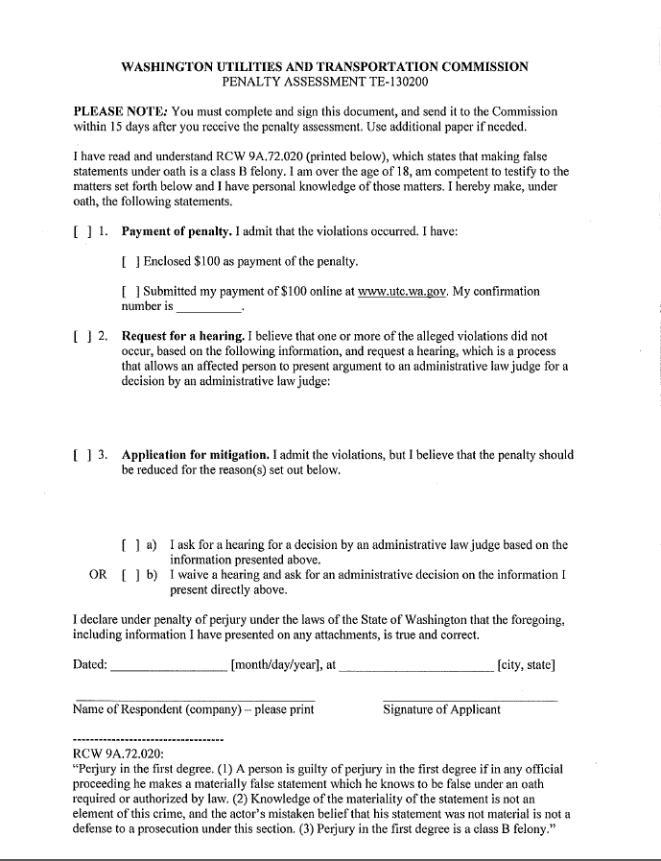

**Attachment B**

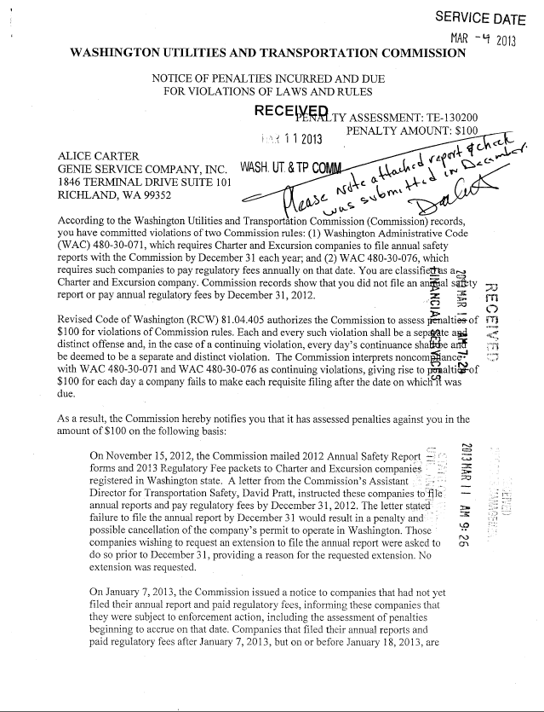

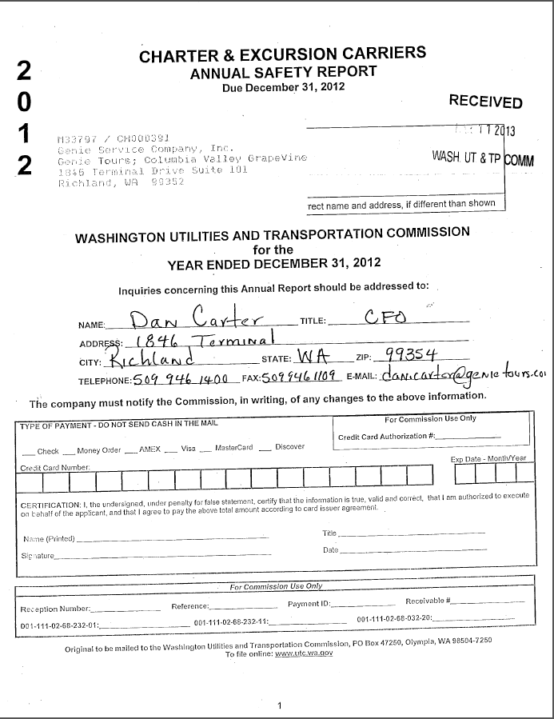

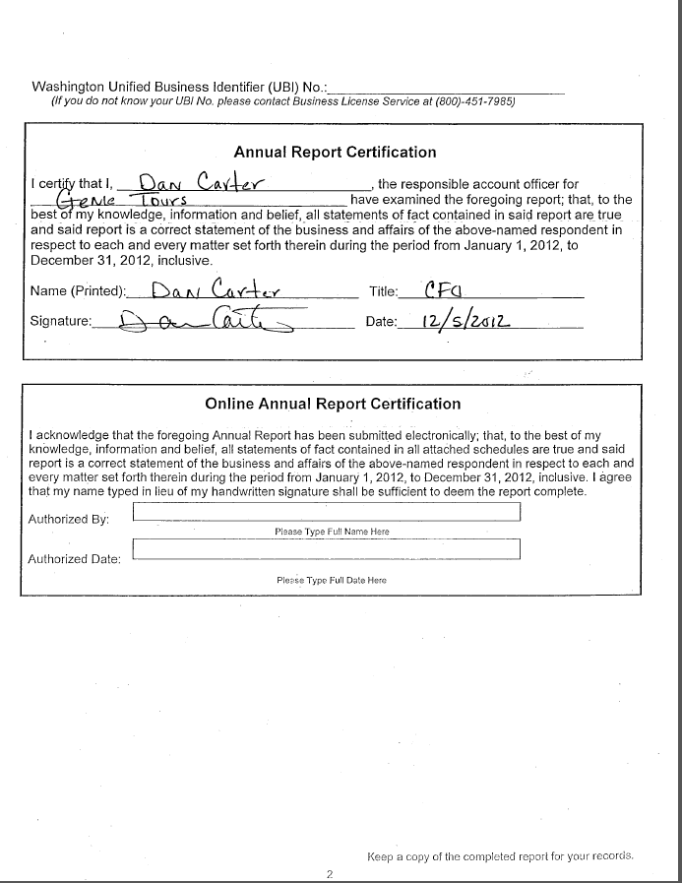

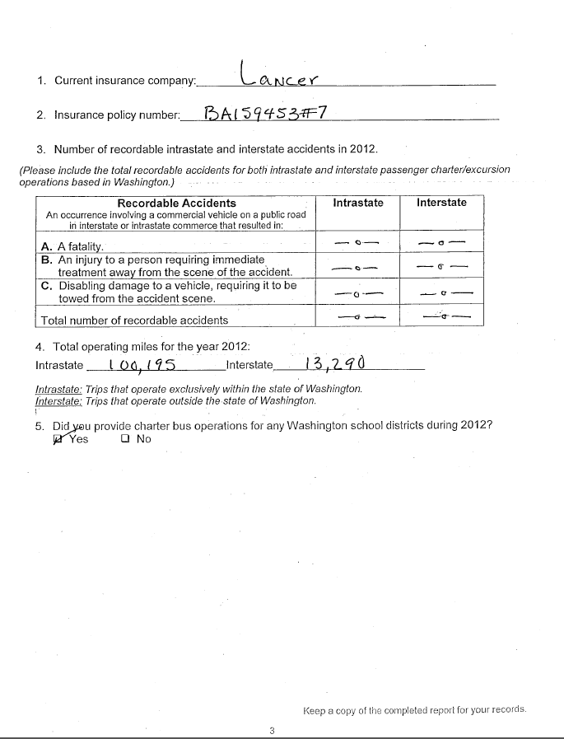

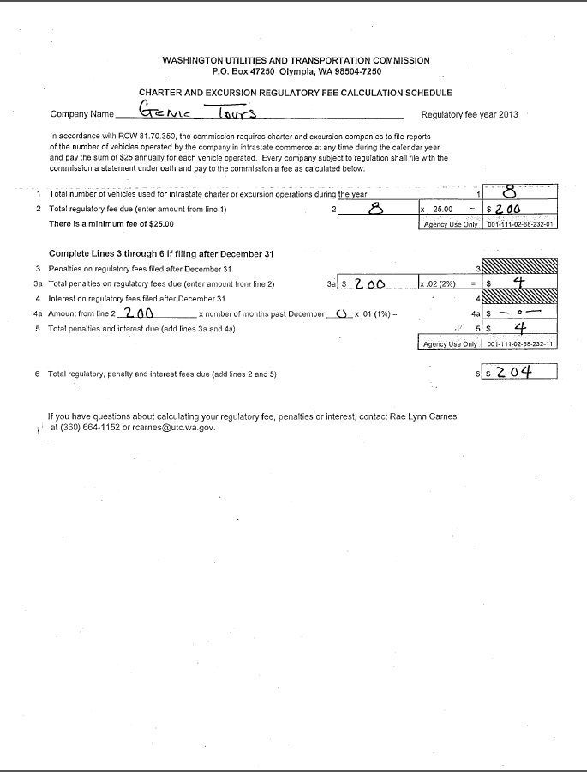

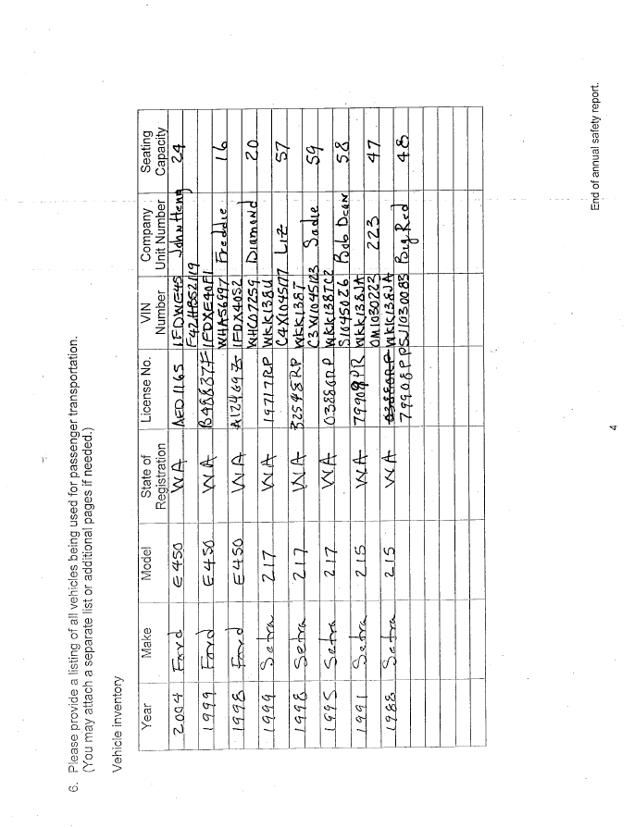

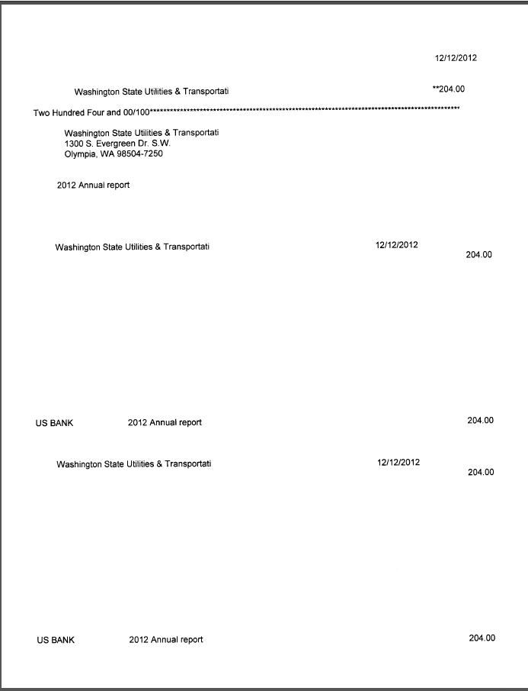

**Attachment C**

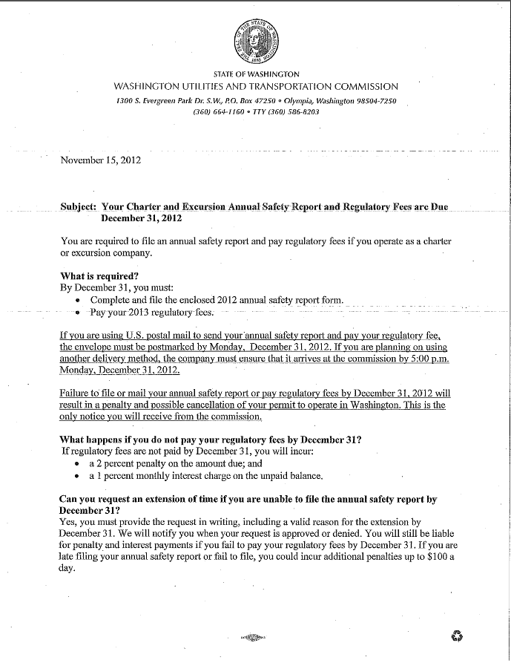

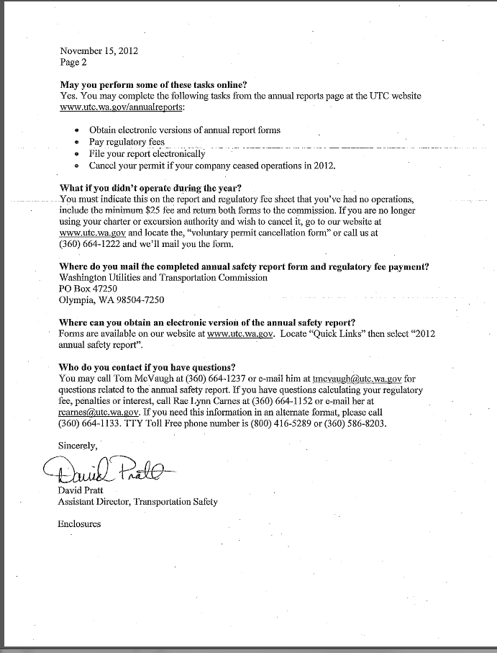

**Attachment D**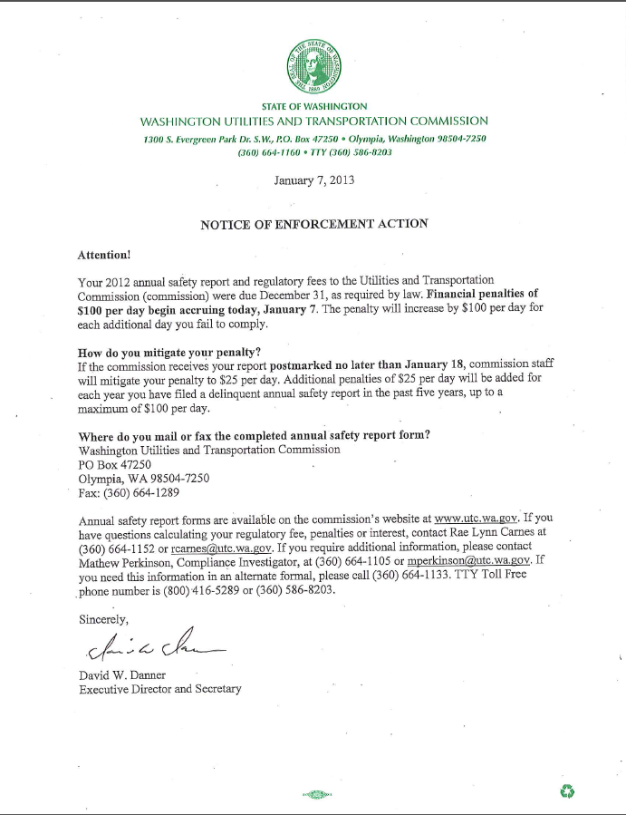

**Attachment E**

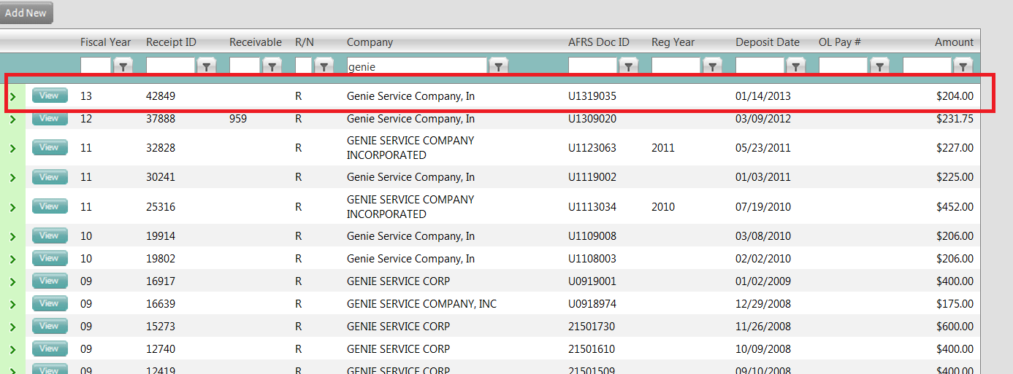

1. See Attachment A for a copy of the penalty assessment sent to Genie Service Company, Inc.
2. See Attachment B for a copy of the request for mitigation submitted on March 11, 2013.
3. See Attachment C for a copy of the letter sent to all regulated companies on November 15, 2012.
4. See Attachment D for a copy of the Enforcement letter sent to all delinquent companies on January 7, 2013.
5. See Attachment E for a copy of the commission’s revenue tracking system, which displays the payment history of the company.