**Puget Sound Energy**

**Annual Report on Program Outcome of PSE's Low Income Program, HELP**

**For 2013 Program Year**

**October 2013 through September 2014**

**Filed May 26, 2015**

**PSE2_TAG_DARK**

Table of Contents

[Introduction and Background 3](#_Toc419976305)

[Description of HELP Bill-Payment Assistance 5](#_Toc419976306)

[HELP Bill-Payment Assistance by Fuel Type and Program Year 5](#_Toc419976307)

[Monthly Pattern of Distribution of HELP Bill-Payment Assistance 8](#_Toc419976308)

[Demographics of Customer Households 11](#_Toc419976309)

[HELP Bill-Payment Assistance by County Area 11](#_Toc419976310)

[HELP Bill-Payment Assistance and Annual Bill by County Area 12](#_Toc419976311)

[HELP Bill-Payment Assistance by Residential Housing Structure 15](#_Toc419976312)

[HELP Bill-Payment Assistance Impacts 16](#_Toc419976313)

[Administration of Program 17](#_Toc419976314)

[Marketing of PSE Home Energy Lifeline Program 18](#_Toc419976315)

## Introduction and Background

Puget Sound Energy's (“PSE’s” or the “Company’s”) low income bill assistance program, the Home Energy Lifeline Program (“HELP”), provides bill-payment assistance to eligible PSE customers whose household is considered as a “very low-income household” per RCW 43.63A.510[[1]](#footnote-1). The majority of the HELP funding is collected from all PSE customers via rates that are set by the Company’s Low Income Program (electric and natural gas Schedules 129). Also, if the Company does not meet any of the service quality index (“SQI”) benchmarks set forth in its Service Quality program and the total annual penalty dollars are less than the equivalent of $12 per customer, the SQI penalty will then be allocated to the appropriate PSE HELP funding based upon the energy service affected by the missed SQI.

HELP benefits are supplemental to the Federal Low Income Home Energy Assistance Program (“LIHEAP”), which are available year-round to eligible households. For the 2013 program year, October 2013 through September 2014, eligible households may receive up to $1,000 per year per customer in HELP credit to offset their PSE electricity or natural gas bills, which is the same maximum as the 2009 through 2013 program years.

Puget Sound Energy’s HELP was first implemented in accordance with Exhibit G to Settlement Stipulation Agreement approved by the Commission in consolidated Dockets UE‑011570 and UG‑011571 Twelfth Supplemental Order dated June 20, 2002, which was amended by the Partial Settlement Agreement approved by the Commission on January 5, 2007, in Dockets UE‑060266 and UG‑060267. The HELP settlement terms allow eligible very low-income customers to receive bill-payment assistance and they do not limit how the benefits are applied to any amounts owed (past, present, and future) by these customers to PSE.

On October 8, 2008, the Commission approved three HELP changes in its Order 12 of the consolidated Dockets UE‑072300 and UG‑072301 (2007 Order 12). Appendix D to the 2007 Order 12 set forth details of these three changes which became effective for program years starting 2008. These changes are:

1. HELP funding is distributed to electric and natural gas customers at the fixed ratio of 75% and 25%, respectively.
2. The total annual HELP funding is increased from $10.25 million to $15 million.
3. Any HELP funds not distributed to customers in any single program year will be carried over to the next program year as supplemental HELP funding.

In Docket U‑072375, merger of PSE and Puget Holdings LLC, these changes are further affirmed as Commitments 22, 23, and 42 of the Multi-Party Settlement Stipulation approved by the Commission on December 30, 2008, in Order 8 of Docket U‑072375, Approving and Adopting Settlement Stipulation; Authorizing Transaction Subject to Conditions.

Additional funding has been available to very low-income customers to mitigate the effect of PSE electric and natural gas rate changes since 2008. This supplemental HELP funding adjustment was described in PSE’s Initial Brief in the Company’s 2009 General Rate Case under the consolidated Dockets UE-090704 and UG-090705, as follows:

The company proposed to increase the annual level of low-income electric and natural gas bill assistance funding by the corresponding percent increase to the residential class that are approved by this Commission. The amount of this percentage increase would be added to the low income tariff in the next program year.

This funding adjustment had been incorporated into PSE’s annual electric and natural gas Schedules 129 HELP funding requirement true-up for the periods of October 1, 2010, through September 30, 2012.

On May 7, 2012, per Order 8 of the consolidated Dockets UE-111048 and UG-111049, the base funding for the low-income bill assistance program was increased to $20.2 million, based on 0.665 percent of PSE’s 2010 operating revenues. Prior funding level reflected about 0.51 percent of PSE’s 2010 operating revenues. The base HELP funding is distributed to electric and natural gas customers at the fixed ratio of 75% and 25%, respectively, as set forth in 2007 Order 12.

For the 2013 program year of October 1, 2013, through September 30, 2014, in addition to the $20.2 million base funds, the available HELP funding was increased, per 2007 Order 12, by the supplemental funding of the carried-over HELP funds of $ $957,487 from the 2012 program year.

## Description of HELP Bill-Payment Assistance

### HELP Bill-Payment Assistance by Fuel Type and Program Year

The following table shows the number of PSE residential very low-income customers who received bill-payment assistance from PSE’s HELP during the 2013 program year, the 12-month period of October 1, 2013, through September 30, 2014.

Electric customers 28,182

Natural gas customers 8,973

The number of eligible very low-income households that received bill-payment assistance is lower than the sum of the two numbers above since some households are both PSE natural gas and electric customers. The total number of very low-income households that received bill-payment assistance is 33,223, i.e., there are 3,932 HELP households that received both PSE electric and natural services in the 2013 program year. Of the electric customers who received bill-payment assistance, 14% were also natural gas customers. Of the natural gas customers who received bill-payment assistance, 44% were also electric customers. The chart below is a comparison of the number of customers who received bill-payment assistance since 2009 by fuel type and by program year.

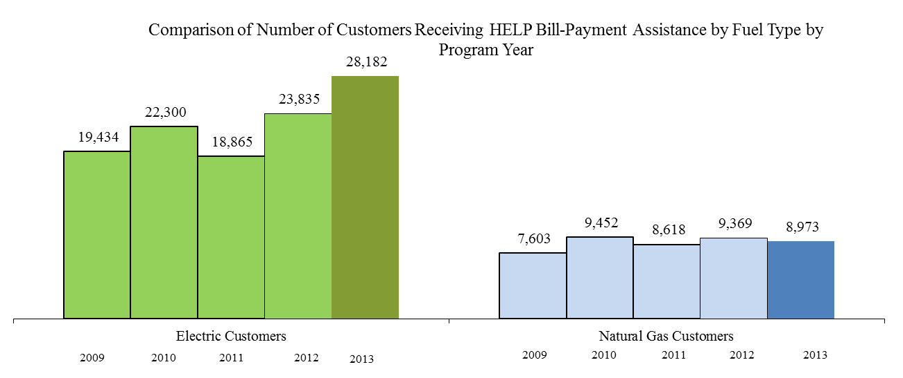

The number of eligible very low-income customers that received HELP bill-payment assistance as percentage of the number of residential customers by electric and natural gas is 3.0% (28,182 out of 937,101) and 1.3% (8,973 out of 713,900), respectively.

The chart below shows the distribution of the number of years a customer received HELP bill-payment assistance during the 2009-2013 program years. About half (52%) of the HELP customers received only one bill-payment assistance during those years; while 6% of customers received HELP assistance every year during that 5-year period.

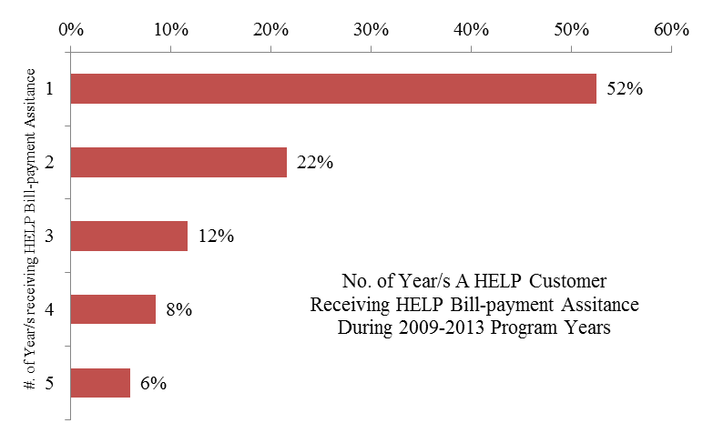

The total dollar amount of HELP bill-payment assistance during the 2013 program year was:

Electric $12,396,524

Natural Gas $3,046,361

Total $15,442,885

The charts below show the relative amount of payment assistance credited to eligible very low-income electric and natural gas residential customers by program year. The total distributed bill payment assistance includes both the base and overflow prior HELP funding net of PSE program costs and agency administration fees.

With the overflow funding of from the 2012 HELP year, the actual percentages of HELP bill-payment assistance credited to each fuel are 80% electric and 20% natural gas for the 2013 program year. The base 2013 program year HELP funding of $22.3 million was allocated as 75% for electric and 25% for natural gas as prescribed in the Appendix D to the 2007 Order 12 while the overflow funding went back to the fuel type that the bill-payment assistance was originally distributed to.

The table below shows a comparison, by fuel type, of the percentages of bill-payment assistance distributed with the percentages of total residential customers and total residential revenues. Electric residential customers were allocated relatively more HELP payment assistance than that of natural gas residential customers based upon the proportion of total residential revenue and total residential customer count percentages.

|  |  |  |  |
| --- | --- | --- | --- |
|  | % of Actual Total Distributed HELP Bill-Payment Assistance Including Overflow Funding from Prior year | % of Residential Customers | % of Residential Revenues |
| Electric | 80% | 57% | 61% |
| Natural Gas | 20% | 43% | 39% |

### Monthly Pattern of Distribution of HELP Bill-Payment Assistance

The following two charts show the monthly pattern of distribution of HELP bill-payment assistance to eligible very low-income PSE customers during the 2013 program year by fuel type. The first chart is a side-by-side bar chart with both the electric and natural gas payment assistance.

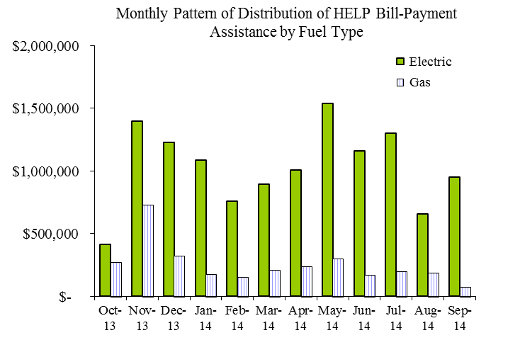

The second chart is a stacked bar chart with both the electric and natural gas payment assistance by month.

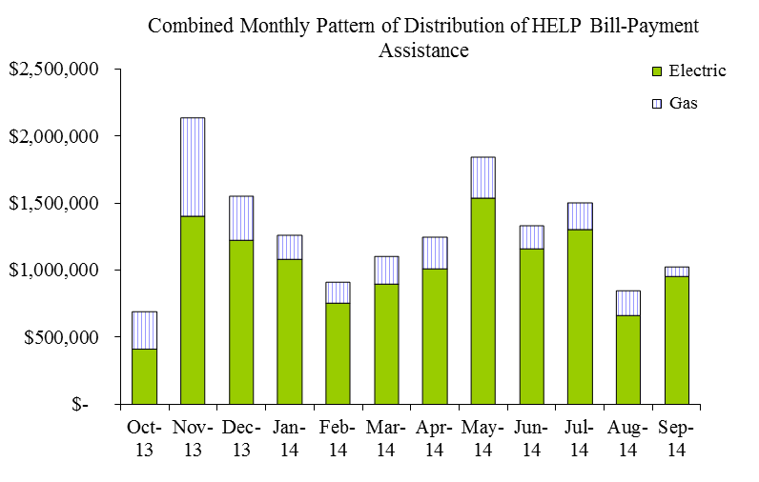

The chart below shows the combined electric and natural gas distributed HELP bill-payment assistance on a monthly basis for the 2013 program year (depicted by the heavy line) and the previous two program years (in light lines). 36% of the annual amount of HELP bill-payment assistance was distributed to the eligible very-low income customers in the first four months of the HELP year, October through January, before and during the peak of winter heating season.

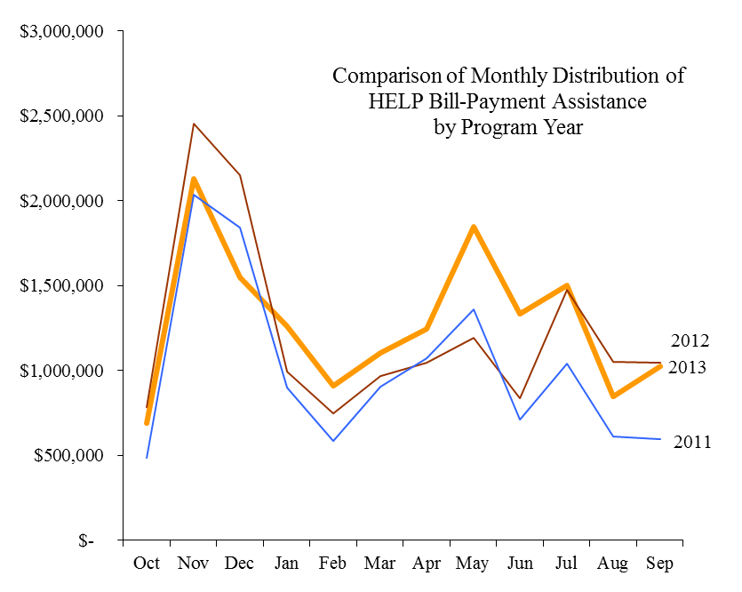

The chart below shows a comparison of the cumulative amount of distributed HELP bill-payment assistance on a monthly basis for the 2013 program year (shown in heavy line) and the previous five program years (in light lines). More HELP payment assistance was distributed to eligible very low-income customers during the 2013 program year compared with the last four program years due to the additional funding increase as discussed in the ***Introduction and Background*** section.

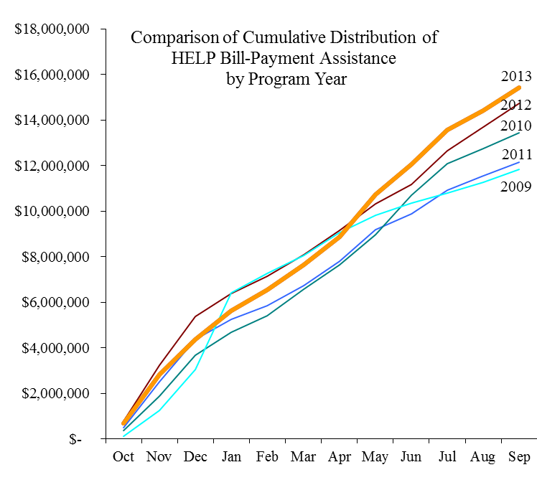

Demographics of Customer Households

### HELP Bill-Payment Assistance by County Area

The average level of HELP bill-payment assistance to each eligible very low-income household is $465 for this program year. It is a $46 decrease from the $511 per household of the 2012 program year.

The chart below shows the average HELP bill-payment assistance per household for the various county areas in PSE’s service territory. The overall average HELP bill-payment assistance per PSE energy account that received HELP bill assistance is $416 due to the fact that 3,932 households have both PSE electric and natural gas services.

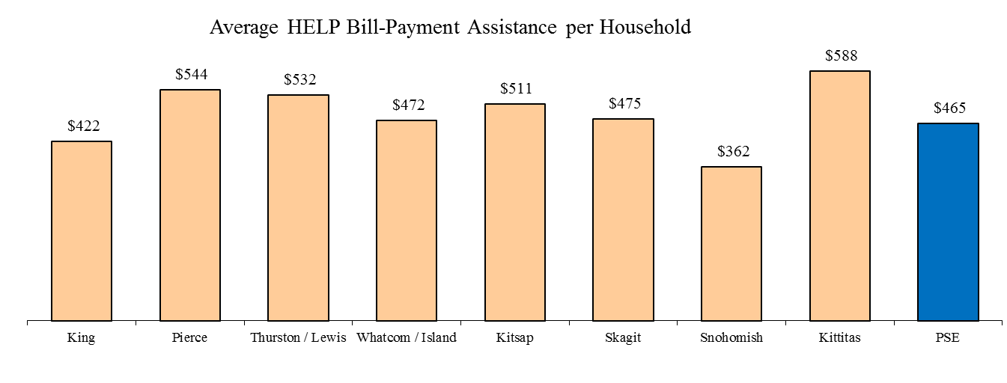

### HELP Bill-Payment Assistance and Annual Bill by County Area

For the purpose of comparison among all the county areas, the average residential and the HELP customer annual bill information presented in the following charts and the customer count information used in the calculation is based upon 12 months ending September 30, 2014, to coincide with the HELP period.

The chart below shows a comparison by county area of the average annual bill per HELP account and per PSE residential account, thus comparing the average bill of a HELP customer to the average bill a general residential customer. For the 2013 program year, the customers who received HELP bill-payment assistance had, on average, annual bills that were about the same as that of average PSE residential customers. Most of the county areas show similar relationship.

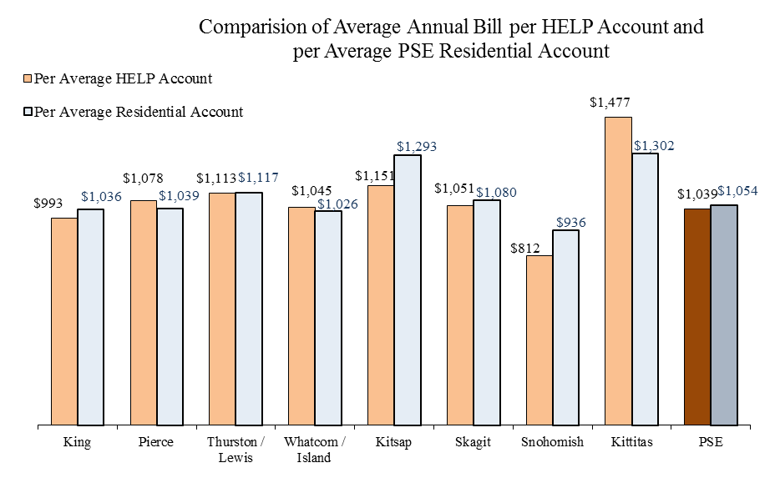

The chart below compares the ratio of average HELP bill-payment assistance per HELP account to the average annual bill per HELP account for the 2013 program year by county area. It generally demonstrates, on average, how much of an electric or natural gas HELP customer’s energy bill was mitigated by HELP bill-payment assistance. The overall average ratio is 40%, i.e. the HELP bill-payment assistance alone could pay for 40% of a HELP customer’s annual energy bills. Among the current PSE service areas, Whatcom/Island, Skagit, and Snohomish Counties have the highest ratio of 45% and King County has the lowest ratio of 36%.

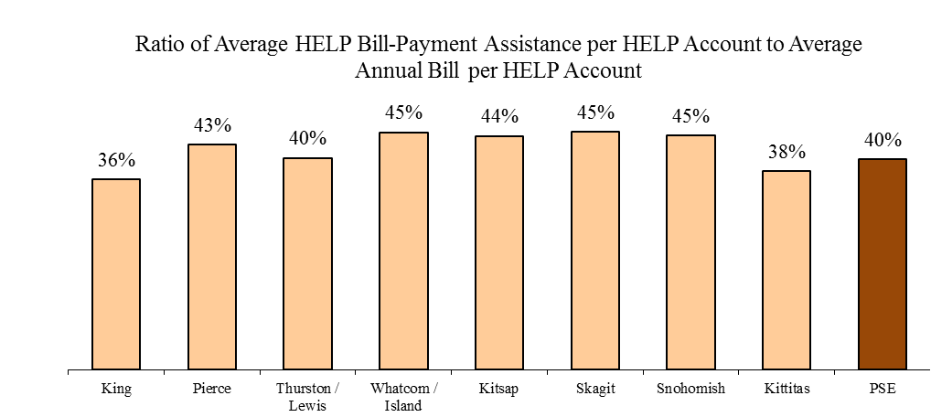

The following charts show the number of eligible very low-income customers receiving HELP bill-payment assistance as percentage of the number of residential customers in a county area. The overall percentages for electric and natural gas are 3.0% and 1.3%, respectively.

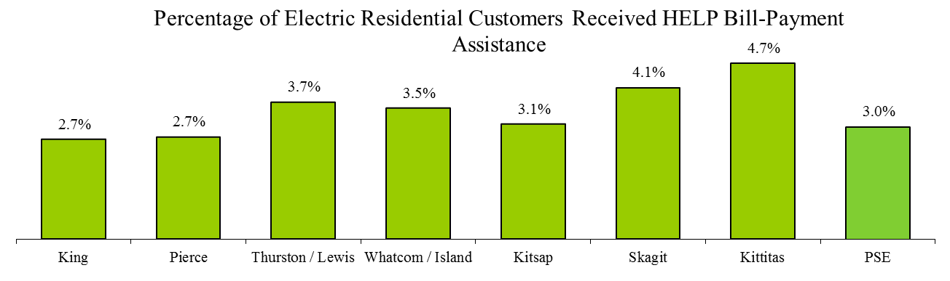

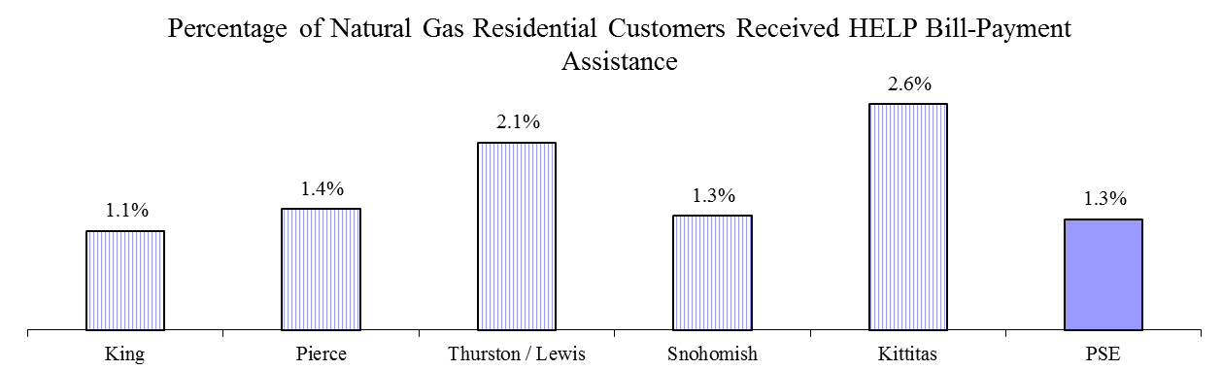

The chart below shows the percentage distribution of PSE residential customers, including both electric and natural gas, by county area along with the percentage of PSE HELP customers in that area. Snohomish County, where PSE provides only natural gas service, and King County, received proportionally significantly less HELP bill-payment assistance than the rest of the county areas. King County has 53.5% of the PSE’s residential customers but in comparison only 46.2% of the PSE HELP customers are in King County. 7.5% of PSE residential customers are in Snohomish County but only 4.3% of the PSE HELP customers are in the county. The other county areas--especially Whatcom/Island, Skagit, and Kittitas Counties--have much higher percentages of PSE HELP customers than that of PSE residential customers in the areas.

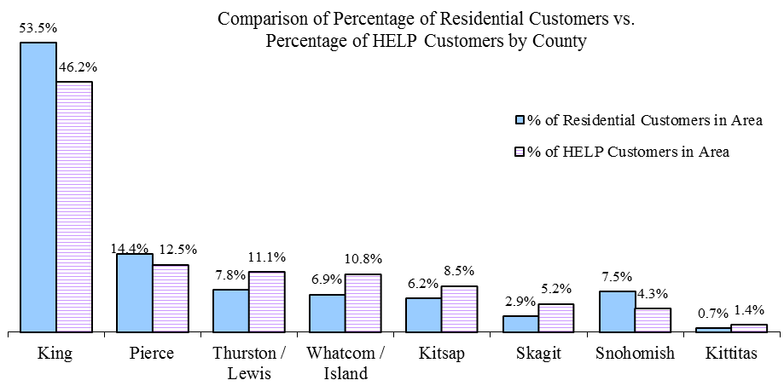

The chart below shows the percentage by county area of PSE total residential electric and natural gas billed amount in a county area compared to the percentage of PSE HELP bill-payment assistance distributed to that area. Similar to the customer count comparison above, Snohomishand King Counties received less HELP bill-payment assistance than the rest of the county areas in terms of the residential billed amount. 6.7% of PSE residential billed amount came from Snohomish County but only 3.8% of the PSE HELP bill-payment assistance went to the area. The results for King County were 52.6% and 40.0%, respectively. Whatcom/Island, Skagit, and Kittitas Counties received higher percentages of PSE HELP bill-payment assistance than that of PSE residential billed amount from these areas.

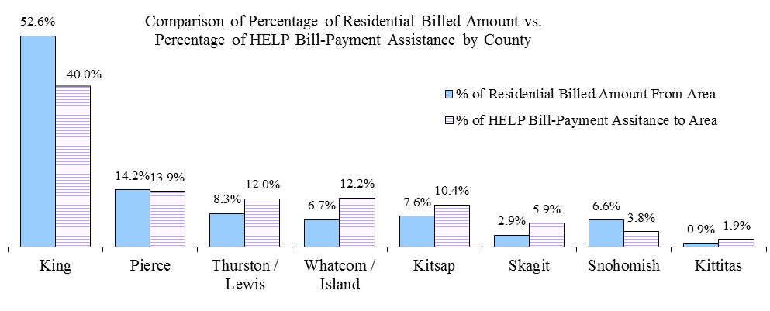

### HELP Bill-Payment Assistance by Residential Housing Structure

The two charts below show comparisons by fuel type and residential housing structure type between PSE residential customers and the eligible very low-income customers receiving HELP bill-payment assistance during the 2013 program year. Electric HELP customers were more likely to live in a multi-family structure whereas natural gas HELP customers were mostly living in a single-family structure.

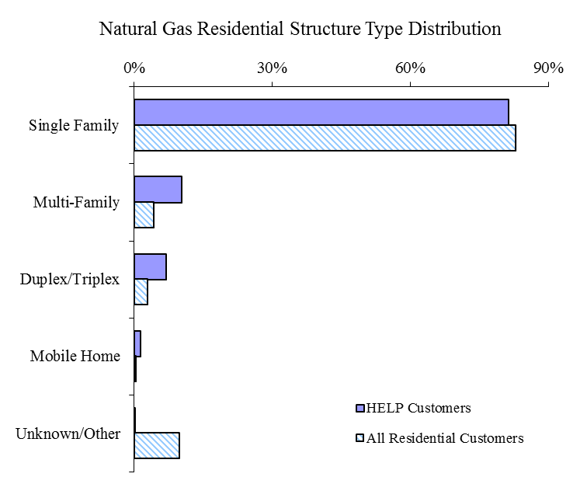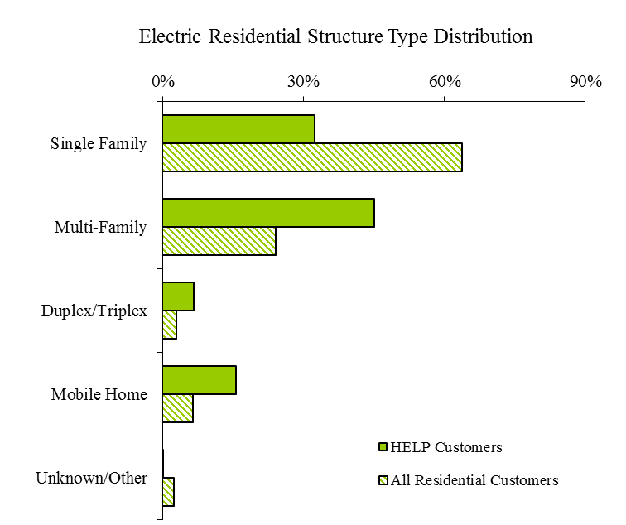

### HELP Bill-Payment Assistance Impacts

The two charts below show the relationship between the very low income customers who became eligible HELP customers during the 2013 HELP period of October 2013 through September 2013 and the non-payment/credit disconnections associated with these customers that occurred during the same period. These two charts only show what happened to these customers during the 2013 HELP period and do not indicate which event occurred first, namely the receipt of HELP assistance or the non-payment/credit disconnection. The first chart highlights the percentage of customers who became eligible HELP customers and were also disconnected due to non-payment/credit by fuel during the period. Overall, 13% of these newly eligible PSE HELP customers experienced non-payment/credit disconnection. The second chart highlights the percentage of non-payment/credit disconnected customers who became eligible HELP customers during the period. The combined percentage for both electric and natural gas non-payment/credit disconnected customers is 12%.



## Administration of Program

During the 2013 program year, there were eleven qualifying low-income agencies administering PSE’s HELP and distributing bill-payment assistance to PSE customers. In addition to the distribution of the HELP bill-payment assistance to eligible low-income customers, these agencies also received allotment of funds from PSE for administrative fees to run HELP and related services such as customer education, eligibility evaluation, bill-assistance amount determination, and other support services.

The charts below illustrate the allocation of the HELP administration costs and bill-payment assistance to customers by program year. For this program year, the overall agency administration fees comprised about 19% of the total funding of the HELP, a 1% decrease from the last program year of 20%. PSE’s own administrative program costs were 3%, a 1% increase from that of the previous program year.



## Marketing of PSE Home Energy Lifeline Program

The following are some highlights regarding the marketing of the HELP during the 2013 program year, October 2013 through September 2014:

* [December 2013](http://pse.com/accountsandservices/YourAccount/monthlyPromotions/Documents/3671_energyWise_2013-12.pdf), [January 2014](http://pse.com/accountsandservices/YourAccount/monthlyPromotions/Documents/3671_voice_2014-01.pdf) and [April 2014](http://pse.com/accountsandservices/YourAccount/monthlyPromotions/Documents/3671_voice_2014-04.pdf) issues of PSE’s customer newsletter featured the article, “Get help paying your heating bill.” The newsletter accompanies customer paper and electronic bill statements and directs customers to contact an energy-assistance agency at 1-866-223-5425.
* January 2014, February 2014, and April 2014, all billing envelopes included messaging about payment options and payment assistance programs.
* December 2013 and April 2014 “Get help paying your heating bill” provided link to [pse.com/lowincome](http://pse.com/accountsandservices/YourAccount/Pages/Low-Income-Assistance.aspx?WT.mc_id=1018), with information about HELP and how to contact energy-assistance agencies.
* *Bill payment and weatherization assistance for income-eligible customers* website information is live 24/7 throughout the year.
* *Multilingual HELP brochures (*[*English*](http://pse.com/accountsandservices/YourBill/Documents/3436_HELP.pdf)*,* [*Spanish,*](http://pse.com/accountsandservices/YourBill/Documents/3437_SPA.pdf)[*Russian*](http://pse.com/accountsandservices/YourBill/Documents/3439_RUS.pdf)*,* [*Korean*](http://pse.com/accountsandservices/YourBill/Documents/3440_KOR.pdf) *and* [*Vietnamese*](http://pse.com/accountsandservices/YourBill/Documents/3438_VIET.pdf)*) with information about income eligibility and assistance centers were available at low income agencies, in PSE customer service offices, and posted on PSE.com. Brochures were updated and posted online in October 2013.*
* *The multilingual recorded telephone line (1-866-223-5425) about the HELP and options for local agency contact information (English, Spanish, Russian, Korean and Vietnamese) was accessible 24/7.*

1. RCW 43.63A.510, Affordable housing — Inventory of state-owned land:

   (1) (b) "Very low-income household" means a single person, family, or unrelated persons living together whose income is at or below fifty percent of the median income, adjusted for household size, for the county where the affordable housing is located. [↑](#footnote-ref-1)