

November 21, 2008

Carole Washburn, Executive Secretary

Washington Utilities and

Transportation Commission

P.O. Box 47250

Olympia, Washington 98504-7250

* **Do Not Re-docket**

RE: Docket UT-081973 (Advice No. 3653T, Replacement No. 3)

ATTENTION: Sharyn Bate

Dear Ms. Washburn:

Pursuant to discussion with Commission Staff, Qwest is making this replacement filing in the above referenced docket to extend the effective date from December 1, 2008 to December 15, 2008. Replacement sheets are attached.

If you have any questions concerning this filing, please contact Sue Henson at 206-345-4341.

Sincerely,

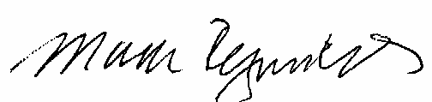

Mark Reynolds

Attachment A

Advice No. 3653T

Replacement No. 3

**ACCESS SERVICE**

**WN U-44**

|  |  |  |
| --- | --- | --- |
| **SECTION** | **SHEET** | **REVISION** |
| 2 | 12 | 3 |
| 2 | 12.1 | Original |
| 2 | 15 | 2 |