

May 6, 2011

Advice No. 3676T

David Danner

Executive Director and Secretary

1300 S. Evergreen Park Dr. S.W.

P.O. Box 47250

Olympia, Washington 98504-7250

Dear Mr. Danner:

Qwest Corporation (Qwest) is forwarding for filing the sheet listed on Attachment A.

This filing increases the City of Roslyn, Washington’s Occupational Tax Rate from 5.0% to 6.0%. The Effective Tax Rate for billing will increase from 5.263% to 6.382%

The Legal Effective Date requested by the City of Roslyn is June 1, 2011. Qwest is requesting an effective date of June 6, 2011, for this filing.

If you have questions concerning this filing please contact me.

Yours very truly,

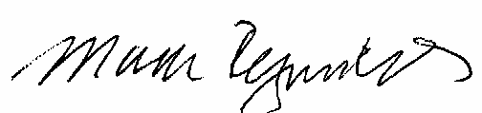

Mark Reynolds

Attachments

Attachment A

Advice No. 3676T

**EXCHANGE AND NETWORK SERVICES**

**WN U-40**

|  |  |  |
| --- | --- | --- |
| **SECTION** | **SHEET** | **REVISION** |
| 2 | 72 | 10 |
|  |  |  |