August 10, 2012

David W. Danner, Executive Director and Secretary

Washington Utilities and Transportation Commission

1300 S. Evergreen Park Dr. SW

P. O. Box 47250

Olympia, Washington 98504-7250

RE: *Washington Utilities and Transportation Commission v. All American Spirit Moving, Co. LLC*

Commission Staff’s Response to Application for Mitigation of Penalties

Docket TV-120907

Dear Mr. Danner:

On July 23, 2012, the Washington Utilities and Transportation Commission issued a $2,100 Penalty Assessment in Docket TV-120907 against All American Spirit Moving Co., LLC for 21 violations of Washington Administrative Code (WAC) 480-15-480, which requires permitted household goods carriers to furnish annual reports to the commission no later than May 1 each year.

On June 1, 2012[1], All American Spirit Moving Co., LLC wrote the commission requesting mitigation of penalties (Mitigation Request). In its Mitigation Request, All American Spirit Moving Co., LLC does not dispute that the violation occurred. The company states, “I was not aware of the new penalties for late filings or when they were put in place. I have no doubt however, that, all the proper and timely notices were sent out. And, I have no excuse for my tardy filing other than a need to survive.” And “I will promise to pay closer attention to my email and mail so this problem does not recur.”

It is the company’s responsibility to ensure that the regulatory fee and the annual report are filed by the May 1 deadline. On February 29, 2012[2], Annual Report forms and Regulatory Fee packets were mailed to all regulated household goods carriers. In addition to other information, the cover letter informed the regulated company it must complete the annual report form, pay any regulatory fees and return the material by May 1, 2012 to avoid enforcement action. On May 15, 2012[3], the commission mailed a letter to those companies that had not yet filed an annual report notifying them that, to date, they had incurred a penalty of $900. The letter went on to explain that companies who filed their annual reports no later than May 25, 2012, would receive mitigated penalties of $25 per day, with an additional $25 per day for each instance in the previous five years that the company received a penalty for filing a late report.

All American Spirit Moving Co., LLC did not file its annual report by May 31, 2012, which is 21 business days past the deadline of May 1, 2012. The penalty is $100 per day for a total of $2,100. All American Spirit Moving Co., LLC became regulated in July 2010 and has never received a penalty for filing a delinquent annual report.

Staff supports mitigating the assessed penalty from $2,100 to $1,050, which represents a 50 percent reduction because this is All American Spirit Moving Co., LLC’s first late filing.

If you have any questions, please contact Mathew Perkinson, Compliance Investigator, at (360) 664-1105, or at [Mperkinson@utc.wa.gov](mailto:Mperkinson@utc.wa.gov).

Sincerely,

Sharon Wallace, Assistant Director

Consumer Protection and Communications

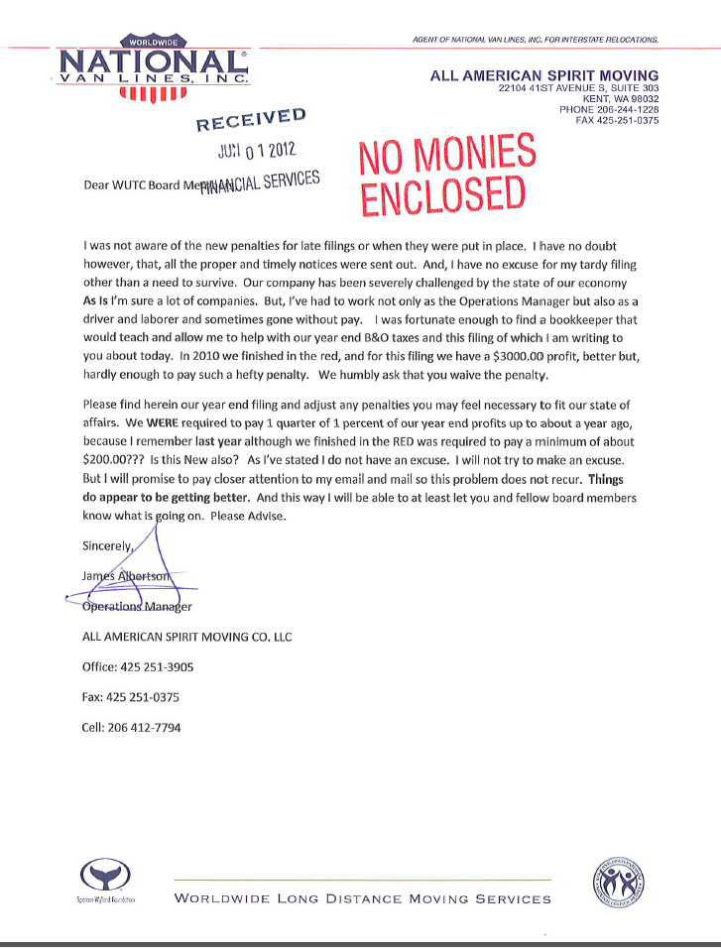**Attachment A**

**Attachment B**

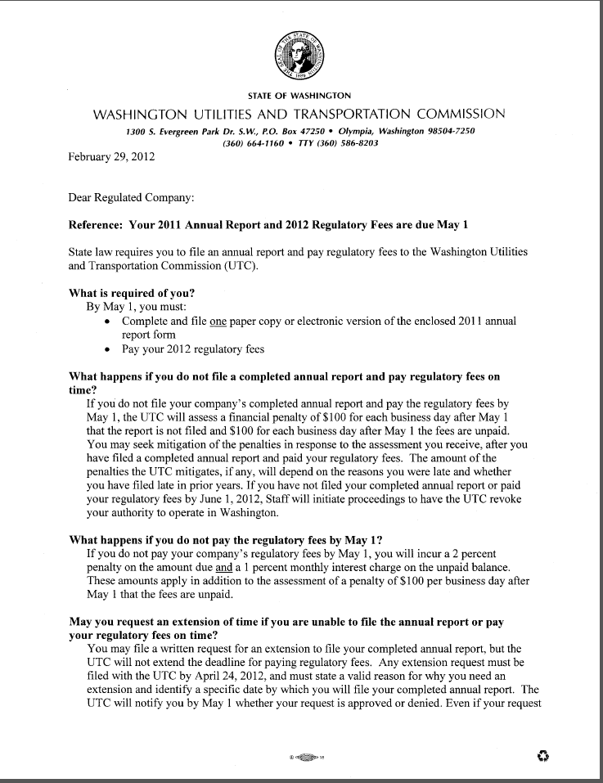

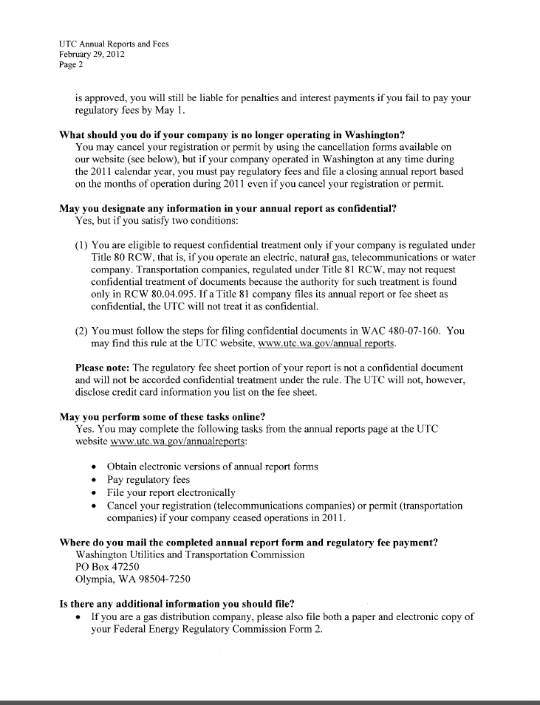

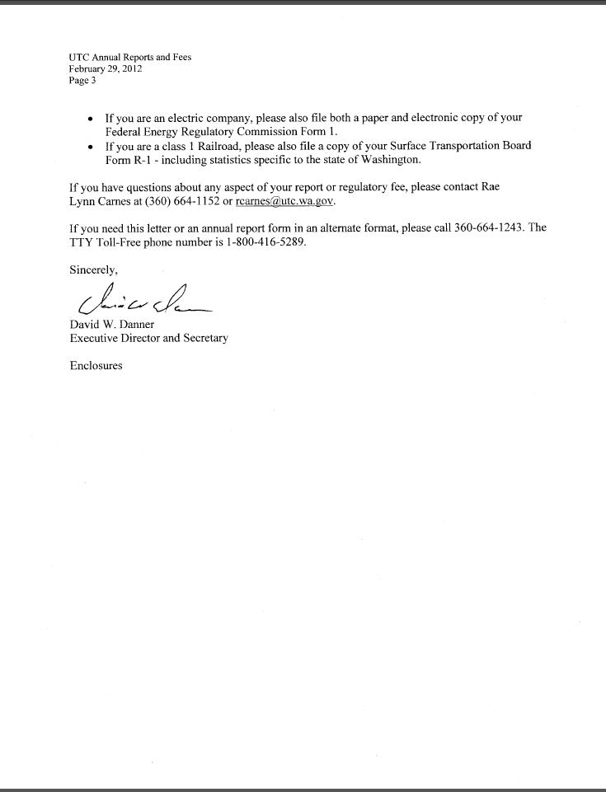**Attachment C**

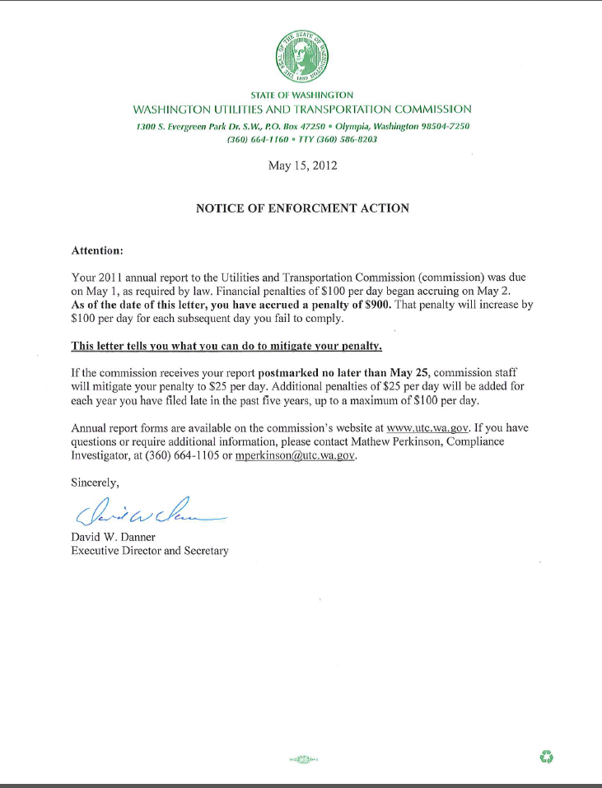

1. See attachment A for a copy of All American Spirit Moving Co., LLC Mitigation Request.
2. See attachment B for a copy of the letter sent to all regulated companies on February 29, 2012.
3. See attachment C for a copy of the enforcement letter sent to the company on May 15, 2012.