**COMMENTS TO WASHINGTON STATE UTILTIES AND TRANPORTATION COMMISSION**

RE: Puget Sound Energy’s Proposed Sale of Non-Controlling Interest in

Puget Holdings LLC, Docket U-180680

Submitted by Puget Sound Sage: October 24, 2018

Puget Sound Sage respectfully requests that the UTC conduct full adjudication of the acquisition of PSE under the net benefits standard. We have two primary concerns regarding racial equity and workplace safety that warrant immediate attention by the UTC and priority in a net benefits analysis. They include:

1. Adequacy of PSE’s Low-Income Program in reaching all eligible households burdened by energy costs.
2. Degradation of roadway safety arising from lack of proper vetting of contractors.

**Puget Sound Sage represents important public interests at stake in the potential acquisition of Puget Sound Energy**

Puget Sound Sage’s mission is to combine research, innovative public policy and organizing to ensure all people have an affordable place to live, a good job, and a clean environment. We bring together community, faith, labor, immigrant & refugee, transit, environmental and public sector partners to advocate for policy that makes racial and social equity a top priority for decision makers at all levels of government. Centering racial justice and equity in all of our work, we have moved numerous groundbreaking policies on transit, housing, labor standards and climate equity.

As one example, in 2009, Puget Sound Sage co-founded [Emerald Cities Seattle](http://emeraldcities.org/cities/seattle/local-council), a partnership of labor, business, environmental and community organizations to promote energy efficiency retrofits and create quality “green job” opportunities for workers traditionally left out of construction jobs.[1] As a result of our work, the Seattle City Council approved a Community High Road Agreement for the City’s Community Power Works program, which ensured quality training, living wages, and career pathways for low-income residents and people with barriers to employment. The program invested $140 million in energy efficiency retrofits, reduced greenhouse gas emissions by 169,700 tons, and provided more than 11,266 jobs. Eventually, the Highroad Agreement became a city-wide policy called Priority Hire, ensuring good jobs and opportunity for communities throughout the region.

Puget Sound Sage is also one of the leading organizations in the coalition that has become the Alliance of Clean Energy and Jobs[2] and we played a critical role in the drafting of Initiative 1631. The Initiative, on the ballot this fall, would institute a carbon production tax, leading to increased costs for energy produced from fossil fuels. During drafting Sage strongly advocated for provisions that would protect low income ratepayers and ensure communities of color are not burdened by increases in energy costs. If passed, Initiative 1631 would direct carbon tax proceeds to reduce the impact of utility rate increases on low-income households, as shown in the explanatory graphic we produced below.

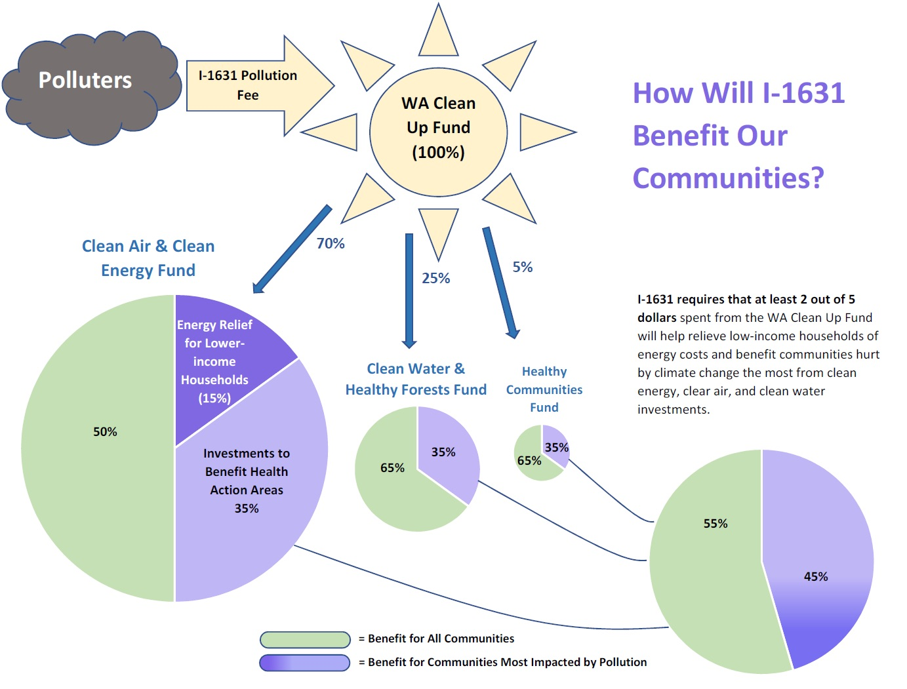

The Office of Management and Budget estimates that by 2023, the Pollution Clean Up Fund will generate around $1 billion in revenue. The initiative will require that about $100 million be provided in assistance for households burdened by energy costs – including bill assistance by private utilities like PSE.

Regardless of whether I-1631 passes, carbon pricing will eventually be adopted in some form in Washington State, and equity for low-income ratepayers will be a central concern. As such, Sage has a profound interest in ensuring the current energy assistance framework is working and capable of handling the infusion of funds that we are working so hard to create. As we explain below, PSE does not provide transparency on their low-income program that either ensures success today or after adoption of a state-wide carbon policy.

**PSE provides insufficient data on the effectiveness of its low-income energy assistance programs and lacks measures of programmatic success**

Meaningful assessments of low-income energy assistance programs, particularly for racial equity, must address two questions: Are all eligible households getting assistance? Are program participants getting the right amount of assistance?

Puget Sound Energy’s ‘Annual Report on Program Outcome of PSE’s Low-Income Program’, the utility’s reporting and assessment tool, lacks the data to answer either of these questions. As a result, the report fails to meaningfully assess the program or to clearly identify ways to improve it. The information PSE does provide suggests the program is falling short in both areas.

For example, PSE does not report how many of its customers were disconnected due to failure to pay. It does not report the race, gender, ages, or household makeup of those receiving assistance – critical data in assessing whether it’s getting to the right people. Nor does it report the distribution of incomes of those receiving assistance. It does not identify or estimate how many people averted disconnection or other negative outcome due to assistance. These pieces of information, and the relationships between them, are critical to any fair assessment of the program.

The fact that PSE’s assistance program has had unused funds to roll over each year could be taken to indicate that the program is sufficiently funded and reaching the right people. The meager relevant data in PSE’s report strongly suggests this isn’t the case.

Specifically, PSE reports that 90% of the customers the company disconnected from service for failure to pay in 2016 *did not* participate in its assistance program. In addition, 12% of the customers who were in the assistance program had their services disconnected for failure to pay (but there is no way to tell from the report whether PSE disconnected their service before or after they entered the program). Surely, reaching only 10% of those disconnected with assistance is too little. And disconnects among those in the program suggest that levels of assistance, which average 33% of total billing, are too low for those households and likely others.

In addition, PSE’s assistance program is proportionally under-enrolled in King, Snohomish, and Pierce Counties.[3] Of the counties PSE serves, those three have the highest proportions of people of color.[4]

The $15 million PSE collects from ratepayers and distributes for low income bill assistance is a significant amount of money and of vital importance to those households. The utility’s reporting on how that money is spent is hardily commensurate. Given the amounts involved, and, in addition, the possibility of greatly increased amounts flowing into the programs under proposed systems of carbon pricing, PSE should report comprehensive data on its program, including critical information on the demographics and incomes of those in its programs and those who are slipping through the cracks.

This lack of data highlights another failure, by PSE and those setting up the assistance program, to define measures of success beyond simple dollars spent. Tracking the information called for here would allow for the development and tracking of measures of meaningful programmatic success.

**The PSE acquisition risks worsening the safety of the utility’s infrastructure projects**

Puget Sound Sage has a longstanding interest in addressing the ways poor labor standards, particularly forms of employment that isolate companies from responsibility for their workers, harm public health and safety. For instance, we’ve examined the public health consequences of limited or nonexistent sick leave among grocery and retail workers.[5] We have reported on how then-pending City legislation would improve the safety and reliability of the for-hire and taxi industry.[6] We have researched the ways involuntary part-time, temp and contract work shifts health-care costs to taxpayers[7] and how use of putative contractors in the port trucking industry created health and safety hazards for nearby community residents.[8]

It is from this long-term interest and expertise that we want to raise the dangers of PSE’s use of unqualified contractors and staffing agencies, particularly flaggers, in its infrastructure projects.

As background, PSE lays and maintains electric and gas infrastructure in, under, and above public right-of-ways. The work zones around those projects are dangerous. According to the State Department of Transportation, there were 1,703 work zone collisions reported to police in 2017. 96% of the people hurt in these collisions were motorists, their passengers or pedestrians.[9]



*Source: Washington State Work Zone Collision Facts[10]*

The leading reasons for the collisions were distracted drivers, following too closely and speeding.[11] Distracted driving accidents in work zones are a particular concern as they have increased 66% in the last ten years[12], probably due to increased cell phone usage. The top three work zone accidents were rear-end collision with another vehicle, striking a fixed object, and sideswiping.

A flagger’s job is to prevent these accidents. Flaggers are the first to arrive in a work zone, which they physically establish by placing cones and warning signs following the project’s traffic control plan. Flaggers are then tasked with maintaining the integrity of the safe work zone and directing traffic through the zone for the duration of the project. In increasing levels of difficulty and danger, this is done by pairs in visual contact with paddles, by radio contact if there’s a rise or a blind corner, or with a pilot car. Regardless, flaggers are the point of first and last contact for the public. In traveling through a work zone, members of the public can drive off the side of the road, have a pipe go through their car, get hit by a construction vehicle, hit site workers, or hit another member of the public. In the most extreme cases, when a flagger fails his or her job, someone, usually a member of the public, dies.

The work is difficult. Flaggers must stand in one spot all day, maintaining focus and attention throughout. They work in beating sun, constant rain, extreme heat, and freezing temperatures all while needing to constantly survey the zone for traffic and work vehicles, head moving in a constant swivel.

PSE contracts out much of the flagger work for its infrastructure projects. One of Sage’s coalition partners, the Washington and Northern Idaho District Council of Laborers, surveyed 20 flaggers that had worked for these contracted companies to gain a better sense of working conditions. The surveys indicate that many flaggers are recruited directly from daily labor firms such as Labor Ready, Command Center Temporary Labor, and Aerotek. Their rates of pay ranged from $10.75 for $16 per hour. They report working as much as 97 hours in a week and as few as 8. Most lack health insurance. Flaggers reported having no training, being badly understaffed, not receiving mandatory work breaks, being hit by cars and witnessing multi-vehicle accidents. Sage has studied and documented in several industries the safety and reliability problems when workers are poorly compensated and poorly trained.[13]

The Washington State Department of Labor and Industries calculates the risk of injury for job classifications to assess workers’ compensation premiums and then applies an ‘experience modification factor’ for each employer, adjusting the employer’s premiums for past history of accidents. An experience modification factor greater than one indicates that the employer has had more accidents than hour worked than the industry average. For the industrial classification 7116, which covers flaggers working on utility lines, PSE contractors have experience rating of 2.00 (Command Center), 1.4 (People Ready (formerly Labor Ready), 1.09 (FlexxStaff), and 1.04 (K&D Services). The premiums for Command Center’s contracted flaggers are twice the industry average. Flaggers for all of these contractors are at greater risk for accidents than the industry average and so to then are members of the public going through the work zones they manage.

PSE’s use of such contracted labor appears to have significantly expanded since Macquarie and the Canadian pension funds decided to take the company private in 2008. This expansion is shown in PSE’s tracking of payments to contractors under the ‘consultative services’ section of its annual FERC reports (Form 2, also filed with the UTC). The transfer of interest in PSE to investors under consideration by the UTC will, if completed, put further pressure on PSE to expand its profit margins, a pressure that has lead in industry after industry to expanding use of contracted and temporary labor.

There is a real risk, should PSE and its new owners not reform their procurement policies to incentivize a more stable, well-trained, properly compensated workforce, that this transaction will create greater risk of harm for the public and ratepayers. In the Commission proceeding considering the Avista-Hydro One merger, this issue merited enough concern to have a remedy placed in the stipulated commitments.[14] The Commission should insist on the same in this case. Doing nothing rises the real specter of increasing public safety hazards from its infrastructure work.

PSE’s investors have seen their profits grow significantly in the last ten years. PSE’s electric and natural gas rate bases have gone from $4.1 billion in 2007 to $6.9 billion in 2017[15], a 66% increase. At the same time, residential gas and electric rates have increased 20%[16] and 17%[17] respectively, even with the recent downward adjustments accounting for the federal corporate tax reductions. PSE does not need to pad it’s profit by continuing, or expanding, its use of contracted labor that endangers public safety.

**Puget Sound Sage supports a full adjudication of the acquisition of PSE under the net benefits standard**

We have high regard for the Public Counsel office’s and the Energy Project’s expertise and experience concerning the standards to apply to determine the type of proceeding and to judge the effects of the ownership change. Puget Sound Sage fully supports their position that a full adjudication under the net benefit standard is appropriate. As a practical matter, the sale of Macquerie’s 44% interest in Puget Holdings will change which entities have ultimate decision-making power over PSE operations. In light of PSE’s lack of data on the effectiveness of its low-income assistance programs and its widespread use of contracted labor outlined above, protecting the safety and interests of Washington residents and ratepayers calls for a comprehensive review of this transaction and inclusion of terms that address these issues.

For any questions regarding this public comment, please contact Howard Greenwich, Senior Policy Advisor, at 206-568-5000 x18, or at howard@pugetsoundsage.org. Visit our web page at [www.pugetsoundsage.org](http://www.pugetsoundsage.org).

1. See http://emeraldcities.org/cities/seattle/local-council.
2. See <https://jobscleanenergywa.com/>.
3. Puget Sound Energy: Annual Report on Program Outcome of PSE’s Low-Income Program for 2016 Program Year, pg. 15.
4. Washington State Office of Financial Management, Race and Hispanic Origin Census 2010 and OFM SADE 2017 data, <https://www.ofm.wa.gov/sites/file/public/dataresearch/pop/asr/race/ofm_pop_race_2000_and_2017.xls>
5. Policy Brief: How Grocers and Retailers Can Curb the Spread of Illness and Promote Public Health. <http://www.pugetsoundsage.org/research/good-jobs/paid-sick-days/>
6. Report: Driving Public Good. <https://pugetsoundsage.org/wp-content/uploads/2016/09/DrivingPublicGood.pdf>
7. Report: Washington’s Changing Workforce: More Involuntary Part-time, Temp & Contract Work Low Wage Employers Shift Health Costs to Taxpayers. <https://pugetsoundsage.org/wp-content/uploads/2014/10/Washingtons-Changing-Workforce.pdf>
8. Community Health Impact Survey Results: Port of Seattle Operations Hazardous to Health in Georgetown and South Park. <http://www.pugetsoundsage.org/research/clean-healthy-environment/community-health-impact-survey-port-of-seattle-operations-hazardous-to-health-in-georgetown-and-south-park/>
9. <https://www.wsdot.wa.gov/Safety/Brake/>
10. <http://www.wsdot.wa.gov/NR/rdonlyres/FC2B6398-A9D7-4E6A-8F9F-AD3181B4AF6E/0/2018workermemorialfactsheet.pdf>
11. <http://www.wsdot.wa.gov/NR/rdonlyres/660961C8-8AEE-4B17-A700-36AA0F7AD09B/0/2018workermemorialinfographic.pdf>
12. <http://www.wsdot.wa.gov/NR/rdonlyres/660961C8-8AEE-4B17-A700-36AA0F7AD09B/0/2018workermemorialinfographic.pdf>
13. Puget Sound Sage: Our Pain Their Gain The Hidden Costs of Profitability in Seattle’s Hotels, <http://www.pugetsoundsage.org/research/good-jobs/our-pain-their-gain/>; Driving Public Good. <https://pugetsoundsage.org/wp-content/uploads/2016/09/DrivingPublicGood.pdf>.
14. Avista-Hydro One: Docket No. U-170970. Settlement Stipulation and Agreement Appendix A. pg. 23-24.
15. See Dockets D-UE-06-0266 (2007), D-UG-06-0267 (2007), D-UE-170033 (2017), D-UG-170034 (2017)
16. Schedule 23 Residential General Service. Dockets UG-060267 (2007), UG-072301 (2008), UG-111049

    (2012), UG-170034 (2017), UG-180283 (2018).
17. See Schedule 7 Residential Service. Dockets UE-060266 (2007), UE-072300 (2008), UE-090704 (2010), UE-111048 (2012), UE-130137 (2013), UE-170033 (2017), UE-180282 (2018).