DEMAND FORECASTING MODELS

Contents

**E-2. ELECTRIC BILLED SALES AND   
 CUSTOMER COUNTS**

**•** System-level Model

• County-level Model

• Eastside King County-level Model

**E-6. ELECTRIC PEAK HOUR LOAD   
 FORECASTING**

**•** System-level Forecast

• County-level Forecasts

• Eastside King County-level Forecast

**E-11. GAS BILLED SALES AND   
 CUSTOMER COUNTS**

**E-14. GAS PEAK DAY LOAD   
 FORECAST**

**E-16. MODELING UNCERTAINTIES IN   
 THE LOAD FORECAST**

**E-17. HOURLY ELECTRIC DEMAND   
 PROFILE**

**•** Data

• Methodology for Distribution of   
 Hourly Temperatures

• Methodology for Hourly Distribution   
 of Load

This appendix describes the econometric models used in creating the demand forecasts

for PSE’s 2015 IRP analysis.

**ELECTRIC BILLED SALES AND CUSTOMER COUNTS**

System-level Model

PSE estimated the following use-per-customer (UPC) and customer count econometric equations using sample dates from a historical monthly data series that extends from January 1989 to December 2013; the sample dates varied depending on sector or class. The billed sales forecast is based on the estimated equations, normal weather assumptions, rate forecasts, and forecasts of various economic and demographic inputs.

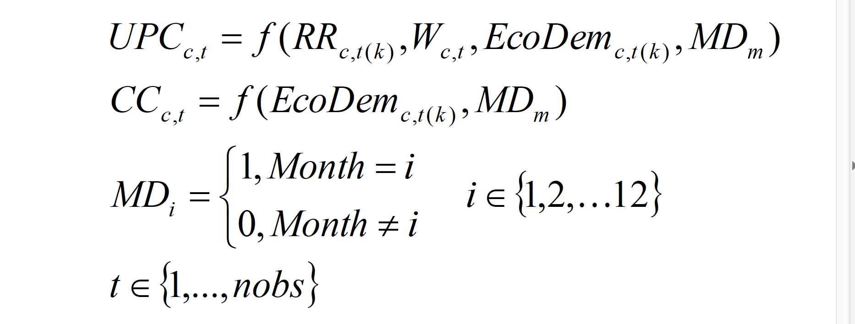The UPC and customer count equations are defined as follows:

 = use (billed sales) per customer for class “c”, month “t”

= customer counts for class “c”, month “t”

 = the subscript denotes either a lag of “k” periods from “t” or a polynomial distributed lag form in “k” periods from month “t”

 = effective real retail rates for class “c” in polynomial distributed lagged form

 = class-appropriate weather variable; cycle-adjusted HDD/CDD using base temperatures of 65, 60, 45, 35 for HDD and 65 and 75 for CDD; cycle-adjusted HDDs/CDDs are created to fit consumption period implied by the class billing cycles

 = class-appropriate economic and demographic variables; variables include income, household size, population, employment levels or growth, and building permits in polynomial distributed lagged form

 = monthly dummy variable that is 1 when the month is equal to “i”, and zero otherwise for “i” from 1 to 12

UPC is forecast monthly at a class level using several explanatory variables including weather, retail rates, monthly effects, and various economic and demographic variables such as income, household size and employment levels. Some of the variables, such as retail rates and economic variables, are added to the equation in a lagged, or polynomial lagged form to account for both short-term and long-term effects of changes in these variables on energy consumption. Finally, depending on the equation, an ARMA(p,q) structure could be imposed to acknowledge that future values of the predicted variables could be a function of its lag value or the lags of forecast errors.

Similar to UPC, PSE forecasts the customer count equations on a class level using several explanatory variables such as household population, building permits, total employment, manufacturing employment or the retail rate. Some of the variables are also implemented in a lagged or polynomial distributed lag form to allow the impact of the variable to vary with time. Many of the customer equations use monthly customer growth as the dependent variable, rather than totals, to more accurately measure the impact of economic and demographic variables on growth, and to allow the forecast to grow from the last recorded actual value. ARMA(p,q) could also be imposed on certain customer counts equations.

The billed sales forecast for each customer class before new conservation is the product of the class UPC forecast and the forecasted number of customers in that class, as defined below.



The billed sales and customer forecasts are adjusted for known, short-term future discrete additions and subtractions not accounted for in the forecast equations, such as major changes in energy usage by large customers. These adjustments may also include fuel and schedule switching by large customers. The forecast of billed sales is further adjusted for new programmatic conservation by class using the optimal conservation bundle from the most recent IRP.

Total billed sales in a given month are calculated as the sum of the billed sales across all customer classes:



PSE estimates total system delivered loads by distributing monthly billed sales into each billing cycle for the month, then allocating the billing cycle sales into the appropriate calendar months using degree days as weights, and adjusting each delivered sales for losses from transmission and distribution. This approach also enables computation of the unbilled sales each month.

County-level Model

We use historical data from PSE’s billing system to generate customer forecasts by county by estimating an equation that relates customer counts by class and county to population or employment levels in that county. The structure of the county-level customer counts econometric equation is similar to the system-level customer counts equation.

 for each county

 = class-appropriate economic and demographic variables in lagged or polynomial distributed lagged forms; variables include population for residential equation, and employment levels or growth for non-residential equations with AR or MA terms.

The forecasts of county-level customers are further adjusted proportionally so that the total of all customer counts is scaled to the original service area forecast at the class level.

The class-level UPC forecast by county is based on the system-level UPC forecast by class, but adjusted to the county level using the ratio of the county to the system-level historical weather-adjusted UPC by class. County-level billed sales forecasts by class are the product of customer counts and use-per-customer, which are further proportionally adjusted so that the total billed sales across all counties is equal to the system-level billed sales by class.

Known discrete additions or deletions to the county-level billed sales are accounted for in the forecast. Finally, projected conservation savings by class are proportionally allocated to county-level class billed sales using the ratio of class-level billed sales for each county to the system-level billed sales. This amount is deducted from the “before conservation” billed sales forecast by class for each county.

Eastside King County Model

The approach used to develop the forecast of billed sales for the Eastside area of King County is similar to that used for the county-level billed sales forecast. Historical customer counts on a monthly basis are used to estimate customer counts econometric equations by class for just the Eastside area. Again, the structure of the customer counts equation is



 = class-appropriate economic and demographic variables in lagged or polynomial distributed lagged forms; variables include population for residential equation, and employment levels or growth for non-residential equations with AR or MA terms.

The historical and projected economic and demographic variables such as population and employment are based on Puget Sound Regional Council jurisdiction population and employment databases and Vision 2040 forecasts.

The class-level UPC forecast for the Eastside area is based on King County-level UPC forecast by class but adjusted using the ratio of the Eastside area to the King County-level historical weather-adjusted UPC by class.

Again, billed sales is adjusted for known block loads, as well as for future conservation savings apportioned using the ratio of billed sales for Eastside to King County-level conservation savings.

**ELECTRIC PEAK HOUR LOAD FORECASTING**

Peak load forecasts are developed using econometric equations that relate observed monthly peak loads to weather-sensitive delivered loads for both residential and non-residential sectors. They account for deviations of actual peak hour temperature from normal peak temperature for the month, day of the week effects, and unique weather events such as a cold snap or an El Niño season.

System-level Forecast

Based on the forecasted delivered loads, we use hourly regressions to estimate a set of monthly peak loads for the system based on three specific design temperatures: “Normal,” “Power Supply Operations” (PSO), and “Extreme.”

The “Normal” peak is based on the average temperature at the monthly peak during a historical time period, currently 30 years. The winter peaks are set at the highest Normal peak, which is currently the December peak of 23 degrees Fahrenheit. We estimated the PSO peak design temperatures to have a 1-in-20 year probability of occurring. These temperatures were established by examining the minimum temperature of each winter month. An extreme value distribution function relating the monthly minimum temperature and the return probability was established. The analysis revealed the following design temperatures: 15 degrees Fahrenheit for January and February, 17 degrees Fahrenheit for November, and 13 degrees Fahrenheit for December. Finally, the “Extreme” peak design temperatures are estimated at 13 degrees Fahrenheit for all winter months.

Weather dependent loads are accounted for by the major peak load forecast explanatory variable, the difference between actual peak hour temperature and the average monthly temperature multiplied by system loads. The equations allow the impact of peak design temperature on peak loads to vary by month. This permits the weather-dependent effects of system delivered loads on peak demand to vary by season. The sample period for this forecast utilized monthly data from January 2002 to December 2013.

In addition to the effect of temperature, peak load estimates account for the effects of several other variables, among them the portion of monthly system delivered loads that affects peak loads but is non-weather dependent; a dummy variable that accounts for large customer changes; and a day of the week variable. The functional form of the electric peak hour equation is



where:



…

 = monthly system peak hour load in MW

 = system delivered loads in the month in aMW

 = monthly dummy variable

 = deviation of actual peak hour temperature from monthly normal temperature

 = day of the week dummy

 = late hour of peak dummy, if the peak occurs in the evening

= dummy variables used to put special emphasis on summer months to reflect growing summer peaks.

To clarify the equation above, when forecasting we allow the coefficients for loads to vary by month to reflect the seasonal pattern of usage. However, in order to conserve space, we have employed vector notation. The Greek letters, , and are used to denote coefficient vectors; there are also indicator variables that account for air conditioning load, to reflect the growing summer electricity usage caused by increased saturation of air conditioning.

The peak load forecast is further adjusted for the peak contribution of future conservation based on the optimal bundle derived from the 2013 IRP.

County-level Forecasts

The county-level peak forecasts are based on the following econometric specification of system monthly peaks as a function of monthly weather and non-weather sensitive loads, and accounting for the deviation of peak temperature from the monthly normal temperature on a seasonal basis, to estimate a system coincident peak forecast. The estimated econometric equation using historical data from January 2002 to December 2012 is represented by



Where:

 = monthly system peak-hour load in MW

 = residential delivered loads in the month in aMW

 = commercial plus industrial delivered loads in the month in aMW

 = deviation of actual peak-hour temperature from monthly normal temperature

 = residential plus a % of commercial delivered loads

Seas = ( Winter if Month = 11,12,1,2; Summer if Month = 7,8; Other if Month = 3,4,5,6,9,10)

AR(1) = autoregressive term of order 1 for time series functions

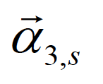The Greek letters  and are used to denote coefficient vectors.

The county-level system coincident peak forecast before conservation is projected by supplying the above equation with the county’s projected residential and non-residential before-conservation loads, and using the design normal peak temperature of 23 degrees Fahrenheit in the. Each county’s normal peak forecast is further adjusted so that the sum of all county peak forecasts is equal to the system peak forecast.

Peak conservation savings are apportioned to each county using the ratio of each county’s peak load to the system peak loads, which is used in adjusting each county’s peak load forecast.

Eastside King County Level Forecast

The Eastside King County coincident peak load forecast based on the normal design temperature of 23 degrees Fahrenheit was developed in a similar manner as the county-level peak forecasts. In the case of the sub-county-level forecast, historical system coincident peak load data for substations serving the area from January 2008 to March 2014 were collected, in addition to the number of customers and billed sales by customer class. The estimated econometric equation for peak loads has the following form:

Where:

 = monthly Eastside peak-hour load in MW

 = Eastside residential delivered loads in the month in aMW

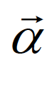

 = Eastside commercial plus industrial delivered loads in the month in aMW

 = deviation of actual peak-hour temperature from monthly normal temperature

 = Eastside residential plus a % of commercial delivered loads

 = ( Winter if Month = 11,12,1,2; Summer if Month = 7,8; Other if Month = 3,4,5,6,9,10)

= time trend starting from 2008, after the housing recession

 = moving average term of order 1 for time series functions



The Greek letters and  are used to denote coefficients to be estimated.

The coincident normal peak hour load forecast is developed using the forecasts of Eastside residential and non-residential loads, using 23 degrees Fahrenheit as the designed normal temperature. The development of the load forecasts by customer class was previously described above. This peak load forecast is further adjusted for conservation by using the ratio of Eastside to King County peak loads as the share of the Eastside in peak conservation within King County.

**GAS BILLED SALES AND CUSTOMER COUNTS**

At the gas system level, PSE forecasts use-per-customer (UPC) and customer counts for each of the customer classes it serves. The gas classes include firm classes (residential, commercial, industrial, commercial large volume and industrial large volume), interruptible classes (commercial and industrial) and transport classes (commercial firm, commercial interruptible, industrial firm and industrial interruptible). Energy demand from firm and interruptible classes is summed to form the 2015 IRP Gas Base Demand Forecast.

PSE estimated the following UPC and customer count econometric equations using sample dates from a historical monthly data series that extends from January 1990 to December 2013; the sample dates varied depending on sector or class. The gas billed sales forecast is based on the estimated equations, normal weather assumptions, rate forecasts, and forecasts of various economic and demographic inputs.

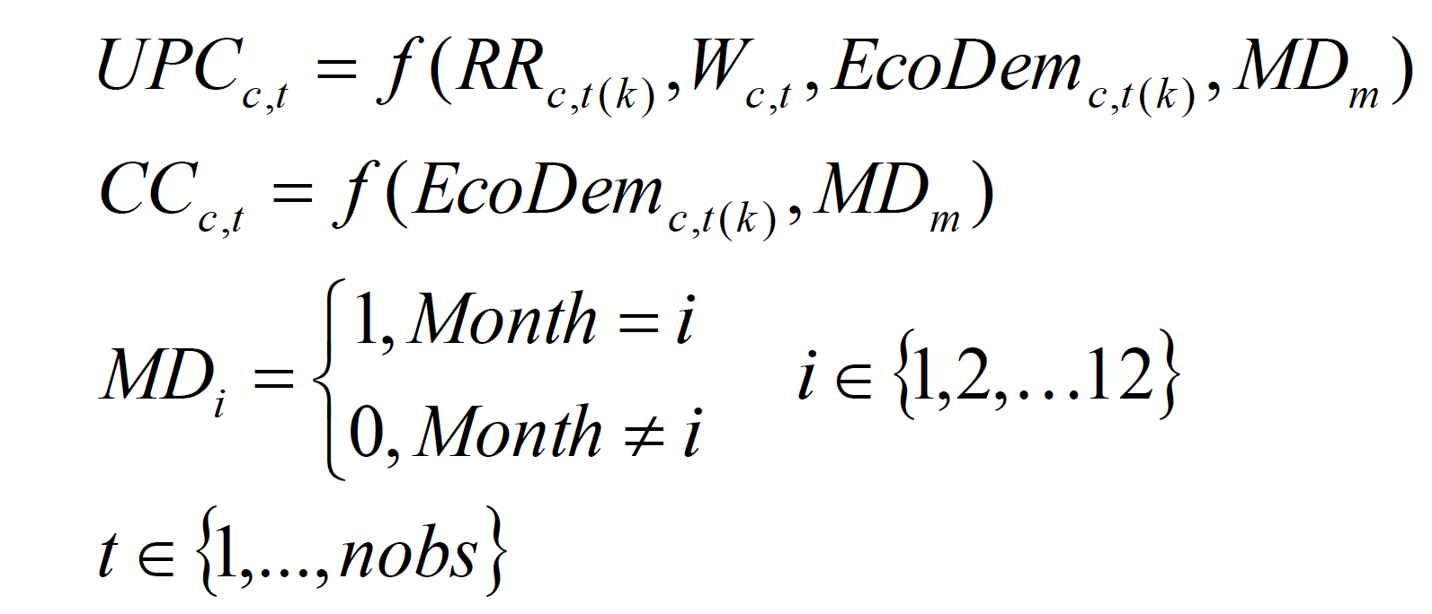The UPC and customer count equations are defined as follows:

 = use (billed sales) per customer for class “c”, month “t”

= customer counts for class “c”, month “t”

 = the subscript denotes either a lag of “k” periods from “t” or a polynomial distributed lag form in “k” periods from month “t”

 = effective real retail rates for class “c” in polynomial distributed lagged form

 = class-appropriate weather variable; cycle-adjusted HDDs using the base temperature of 65; cycle-adjusted HDDs are created to fit consumption period implied by the class billing cycles

 = class-appropriate economic and demographic variables; variables include unemployment rate, household size, non-farm employment levels and growth, manufacturing employment levels and growth, and building permits. Economic and demographic variables may be used in lag form or in polynomial distributed lag form.

 = monthly dummy variable that is 1 when the month is equal to “i”, and zero otherwise for “i” from 1 to 12

UPC is forecast monthly at a class level using several explanatory variables including weather, retail rates, monthly effects, and various economic and demographic variables such as unemployment rate, non-farm employment and manufacturing employment. Some of the variables, such as retail rates and economic variables are added to the equation in a lagged, or polynomial lagged form to account for both short-term and long-term effects of changes in these variables on energy consumption. Finally, depending on the equation, an ARMA(p,q) structure could be imposed to acknowledge that future values of the predicted variables could be a function of its lag value or the lags of forecast errors.

Similar to UPC, PSE forecasts the gas customer count equations on a class level using several explanatory variables such as household size, building permits, total employment and manufacturing employment. Some of the variables are also implemented in a lagged or polynomial distributed lag form to allow the impact of the variable to vary with time. Many of the customer equations use monthly customer growth as the dependent variable, rather than totals, to more accurately measure the impact of economic and demographic variables on growth, and to allow the forecast to grow from the last recorded actual value. ARMA(p,q) could also be imposed on certain customer counts equations. In addition, some of the smaller customer classes are not forecast using equations; instead, those current customer counts are held constant throughout the forecast period. This is done for the transport classes, industrial interruptible class and industrial large volume class. These classes have low customer counts and are not expected to change significantly over the forecast period.

The billed sales forecast for each customer class, before new conservation, is the product of the class UPC forecast and the forecasted number of customers in that class, as defined below.



The gas billed sales and customer forecasts are adjusted for known, short-term future discrete additions and subtractions not accounted for in the forecast equations, such as major changes in energy usage by large customers. These adjustments may also include fuel and schedule switching by large customers. The forecast of billed sales is further adjusted for new programmatic conservation by class using the optimal conservation bundle from the most recent IRP.

Total billed sales in a given month are calculated as the sum of the billed sales across all customer classes:



PSE estimates total gas system delivered loads by distributing monthly billed sales into each billing cycle for the month, then allocating the billing cycle sales into the appropriate calendar months using heating degree days as weights, and adjusting each delivered sales for losses from transmission and distribution. This approach also enables computation of the unbilled sales each month.

**GAS PEAK DAY LOAD FORECAST**

Similar to the electric peaks, the gas peak day is assumed to be a function of weather-sensitive delivered sales, the deviation of actual peak day average temperature from monthly normal average temperature and other weather events. The following equation used monthly data from October 1993 to December 2013 to represent peak day firm requirements:





where:

 = monthly system gas peak day load in dekatherms

 = monthly delivered loads by firm customers

= deviation of actual gas peak day average daily temperature from monthly normal temperature

 = dummy for when El Niño is present during the winter

 = dummy variable for month of the year

 = indicator variable for when the peak occurred within a cold snap period lasting more than one day, multiplied by the minimum temperatures for the day

As before, the Greek letters are coefficient vectors as defined in the electric peak section above.

This formula uses forecasted billed sales as an explanatory variable, and the estimated model weighs this variable heavily in terms of significance. Therefore, the peak day equation will follow a similar trend as that of the billed sales forecast with minor deviations based on the impact of other explanatory variables. An advantage of this process is that it helps estimate the contribution of distinct customer classes to peak loads.

The design peak day used in the gas peak day forecast is a 52 heating degree day (13 degrees Fahrenheit average temperature for the day), based on the costs and benefits of meeting a higher or lower design day temperature. In the 2003 LCP, PSE changed the gas supply peak day planning standard from 55 heating degree days (HDD), which is equivalent to 10 degrees Fahrenheit or a coldest day on record standard, to 51 HDD, which is equivalent to 14 degrees Fahrenheit or a coldest day in 20 years standard. The Washington Utilities and Transportation Commission (WUTC) responded to the 2003 plan with an acceptance letter directing PSE to “analyze” the benefits and costs of this change and to “defend” the new planning standard in the 2005 LCP.

As discussed in Appendix I of the 2005 LCP, PSE completed a detailed, stochastic cost-benefit analysis that considered both the value customers place on reliability of service and the incremental costs of the resources necessary to provide that reliability at various temperatures. This analysis determined that it would be appropriate to increase our planning standard from 51 HDD (14 degrees Fahrenheit) to 52 HDD (13 degrees Fahrenheit). PSE’s gas planning standard relies on the value our natural gas customers attribute to reliability and covers 98 percent of historical peak events. As such, it is unique to our customer base, our service territory and the chosen form of energy. Thus, we use projected delivered loads by class and this design temperature to estimate gas peak day load.

**MODELING UNCERTAINTIES IN THE LOAD FORECAST**

Load forecasts are inherently uncertain, and to acknowledge this uncertainty, high and low load forecasts are developed. There are many sources of uncertainties in the load forecasts including weather and modelling errors, but a key driver in loads are the assumptions on economic and demographic growth within the service territory. Since the IRP focuses on long-term uncertainty, the high and low load forecasts are based on uncertainties related to long-term economic and demographic growth.

The econometric load forecast equations depend on certain types of economic and demographic variables; these may vary depending on whether the equation is for customer counts or use-per-customer, and whether the equation is for residential or non-residential customer class. In PSE’s load forecast models, the key service area economic and demographic inputs are population, employment, unemployment rate, personal income and building permits. These variables are inputs into one or more load forecast equations.

The high and low load forecasts are defined in the IRP as the 95th and 5th percentile, respectively, of the stochastic simulation of the loads based on uncertainties in the economic and demographic inputs. To develop the stochastic simulations of loads, a stochastic simulation of PSE’s economic and demographic electric and gas models is performed to produce the distribution of PSE’s economic and demographic forecast variables. The forecasts of PSE’s economic and demographic variables are also a function of key U.S. macroeconomic variables such as population, employment, unemployment rate, personal income, personal consumption expenditure index and long-term mortgage rates. We utilize the stochastic simulation functions in EViews, a popular econometric, forecasting and simulation tool, by providing the standard errors of the quarterly growths of key U.S. macroeconomic inputs into the PSE’s economic and demographic models. These standard errors were based on historical actuals from 1980 to 2013. The stochastic simulation of PSE’s economic and demographic models from 1,000 draws provides the basis for developing the distribution of the relevant economic and demographic inputs for the load forecast models over the forecast period. Based on these distributions, standard errors were estimated for PSE service area population, employment, unemployment rate, personal income and building permits for each year over the forecast horizon. In a similar manner, these standard errors were used in producing the 250 stochastic simulations of PSE’s load forecasts within EViews. The 5th and 95th percentile of these stochastic simulations were used as the low and high load forecasts in the 2015 IRP.

**HOURLY ELECTRIC DEMAND PROFILE**

Because temporarily storing large amounts of electricity is costly, the minute-by-minute interaction between electricity production and consumption is very important. For this reason, and for purposes of analyzing the effectiveness of different electric generating resources, an hourly profile of PSE electric demand is required.

We use our hourly (8,760 hours) load profile of electric demand for the IRP for the stochastic analysis in the Resource Adequacy Model (RAM), for our power cost calculation and for other AURORA analyses. The estimated hourly distribution is built using statistical models relating actual observed temperatures, recent load data and the latest customer counts.

Data

PSE developed a representative distribution of hourly temperatures based on data from January 1, 1950 to December 31, 2014. Actual hourly delivered electric loads between January 1, 1994 and December 31, 2014 were used to develop the statistical relationship between temperatures and loads for estimating hourly electric demand based on a representative distribution of hourly temperatures.

Methodology for Distribution of Hourly Temperatures

The above temperature data were sorted and ranked to provide two separate data sets:

For each year, a ranking of hourly temperatures by month, coldest to warmest, over 60 years was used to calculate average monthly temperature. A ranking of the times when these temperatures occurred, by month, coldest to warmest, was averaged to provide an expected time of occurrence. Next PSE found the hours most likely to have the coldest temperatures (based on observed averages of coldest-to-warmest hour times) and matched them with average coldest-to-warmest temperatures by month. Sorting this information into a traditional time series then provided a representative hourly profile of temperature.

Methodology for Hourly Distribution of Load

For the time period January 1, 1994 to December 31, 2014, PSE used the statistical hourly regression equation:



for hours from one to 24 to calculate load shape from the representative hourly temperature profile. This means that a separate equation is estimated for each hour of the day.

 Estimated hourly load at hour “h”

= Load at hour “h”

= Load “k” hours before hour “h”

= Temperature at time “h”

= Squared hourly temperature at time “h”

 = 1st degree polynomial

= NERC holiday dummy variables

All Greek letters again denote coefficient vectors.