

**STATE OF WASHINGTON**

WASHINGTON UTILITIES AND TRANSPORTATION COMMISSION

***1300 S. Evergreen Park Dr. S.W., P.O. Box 47250 ● Olympia, Washington 98504-7250***

***(360) 664-1160 ● TTY (360) 586-8203***

March 28, 2013

Steven V. King, Acting Executive Director and Secretary

Washington Utilities and Transportation Commission

1300 S. Evergreen Park Dr. SW

P. O. Box 47250

Olympia, Washington 98504-7250

RE: *Washington Utilities and Transportation Commission v. Leavenworth’s Enchanted Tours, LLC*

Commission Staff’s Response to Application for Mitigation of Penalties

Docket TE-130205

Dear Mr. King:

On March 5, 2013, the Washington Utilities and Transportation Commission issued a $900 Penalty Assessment in Docket TE-130205 against Leavenworth’s Enchanted Tours, LLC, (Leavenworth) for 18 violations of WAC 480-30-071, which requires charter and excursion companies to file annual safety reports with the Commission by December 31 each year; and WAC 480-30-076, which requires such companies to pay regulatory fees annually on that date. [1]

On March 14, 2013, Leavenworth responded to the commission, requesting mitigation of the penalty. In its Mitigation Request, Leavenworth does not dispute that the violations occurred. The company states, “This is Brian Parton with Leavenworth’s Enchanted Tours LLC (UBI# 602 746 035 and CH062961 [sic] I have no record I received anything else other than our normal notice we received in November with the scale late payment schedule attached to our blank Annual Report forms, which I have filed [sic] out and have sent in today via fax. I run a small fleet that runs mostly inside Leavenworth’s immediate area, qualifying for urban transport and outside the commission’s dealings, but we still do some work outside and want to do more in the future. This time of year is our “down season”, and pushes me outside of my company for employment [sic] make ends meet and even more challenging to stay up on all paperwork [sic] Obviously, I wouldn’t knowingly Ignore [sic] such a huge penalty and don’t understand how I missed that. Normally important notices that were apparently (according to my violation) sent out in January that represented “new fines being accessed, [sic] ” at least I was unaware that these laws [sic] and now are being enforced across the board according to Rae Lynn Carnes whom I spoke to earlier today. I believe that it should require registered mail, in order to, insure every company does receive notice of the impending violations due to the severity of the fine. The registered mail with the fine was my first understanding of the violation!”[2]

It is the company’s responsibility to ensure that the regulatory fee is paid and the annual report is filed by the December 31 deadline. On November 15, 2012, the commission mailed 2012 Annual Safety Report forms and 2013 regulatory fee packets to Charter and Excursion companies registered in Washington state. A letter from the commission’s Assistant Director for Transportation Safety, David Pratt, instructed these companies to file annual reports and pay regulatory fees by December 31, 2012. The letter stated failure to file the annual report by December 31 would result in a penalty and possible cancellation of the company’s permit to operate in Washington. Those companies wishing to request an extension to file the annual report were asked to do so prior to December 31, providing a reason for the requested extension. No extension was requested.[3]

On January 7, 2013, the commission issued a notice to companies that had not yet filed their annual report and paid regulatory fees, informing these companies that they were subject to enforcement action, including the assessment of penalties beginning to accrue on that date. Companies that filed their annual reports and paid regulatory fees after January 7, 2013, but on or before January 18, 2013, are subject to penalties that the commission uses its discretion to mitigate to $25 per day if the company had not made these filings late in prior years. Companies that were late in prior years are subject to an additional $25 per day for each year in which they were late up to a total of $100 per day. For first time late-filers who filed their report after January 18, the commission will mitigate the penalties to 50 percent of the maximum permissible amount. No further mitigation will be granted unless the company provides new information that is unrelated to these factors. Mitigation will not be granted on the basis that a company was unaware a report must be filed.[4]

Leavenworth filed its completed 2012 annual safety report on March 14, 2013, and paid its 2013 regulatory fees on March 19, 2013. As of January 31, 2013, Leavenworth failed to file the report and pay the required regulatory fees. That date is 18 business days past the January 7, 2013, notice date when penalties began to accrue, resulting in a potential penalty assessment of $1,800 ($100 per day times eighteen days). Leavenworth has not previously missed the deadline for filing its annual report and paying its regulatory fees. The commission therefore mitigated the penalty by 50 percent to a total assessed penalty of $900. In its mitigation request, Leavenworth admits it received the penalty assessment, which was mailed to PO BOX 342, Leavenworth, WA 98826. The notice sent to Leavenworth on January 7, was also mailed to PO BOX 342, Leavenworth, WA 98826.[5] There were no returned mailings.

Staff does not support mitigating the $900 penalty assessment further. The penalty was already administratively mitigated by 50 percent, from $1,800 to $900. Also, the penalty assessment states that mitigation will not be granted on the basis that a company was unaware a report must be filed. Staff recommends denying the mitigation request.

If you have questions regarding this recommendation, please contact Mathew Perkinson, Compliance Investigator, at (360) 664-1320, or at mperkinson@utc.wa.gov.

Sincerely,

Sharon Wallace, Assistant Director

Consumer Protection and Communications

**Attachment A**

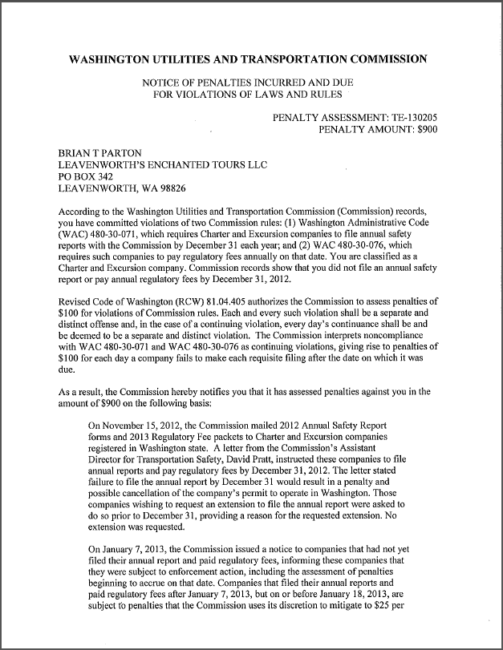

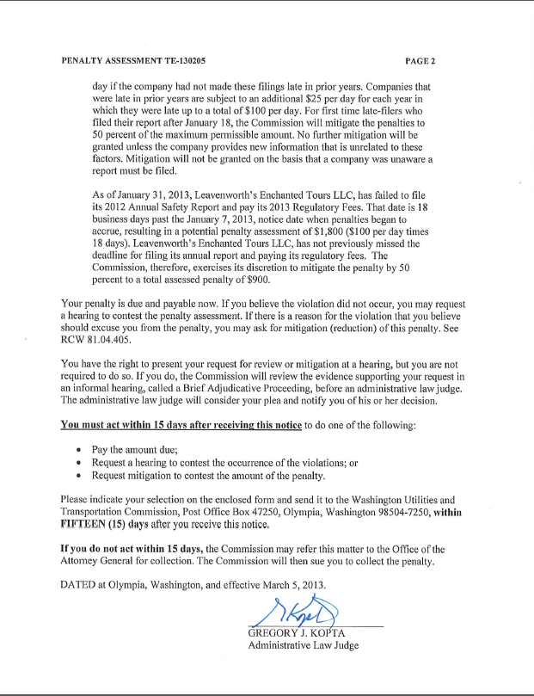

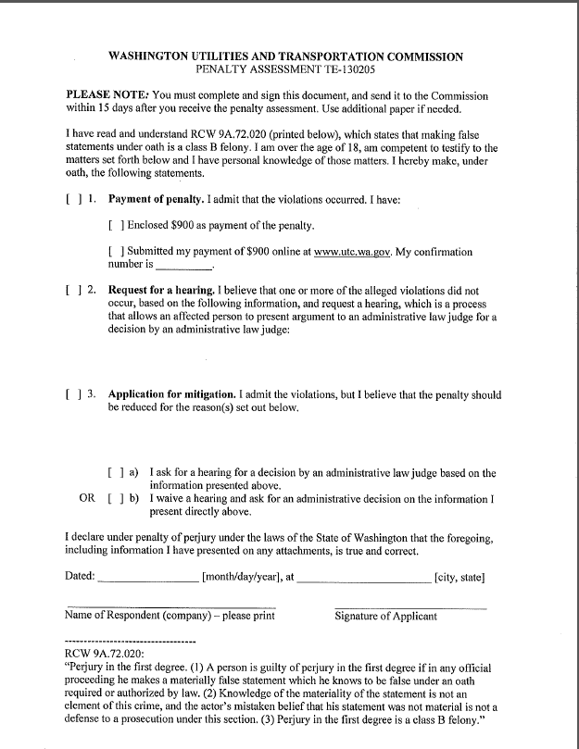

**Attachment B**

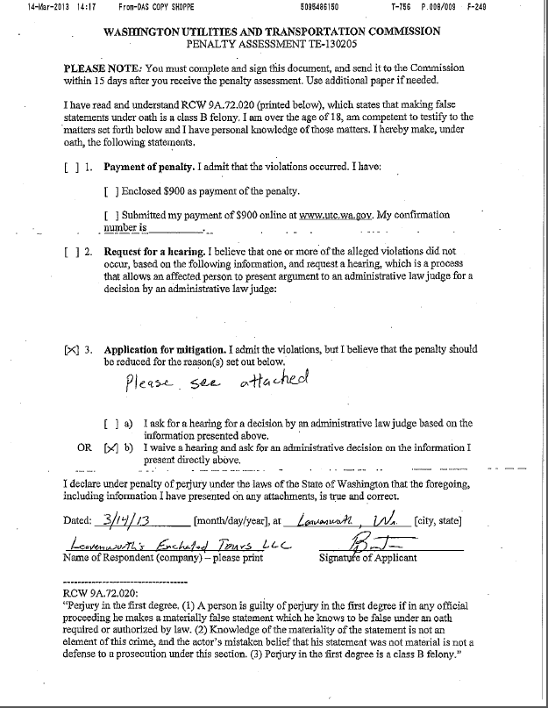

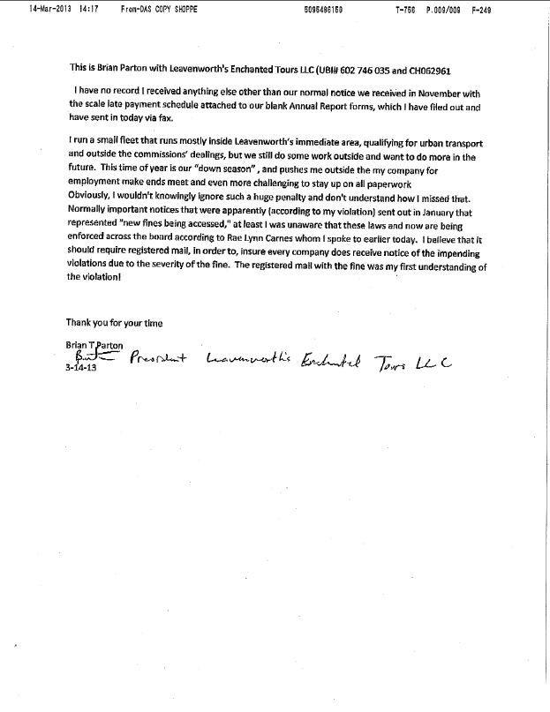

**Attachment C**

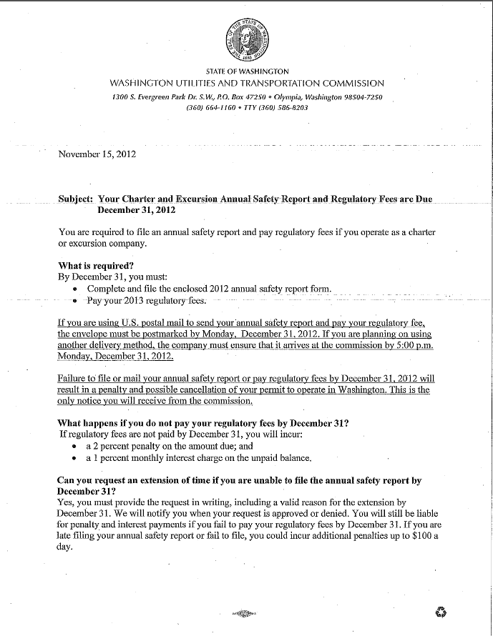

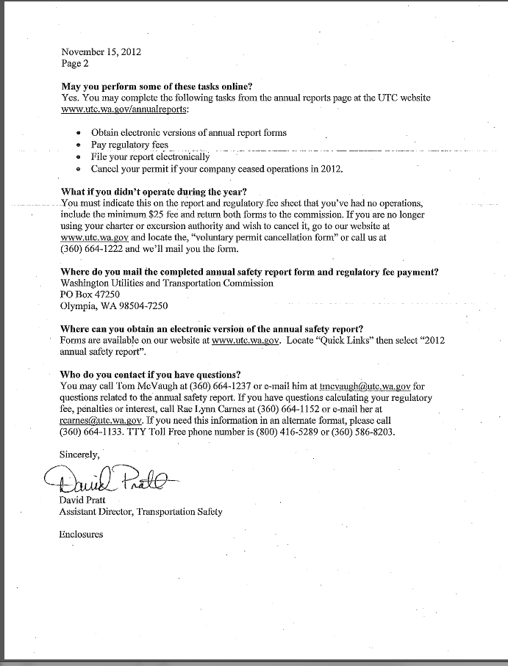

**Attachment D**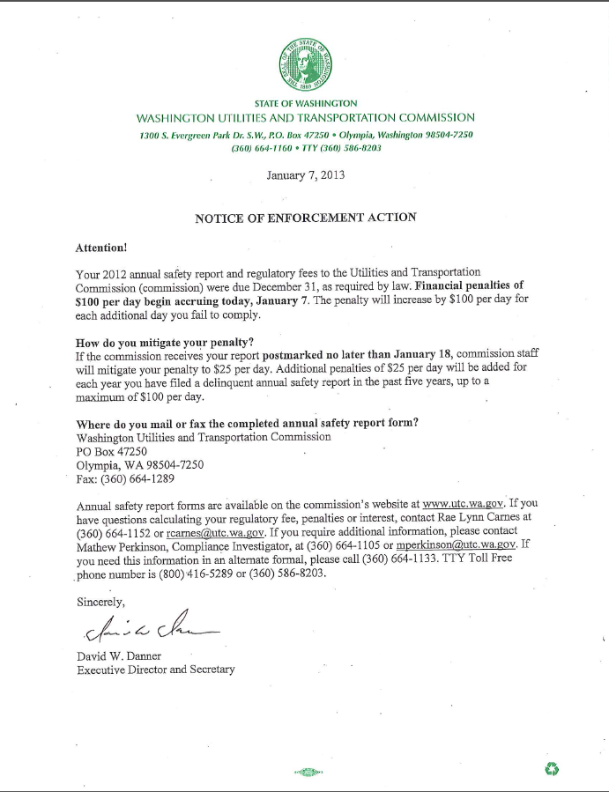

**Attachment E**

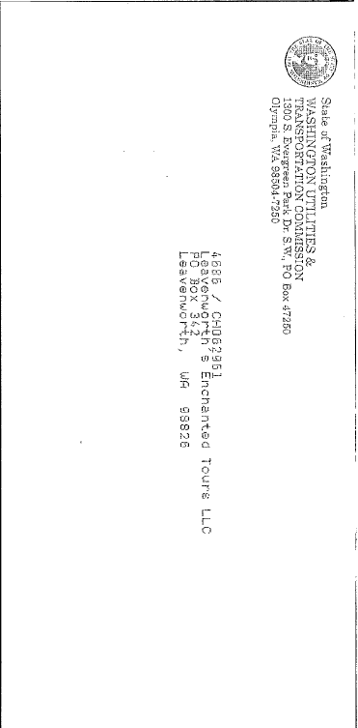

1. See Attachment A for a copy of the penalty assessment sent to Leavenworth’s Enchanted Tours, LLC.
2. See Attachment B for a copy of the letter submitted by the company on March 14, 2013.
3. See Attachment C for a copy of the letter sent to all regulated companies on November 15, 2012.
4. See Attachment D for a copy of the Enforcement letter sent to all delinquent companies on January 7, 2013.
5. See Attachment E for a copy of the mailing envelope which delivered the Notice of Enforcement January 7, 2013.