March 4, 2011

David W. Danner, Executive Director and Secretary
Washington Utilities and Transportation Commission
1300 S. Evergreen Park Dr. SW
P. O. Box 47250
Olympia, Washington 98504-7250

RE: Washington Utilities and Transportation Commission v. Landmark Travel Service, Inc. d/b/a Puget Sound Coachlines
Commission Staff’s Response to Application for Mitigation of Penalties
Docket TE-110216

Dear Mr. Danner:

On February 11, 2011, the Washington Utilities and Transportation Commission (commission) assessed a $2,400 penalty against Landmark Travel Service, Inc. d/b/a Puget Sound Coachlines (Landmark) for violations of WAC 480-30-221, Operation of motor vehicles, which requires charter carriers to comply with Title 49, Code of Federal Regulations (CFR), including Part 391, which governs qualification of drivers. The company was penalized for 24 violations of WAC 480-30-221, which adopts by reference CFR Part 391.45(a), Using a driver not medically examined and certified. Commission staff found that driver Raymond Borge drove with an expired medical card on 24 occasions.

On March 4, 2011, Landmark filed an Application for Mitigation of Penalties (mitigation request), waiving a hearing and asking for an administrative decision on the information it presented. For the reasons below, staff opposes mitigation of the penalty.

Commission records indicate that Landmark received the Notice of Penalties (penalty assessment) on February 14, 2011, by certified mail. Page three of the penalty assessment directs the respondent to complete and sign the document and send it to the commission within 15 days of receipt. The deadline for filing the mitigation request was March 1.

Because Landmark failed to timely file its mitigation request, staff recommends the request be denied.
If you have any questions, please contact Betty Young, Compliance Investigator, Transportation Safety, at 360-664-1202, or by e-mail at byoung@utc.wa.gov.

Sincerely,

David Pratt
Assistant Director, Transportation Safety

Enclosure

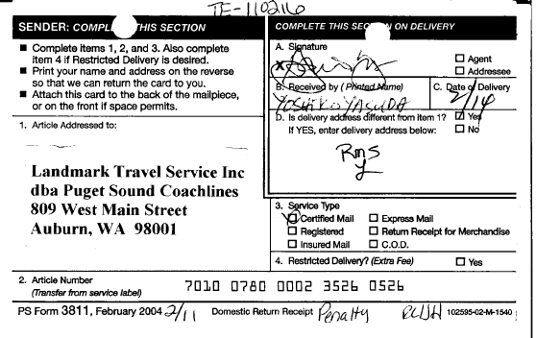

A true and accurate copy of the signed certified mail card is enclosed.

