**Puget Sound Energy**

**Annual Report on Program Outcome of PSE's Low Income Program**

**Home Energy Lifeline Program (“HELP”)**

**For 2014 Program Year**

**October 2014 through September 2015**

**Filed May 31, 2016**

**PSE2_TAG_DARK**

Table of Contents

[Introduction and Background 3](#_Toc450739796)

[Description of HELP Bill-Payment Assistance 5](#_Toc450739797)

[HELP Bill-Payment Assistance by Fuel Type and Program Year 5](#_Toc450739798)

[Monthly Pattern of Distribution of HELP Bill-Payment Assistance 8](#_Toc450739799)

[Demographics of Customer Households 11](#_Toc450739800)

[HELP Bill-Payment Assistance by County Area 11](#_Toc450739801)

[HELP Bill-Payment Assistance and Annual Bill by County Area 12](#_Toc450739802)

[HELP Customers Average Monthly Energy Usage 15](#_Toc450739803)

[HELP Bill-Payment Assistance by Residential Housing Structure 16](#_Toc450739804)

[HELP Bill-Payment Assistance Impacts 17](#_Toc450739805)

[Administration of Program 18](#_Toc450739806)

[Marketing of PSE Home Energy Lifeline Program 19](#_Toc450739807)

## Introduction and Background

Puget Sound Energy's (“PSE’s”) low income bill assistance program, the Home Energy Lifeline Program (“HELP”), provides bill-payment assistance to eligible PSE customers whose household is considered as a “very low-income household” per RCW 43.63A.510[[1]](#footnote-1). The majority of the HELP funding is collected from all PSE customers via rates that are set by PSE’s electric and natural gas tariff Schedules 129: Low Income Program.

Also, if PSE does not meet any of the service quality index (“SQI”) benchmarks set forth in its Service Quality program and the total annual penalty dollars are less than the equivalent of $12 per customer, the SQI penalty will then be allocated to the appropriate PSE HELP funding based upon the energy service affected by the missed SQI.

PSE’s HELP bill-payment assistance is separate but supplemental to the Federal Low Income Home Energy Assistance Program (“LIHEAP”), which is available year-round to eligible households. For the 2014 program year, October 2014 through September 2015, eligible households may receive up to $1,000 per year per customer in HELP credit to offset their PSE electricity or natural gas bills, which is the same maximum as the 2009 through 2013 program years.

PSE’s HELP was first implemented in accordance with Exhibit G to Settlement Stipulation Agreement approved by the Commission in consolidated Dockets UE‑011570 and UG‑011571 Twelfth Supplemental Order dated June 20, 2002. The HELP was further amended by the Partial Settlement Agreement approved by the Commission on January 5, 2007, in Dockets UE‑060266 and UG‑060267. The HELP settlement terms allow eligible very low-income customers to receive bill-payment assistance with no limitation on how the HELP bill-payment assistances are applied to any amounts owed (past, present, and future) by these customers to PSE.

On October 8, 2008, the Commission approved three additional HELP changes in its Order 12 of the consolidated Dockets UE‑072300 and UG‑072301 (2007 Order 12). Appendix D to the 2007 Order 12 detailed of these changes which became effective for program years starting 2008. The three changes are:

1. HELP funding is distributed to electric and natural gas customers at the fixed ratio of 75% and 25%, respectively.
2. The total annual HELP funding is increased from $10.25 million to $15 million.
3. Any HELP funds not distributed to customers in any single program year will be carried over to the next program year as supplemental HELP funding.

In Docket U‑072375, merger of PSE and Puget Holdings LLC, these changes above were further affirmed as Commitments 22, 23, and 42 of the Multi-Party Settlement Stipulation approved by the Commission on December 30, 2008, in Order 8 of Docket U‑072375, Approving and Adopting Settlement Stipulation; Authorizing Transaction Subject to Conditions.

Additional funding has been available to very low-income customers to mitigate the effect of PSE electric and natural gas rate changes (Supplemental HELP Funding Adjustment). This Supplemental HELP Funding Adjustment was described in PSE’s Initial Brief in the PSE’s 2009 General Rate Case (“2009 GRC”) under the consolidated Dockets UE-090704 and UG-090705, as follows:

The company proposed to increase the annual level of low-income electric and natural gas bill assistance funding by the corresponding percent increase to the residential class that are approved by this Commission. The amount of this percentage increase would be added to the low income tariff in the next program year.

This Supplemental HELP Funding Adjustment had been incorporated into PSE’s annual electric and natural gas Schedules 129 HELP funding requirement true-up for the HELP periods of October 1, 2010, through September 30, 2015.

On May 7, 2012, per Order 8 of the consolidated Dockets UE-111048 and UG-111049, the base funding for the low-income bill assistance program was increased to $20.2 million, based on 0.665 percent of PSE’s 2010 operating revenues. Prior funding level reflected about 0.51 percent of PSE’s 2010 operating revenues. The base HELP funding is distributed to electric and natural gas customers at the fixed ratio of 75% and 25%, respectively, as set forth in 2007 Order 12.

On June 25, 2013, as a condition for the Commission’s approval of PSE’s Expedited Rate Filing (“ERF”) and Decoupling mechanisms[[2]](#footnote-2), the Commission ordered an increase of HELP funding of $1.0 million per year during the three-year rate plan for the two mechanisms. The additional $1.0 million per year brings the base HELP founding to $21.2 million for the following three program years, October 2013 through September 2014, October 2014 through September 2015, and October 2015 through September 2016.

For the 2014 program year of October 1, 2014, through September 30, 2015, in addition to the $21.2 million base funds, the available HELP funding was increased by the following:

1. Carried-over HELP funding of $2.5 million from the 2013 program year per 2007 Order 12.
2. Electric Supplemental HELP Funding Adjustment of $8,660 to mitigate the effect of electric residential Schedule 142: Revenue Decoupling Adjustment Mechanism rate increase, which became effective in May 2014. There is no adjustment for the natural gas HELP funding because the Schedule 142 residential rate for natural gas was a decrease.

## Description of HELP Bill-Payment Assistance

### HELP Bill-Payment Assistance by Fuel Type and Program Year

The following table shows the number of PSE residential very low-income customers who received bill-payment assistance from PSE’s HELP during the 2014 program year, the 12-month period of October 1, 2014, through September 30, 2015.

Electric customers: 30,388

Natural gas customers: 8,953

The number of eligible very low-income households that received bill-payment assistance is lower than the sum of the two numbers above since some households are both PSE natural gas and electric customers. The total number of very low-income households that received bill-payment assistance is 34,938, i.e., there are 4,403 HELP households that received both PSE electric and natural services during the period of October 1, 2014, through September 30, 2015. Of the electric customers who received bill-payment assistance, 14% were also natural gas customers. Of the natural gas customers who received bill-payment assistance, 49% were also electric customers. The chart below is a comparison of the number of customers who received bill-payment assistance since 2010 by fuel type and by program year.

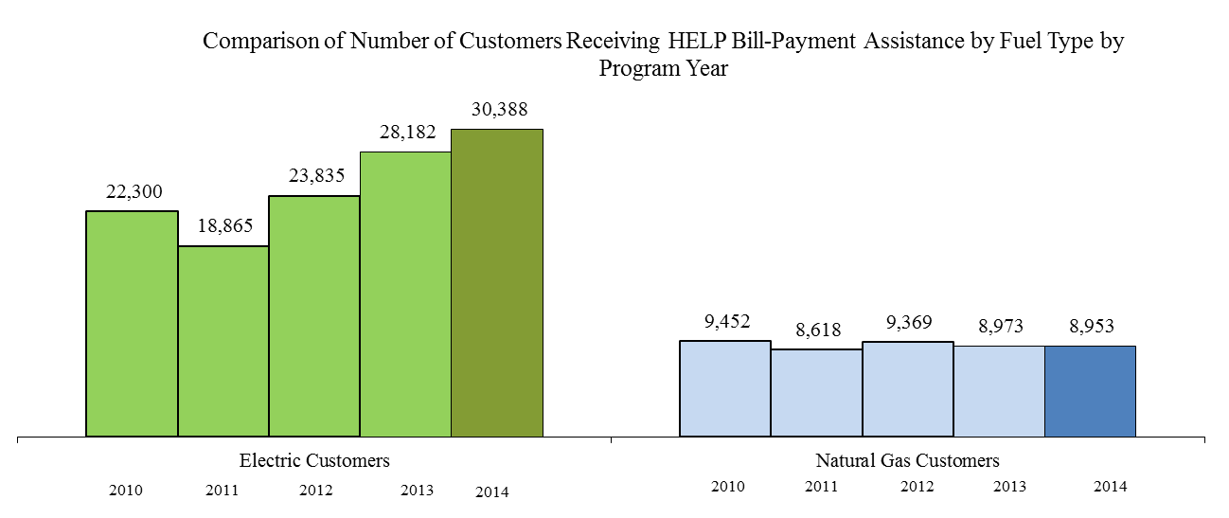

The number of eligible very low-income customers that received HELP bill-payment assistance as percentage of the total number of residential customers by electric and natural gas is 3.1% (30,388 out of 968,160) and 1.2% (8,953 out of 734,989), respectively.

The chart below shows the distribution of the number of years a customer received HELP bill-payment assistance during the 2010-2014 program years. About half (51%) of the HELP customers received only one bill-payment assistance during those years; while 7% of customers received HELP assistance every year during that 5-year period.

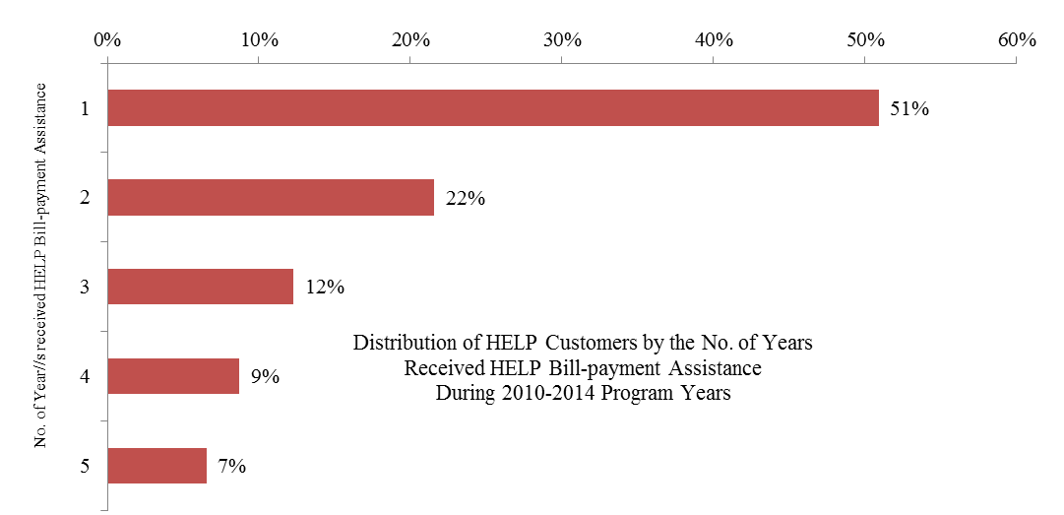

The total dollar amount of HELP bill-payment assistance distributed during the 2014 program year was:

Electric $11,737,987

Natural Gas $2,395,694

Total $14,133,681

The total HELP bill‑payment assistance includes the base funding, the Supplemental HELP Funding Adjustment, and the overflow prior HELP funding net of PSE program costs and agency administration fees. The base 2014 program year HELP funding was allocated as 75% for electric and 25% for natural gas as prescribed in the Appendix D to the 2007 Order 12 while the overflow funding went back to the fuel type that the bill-payment assistance was originally distributed to. The actual percentages of HELP bill-payment assistance distributed to each fuel are 83% electric and 17% natural gas for the 2014 program year.

The following charts show the relative amount of bill‑payment assistance distributed to eligible very low-income electric and natural gas residential customers by program year.



The table and chart below shows a comparison, by fuel type, of the percentages of bill-payment assistance distributed with the percentages of total residential customers and total residential revenues. Electric residential customers were allocated relatively more HELP payment assistance than that of natural gas residential customers based upon the proportion of total residential revenue and total residential customer count percentages.

|  |  |  |  |
| --- | --- | --- | --- |
|  | % of Actual Total Distributed HELP Bill-Payment Assistance Including Overflow Funding from Prior year | % of Residential Customers | % of Residential Revenues |
| Electric | 83% | 57% | 61% |
| Natural Gas | 17% | 43% | 39% |

### 

### Monthly Pattern of Distribution of HELP Bill-Payment Assistance

The following two charts show the monthly pattern of distribution of HELP bill-payment assistance to eligible very low-income PSE customers during the 2014 program year by fuel type. The first chart is a side-by-side bar chart with both the electric and natural gas payment assistance.

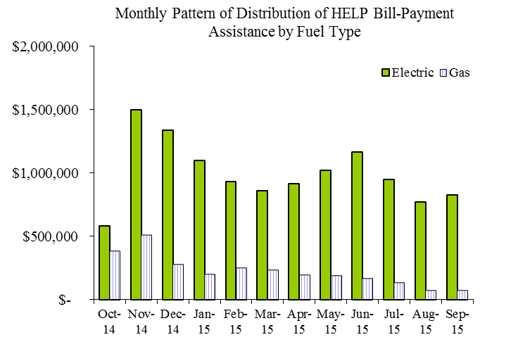

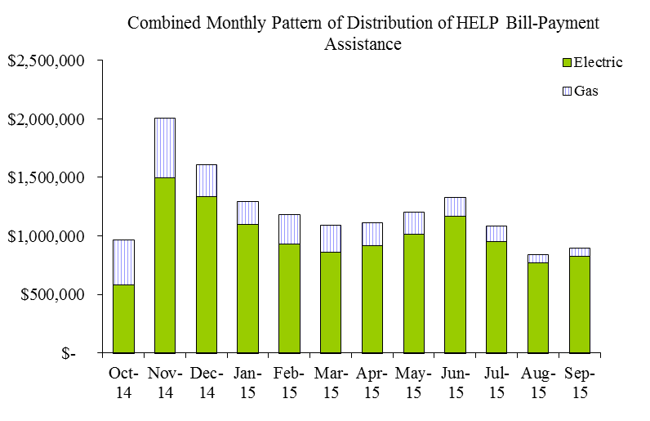The second chart is a stacked bar chart with both the electric and natural gas payment assistance by month.

The chart below shows the combined electric and natural gas distributed HELP bill-payment assistance on a monthly basis for the 2014 program year (depicted by the heavy line) and the previous two program years (in light lines). 40% of the annual amount of HELP bill-payment assistance was distributed to the eligible very-low income customers in the first four months of the HELP year, October through January, before and during the peak of winter heating season.

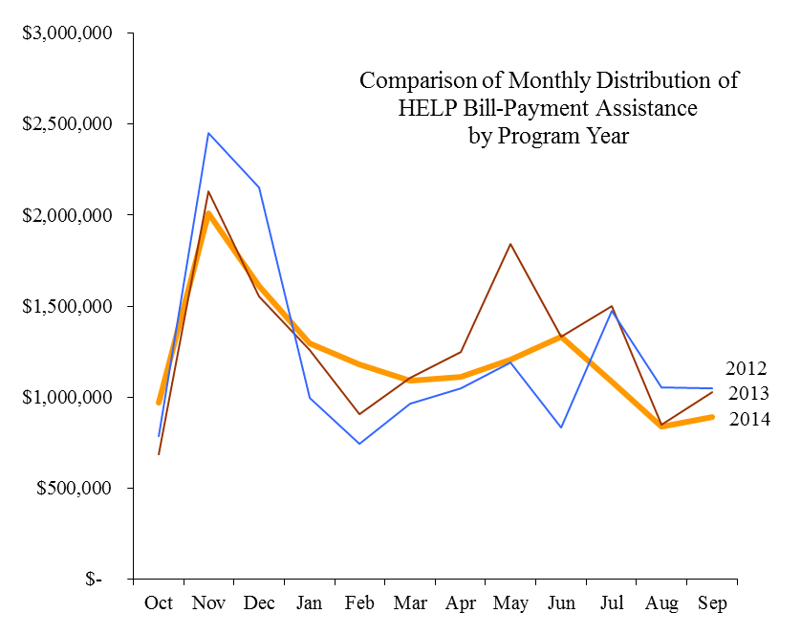

The chart below shows a comparison of the cumulative amount of distributed HELP bill-payment assistance on a monthly basis for the 2014 program year (shown in heavy line) and the previous five program years (in light lines). While HELP payment assistance was higher in 2014 than in 2010 and 2011, it was lower than the two previous program years, namely 2012 and 2013.

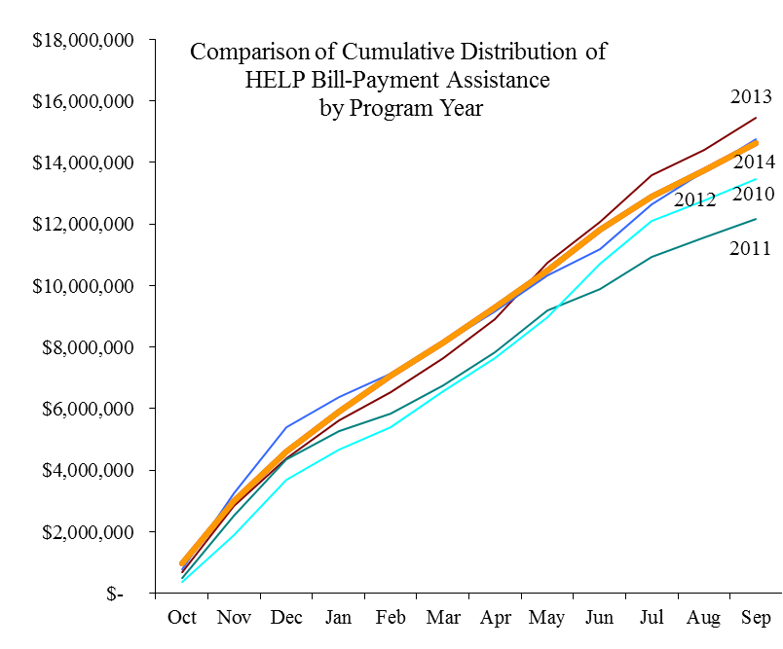

Demographics of Customer Households

### HELP Bill-Payment Assistance by County Area

The average level of HELP bill-payment assistance to each eligible very low-income household is $420 for this program year. It is a $45 decrease from the $465 per household of the 2013 program year. The overall average HELP bill-payment assistance per PSE energy account that received HELP bill assistance is $373 due to the fact that 4,403 households have both PSE electric and natural gas services.

The chart below shows the average HELP bill-payment assistance per household for the various county areas in PSE’s service territory. Kittitas County has the highest average of HELP bill-payment assistance per household whereas Snohomish County as the lowest average assistance amount.

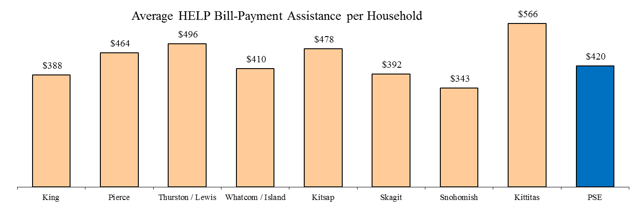

### HELP Bill-Payment Assistance and Annual Bill by County Area

For the purpose of comparison among all the county areas, the average residential and the HELP customer annual bill information presented in the following charts and the customer count information used in the calculation is based upon 12 months ending September 30, 2015, to coincide with the HELP period.

The chart below shows a comparison by county area of the average annual bill per HELP account and per PSE residential account, thus comparing the average bill of a HELP customer to the average bill a general residential customer. For the 2014 program year, the customers who received HELP bill-payment assistance had, on average, annual bills that were about the same as that of average PSE residential customers. Most of the county areas show similar relationship except Kitsap, Snohomish, and Kittitas Counties.

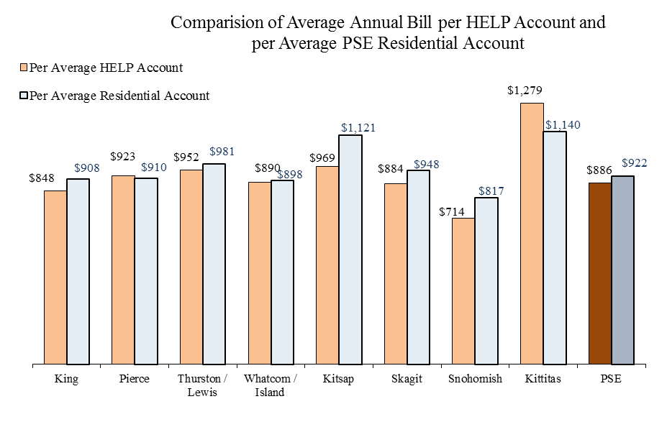

The chart below compares the ratio of average HELP bill-payment assistance per HELP account to the average annual bill per HELP account for the 2014 program year by county area. It generally demonstrates, on average, how much of an electric or natural gas HELP customer’s energy bill was mitigated by HELP bill-payment assistance. The overall average ratio is 42%, i.e. the HELP bill-payment assistance alone could pay for 42% of a HELP customer’s annual energy bills. Among the current PSE service areas, Kitsap and Snohomish Counties have the highest ratio about 50% and King County has the lowest ratio of 39%.

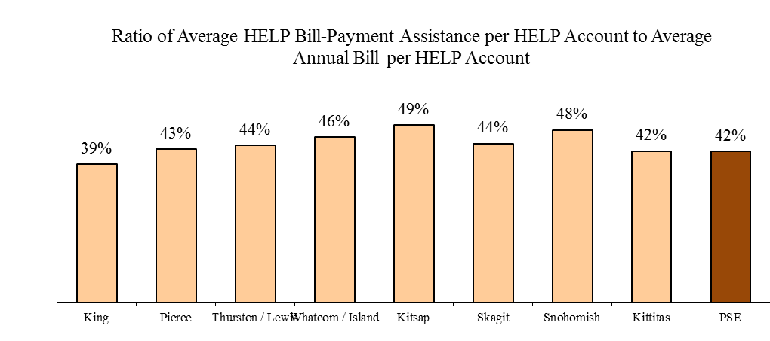

The following charts show the number of eligible very low-income customers receiving HELP bill-payment assistance as percentage of the number of residential customers in a county area. The overall percentages for electric and natural gas are 3.1% and 1.2%, respectively.

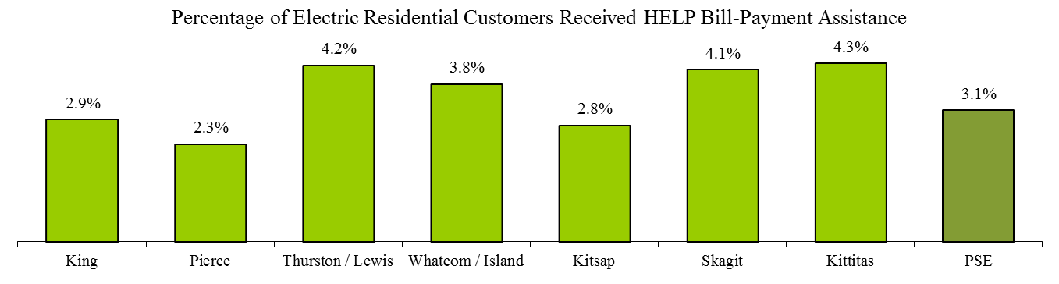

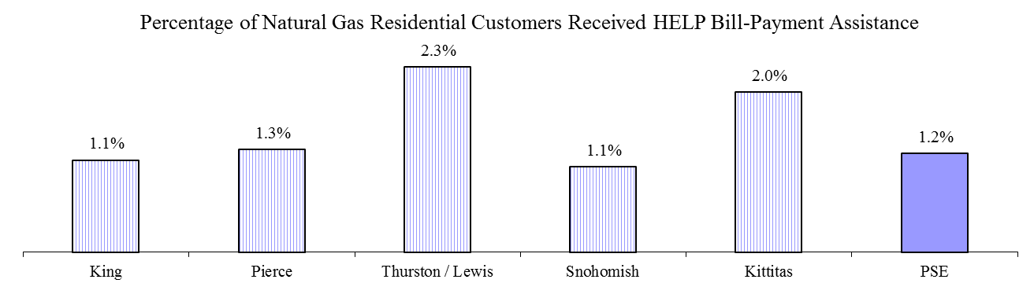

The chart below shows the percentage distribution of PSE residential customers, including both electric and natural gas, by county area along with the percentage of PSE HELP customers in that area.

* Snohomish County, where PSE provides only natural gas service, and King County, received proportionally significantly less HELP bill-payment assistance than the rest of the county areas.
* King County has 53.5% of the PSE’s residential customers but in comparison only 48.4% of the PSE HELP customers are in King County.
* 7.5% of PSE residential customers are in Snohomish County but only 3.4% of the PSE HELP customers are in the county.
* The other county areas--especially Thurston/Lewis, Whatcom/Island, Skagit, and Kittitas Counties--have much higher percentages of PSE HELP customers than that of PSE residential customers in the areas.

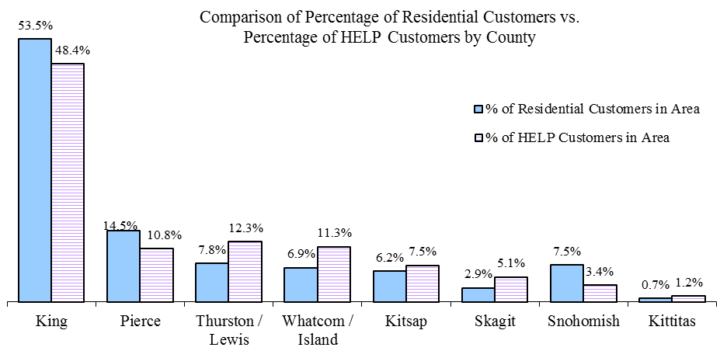

The chart below shows the percentage by county area of PSE total residential electric and natural gas billed amount in a county area compared to the percentage of PSE HELP bill-payment assistance distributed to that area.

* Similar to the customer count comparison above, Snohomishand King Counties received less HELP bill-payment assistance than the rest of the county areas in terms of the residential billed amount.
* 6.6% of PSE residential billed amount came from Snohomish County but only 3.2% of the PSE HELP bill-payment assistance went to the area. The results for King County were 52.6% and 42.5%, respectively.
* Thurston/Lewis, Whatcom/Island, Skagit, and Kittitas Counties received higher percentages of PSE HELP bill-payment assistance than that of PSE residential billed amount from these areas.

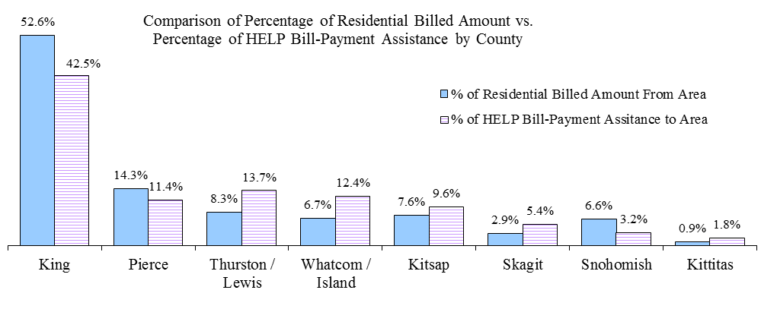

### HELP Customers Average Monthly Energy Usage

The following charts, by electric and natural gas, show the distribution curve of the average monthly energy usage of PSE HELP customers for the 2014 program year of October 1, 2014, through September 30, 2015. These charts demonstrate the average monthly electric and natural gas usages of HELP customers in comparison with that of all PSE residential customers.

The data is based upon the customers who received either electric and/or natural gas PSE HELP assistance/s during the 2014 program year. Both natural gas and electric usage of a PSE HELP customer are included in the analysis, i.e., an electric PSE HELP bill-assistance recipient's natural gas usage is also reflected in the average natural gas monthly distribution curve.

PSE HELP customers, in general, had higher average monthly usage than PSE’s residential customers except during the months of July, August, and September 2015. For the natural gas usage, the HELP customers’ average monthly usage was always less than PSE’s residential customers.

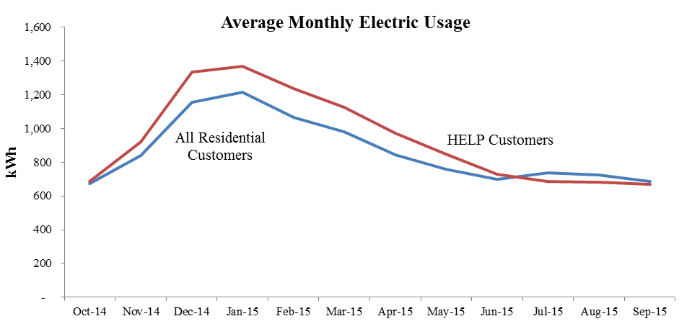

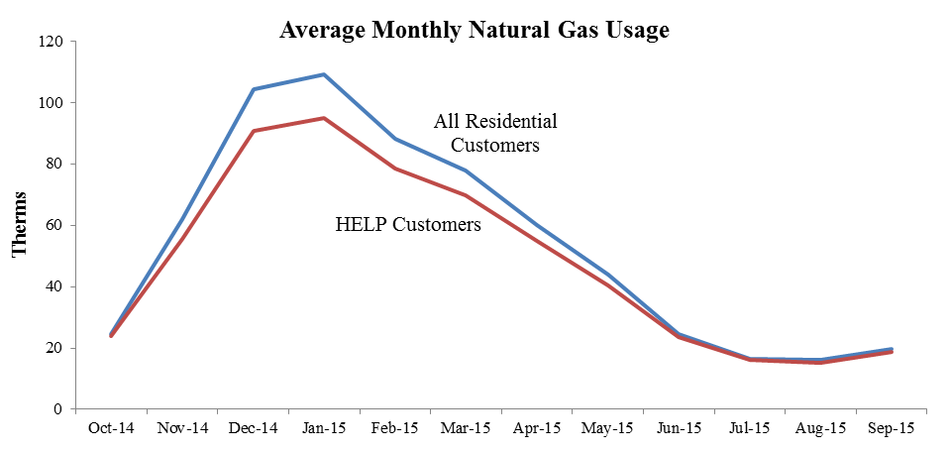

### HELP Bill-Payment Assistance by Residential Housing Structure

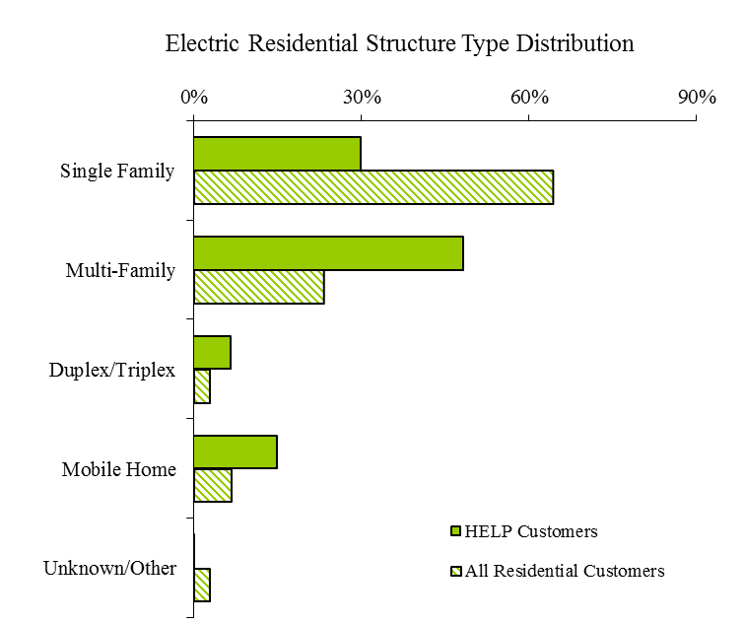The two charts below show comparisons by fuel type and residential housing structure type between PSE residential customers and the eligible very low-income customers who received HELP bill-payment assistance during the 2014 program year. Electric HELP customers were more likely to live in a multi-family structure whereas natural gas HELP customers were mostly living in a single-family structure.

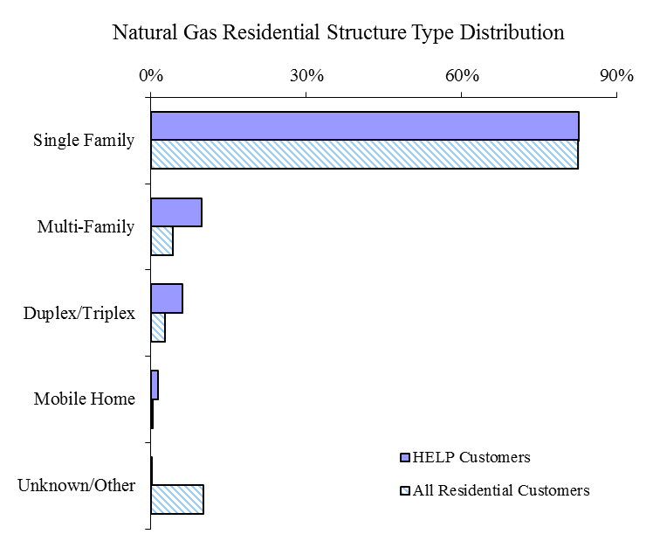

### HELP Bill-Payment Assistance Impacts

The two charts below show the relationship between the very low income customers who became eligible HELP customers during the 2014 HELP period of October 2014 through September 2015 and the non-payment/credit disconnections associated with these customers that occurred during the same period. These two charts only show what happened to these customers during the 2014 HELP period and do not indicate which event occurred first, namely the receipt of HELP assistance or the non-payment/credit disconnection. The first chart highlights the percentage of customers who became eligible HELP customers and were also disconnected due to non-payment/credit during the period by fuel. Overall, 12% of these newly eligible PSE HELP customers experienced non-payment/credit disconnection. The second chart highlights the percentage of non-payment/credit disconnected customers who became eligible HELP customers during the period. The combined percentage for both electric and natural gas non-payment/credit disconnected customers is 10%.



## Administration of Program

During the 2014 program year, there were eleven qualifying low-income agencies administering PSE’s HELP and distributing bill-payment assistance to PSE customers. In addition to the distribution of the HELP bill-payment assistance to eligible low-income customers, these agencies also received allotment of funds from PSE for administrative fees to run the HELP and related support services such as customer education, eligibility evaluation, bill-assistance amount determination, and other services.

The charts below illustrate the allocation of the HELP administration costs and bill-payment assistance to customers by program year. For this program year, the overall agency administration fees comprised about 20% of the total funding of the HELP, a 1% increase from the last program year of 19%. PSE’s own administrative program costs were 2%, a 1% decrease from that of the previous program year.

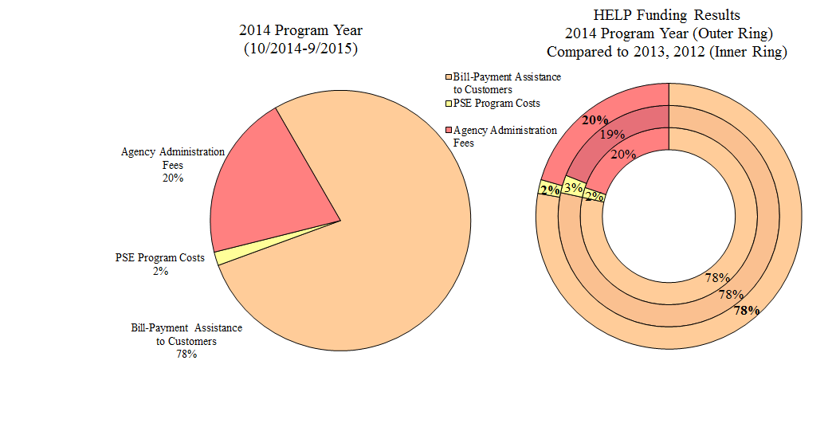

## Marketing of PSE Home Energy Lifeline Program

The following are some highlights regarding the marketing of the HELP during the 2014 program year, October 2014 through September 2015:

* [November 2014](http://pse.com/accountsandservices/YourAccount/monthlyPromotions/Documents/Customer_bill_2014-11.pdf), [January 2015](http://pse.com/accountsandservices/YourAccount/monthlyPromotions/Documents/Customer_bill_2015-01.pdf), [April 2015](http://pse.com/accountsandservices/YourAccount/monthlyPromotions/Documents/Customer_bill_2015-04.pdf), and [August 2015](http://pse.com/accountsandservices/YourAccount/monthlyPromotions/Documents/Customer_bill_2015-08.PDF) issues of PSE’s customer newsletter featured HELP related article. The newsletter accompanies customer paper and electronic bill statements and directs customers to contact an energy-assistance agency at 1-866-223-5425.
* [January 2015](http://pse.com/accountsandservices/YourAccount/monthlyPromotions/Documents/Customer_bill_2015-01.pdf) and [February 2015](http://pse.com/accountsandservices/YourAccount/monthlyPromotions/Documents/Customer_bill_2015-02.pdf) bill inserts included the brochure “Energy assistance for PSE customers”. PSE HELP was one of the available energy bill payment assistance programs.
* In [January 2015](http://pse.com/accountsandservices/YourAccount/monthlyPromotions/Documents/Customer_bill_2015-01.pdf), [February 2015](http://pse.com/accountsandservices/YourAccount/monthlyPromotions/Documents/Customer_bill_2015-02.pdf), [March 2015](http://pse.com/accountsandservices/YourAccount/monthlyPromotions/Documents/Customer_bill_2015-03.pdf), and [April 2015](http://pse.com/accountsandservices/YourAccount/monthlyPromotions/Documents/Customer_bill_2015-04.pdf), all billing envelopes included messaging about payment options and payment assistance programs.
* August 4, 2015 news release “*Trouble Paying Energy Bills?*” featured HELP and other bill payment assistance programs.
* [*Bill payment and weatherization assistance for income-eligible customers*](http://pse.com/accountsandservices/YourAccount/Pages/Low-Income-Assistance.aspx)website information is live 24/7 throughout the year at pse.com.
* Multilingual HELP brochures in [*English*](http://pse.com/accountsandservices/YourAccount/Documents/6442_HELP.pdf)*,* [*Spanish*](http://pse.com/Other-Languages/Documents/6442_LowIncome_SPA.pdf)*,* [*Russian*](http://pse.com/Other-Languages/Documents/6442_LowIncome_RUS.pdf)*,* [*Korean*](http://pse.com/Other-Languages/Documents/6442_LowIncome_KOR.pdf)*, and* [*Vietnamese*](http://pse.com/Other-Languages/Documents/6442_LowIncome_VIET.pdf)with information about income eligibility and assistance centers were available at low income agencies, in PSE customer service offices, and posted on PSE.com. Brochures were updated in November 2014 and have posted online at pse.com since the update.
* The multilingual recorded telephone line (1-866-223-5425) about the HELP and options for local agency contact information (English, Spanish, Russian, Korean and Vietnamese) was accessible 24/7.
* August 2015 Facebook posting.  
  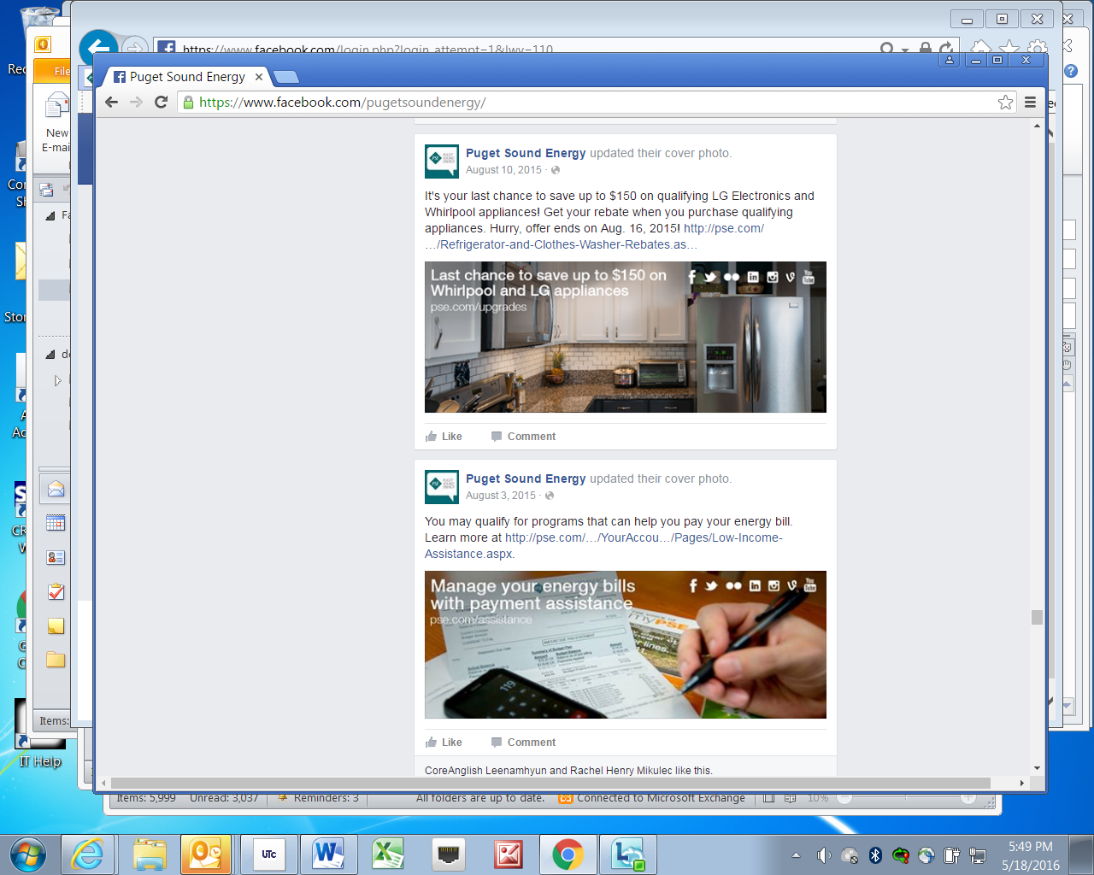

1. RCW 43.63A.510, Affordable housing — Inventory of state-owned land:

   (1) (b) "Very low-income household" means a single person, family, or unrelated persons living together whose income is at or below fifty percent of the median income, adjusted for household size, for the county where the affordable housing is located. [↑](#footnote-ref-1)
2. Order 7 of consolidated Dockets UE-121697/UG-121705 (Decoupling) and consolidated Dockets UE-130137/UG-130138 (Expedited Rate Filing) [↑](#footnote-ref-2)