BEFORE THE WASHINGTON UTILITIES AND TRANSPORTATION COMMISSION

DOCKET NO. UE-17_______

DOCKET NO. UG-17_______

DIRECT TESTIMONY OF

KAREN K. SCHUH

REPRESENTING AVISTA CORPORATION

### I. INTRODUCTION

**Q. Please state your name, employer and business address.**

A. My name is Karen K. Schuh. I am employed by Avista Corporation as a Senior Regulatory Analyst in the State and Federal Regulation Department. My business address is 1411 East Mission, Spokane, Washington.

**Q. Please briefly describe your educational background and professional experience.**

A. I graduated from Eastern Washington University in 1999 with a Bachelor of Arts Degree in Business Administration, majoring in Accounting. After spending six years in the public accounting sector, I joined Avista in January of 2006. Since 2006, I have worked in various positions within the Company in the Finance Department (Plant Accounting and Resource Accounting) and joined the State and Federal Regulation Department as a Regulatory Analyst in 2008. Currently, as a Senior Regulatory Analyst, I am responsible for, among other things, preparing the capital adjustments in general rate cases for the Washington and Idaho jurisdictions.

**Q. What is the scope of your testimony?**

A. My testimony and exhibits in this proceeding will explain how the Company’s capital investments in utility plant from December 31, 2016 through April 30, 2021 are incorporated into the proposed revenue requirements in this case. As discussed by Company witnesses Mr. Morris and Ms. Andrews, the Company is proposing a Three-Year Rate Plan for the period beginning May 1, 2018 through April 30, 2021. As a part of the Three-Year Rate Plan, I prepared the capital adjustments that are incorporated in each of the four Studies prepared in this case sponsored by Ms. Andrews.

A table of contents for my testimony is as follows:

**TABLE OF CONTENTS**

**Description Page**

I. INTRODUCTION 1

II. WITNESSES TESTIFYING TO CAPITAL ADDITIONS 2

III. CAPITAL ADJUSTMENT OVERVIEW 5

IV. TRADITIONAL PRO FORMA STUDIES 9

V. END OF PERIOD RATE BASE STUDIES 10

VI. RATE YEAR STUDIES 13

VII.DEPRECIATION STUDY 19

VIII. REPORTING FOR CAPITAL ADDITIONS 20

**Q. Are you sponsoring any exhibits?**

A. Yes. I am sponsoring Exh. KKS-2 which was prepared by me. This exhibit provides a summary of the capital investments included in each of the capital witnesses[1] testimony by year.

### II. WITNESSES TESTIFYING TO CAPITAL ADDITIONS

**Q. Would you please provide a brief summary of the witnesses who provide testimony related to capital additions in this proceeding?**

A. Yes. The following witnesses are presenting direct testimony supporting capital additions in this case:

Mr. Scott Kinney, Director of Power Supply, will provide detailed explanations of the Company’s power supply-related capital additions as well as the capital requirements for the implementation of Protection, Mitigation and Enhancement programs (“PM&E”), related to hydroelectric licenses.

Ms. Heather Rosentrater, Vice President of Energy Delivery, will explain capital additions related to electric transmission and distribution, natural gas delivery, facilities, fleet, as well as general plant.

Mr. James Kensok, Vice President and Chief Information and Security Officer, will provide an overview of Avista’s Information Service/Information Technology (IS/IT) programs and projects. This includes summaries of the Company’s capital investments for a range of IS/IT systems used by the Company.

**Q. How have capital witnesses presented the transfers-to-plant in their testimony?**

A. Mr. Kinney, Ms. Rosentrater and Mr. Kensok present capital transfers-to-plant on a calendar year basis from January 1, 2017 through December 31, 2021 on a total system basis, i.e, the totals include all[2] planned transfers to plant for electric and natural gas operations, for the Washington, Idaho and Oregon Jurisdictions. A detailed listing of project names and calendar year totals can be found in Exh. KKS-2.

The table below reflects the calendar year transfers to plant totals that are represented in each witness’ testimony:

**Q. Mr. Thies makes reference to planned capital expenditures of $405 million per year. Why are some of the annual totals in Table No. 1 different than $405 million?**

A. There are two primary reasons. First, totals in Table No. 1 above represent transfers-to-plant, whereas, Mr. Thies’ $405 million represents capital expenditures. There is a timing difference between when the dollars are spent, and when the various capital projects are completed and transferred to plant-in-service.

Second, Mr. Thies’ $405 million includes the investment associated with Advanced Metering Infrastructure (“AMI”), and Table No. 1 excludes all investment associated with AMI. Avista has excluded AMI investment from this general rate case, and has requested separate regulatory accounting treatment for AMI through an accounting petition filed May 1, 2017 in Docket Nos. UE-170327 and UG-170328.

### III. CAPITAL ADJUSTMENT OVERVIEW

**Q. Prior to explaining the adjustments you make to incorporate Avista’s investments in the proposed revenue requirement in this case, please summarize the different ratemaking studies, and what adjustments are included in each.**

A. As discussed by Ms. Andrews, as part of Avista’s demonstration of our need for electric and natural gas revenue increases, the Company has presented four ratemaking studies. Each Study is summarized below, along with a brief explanation of the capital adjustments included in each study:

1) **Traditional Pro Forma Study** – The Traditional Historical Modified Test Year Pro Forma Study. This Study starts with average-of-monthly average (“AMA”) rate base[3] for 2016 and includes a “Threshold” adjustment[4] related to 2017 capital additions, as explained later in my testimony.

2) **EOP Rate Base Study** – An End of Period (EOP) Rate Base Study, which also employs the use of an adjusted capital structure. This Study starts with the Traditional Pro Forma Study results and adjusts total rate base, including all 2017 remaining capital additions, to a December 31, 2017 EOP basis to determine the proposed revenue increase for Rate Year 1 beginning May 1, 2018. A K-Factor is used to determine the revenue increases for rate years two and three (effective May 1, 2019 and May 1, 2020) of the three-year rate plan, as explained by Ms. Andrews.

3) **K-Factor Study** – A study which employs the use of an annual revenue escalator (K-Factor) for a multi-year period to determine the revenue increases. This Study starts with the restated Commission Basis results (including 2016 AMA net plant balances).

4) **Rate Year Study** – A study which incorporates all of the planned capital investments, operating expenses, and revenues for each year of the Three-Year Rate Plan. This study includes all capital additions on an AMA basis for each Rate Year beginning May 1, 2018 through April 30, 2021.

The Company’s electric and natural gas revenue increases in this case for the rate year beginning May 1, 2018 are based on the EOP Rate Base Study. The proposed revenue increases for May 1, 2019 (Rate Year 2), and May 1, 2020 (Rate Year 3), are based on the application of a “K-Factor” revenue escalator applied to the non-Energy Recovery Mechanism (ERM) and non-gas cost authorized revenues.

As noted above, the EOP Rate Base Studies begin with the Traditional Pro Forma Study results. The other three studies are foundational evidence that demonstrate, among other things, that the results from the Traditional Pro Forma Studies will not yield the electric and natural gas revenue increases necessary for the prospective rate years.

**Q. Please explain how you have incorporated the electric and natural gas capital investments into the proposed revenue requirements in this case.**

A. Summarized below in Table No. 2 are the electric capital adjustments I have prepared for the following studies: 1) Traditional Pro Forma Study, 2) EOP Rate Base Study, and 3) Rate Year Study.



Summarized below in Table No. 3 below are the natural gas capital adjustments I have prepared for the following three studies: 1) Traditional Pro Forma Study, 2) EOP Rate Base Study, and 3) Rate Year Study.



The transfers to plant adjustments presented in my testimony and reflected in the Three-Year Rate Plan, have been included using Washington’s share (electric and natural gas) of the monthly transfers to plant for each rate year as follows: May 1, 2018 –April 30, 2019 - *Rate Year 1*; May 1, 2019 – April 30, 2020 – *Rate Year 2*; and May 1, 2020 – April 30, 2021 – *Rate Year 3*. Mr. Kinney, Ms. Rosentrater and Mr. Kensok have provided transfers to plant on a system basis for each calendar year, and I have incorporated the Washington share of these investments for the three rate years beginning May 1, 2018.

### IV. TRADITIONAL PRO FORMA STUDIES

**Q. How were the capital additions developed for the Traditional Pro Forma Studies?**

A. As discussed by Ms. Andrews, theelectric and natural gas Traditional Pro Forma Studies, include traditional restating and pro forma adjustments beyond the historical test year (2016), traditionally accepted and approved by the Washington Utilities and Transportation Commission (“WUTC” or “Commission”).

Avista started with rate base for the historical test year ending December 31, 2016 on an AMA basis. Per Commission Order 05, in Docket Nos. UE-150204 and UG-150205 (Consolidated), the Company determined a threshold for the Pro Forma electric and natural gas projects of one-half of one percent of the Company’s rate base. Per that threshold, the Company identified Pro Forma Projects that are above the threshold of $6.9 million for electric and $1.3 million for natural gas (i.e. equivalent to one-half of one percent of the Company’s rate base). This threshold yielded six electric projects and seven natural gas projects to be included within Avista’s Pro Forma Studies.

These Pro Forma projects were included on a 2017 EOP basis together with the associated accumulated depreciation (“AD”) and accumulated deferred federal income taxes (“ADFIT”). The associated ADFIT includes the repairs deduction and bonus tax depreciation expected through 2017 on an EOP basis. These adjustments also include associated depreciation expense for each capital addition. These adjustments are included by Ms. Andrews as Pro Forma Adjustment 3.10 in her electric and natural gas Traditional Pro Forma Studies. The Pro Forma threshold adjustments are reflected in Table Nos. 2 and 3 and the specific projects are identified in Exh. KKS-2 on a calendar year basis, as well as in my workpapers.

The results of the Traditional Pro Forma Study reflect only a portion the rate base that will be in service serving customers during the rate year beginning May 1, 2018. Additional adjustments necessary to reflect the level of rate base serving customers are discussed below within the EOP Rate Base and Rate Year Studies.

### V. END OF PERIOD RATE BASE STUDIES

**Q. How were the capital additions developed for the electric and natural gas EOP Rate Base Studies?**

A. Avista reviewed the planned capital projects that were below the 0.5 percent threshold for 2017 (i.e., those not included in the Traditional Pro Forma Studies discussed above). These additions were included in the EOP Rate Base Studies for 2017, together with the associated AD and ADFIT on a 2017 EOP basis.[5] The associated ADFIT includes the repairs deduction and bonus tax depreciation expected through 2017 on an EOP basis[6][7]. In addition, the plant-in-service for 2016 AMA was adjusted to a 2017 EOP basis.

**Q. How do the results of EOP Rate Base Studies compare with those of the Traditional Pro Forma Study?**

A. Illustration No. 1 below provides a comparison of the electric rate base for the electric Traditional Pro Forma Study and the EOP Rate Base Study for the rate year beginning May 1, 2018.

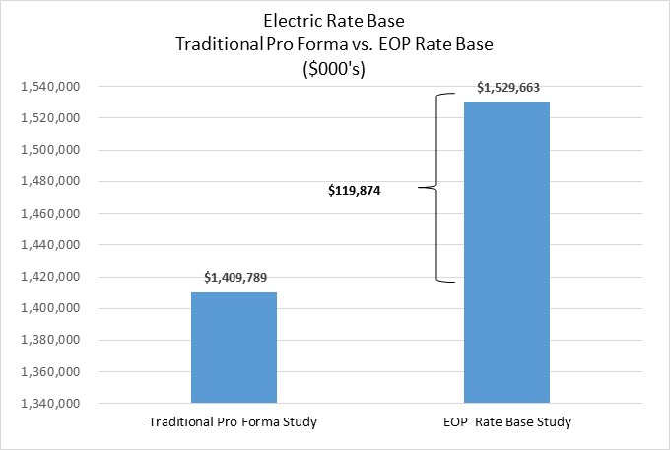**Illustration No. 1:**

The illustration demonstrates that using the Traditional Pro Forma Study, approximately $120 million of net electric plant after ADFIT, would not be included in rate base, even though the rate base will be in service serving customers by December 31, 2017 - well before new retail rates would take effect May 1, 2018.

Illustration No. 2 shows a similar comparison for natural gas rate base:

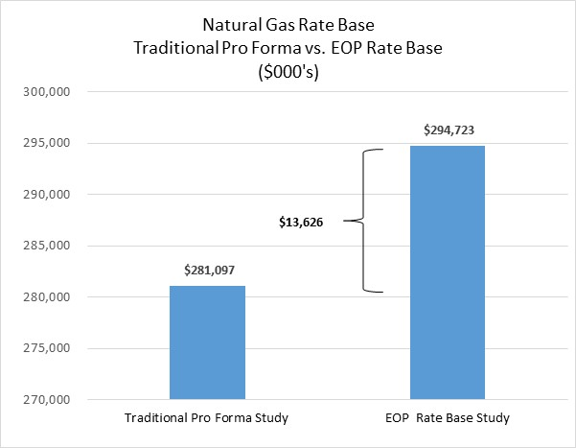**Illustration No. 2:**

The illustration demonstrates that using the Traditional Pro Forma Study, approximately $14 million of net natural gas plant after ADFIT, would not be included in rate base, even though the rate base will be in service serving customers by December 31, 2017; well before new retail rates would take effect May 1, 2018.

These illustrations show that the electric and natural gas rate base adjustments for the Traditional Pro Forma Study fall well below the level of rate base that will be in service during the first rate year.

### VI. RATE YEAR STUDIES

**Q. How were the capital additions developed for the Rate Year Studies?**

A. The Rate Year Studies include all capital additions for the Three-Year Rate Plan for the periods, May 1, 2018 –April 30, 2019 – *Rate Year 1*; May 1, 2019 – April 30, 2020 – *Rate Year 2*; and May 1, 2020 – April 30, 2021 – *Rate Year 3,* together with the associated AD and ADFIT. This includes associated depreciation expense for the capital additions. The plant-in-service was adjusted each rate year in the Three-Year Rate Plan to reflect rate base on an AMA basis. These rate base adjustments are summarized in Tables 2 and 3 above.

**Q. How do the results of Rate Year Studies compare with those of the Traditional Pro Forma Studies?**

A. Illustration No. 3 below provides a comparison of the electric rate base for the electric Traditional Pro Forma Study and the Rate Year Study, for the first rate year beginning May 1, 2018.

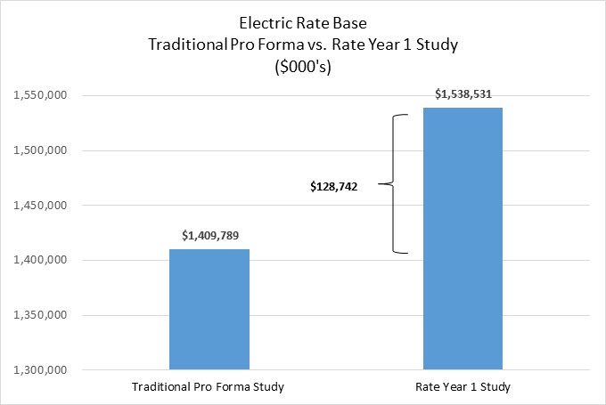**Illustration No. 3:**

The illustration demonstrates that using the Traditional Pro Forma Study, approximately $128 million of net electric plant after ADFIT, would be in service serving customers during the first rate year beginning May 1, 2018, would not be reflected in retail rates.

Illustration No. 4 shows a similar comparison for natural gas rate base:

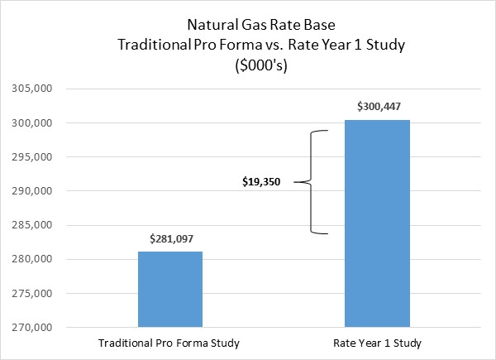**Illustration No. 4:**

The illustration demonstrates that using the Traditional Pro Forma Study, approximately $19 million of net natural gas plant after ADFIT, that would be in service serving customers during the first rate year beginning May 1, 2018, would not be reflected in retail rates.

These illustrations show that the electric and natural gas rate base adjustments for the Traditional Pro Forma Study fall well below the level of rate base that will be in service during the first rate year.

**Q. Please summarize the level of electric and natural gas rate base under the Traditional Pro Forma Studies, the EOP Rate Base Studies and the Rate Year Studies.**

A. Illustration No. 5 below provides a comparison of the level of electric rate base reflected in each of the three studies for the first rate year beginning May 1, 2018.

**Illustration No. 5:**

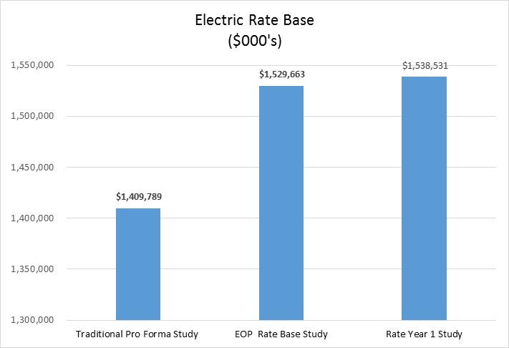

The illustration demonstrates that using the Traditional Pro Forma Study, when compared to the other two Studies, significantly understates the level of net electric plant after ADFIT, for the first rate year beginning May 1, 2018.

Illustration No. 6 shows a similar comparison for natural gas rate base:

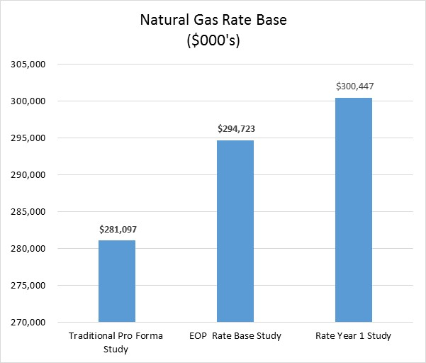**Illustration No. 6:**

Illustration No. 6 demonstrates that using the Traditional Pro Forma Study, when compared to the other two Studies, significantly understates the level of net natural gas plant after ADFIT for the first rate year beginning May 1, 2018.

**Q. Ms. Andrews refers to capital additions for 2019 and 2020 being lower than in prior years. Does the information you have provided illustrate this reduced growth in capital additions for 2019 and 2020?**

A. Yes. As shown below in Table No. 4 the average annual rate base increase from December 31, 2016 AMA to April 30, 2019 is approximately $70 million for electric plant and $16 million for natural gas.

**Table No. 4:**



When reviewing Rate Year 2 for electric and natural gas rate base, the growth in rate base has decreased to approximately $35 million and $15 million for electric and natural gas, respectively. The lower growth in rate base in Rate Year 2 for both services is due in large part to the timing of transfers to plant. There are approximately $63 million less transfers to plant on a system basis, when compared to the average of the previous periods. Also, the continued impact of the repairs deduction and bonus depreciation on ADFIT through 2020 will also slow the growth in net plant balances for electric and natural gas in these periods. Finally, carrying forward the accumulated depreciation on all plant from December 31, 2016 on an AMA basis to each rate year will impact each rate years’ net plant adjustment amount. A summary of each plant component (Gross Plant in Service, AD and ADFIT) is shown in Table Nos. 2 and 3 earlier in my testimony.

### VII. DEPRECIATION STUDY

**Q. When has Avista planned for its next depreciation study?**

A. Avista’s next depreciation study is currently underway and is expected to be completed towards the end of 2017. After completion of this study the Company will file a petition in all of its jurisdictions to request to change depreciation rates as determined by this study.

**Q. Why is this depreciation study being performed?**

A. The objective of a depreciation study is to recommend depreciation rates to be utilized by Avista for accounting and ratemaking purposes. Also, it is sound accounting practice to periodically update depreciation rates to recognize additions to investment in plant assets and to reflect changes in asset characteristics, technology, salvage, removal costs, life span estimates and other factors that impact depreciation rate calculations. The Company last changed its depreciation rates in Washington effective January 1, 2013, per Order No. 09 in Docket Nos. UE-120436 and UG-120437. The depreciation rates approved by the Commission were developed from a study based on depreciable plant balances at December 31, 2011 for Transportation assets and December 31, 2010 for all other assets. The Company typically conducts depreciation studies at approximately five-year intervals. For the current study, Avista hired Gannett Fleming, Inc. to undertake a depreciation study of its depreciable electric, natural gas and general plant in service as of December 31, 2016.

**Q. Is it important to maintain uniform depreciation rates on common plant by the Company’s three jurisdictions?**

A. Yes. Avista will be making similar depreciation filings with the Idaho Public Utilities Commission and the Public Utility Commission of Oregon. It is important that the Company maintain uniform plant accounts and depreciation rates on common plant that are allocated to the various services and jurisdictions in which the Company operates. In the event different depreciation rates or methods were to be ordered, it would result in multiple sets of depreciation accounts and records that would need to be adjusted annually for changes in allocation factors. This would impose a costly administrative burden on the Company and unnecessary expense for the Company’s ratepayers.

### VIII. REPORTING FOR CAPITAL ADDITIONS

**Q. Is the Company proposing a periodic report to the Commission on completed capital additions as part of its proposed Three-Year Rate Plan?**

A. Yes. For Rate Years 2 and 3 effective May 1, 2019 and May 1, 2020, the Company is proposing to file with this Commission an Annual Washington Electric and Natural Gas Capital Report by February 15, 2019 and February 15, 2020 (approximately 75 days) prior to new rates going into effect. The annual report would provide actual year-end balances for the calendar year as of December 31st (EOP net plant balances including impact of A/D and ADFIT). This would provide assurance to the Commission that the rate increases approved effective May 1, 2019 and 2020, would include net plant which actually is in-service and serving customers prior to new rates going into effect.

**Q. What type of information will this report include on capital additions?**

A. This report will include similar information regarding transfers to plant, as the Company has provided in previous reports where this Commission required certain annual reporting to support a multi-year rate plan. [8]

**Q. Does this conclude your pre-filed direct testimony?**

A. Yes, it does.

1. Company witnesses Mr. Kinney, Ms. Rosentrater and Mr. Kensok sponsor testimony explaining the Company’s capital investments.
2. References to “all” plant within this testimony refer to all plant excluding the Company’s Advanced Metering Infrastructure (“AMI”) project. Avista has excluded AMI investment from this general rate case, and has requested separate regulatory accounting treatment for AMI through an accounting petition filed May 1, 2017 in Docket Nos. UE-170327 and UG-170328.
3. My reference to rate base reflects net plant after ADFIT. My rate base figures do not include working capital and other adjustments that are made to rate base.
4. The Company reviewed planned capital projects from January 1, 2017 through December 31, 2017. Based on Commission Order 05, Dockets UE-150204/UG-150205, the Company identified electric and natural gas Pro Forma capital projects that met the threshold of one-half of one percent of the Company’s rate base (i.e., above $6.9 million for electric and $1.3 million for natural gas).
5. The Company reviewed large capital additions in 2017 to determine any offsets (e.g., reduced O&M costs, reduced load losses, etc.). Maintenance records were reviewed to determine whether any specific maintenance costs were incurred in the test year that would be reduced or eliminated by the investment. Those costs were quantified and included as a reduction to O&M costs in the Pro Forma O&M Savings adjustment included by Ms. Andrews as a part of her End of Period Rate Base Study. In addition, the output from generation assets is included in the AURORAXMP power cost model. Therefore, to the extent that the additional investments serve to either preserve or increase generation from the generation projects, the benefits are already reflected in the AURORAXMP model.
6. The IRS extended bonus depreciation through 2019. The Company has included bonus depreciation through 2019 within its capital adjustments.
7. The Company used estimated retirements for the period January 1, 2017 through April 30, 2021, and then allocated these by functional group to service and jurisdiction. Further detail has been provided in my workpapers.
8. Order 09 in Docket Nos. UE-120436 and UG-120437 *(Consolidated)*