**BEFORE THE WASHINGTON STATE**

**UTILITIES AND TRANSPORTATION COMMISSION**

BNSF RAILWAY COMPANY,

Petitioner

vs.

YAKIMA COUNTY,

Respondent,

YAKAMA NATION,

Intervenor.

________________________________________

)

)

)

)

)

)

)

)

)

)

)

DOCKET NO: TR-140382 and

DOCKET NO: TR-140383

**PETITIONER BNSF RAILWAY COMPANY’S POST-HEARING BRIEF**

**TABLE OF CONTENTS**

1. INTRODUCTION 4
2. SUMMARY OF KEY FACTS 4
3. LEGAL FRAMEWORK 6
4. The Commission Has Both the Authority and Duty   
   to Close At-Grade Crossings in the Interest of Public Safety 6
5. In Determining Whether Closure Is Mandated, Washington Law   
   Unabmiguously Declares that Public Safety Must Be the Focus 7
6. Issues Unrelated to Present Safety, Necessity, and Convenience   
   Are Not Considered 8
7. The North Stevens Road Crossing Should Be Closed 9
8. Background on North Stevens Road Crossing 9
9. The Duplicative North Steven Road Crossing Is Inherently Dangerous 9
10. The Danger to the Public Is Not Outweighed by Minimal Inconvenience   
    to the Four Agribusiness that Wish to Continue Using It 12
11. The North Stevens Road Crossing is Rarely Used 12
12. The Crossings Adjacent to North Stevens Road Are Safer   
    and Can Absorb the Additional Traffic 13
13. Inconvenience and Risks to Safety   
    Associated with Closure Are Minimal 16
14. Conclusion: The North Stevens Road Crossing Should Be Closed 17
15. The Barnhart Road Crossing Should Be Closed 18
16. Background on Barnhart Road Crossing 18
17. The Duplicative Barnhart Road Crossing Is Inherently Dangerous 18
18. The Danger to the Public is Not Outweighed by the Minimal Inconvenience   
    to Sporadic Funeral Processions that Travel Upon It, or to the Two or Three Agribusinesses that Wish to Continue to Use It 20
19. The Barnhart Road Crossing Is Rarely Used 20
20. Traffic Will Be Diverted to Safer Crossings,   
    Which Have the Capacity to Absorb the Additional Traffic 21
21. Inconvenience and Risks to Safety   
    Associated with Closure Are Minimal 23
22. Conclusion: The Barnhart Road Crossing Should Be Closed 26
23. Conclusion 27

TABLE OF AUTHORITIES

Cases

*BNSF Railway Company v. Snohomish County*, TR-090121, 2009 WL 3413309   
(Oct. 21, 2009) 8, 11, 17, 20, 26

*BNSF Railway Co. v. Mt. Vernon*, 2007 WL 2907339 (2007) 8, 25

*Burlington Northern & Santa Fe Railway Co. v. City of Sprague*, TR-010684,   
2003 WL 24122604 (2003) 6, 8, 9, 11, 19

*Burlington Northern RR Co. v. Skagit County,* TR-940282,   
1996 WL 34900586 (1996) 7, 8, 9, 11, 12, 18, 20, 26

*Burlington Northern Railroad Company v. City of Ferndale*, TR-940330,   
1995 WL 18090851 (1995) 7, 8, 9, 11, 18, 19

*Department of Transportation v. Snohomish County,* 35 Wn. 2d 247, 254, 255, 256-257,  
212 P.2d 829 (1949) 7, 8, 11, 12, 18, 20, 25, 26

*Leathers v. Mo. Hwy. & Transp. Commission,* 961 S.W.2d 83, 87 (Mo. App. Ct. 1997) 8

*Prosser v. Seaboard Air Line R. Co.,* 216 S.C. 33, 39, 56 S.E.2d 591 (S.C. 1949) 8

*Reines v. Chicago, Milwauke, St. Paul & Pacific R.*, 195 Wn. 146,   
80 P.2d 406 (1938) 7, 9, 11, 18, 19

*State ex rel. City of St. Joseph v. Pub. Serv. Commission,* 713 S.W.2d 593, 597   
(Mo. App. Ct. 1986) 8

*State ex rel. Oregon-Washington Railroad & Navigation Co. v. Walla Walla County*,   
5 Wn. 2d 95, 104 P.2d 764 (1940) 7, 9, 11, 18, 19

*Union Paific. RR v. Spokane County*, Docket No. TR-950177 (1996) 8

Statutes

RCW 81.53.271 6

RCW 81.53.010 6

RCW 81.53.060 6

**Regulations**

WAC 480-07-820 7

WAC 480-07-825 7

Other Authorities

Railroad-Highway Grade Crossing Handbook, Chapter 4 (Rev. 2d. Ed., August 2007) 7

1. **INTRODUCTION**

Both law and policy in Washington State are unambiguous that at-grade crossings present a substantial danger to the public and should be closed absent a strong showing of public necessity. This matter involves two separate Petitions to close rural at-grade crossings in Yakima County. The testimony established that both crossings, the North Stevens Road crossing and the Barnhart Road crossing, are uniquely dangerous and present a substantial risk to public safety. Likewise, the testimony showed no public necessity sufficient to outweigh this risk to public safety. To the contrary, the testimony established that each of the duplicative crossings is only sparsely used by a small handful of agribusinesses, who oppose the closure based upon minimal inconvenience to their business operations. BNSF Railway Company (“BNSF” or “Petitioner”), therefore, respectfully requests that the Commission grant both of its Petitions and that each of the two crossing be closed in the interest of public safety.

1. **SUMMARY OF KEY FACTS MANDATING CLOSURE**

While the North Stevens Road and Barnhart Road crossings have important differences and must each be individually analyzed under the respective Petitions, both crossings share a number of key similarities that demand closure in the interest of public safety.

First, as testimony from both the Petitioners and the Respondents established, the North Stevens Road and Barnhart Road crossings are both dangerous. At-grade railroad crossings are inherently dangerous, and this conclusion underlies the policy of both the State and the Federal Railroad Administration that public safety mandates the closure of at-grade crossings whenever plausible. The efforts of the railroads, the WUTC, and the FRA in seeking such closures over the past decades has been central to the dramatic reduction in at-grade crossing accidents during that time. Here, each crossing is unpaved, has various obstructions to visibility, is used, at least to some extent, by heavy trucks and slow-moving farm equipment, and is controlled solely by passive warning devices.

Second, the alternative available crossings adjacent to the Barnhart Road and North Stevens Road crossings are substantially safer. Three of the four alternative crossings have active warning devices, which the Federal Railroad Administration studies demonstrate are ten times safer than the type of passive warning devices present at both the Barnhart Road and the North Stevens Road crossings.

Third, the existing use of the North Stevens Road and Barnhart Road crossings, each rural dirt roads, is extremely limited. Each of the crossings has very limited traffic flow, with average daily traffic counts ranging between 39 and 102.

Fourth, closure would only result in *de minimis* inconveniences to the community. Testimony at the hearing made clear that any inconvenience associated with additional travel will be focused on a small handful of agribusinesses with portions of their land holdings adjacent to the crossings. While it is evident that a number of those businesses have significant political power within Yakima County, the minimal inconvenience to those few well-connected businesses does not justify the inherent risk to the community associated with keeping each crossing open. As the public comment of their trade organization made clear, these businesses generally oppose ***all*** at-grade closures near agribusinesses, in favor of the convenience of their constituents over the well-established safety benefit to the community.

Fifth, any minimal amount of additional slow-moving farm traffic added to roads does not outweigh the real and established risk of a catastrophic event if the Barnhart Road and North Stevens Road crossings remain open. While respondents’ pre-filed testimony made claims about more substantial volumes of slow-moving “farm traffic” being diverted to the state highway, these claims could not withstand scrutiny. Testimony established that the number of trips by slow-moving farm vehicles (as opposed to farm cars, pick-ups, and semi-trucks) that would be rerouted at each of the two crossing averaged out to less than one additional slow moving vehicle every other day. With the substantial existing volume of slow-moving farm vehicles already operating in that area, any hypothetical increase would be statistically insignificant.

Given each of these circumstances, the inherent safety risks to the community associated with keeping each of the crossings open is not outweighed by the necessity or convenience of the community.

1. **LEGAL FRAMEWORK**
   1. **The Commission Has Both the Authority and Duty to Close At-Grade Crossings in the Interest of Public Safety.**

Chapter 81.53 of the Revised Code of Washington grants the Washington Utilities and Transportation Commission (“WUTC” or “Commission”) the authority to regulate the safety of railroad grade crossings.[1] The “legislature finds that grade crossing, rail trespass, and other safety issues continue to present a public safety problem.”[2]  RCW 81.53.020 states the legislature’s preference for overcrossings and undercrossings where practicable, and prohibits the construction of a crossing at grade without prior Commission approval. “The principle underlying this provision is that grade crossings are inherently dangerous.”[3] Closing at-grade rail crossings is among the most effective means of addressing this public danger.[4] The systematic and successful closure of dangerous at-grade crossings over the past 15-plus years has been instrumental in dramatically reducing the number of at-grade crossing accidents during that time.[5]

When an at-grade railroad crossing becomes too dangerous to keep open to public travel, a railroad company or other government body may file a petition with the Commission to close the crossing.[6] Where, as here, a petition to close a crossing is opposed, the WUTC holds a public hearing to “resolve contested issues on the basis of the official record in a proceeding.”[7] The Commission is then authorized to issue a final order closing the at-grade crossing.[8]

* 1. **In Determining Whether Closure Is Mandated, Washington Law Unambiguously Declares that Public Safety Must Be the Focus.**

“All crossings at grade are dangerous, and the policy of the law is strongly against the allowance of such crossings.”[9]  In addition to dangers inherent at all grade crossings, “there are factors that may make a particular crossing especially hazardous,” including “vegetation or other obstacles that limit the motorist’s view of the tracks as the motorist approaches the crossing.”[10]

The Federal Highway Administration has instructed that “state agencies should utilize their authority to close crossings whenever possible.”[11] Because of the inherent dangers of grade crossings, “the Commission generally will grant a petition to close a grade crossing unless the public need for the crossing outweighs the hazards that result from the crossing.”[12]

The Washington Supreme Court has established the following analysis for balancing safety with such public need:

Having found that the grade crossing herein is dangerous and unsafe, we must also consider the convenience and necessity of those using the crossing and whether the need of the crossing is **so great that it must be kept open notwithstanding its dangerous condition**.[13]

Accordingly, “by law, [a dangerous crossing] ***can only remain open if*** ‘the need for the crossing is so great that it must be kept open notwithstanding its dangerous condition.’”[14]

In determining whether public convenience and need so outweigh the danger of the crossing, the Commission may consider:

the amount and character of travel on the road and on the highway, the availability of alternate crossings, whether the alternate crossings are less hazardous, and ability of alternate crossings to handle any additional traffic that would result from the closure, and the effect of closing the crossing on public safety factors such as police control.[15]

As there will always be some level of inconvenience to the community, the law on crossing closures throughout the country has long made clear that public safety outweighs inconvenience to the public.[16]

* 1. **Issues Unrelated to Present Safety, Necessity, and Convenience Are Not Considered.**

In balancing the factors above, the Commission “may only consider whether or not convenience and necessity justifies the closing of the crossing.”[17] Factors not directly pertinent to convenience or necessity, such as loss of business[18] and external policy considerations[19], are outside the appropriate scope of the WUTC’s consideration, and are therefore ignored.[20] Similarly, “only the present public need should be considered in determining whether to close a crossing.”[21] The fact that growth and construction *may* happen in the future should not be considered in the Commission’s analysis.[22]

1. **THE NORTH STEVENS ROAD CROSSING SHOULD BE CLOSED**
   1. **Background on North Stevens Road Crossing**

The North Stevens Road crossing is an unpaved, rural, at-grade crossing.[23] It is controlled by passive warning devices, namely crossbucks and stop signs.[24] The roadway approach from the south turns at approximately a 45 degree angle shortly before approaching the tracks.[25] Brush obscures the view to the east and west from the southern approach.[26] Although a small dirt road, the speed limit on North Stevens Road, including as it approaches the crossing, is 50 miles per hour.[27] The average daily vehicle traffic count over the North Stevens Road crossing is between 39 and 74 vehicles per day.[28] The average daily train count at the North Stevens Road crossing is between 12 and 14, with an actual and maximum train speed of 49 miles per hour. [29]

* 1. **The Duplicative North Stevens Road Crossing Is Inherently Dangerous.**

It is well established that at-grade rail crossings present a substantial danger to the public.[30]  The weight ratio of a car to a train is about that of a soda can to a car–about 4,000 to 1.[31]  Accordingly, basic physics mandates that a train-vehicle collision, particularly at speed, has a high probability of catastrophic results.[32]

The risk of a train-vehicle accident is particularly acute at the North Stevens road crossing, which is controlled solely by passive warning devices, namely crossbucks and stop signs.[33] Recent data from the Federal Railroad Association indicates that when adjusted for volume, the risk of a train-vehicle collision at crossings with only passive warning devices is approximately ten times greater than crossings with active warning devices, such as gates, lights, and whistles.[34] As traffic engineering expert Gary Norris explained:

The reason for this is fairly obvious: people are much less likely to try to drive across tracks in front of the train, either accidently or intentionally, if they have to run a red light and evade lowered gates. Under passive control, the driver must determine if it is safe to cross whereas under active control the driver is informed through gates and flashers that it is not safe to cross.[35]

Respondent concedes the obvious safety risks associated with crossings, such as the North Stevens Road crossing, controlled solely by passive warning devices.[36]

Further, the use of the North Stevens Road crossing by various heavy or slow-moving vehicles, described in the testimony of various Yakima County witnesses, presents additional dangers to the community. First, the low speed and lack of maneuverability of such vehicles increases the likelihood of a collision.[37] Second, the substantial weight of such vehicles increases the likelihood that a collision with a train would result in catastrophic consequences, including derailment of the train.[38] Moreover, as Respondent’s witnesses testified, a number of these vehicles carry fertilizers, pesticides, and other chemicals, which may constitute hazardous materials under the U.S. Department of Transportation regulations.[39]  Were such a chemical-loaded vehicle struck by a fast-moving train, there is an unacceptable risk of chemical leaks, groundwater contamination, explosion, derailment, and/or death.[40]

The North Stevens Road crossing also suffers from limitations on visibility. Notably, visibility at the crossing is compromised from the southern approach by brush and other vegetation.[41] It is well established that the inability of vehicles to clearly see down the tracks results in a dangerous condition.[42]

Neither Yakima County nor the Yakama Nation meaningfully deny the danger of the North Stevens Road crossing. Instead, they only note the absence of any accidents at this crossing. Of course, Washington law has long rejected this argument.[43] As the Washington Supreme Court succinctly stated, by analogy, in the seminal *Snohomish* case:

A father, with knowledge that his ten-year-old son constantly attended the so-called Western movies, would hardly be considered prudent if he persisted in permitting a loaded pistol to lie around the home, on the theory that there was no danger in so doing since the boy had not yet shot any one while playing with it.[44]

Simply put, “[t]he lack of prior disastrous consequences from such events at these locations in the past does not predict that accidents will not occur there in the future.”[45]

As set forth above, it is well established that “[a]ll crossings at grade are dangerous, and the policy of the law is strongly against the allowance of such crossings.”[46]  Here, the danger is apparent given the lack of active warning devices, the types of traffic using the crossing, and limited visibility. Accordingly, under Washington law, the North Stevens Road crossing must be closed unless “the need of the crossing is so great that it must be kept open notwithstanding its dangerous condition.”[47]

* 1. **The Danger to The Public Is Not Outweighed by Minimal Inconvenience to the Four Agribusinesses that Wish to Continue Using It.**

In analyzing whether the need for the North Stevens Road crossing is “so great that it must be kept open notwithstanding its dangerous condition,” the Commission considers “the amount and character of travel on the road and on the highway, the availability of alternate crossings, whether the alternate crossings are less hazardous, and ability of alternate crossings to handle any additional traffic that would result from the closure, and the effect of closing the crossing on public safety factors such as police control.”[48] Respondents have failed to present evidence demonstrating that the public’s need for the North Stevens Road crossing is “so great that it must be kept open notwithstanding its dangerous condition.”[49]

* + 1. **The North Stevens Road Crossing Is Rarely Used.**

Contrary to the rosy characterization of the North Stevens Road crossing in Yakima County’s witnesses’ pre-filed testimony, the North Stevens Road is a small rural, unpaved, at-grade crossing, with average daily vehicle use of between 39 and 74 vehicles.[50] Testimony at the hearing made clear that there are only a handful of well-connected agribusinesses that make up the vast majority of the minimal traffic over the North Stevens Road crossing, and they are driving the County’s opposition.[51] Notably, SP Farms testified that it was aware of only three others who use the North Stevens Road crossing – T&K Farms and two farms operated by Mr. Sealock and Mr. Bangs, respectively. Both Mr. Sealock and Mr. Bangs withdrew their pre-filed testimony, and thus were not offered for cross-examination as to the extent of any use of the crossing.

* + 1. **The Crossings Adjacent to North Stevens Road Are Safer and Can Absorb the Additional Traffic.**

Testimony clearly established that both the Myers Street crossing and the South Track Road crossing, the two crossings adjacent to the North Stevens Road crossing, are substantially safer than the North Stevens Road crossing.

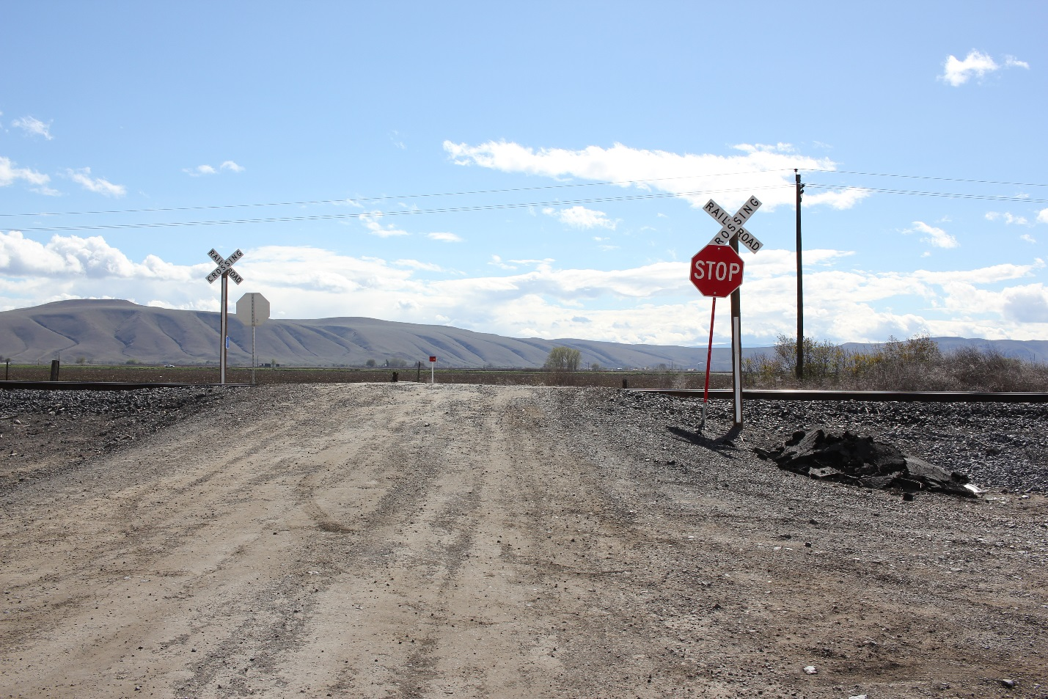As set forth above, the North Stevens Road crossing is a rural, unpaved, at-grade crossing, controlled by passive warning devices, with an angled approach, and brush obscuring the view to the east and west from the southern approach.[52]

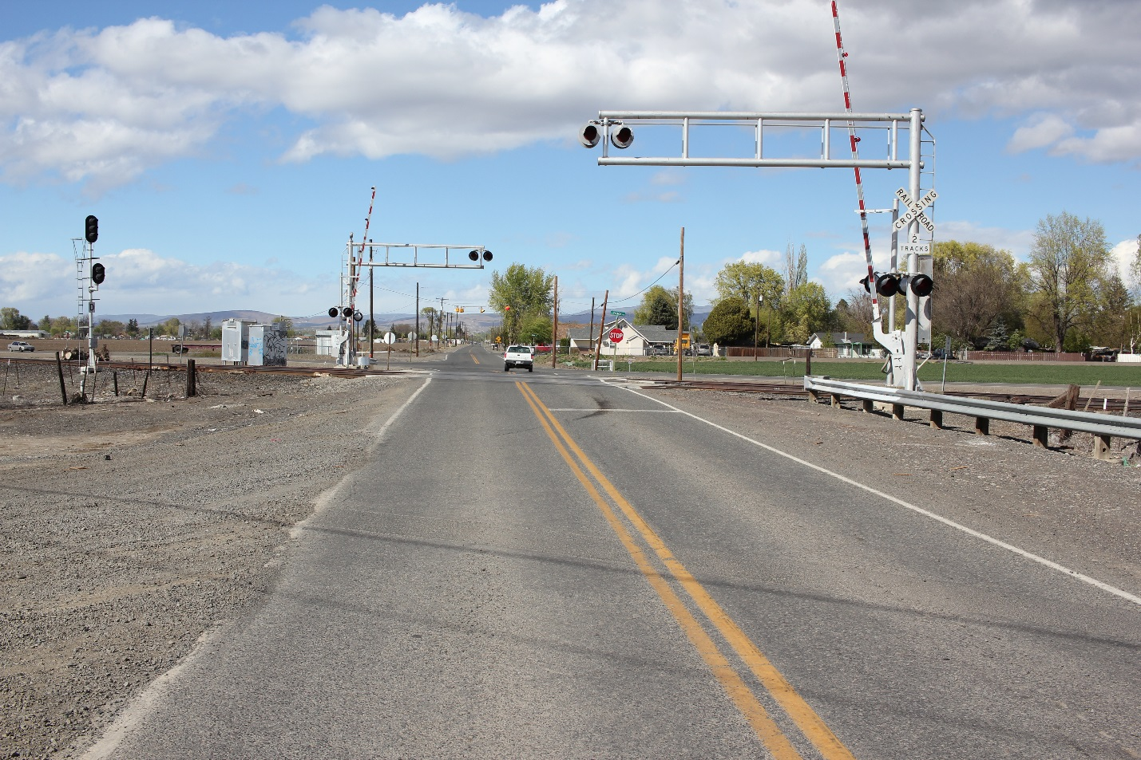The alternative crossing to the West, at Myers Road, is a paved crossing, controlled by active warning devices, including lights, gates, and bells. The visibility in each direction, from each approach, is excellent.[53]

Testimony conclusively demonstrated that these features, and in particular, the existence of active warning devices, make the Myers Road crossing substantially safer than the North Stevens Road crossing.[54]

The alternative crossing to the East, at South Track Road, is also a paved crossing, controlled by active warning devices, including lights and bells, and advance LED warning signs funded by the WUTC and installed in 2013.[55] While there are turns near the crossing, the advance LED warning signs alert drivers in advance of the turns, and the tracks are in the middle of a 400 foot straightaway.[56] As with the Myers Road crossing, the visibility at the South Track 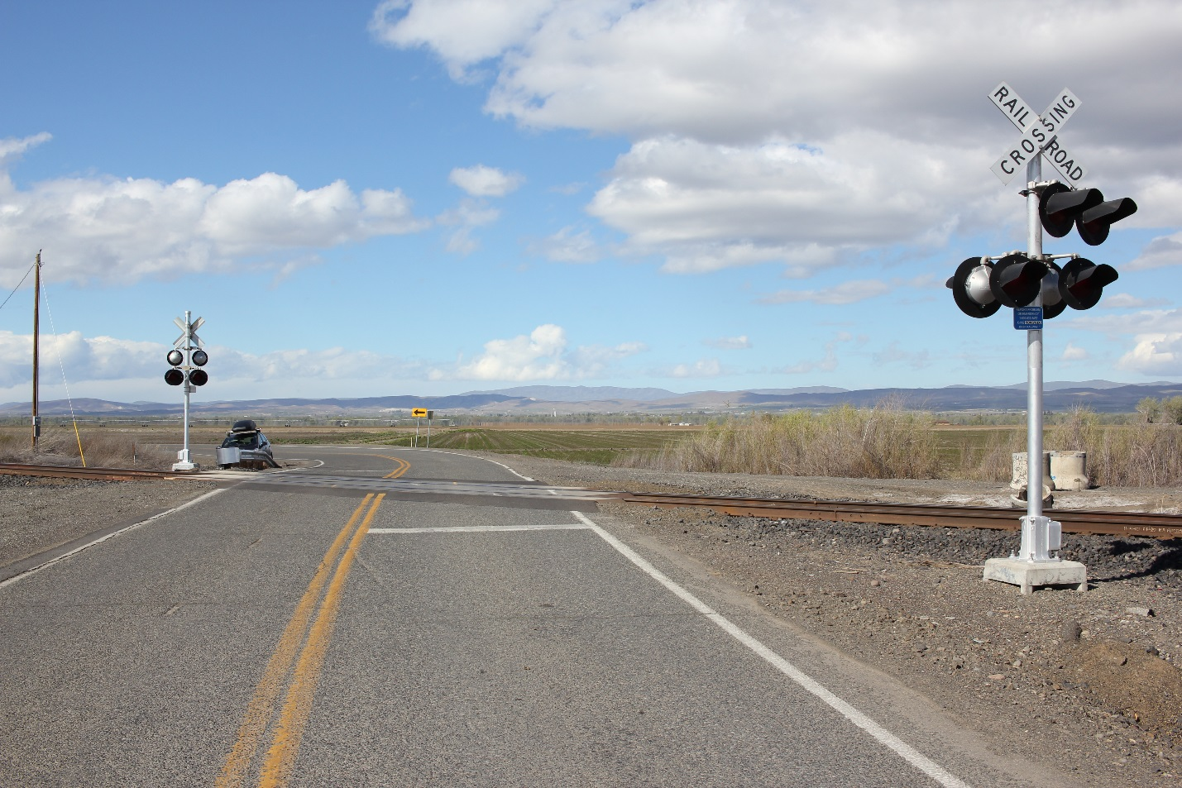Road crossing is excellent in each direction, from each approach.[57]

Again, testimony conclusively demonstrated that these features, and in particular, the existence of active warning devices, made the South Track Road crossing substantially safer than the North Stevens Road crossing.[58]

Moreover, given the minimal amount of traffic that will be diverted, it is uncontested that both the Myers Road crossing and the South Track Road crossing could safely absorb any additional traffic resulting from the closure of the North Stevens Road crossing. [59]

* + 1. **Inconvenience and Risks to Safety Associated with Closure Are Minimal**.

Before the County was contacted by a handful of politically-connected businesses, it was strongly in favor of the closure of the North Stevens Road crossing, filing its own Petition to close the North Stevens Road crossing.[60] In that Petition, Yakima County’s chief witness, Kent McHenry, a licensed engineer with more than 20 years of experience, certified that there would be no “homes or businesses that might be affected by the closure.”[61] After receiving political pressure, however, Yakima County changed its position, withdrawing its Petition, and asserting in opposition to this Petition that there was a safety risk associated with putting a large volume of additional slow-moving farm traffic on State Route 22 and South Track Road.[62]

Again, this assertion could not stand up to scrutiny. The substantial volume of “farm vehicles” referenced in Yakima County’s witnesses’ testimony turned out to consist almost exclusively of the types of semi-truck trailers that already are prevalent on State Route 22, and other highways around Yakima, “all day long and all night long.”[63] Testimony regarding ***slow moving*** farm equipment, on the other hand, demonstrated that the quantity of additional ***slow-moving*** farm equipment that would be diverted to State Route 22, or other highways, would be *de minimis*. T&K Farms testified that its slow-moving farm vehicles used the North Stevens Road crossing 5-10 times per week, for three months out of the year (totaling roughly 60-120 crossing annually).[64]  SP Farms testified that it used the North Stevens Road with such slow-moving equipment 36 times annually.[65] No other farmers or residents testified about their use of the crossing.[66] Based upon the numbers provided, the closure would result in less than 160 additional trips annually for slow-moving farm vehicles. Even accepting the testimony of the farm company representatives, this equates to only one additional trip every other day.

As both Petitioner and Respondents’ witnesses testified, there is a substantial amount of slow moving farm traffic already existing on State Route 22, and other adjacent highways in the area.[67] The addition of one short trip to that existing traffic, every other day, is *de minimis*, and cannot justify the failure to remedy the admittedly dangerous condition created by the North Stevens Road crossing.

In assessing other safety risks besides the purported diversion of “slow-moving” farm vehicles, neither Yakima County nor the Yakama Nation presented testimony demonstrating access by school buses or emergency services would be affected by the closure of the North Stevens Road crossing. The evidence demonstrated that North Stevens Road crossing was either not used for these purposes, or alternative routes were equally available.[68]

* 1. **Conclusion: The North Stevens Road Crossing Should Be Closed.**

Given the lack of active warning devices, the types of traffic using the crossing, and the limited visibility at the crossing, Petitioner has plainly established that the North Stevens Road crossing is dangerous.

While respondents have presented evidence of some minor inconvenience to a small handful of businesses with fields abutting the North Stevens Road crossing, they are not, as the law requires, “so great that it must be kept open notwithstanding its dangerous condition.”[69] In analyzing whether the public’s need for the North Stevens Road crossing is “so great that it must be kept open notwithstanding its dangerous condition,” the Commission considers “the amount and character of travel on the road and on the highway, the availability of alternate crossings, whether the alternate crossings are less hazardous, and ability of alternate crossings to handle any additional traffic that would result from the closure, and the effect of closing the crossing on public safety factors such as police control.”[70] For each of the reasons set forth above, the County has failed to present evidence demonstrating that the public’s need for the North Stevens Road crossing is “so great” as to require the dangerous crossing to remain open.[71]

1. **THE BARNHART ROAD CROSSING SHOULD BE CLOSED**
   1. **Background on Barnhart Road Crossing.**

The Barnhart Road crossing is a rural, at-grade crossing.[72] The approach is paved to the South, and unpaved to the North. It is controlled by passive warning devices, namely crossbucks and stop signs, and a pavement marking on the south side only.[73] Brush obscures the view to the east and west from the northern approach.[74] Although only a small dirt road, the speed limit on Barnhart Road, including approaching the crossing, is 50 miles per hour.[75] The average daily traffic count at the Barnhart Road crossing is between 72 and 102 vehicles per day.[76] The average daily train count at the Barnhart Road crossing is between 12 and 14, with an actual and maximum train speed of 49 miles per hour.[77]

* 1. **The Duplicative Barnhart Road Crossing Is Inherently Dangerous.**

As set forth above in detail with respect to the North Stevens Road crossing, it is well established that at-grade rail crossings present a substantial danger to the public.[78]  At hearing, testimony established numerous features that make the Barnhart Road crossing Dangerous, including that it is controlled solely by passive warning devices, namely crossbucks and stop signs.[79]

Further, the use of the Barnhart Road crossing by various heavy or slow-moving vehicles, described in the testimony of Yakima County and Yakama Nation witnesses, presents additional dangers to the community, as both the likelihood and severity of a collision increases as a result of the low speed and lack of maneuverability of such vehicles.[80] As Yakima County’s witnesses testified, a number of these vehicles carry fertilizers, pesticides, and other chemicals, which may constitute hazardous materials under the U.S. Department of Transportation regulations.[81]  Were such a chemical-loaded vehicle struck by a fast-moving train, there is an unacceptable risk of chemical leaks, groundwater contamination, explosion, derailment, and/or death.[82]

The Barnhart Road crossing also suffers from limitations on visibility due to extensive vegetation growth.[83] As Mr. Peterson testified, “the Barnhart Road crossing, of all of the crossings basically from North Myers to Satus Longhouse, in my opinion, had the least amount of visibility down the track, especially on the approach to the crossings.” [84] It is well established that the inability of vehicles to clearly see down the tracks results in a dangerous condition.[85] As with the North Stevens Road crossing, the fact that there has not been an accident in recent memory is not indicative of “does not predict that accidents will not occur there in the future.”[86]

As set forth above, the law is clear that “[a]ll crossings at grade are dangerous, and the policy of the law is strongly against the allowance of such crossings.”[87]  Here, the danger is apparent given the lack of active warning devices, the types of traffic using the crossing, and limited visibility. Accordingly, under Washington law, the Barnhart Road crossing must be closed unless “the need of the crossing is ***so great*** that it must be kept open notwithstanding its dangerous condition.”[88]

* 1. **The Danger to the Public Is Not Outweighed by the Minimal Inconvenience to Sporadic Funeral Processions that Travel Upon It, or the Two or Three Agribusinesses Which Wish to Continue to Use It.**

In analyzing whether the need for the Barnhart Road crossing is “so great that it must be kept open notwithstanding its dangerous condition,” the Commission considers “the amount and character of travel on the road and on the highway, the availability of alternate crossings, whether the alternate crossings are less hazardous, ability of alternate crossings to handle any additional traffic that would result from the closure, and the effect of closing the crossing on public safety factors such as police control.”[89] Neither Yakima County nor the Yakama Nation have presented evidence demonstrating that the public’s need for the Barnhart Road crossing is “so great that it must be kept open notwithstanding its dangerous condition.”[90]

* + 1. **The Barnhart Road Crossing Is Rarely Used.**

As with the North Stevens Road, Respondent attempted to paint the Barnhart Road crossing as more substantial than it is. The Barnhart Road crossing is a small rural, unpaved, at-grade crossing, with average daily vehicle use of only between 72 and 102 vehicles per day.[91]

Testimony from the Yakama Nation’s witnesses at the hearing demonstrated that the Barnhart Road crossing is used sporadically, at best, for funeral processions from the Satus Longhouse to the Satus Point Cemetery.[92] The Yakama Nation’s witnesses established that such funerals happen only a few times a year, at most, and the procession has at times used alternative routes, such as over the Indian Church Road crossing.[93]

Similarly, testimony at the hearing made clear that there are three agribusinesses that make up the vast majority of the minimal traffic over the Barnhart Road crossing.[94] Zecchino Farms testified that it was aware of only two others who use the Barnhart Road crossing – T&K Farms, and a farm owned by Mr. Oswalt.[95] Mr. Oswalt was not a witness and was not available for cross examination as to the extent of his business’s use of the Barnhart Road crossing, if any.

* + 1. **Traffic Will Be Diverted to Safer Crossings, Which Have the Capacity to Absorb the Additional Traffic.**

Testimony also clearly established that the Indian Church Road crossing was substantially safer than the Barnhart Road crossing, while the Satus Longhouse Road crossing was marginally safer than the Barnhart Road crossing.

As set forth above, The Barnhart Road crossing is a rural, at-grade crossing, controlled by crossbucks and stop signs, with visual obstructions from vegetation on the northern approach.[96]

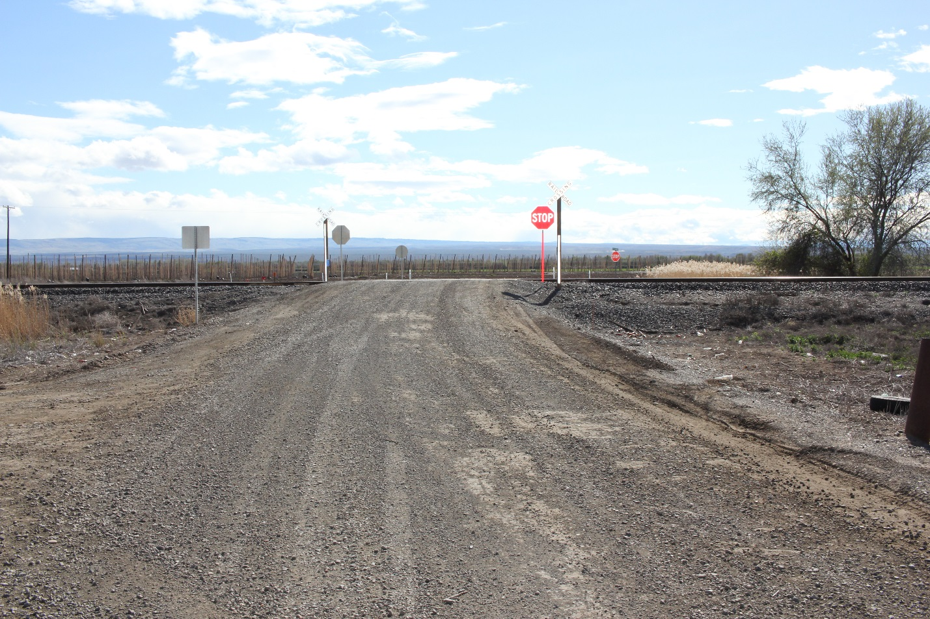

The alternative crossing to the West, at Indian Church Road, is a paved crossing, controlled by active warning devices, including lights, gates, and bells.[97] The visibility in each direction, from each approach, is excellent.[98]

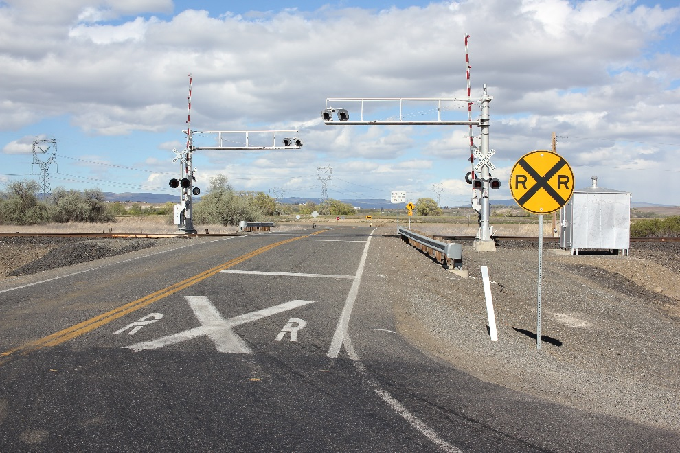

Testimony conclusively demonstrated that these features, and in particular, the existence of active warning devices, made the Indian Church Road crossing substantially safer than the Barnhart Road crossing.[99]

The alternative crossing to the East, at Satus Longhouse Road, is also a paved crossing. It is controlled by clearly visible ground markings, crossbucks, and stop signs. While there are some obstructions on approach from the North, the visibility at the Satus Longhouse Road crossing, itself, is excellent.[100]

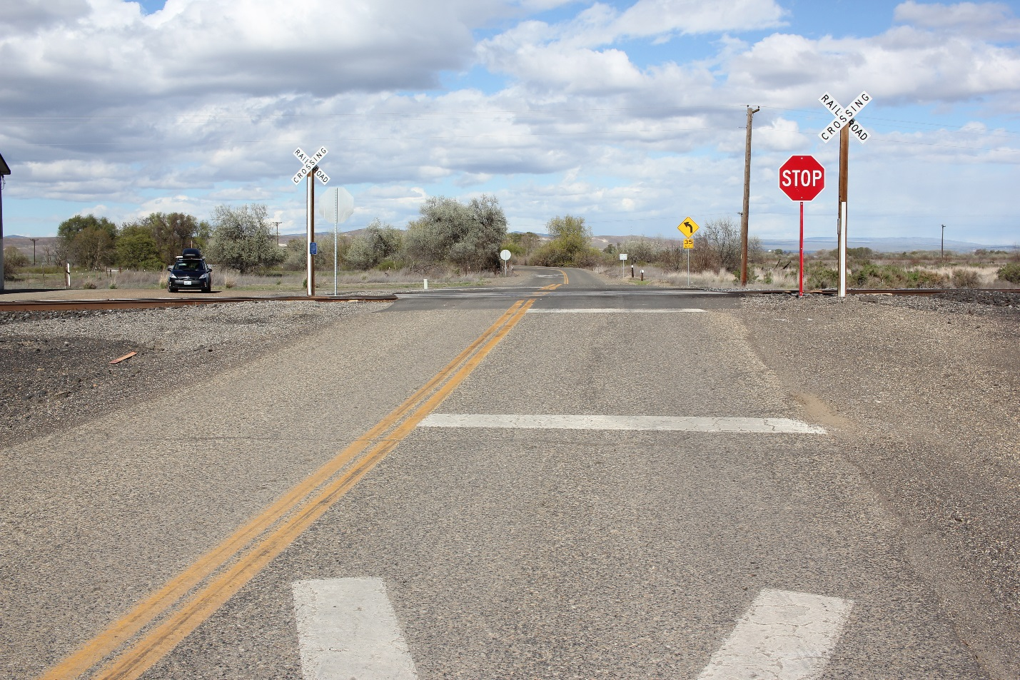

Again, testimony conclusively demonstrated that these features made the Satus Longhouse Road crossing safer than the Barnhart Road crossing.[101]

Moreover, given the minimal amount of traffic that will be diverted, it is uncontested that both the Indian Church Road crossing and the Satus Longhouse Road crossing could safely absorb any additional traffic resulting from the closure of the Barnhart Road crossing.[102]

* + 1. **Inconvenience and Risks to Safety Associated with Closure Are Minimal**.

As it was with the North Stevens Road crossing, the County previously was strongly in favor of the closure of the Barnhart Road crossing, filing its own Petition to close the Barnhart Road crossing, before being contacted by a handful of politically-connected agribusinesses.[103] In the County’s Petition to close the Barnhart Road crossing, Yakima County’s chief witness in this matter, Kent McHenry, a licensed engineer with more than 20 years of experience, again certified that there would be no “homes or businesses that might be affected by the closure.”[104] After receiving political pressure, however, the County backed off, withdrew its own Petition, and asserted in opposition to this Petition that there was a safety risk associated with putting a large volume of additional slow-moving farm traffic on State Route 22.[105]

This assertion is even less credible with respect to the Barnhart Road crossing than it is with respect to the North Stevens Road crossing, and again could not stand up to scrutiny under cross-examination. As with the North Stevens Road crossing, the substantial volume of “farm vehicles” referenced in Yakama County’s witnesses’ testimony turned out to consist almost exclusively of the types of semi-truck trailers that already are prevalent on State Route 22, and other highways around Yakima, “all day long and all night long.”[106] Testimony regarding ***slow moving*** farm equipment, on the other hand, demonstrated that the quantity of additional ***slow-moving*** farm equipment that would be diverted to State Route 22, or other highways, would be *de minimis*. T&K Farms testified that its use of the Barnhart Road crossing was even more limited than the North Stevens Road crossing.[107] At that crossing, T&K farms testified that slow-moving farm vehicles only used the crossing 5-10 times per week, for three months out of the year (totaling roughly 60-120 crossing annually).[108]  Zecchino Farms also testified that it used the Barnhart Road crossing with slow-moving equipment only about 20 days annually.[109] No other farmers or residents testified about their use of the crossing.[110] Based upon the numbers provided, the closure would result in less than 140 additional trips annually for slow moving farm vehicles. Again, even crediting Respondent’s witnesses’s testimony, this equates to less than one additional trip for such vehicles every other day.

As both Petitioner and Respondents’ witnesses testified, there is a substantial amount of slow moving farm traffic already existing on State Route 22, and other adjacent highways in the area.[111] The addition of one short trip to that existing traffic, every other day, is *de minimis*, and cannot justify the failure to remedy the admittedly dangerous condition created by the Barnhart Road crossing.

The Yakama Nation also testified that there would be inconvenience to sporadic funeral processions a few times per year, at most. [112] The Nation’s witnesses testified that some funerals take the alternate route over the Indian Church Road crossing, which is only .3 miles longer, and avoids taking the slow moving funeral procession on the highway. [113] It also allows the slow-moving funeral procession, which could contain as many as 300 people, to use the safer Indian Church Road crossing with its active warning devices. [114] While the Yakama Nation has asked the Commission to consider the importance of the “traditional” route over Barnhart, which is only sometimes used, consideration of the issue is beyond the proper scope of the Commission’s analysis.[115]

Neither Yakima County nor the Yakama Nation expressed safety, convenience, or necessity concerns regarding access by school buses. [116] However, the Yakama Nation expressed some concern regarding emergency vehicle access to three home sites north of the railroad tracks, near Barnhart Road.[117] Upon cross-examination, however, it was apparent that emergency services would not be adversely affected.

Emergency services in the vicinity of the Barnhart Road crossing typically come from either Toppenish or Granger. [118] If coming from Toppenish, emergency vehicles would take State Route 22, and therefore pass Indian Church Road. Were the Barnhart Road crossing closed, emergency vehicles could simply take the Indian Church Road crossing without any substantial delay. [119] Similarly, if coming from Granger, emergency vehicles would be able to access to the three homesites without crossing to the South of the tracks, or traveling additional distance, by turning directly off of Indian Church Road onto Drainbank Road, north of the BNSF line.[120]

* 1. **Conclusion: The Barnhart Road Crossing Should Be Closed.**

Given the lack of active warning devices, the types of traffic using the crossing, and the limited visibility at the crossing, Petitioner has plainly established that the Barnhart Road crossing is dangerous.

While respondents have presented evidence of some minor inconvenience to a small handful of businesses with fields abutting the crossings, they are not “so great that it must be kept open notwithstanding its dangerous condition.”[121] In analyzing whether the need for the Barnhart Road crossing is “so great that it must be kept open notwithstanding its dangerous condition,” the Commission considers “the amount and character of travel on the road and on the highway, the availability of alternate crossings, whether the alternate crossings are less hazardous, and ability of alternate crossings to handle any additional traffic that would result from the closure, and the effect of closing the crossing on public safety factors such as police control.”[122] Neither Yakima County nor the Yakama Nation have presented evidence sufficient to demonstrate that the public’s need for the Barnhart crossing is “so great.”[123]

1. **CONCLUSION**

As set forth above, both law and policy in Washington State are unambiguous that at-grade crossings present a substantial danger to the public and should be closed absent a strong showing of public necessity. Petitioner established that both the North Stevens Road crossing and the Barnhart Road crossing are uniquely dangerous, and present a substantial risk to public safety. In responding, neither Yakima County nor the Yakama Nation established a public necessity sufficiently to outweigh this risk to public safety. To the contrary, the testimony established only that each of the duplicative crossing is only sparsely used by a small handful of agribusinesses who oppose the closure based upon minimal inconvenience to their business operations. Accordingly, BNSF respectfully requests that the Commission grant both of its Petitions and close both the North Stevens crossing and the Barnhart Road crossing.

DATED this 1st day of June, 2015.

Montgomery Scarp, PLLC

_____________________________________

Bradley P. Scarp, WA. Bar No. 21453

Michael E. Chait, WA. Bar No. 48842

Attorneys for BNSF Railway Company

1218 Third Ave., Ste. 2500

Seattle, WA 08101

**CERTIFICATE OF SERVICE**

I am over the age of 18; and not a party to this action. I am the assistant to an attorney with Montgomery Scarp, PLLC, whose address is 1218 Third Avenue, Suite 2500, Seattle, Washington, 98101.

I hereby certify that the original and 3 copies of PETITIONER’S POST HEARING BRIEF has been sent by FedEx to WUTC and filed electronically. I also certify that true and complete copies have been sent via electronic mail to the following interested parties:

|  |  |
| --- | --- |
| Kenneth W. Harper  Menke Jackson Beyer, LLP  807 North 39th Avenue  Yakima, WA 98902 | Rayne Pearson  1300 S. Evergreen Park Dr. SW  P.O. Box 47250  Olympia, WA 98504-7250 |
| Gary Ekstedt  Yakima County Dept of Public Services  County Engineer/Assistant Director  128 N. 2nd Street, Room 408 (Courthouse)  Yakima, WA 98901-2639 | Ethan Jones  Associate Attorney  Confederated Tribes and Bands of the Yakama Nation  P.O. Box 151  401 Fort Road  Toppenish, WA 98948 |
| Al Pinkham  Engineering Planner  Confederated Tribes and Bands of the Yakama Nation  P.O. Box 151  401 Fort Road  Toppenish, WA 98948 | Joseph Sexton  GLANADA BROADMAN, PLLC  8606 35th Ave NE, Suite L1  P.O. Box 15146  Seattle, WA 98115 |
|  |  |

I declare under penalty under the laws of the State of Washington that the foregoing information is true and correct.

DATED this 1st day of June, 2015 at Seattle, Washington.

___________________________

Pamela Ruggles, Paralegal

1. RCW §§ 81.53.010 et seq.
2. RCW § 81.53.271, Findings -- 2003 c 190.
3. *Burlington Northern & Santa Fe Ry. Co., v. City of Sprague.*, Docket No. TR-010684, 2003 WL 24122604 (2003) (hereinafter “*Sprague*”).
4. Exhibit GN-IT, pp. 3:20-4:3, Exhibit GN-12, p.3.
5. *Sprague*, Docket No. TR-010684, 2003 WL 24122604 (2003) (“the numbers show that over the period of time the railroads have been acting aggressively to close unnecessary crossings, such accidents have decreased”); Exhibit GN-1T, pp. 3:20-4:3, Exhibit GN-12, p. 3.
6. *See* RCW 81.53.060.
7. WAC 480-07-820.
8. *Id*. All initial orders are “subject to further action by the commission as provided in WAC 480-07-825”and become final orders of the commission unless the commission reviews the initial order.” *See* WAC 480-07-825. If a party requests administrative review, the Commission “may by final order adopt, modify, or reject an initial order after considering the pleadings and the record. Alternatively, the commission may remand the matter for further proceedings with instructions to the presiding officer.” WAC 480-07-825(9).
9. *Burlington Northern Railroad Company v. City of Ferndale*, Docket No. TR-940330, 1995 WL 18090851 (1995) (hereinafter “*Ferndale*”) (citing *Reines v. Chicago. Milwaukee. St. Paul & Pacific R.R.*, 195 Wn. 146, 80 P.2d 406 (1938); *State ex rel. Oregon-Washington Railroad & Navigation Co. v. Walla Walla County*, 5 Wn. 2d 95, 104 P.2d 764 (1940). *See also Burlington Northern R.R. Co. v. Skagit County,* Docket No. TR-940282, 1996 WL 34900586, (1996) (hereinafter, “*Skagit County*”).
10. *Skagit County,* Docket No. TR-940282, 1996 WL 34900586.
11. Railroad-Highway Grade Crossing Handbook, Chapter 4 (Rev. 2d. Ed., August 2007), *available at* <http://safety.fhwa.dot.gov/xings/com_roaduser/07010/sec04a.cfm>.
12. *Ferndale*, Docket No. TR-940330, 1995 WL 18090851 (1995).
13. *Department of Transportation v. Snohomish County,* 35 Wn. 2d 247, 254, 212 P.2d 829 (1949) (hereinafter, “*Snohomish*”) (emphasis added);
14. *B.N.S.F. Railway Company v. Snohomish County*, Docket No. TR-090121, 2009 WL 3413309, (Oct. 21, 2009) (Hereinafter, “*Logan Road*”).
15. *Skagit County,* Docket No. TR-940282 at p. 4 (1996); *see also* *Ferndale*, Docket No. TR-940330, 1995 WL 18090851 (1995); *Union Pac. R.R. v. Spokane County*, Docket No. TR-950177 (1996).
16. *Leathers v. Mo. Hwy. & Transp. Comm 'n,* 961 S.W.2d 83, 87 (Mo. App. Ct. 1997) (“The Commission places the consideration of public safety above that of public convenience.”); *State ex rel. City of St. Joseph v. Pub. Serv. Comm 'n,* 713 S.W.2d 593, 597 (Mo. App. Ct. 1986); *Prosser v. Seaboard Air LineR. Co.,* 216 S.C. 33, 39, 56 S.E.2d 591 (S.C. 1949) (“This case further holds that public safety is paramount to that of public convenience and necessity, and with this we find no fault.”).
17. *Snohomish*, 35 Wn. 2d at 255.
18. *Id.*
19. *BNSF Railway Co. v. Mt. Vernon*, 2007 WL 2907339 (2007) (hereinafter, “*Mt. Vernon I”*).
20. *Snohomish*, 35 Wn. 2d at 255; *see also Mt. Vernon I*, 2007 WL 2907339 (2007).
21. *Ferndale*, Docket No. TR-940330, 1995 WL 18090851 (1995).
22. *Sprague*, Docket No. TR-010684, 2003 WL 24122604 (2003).
23. Exhibit GN-1T, p.5:14-6:3; Exhibit GN-6; Exhibit KM-29-CX.
24. Exhibit GN-1T, p.5:14-6:3; Exhibit GN-6; Exhibit KM-29-CX.
25. Exhibit KM-29-CX, p. 5.
26. Exhibit KM-29-CX, pp. 9, 10, 12, 13.
27. Petition, p. 4.
28. Petition, p. 4; Exhibit GN-1T, pp. 6:22-7:3.
29. Petition, p. 4; Exhibit GN-1T, 6:12.
30. *Ferndale*, Docket No. TR-940330, 1995 WL 18090851; *Reines*, 195 Wn. at 146; *State ex rel. Oregon-Washington Railroad & Navigation Co.*, 5 Wn. 2d 95; *Skagit County,* Docket No. TR-940282, 1996 WL 34900586; RCW § 81.53.271, Findings -- 2003 c 190.
31. Exhibit DA-1T, p. 3:15-21, Exhibit DA-2, p. 7.
32. Exhibit DA-1T, pp. 3:15-4:2, Exhibit DA-2, p. 7.
33. Exhibit GN-11T, pp. 2:17-4:2, Exhibit CN-12.
34. Exhibit GN-11T, p. 2:22-25, Exhibit CN-12.
35. Exhibit GN-11T, p. 2:25-3:1.
36. Hearing Transcript, Vol. III, 192:5-11, 221:13-19.
37. Exhibit DA-1T, p. 7:4-5; Exhibit FP-1T, pp. 3:21-4:20; Hearing Transcript, Vol. III, pp. 206:20-207:23.
38. Exhibit GN-11T, p. 2:18-3:25; Exhibit DA-5T, p. 2:7-23; Exhibit FP-1T, pp. 3:21-4:20; Hearing Transcript, Vol. III, pp. 206:20-207:23.
39. Hearing Transcript, Vol. III, 148:7-149:4.
40. Hearing Transcript, Vol. III, 72:8-18, 149:1-4, 154:15-23.
41. Exhibit KM-29-CX, pp. 9, 10, 12, 13.
42. *Skagit County*, Docket No. TR-940282, 1996 WL 34900586.
43. *Sprague*, Docket No. TR-010684, 2003 WL 24122604.
44. *Snohomish*, 35 Wn. 2d at 256-57.
45. *Sprague*, Docket No. TR-010684, 2003 WL 24122604.
46. *Ferndale*, Docket No. TR-940330, 1995 WL 18090851 (citing *Reines v. Chicago. Milwaukee. St. Paul & Pacific R.R.*, 195 Wn. 146, 80 P.2d 406 (1938); *State ex rel. Oregon-Washington Railroad & Navigation Co. v. Walla Walla County*, 5 Wn.2d 95, 104 P.2d 764 (1940). See also *Skagit County*, Docket No. TR-940282, 1996 WL 34900586.
47. *Logan Road*, Docket No. TR-090121, 2009 WL 3413309.
48. *Skagit County*, Docket No. TR-940282, 1996 WL 34900586.
49. *Snohomish*, 35 Wn.2d at 254 (emphasis added).
50. Exhibit GN-1T, p.5:14-6:3; Exhibit GN-6; Exhibit KM-29-CX.
51. Hearing Transcript, Vol. III, 193:12-15.
52. Exhibit KM-29-CX.
53. Exhibit KM-28-CX.
54. Exhibit GN-11T, pp. 2:17-3:25; Exhibit GN-12; Exhibit FP-1T, p. 3:14-19; Exhibit MET-1T 4:8-11; Hearing Transcript, Vol. III., pp. 201:5-202:10. 254:8-13. Respondent attempted to argue that the alternative crossings were safer based upon rankings from the FRA accident prediction model, a model typically used for allocation of funding resources. Exhibit GN 13CX. As explained by Gary Norris, this is not evidence of the safety, or relative safety, of the crossings. Hearing Transcrtipt Vol. III, 289:4-294:23. Notably, the report itself is explicit that, among other things,“***[t]his computer model does not rank crossings in terms of most to least dangerous. Use of WBAPS data in this manner is incorrect and misleading***.” Exhibit GN CX 13 (emphasis added). Further, as demonstrated, the methodology and inputs are dated and not generally reliable. Hearing Transcript Vol. III, 291:7-292:7. The use of such ranking also defies common sense based upon observation. Hearing Transcript Vol. III, 292:8-293:13.
55. Exhibit KM-30-CX; Hearing Transcript, Vol. III, pp. 174:18-175:16.
56. Exhibit KM-30-CX.
57. Exhibit KM-30-CX.
58. Exhibit GN-11T, pp. 2:17-3:25; Exhibit FP-1T, p. 3:14-19; Exhibit MET-1T 4:8-11; Hearing Transcript, V. III., pp. 201:5-202:10. The safety differential between the actively- and passively-controlled crossings would appear even more dramatic here, given Yakima County’s own witness’s description of a substantial problem enforcing the use of stop signs, countywide. Hearing Transcript, Vol. III, pp. 194:3-195:19.
59. Exhibit GN-1T, p. 13:4-7.
60. Exhibit KM-19-CX.
61. Exhibit KM-19-CX, p. 5.
62. Exhibit KM-24-CX; Hearing Transcript, Vol. III, p. 193:13-15.
63. Hearing Transcript, Vol. III, pp. 99:21-101:10.
64. Hearing Transcript, Vol. III, pp. 94:21-95:12, 99:21-101:10.
65. Hearing Transcript, Vol. III, p. 115:20-22.
66. Although two chemical supply companies that service the above referenced farmers also testified that they used the North Stevens Road crossing during to service those customers during farming season, both admitted that they passed other crossings on their way to the farms abutting the North Stevens Road crossing that could just as easily be used, and in most cases would require less travel on State Route 22. Hearing Transcript, Vol. III, pp. 67:9-25, 151:9-14. Each also admitted that they already had to travel between 20 and 30 miles from their shops to reach North Stevens Road, often times using State Route 22 or other highways and freeways. Hearing Transcript, Vol. III, pp. 67:9-25; 149:16-21.
67. Exhibit TS-1T, pp. 2:26-3:23; Exhibit GN-11T, p. 4:4-19; Exhibit AC-1T, pp. 5:7-6:4; Exhibit AC-3, 4, 5; Hearing Transcript, Vol. III, pp. 67:9-16, 85:8-86:8, 91:13-16, 92:11-18, 149:9-21, 152:3-9; Hearing Transcript, Vol. V, pp. 354:9-355:9.
68. Exhibit GN-1T, pp. 11:5-12:24; Exhibit GN-9; Exhibit GN-10.
69. *Logan Road*, Docket No. TR-090121, 2009 WL 3413309.
70. *Skagit County,* Docket No. TR-940282.
71. *Snohomish County*, 35 Wn.2d at 254.
72. Exhibit GN-1T, p.5:13-22; Exhibit GN-5; Exhibit KM-32-CX.
73. Exhibit GN-1T, p.5:13-22; GN-5; Exhibit KM-32-CX.
74. Exhibit KM-32-CX, pp. 3, 4, 6, 7, 9, 10, 12, 13, 15, 16.
75. Hearing Transcript, Vol. III, p. 160:10-17.
76. Petition, p. 4, GN-1T, pp. 6:23-7:3.
77. Petition, p. 4.
78. *See* notes 30-32, *supra*.
79. Exhibit GN-1T, p. 8:12-19. Exhibit GN-11T, pp. 2:17-4:2, Exhibit GN-12; Exhibit FP-1T, p. 3:14-19; *see also* discussion of the relative safety of crossings with active vs. passive controls at p. 7 and notes 34-35, *supra*.
80. Exhibit DA-1T, p. 7:4-5; Exhibit FP-1T, pp. 3:21-4:20; Hearing Transcript, Vol. III, pp. 206:20-207:23; *see also* additional discussion of issue at p.6 and notes 37-40, *supra*.
81. Hearing Transcript, Vol. III, 148:1-149:4.
82. Hearing Transcript, Vol. III, 72:8-18, 149:1-4, 154:15-23.
83. Exhibit KM-32-CX, pp. 3, 4, 6, 7, 9, 10, 12, 13, 15, 16.
84. Hearing Transcript, Vol. III, p. 201:19-23.
85. *Skagit County*, Docket No. TR-940282, 1996 WL 34900586.
86. *Sprague*, Docket No. TR-010684, 2003 WL 24122604; *Snohomish*, 35 Wn. 2d at 256-57.
87. *Ferndale*, Docket No. TR-940330, 1995 WL 18090851 (citing *Reines v. Chicago. Milwaukee. St. Paul & Pacific R.R.*, 195 Wn. 146, 80 P.2d 406 (1938); *State ex rel. Oregon-Washington Railroad & Navigation Co. v. Walla Walla County*, 5 Wn.2d 95, 104 P.2d 764 (1940). *See also* *Skagit County,* Docket No. TR-940282, 1996 WL 34900586.
88. *Logan Road*, Docket No. TR-090121, 2009 WL 3413309 (emphasis added).
89. *Skagit County,* Docket No. TR-940282, 1996 WL 34900586.
90. *Snohomish,* 35 Wn.2d at 254 (emphasis added).
91. Petition, p. 4, Exhibit GN-1T, pp. 6:23-7:3.
92. Hearing Transcript, Vol. III, p. 238:8-24.
93. Hearing Transcript, Vol. III, p. 238:8-24; AAP-14-CX. *See also* Hearing Transcript, Vol. III, p. 240:8-15 and Hearing Transcript, Vol. V, p. 348:8-18 (discussing use of alternative route).
94. Hearing Transcript, Vol. III, 137:5-18.
95. *Id.*
96. GN-1T, p.5:13-22; GN-5; KM-32-CX.
97. Exhibit KM-31-CX.
98. Exhibit KM-31-CX.
99. Exhibit GN-11T, pp. 2:17-3:25; Exhibit FP-1T, p. 3:14-19; Exhibit MET-1T 4:8-11; Hearing Transcript, V. III., pp. 201:5-202:10. 254:8-13. Respondent attempted to argue that the alternative crossings were safer based upon rankings from the FRA accident prediction model, a model typically used for allocation of funding resources. Exhibit GN CX 13. As explained by Gary Norris, this is not evidence of the safety, or relative safety, of the crossings. Hearing Transcript Vol. III, 289:4-294:23. Notably, the report itself is explicit that, among other things,“***[t]his computer model does not rank crossings in terms of most to least dangerous. Use of WBAPS data in this manner is incorrect and misleading***.” Exhibit GN CX 13 (emphasis added). Further, as demonstrated, the methodology and inputs are dated and not generally reliable. Hearing Transcript Vol. III, 291:7-292:7. Finally, the use of such a ranking defies common sense based upon observation. Hearing Transcript Vol. III, 292:8-293:13.
100. Exhibit KM-33-CX; Hearing Testimony, Vol. III, p. 188:7-21.
101. Exhibit KM-33-CX; Hearing Testimony, Vol. III, p. 201:18-202:10.
102. Exhibit GN-1T, pp. 12:27-13:7.
103. Exhibit KM-19-CX.
104. Exhibit KM-19-CX, p. 5.
105. Exhibit KM-24-CX; Hearing Transcript, Vol. III, p. 193:13-15.
106. Hearing Transcript, Vol. III, pp. 99:21-101:10.
107. Hearing Transcript, Vol. III, pp. 95:13-96:4.
108. Hearing Transcript, Vol. III, pp. 94:21-95:12, 99:21-101:10.
109. Hearing Transcript, Vol. III, p. 143:9-16
110. Although two chemical supply companies that service the above referenced farmers also testified that they used the Barnhart Road crossing during to service those customers during farming season, both admitted that they passed other crossings on their way to the farms abutting the Barnhart Road crossing that could also be used, and in most cases would require less travel on State Route 22. Hearing Transcript, Vol. III, pp. 75:8-19, 152:23-153:3. Each also admitted that they already had to travel between 20 and 30 miles from their shops to reach Barnhart Road, often times using State Route 22 or other highways and freeways. Hearing Transcript, Vol. III, pp. 75:13-19; 149:16-21.
111. Exhibit TS-1T, pp. 2:26-3:23; Exhibit GN-11T, p. 4:4-19; Exhibit TS-1T, pp. 2:26-3:23; Hearing Transcript, Vol. III, pp. 67:9-16, 85:8-86:8, 91:13-16, 92:11-21, 149:9-21, 152:3-9; Hearing Transcript, Vol. V, pp. 354:9-355:9.
112. Hearing Transcript, Vol. III, p. 238:12-24.
113. Hearing Transcript, Vol. III, p. 240:8-15 and Hearing Transcript, Vol. V, p. 348:8-18 (discussing use of alternative route).
114. Hearing Transcript, Vol. III, pp. 224:24-225:7.
115. *Snohomish*, 35 Wn. 2d at 255; *Mt. Vernon I*, 2007 WL 2907339.
116. Exhibit GN-1T, p. 12:1-16; Exhibit GN-10.
117. Exhibit AAP-3; Hearing Transcript, Vol. III, pp.227:23-228:8.
118. Exhibit AAP-3; Hearing Transcript, Vol. III, p.228:9-12.
119. Exhibit AAP-3; Hearing Transcript, Vol. III, pp.228:18-229:3. Alan Pinkham initially had a concern that a fire truck coming from Toppenish would have difficulty making the right turn onto Drainbank Road, when coming North on Indian Church Road. However, the two nearest fire stations to the referenced home sites are in Granger, and just south of State Route 22 on Satus Longhouse Road. Exhibit GN-9. Accordingly, it is unlikely that any firetruck would be coming from Toppenish. GN-9; Hearing Transcript, Vol. III, pp.233:23-235:8.
120. Exhibit AAP-3; Hearing Transcript, Vol. III, p.229:6-25.
121. *Logan Road*, Docket No. TR-090121, 2009 WL 3413309.
122. *Skagit County,* Docket No. TR-940282.
123. *Snohomish County,* 35 Wn.2d at 254.