Fifteenth Revision Sheet 59 59  
 Canceling   
WN U-28 Fourteenth Revision Sheet 59

Avista Corporation  
dba Avista Utilities

SCHEDULE 59

RESIDENTIAL AND FARM ENERGY RATE ADJUSTMENT - WASHINGTON

APPLICABLE:

To Residential Customers in the State of Washington where Company has electric service available. This rate adjustment results from an Agreement between the Company and Bonneville Power Administration (BPA) covering Residential Exchange Program benefits. The rate adjustment in this schedule shall be applicable to customers served under Schedules 1, 12, 22, 32 and 48.

(R)

MONTHLY RATE:

The energy charges for all blocks of electric Schedules 1, 12, 22 and 32 and the charges for area lights based on the energy usages of the lights on Schedule 48 are to be decreased by 0.051¢ per kWh.

SPECIAL TERMS AND CONDITIONS:

The rate adjustment under this schedule is subject to revision to reflect the true up from estimated to actual benefits and to reflect projected future benefits. In the event the credits applied under this schedule vary from the benefits, the Company will adjust the rate on this schedule to recover or pass through that difference. The carrying charge on the Residential Exchange deferral balance is a money market carrying charge.

The energy credit applied to Schedule 32 for farm irrigation and pumping load, for each billing period, shall not exceed the amount of energy determined by the following formula:

400 x 0.746 x days in the billing period x 24

In no instance shall any qualifying irrigation and pumping load for any month exceed 222,000 kWh.

Service under this schedule is subject to the Rules and Regulations contained in this tariff.

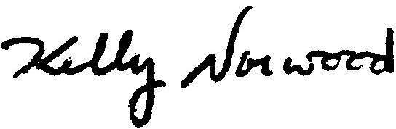 The above rate is subject to the provisions of Tax Adjustment Schedule 58.