

January 19, 2010

David Danner

Executive Director and Secretary

1300 S. Evergreen Park Dr. S.W.

P.O. Box 47250

Olympia, Washington 98504-7250

ATTENTION: Cathy Kern

Re: Advice No. 3662T Replacement No. 1 – Docket UT-100097 –

**Do Not Redocket**

Dear Mr. Danner:

On January 15, 2010, Qwest Corporation filed Advice 3662T, a tariff filing to modify Section 9.2.1 by designating Universal Emergency Number Service–911 (UENS911) as an ONA Basic Service Element (BSE). This replacement filing provides 3rd Revised Sheet No. 78.1 which was inadvertently omitted from our original filing.

If you have questions concerning this filing, please contact Robin Terry on (303) 383‑6753.

Sincerely,

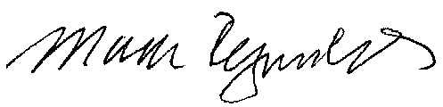

Mark Reynolds

Attachments

Attachment A

Advice No. 3662T

**EXCHANGE AND NETWORK SERVICES**

**WN U-40**

|  |  |  |
| --- | --- | --- |
| **SECTION** | **SHEET** | **REVISION** |
| 9 | 78.1 | 3rd |
|  |  |  |