June 16, 2014

Steven V. King, Executive Director and Secretary
Utilities and Transportation Commission
1300 S. Evergreen Park Dr. SW
P.O. Box 47250
Olympia, WA 98504-7250

RE: Washington Utilities and Transportation Commission v. Aladin Coachlines, Inc.

Commission Staff’s Response to Application for Mitigation of Penalties TE-141048

Dear Mr. King:

On May 23, 2014, the Utilities and Transportation Commission issued a $1,000 Penalty Assessment in Docket TE-141048 against Aladin Coachlines, Inc. for 10 violations of Washington Administrative Code (WAC) 480-30-071, which requires charter and excursion carriers to furnish annual reports to the commission no later than May 1 each year.¹

On June 5, 2014, Aladin Coachlines, Inc. wrote the commission requesting mitigation of penalties (Mitigation Request).² In its Mitigation Request, Aladin Coachlines, Inc. does not dispute that the violation occurred. The company states, “I thought I had until May 15, 2014. I can assure you that this will never happen again. I am hoping that the UTC will excuse my filing timing ignorance this time and waive or reduce any penalties PLEASE.”

It is the company’s responsibility to ensure that the regulatory fee is paid and the annual report is filed by the May 1 deadline. On February 28, 2014, Annual Report packets were mailed to all regulated charter and excursion companies. The instructions for annual report completion page of the annual report informed the regulated company that it must complete the annual report form, pay the regulatory fees, and return the materials by May 1, 2014, to avoid enforcement action.

On May 30, 2014, Aladin Coachlines, Inc. filed the 2013 annual report and timely paid the required regulatory fees on December 30, 2013. The company has been active since March 31, 2006. No previous violations of WAC 480-30-071 are on commission record. The UTC also

UTC Annual Reports
June 16, 2014
Page 2

recently adopted new rules requiring the annual report to be filed by May 1 while the regulatory fees remained due on December 31. Despite the commission communication regarding these
filing changes to all regulated charter and excursion companies, commission staff supports the company’s request for mitigation. Staff recommends a reduced penalty assessment of $200.

If you have any questions regarding this recommendation, please contact Amy Andrews, Regulatory Analyst, at (360) 664-1157, or aandrews@utc.wa.gov.

Sincerely,

Sondra Walsh, Director
Administrative Services

ATTACHMENT A
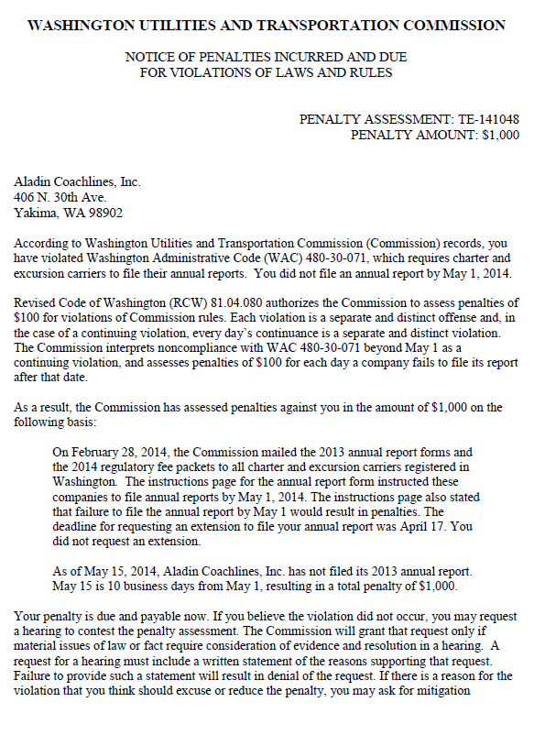

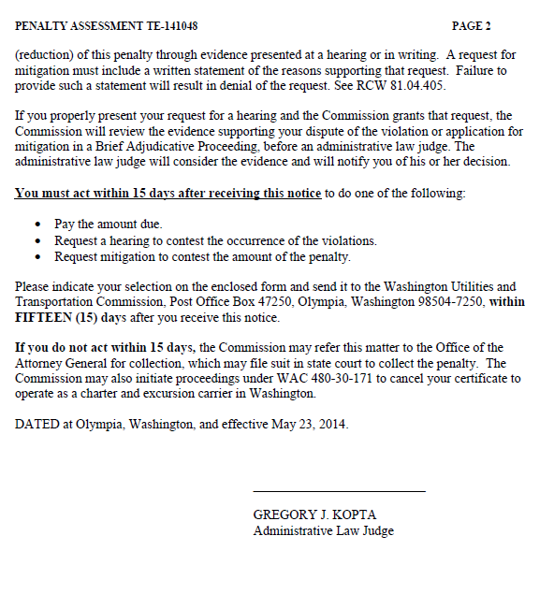

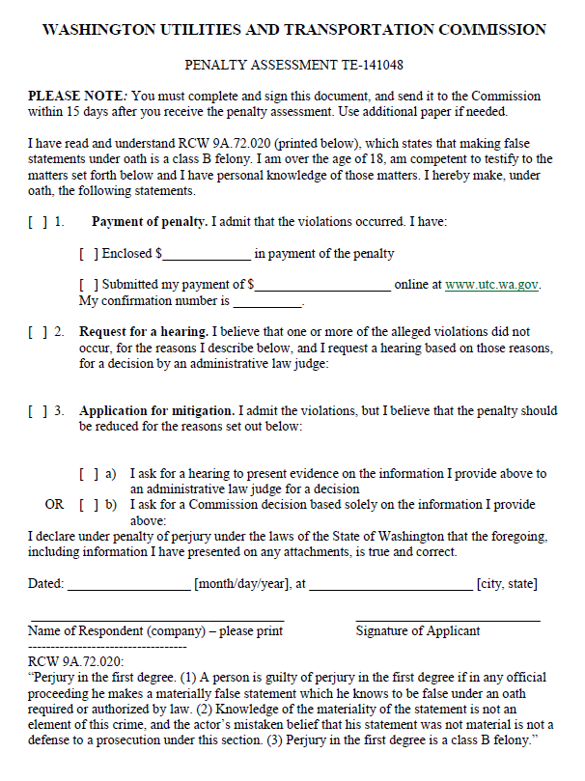

ATTACHMENT B
