 February 15, 2016

Docket UE-141170 (Electric) and UG-141169 (Gas)

To: Washington Utilities and Transportation Commission

**RE:** Sierra Club Comments on 2015 Integrated Resource Plan

Dear Commissioners:

Sierra Club provides the following comments based on Puget Sound Energy’s (“PSE”) Draft 2015 Integrated Resourced Plan (“Draft IRP”). As you know, Sierra Club has participated extensively throughout the 2015 IRP process, and has done so since 2009. Nationally, the Sierra Club’s Beyond Coal campaign advocates for the transition off fossil fuel sources through the development of energy conservation and renewable energy policies. Sierra Club’s work includes advocating for the implementation of robust incentive programs that assist its members and utility consumers to generate their own renewable energy and increase energy efficiency. We appreciate the work that both PSE staff and UTC staff have committed during this process.

In general, we find that PSE made some significant changes to methodology this year, switching to a new standard for analyzing the value of blackouts and brownouts. This IRP is very heavy on new natural gas for both the electric book and gas book, which seems out of step with regional planning. We note that PSE is gearing up to have a more elaborate discussion around customer solar installations. However, they are starting with a projection for solar demand that is undeservingly off-base, while also raising an incorrect concern about the amount of solar they can support. We are encouraged to see PSE’s adoption of demand response as a resource alternative in this IRP. Finally, it is time for PSE to revisit electric vehicle projections and loads.

Unlike the prior 2013 IRP, PSE did not to provide a detailed look at Colstrip in this IRP. PSE also has not initiated the administrative hearing to address Colstrip that the UTC contemplated in its acknowledgement of the 2013 IRP, and in fact, PSE opposed a petition from the Sierra Club and other interested parties to initiate such a proceeding. The economic future of Colstrip, especially for Units 1 and 2, is precarious and future capital expenditures may not be prudent. The plant continues to harm the environment, and PSE’s continued ownership and capital expenditures are wasting ratepayer money and creating substantial liabilities. PSE’s co-owners in Units 1 and 2 are under financial distress, and several media outlets have speculated that the plant may close in the near future. PSE has not provided any information through this IRP to the UTC or the public about its plans to transition away from Colstrip. This deficiency must be corrected. Sierra Club reiterates its request to the UTC to require PSE to engage in a full accounting of the costs and risks related to its ongoing reliance on Colstrip.

Beyond concerns over process and calculations, the IRP document fails to provide a better vision of the future and how PSE can meet that future. For example, the Northwest Power and Conservation Council has provided a very compelling vision for meeting load growth without new gas plants, and how we can most cost effectively reduce carbon by retiring our remaining coal plants. Instead, PSE provides reason why it, as an individual utility, cannot meet these goals. PSE needs to provide stronger leadership on these matters. Instead of proving why it cannot meet these regional goals, it needs to provide a clear road map of its role in helping the region meet the challenge. Perhaps we need to move away from our very balkanized system of multiple Balancing Authorities toward a more integrated and efficient grid. Or perhaps rather than showing why bringing in more diverse wind resources from Montana appears cost-prohibitive, instead PSE can lay out the pathway for its role in knocking down these transmission barriers. This is the type of broader vision and leadership that PSE customers have come to expect from PSE.

**Good Improvements in 2015’s IRP**

1. **Demand Response & the Third Industrial Revolution**

We are enthusiastic about PSE’s recommendation to include demand response measures in this IRP, including control of distributed customer-owned devices (space heaters & water heaters) as well as critical peak pricing.

However, if you look at the amount of Demand Response resources that PSE expects to acquire, this grows at a fast pace then tapers off suddenly to only 2 MW/year around 2025. We do not understand this drop. Author Jeremy Rifkin (who helped shape the European Union’s climate and energy policy) proposes we are on the cusp of a Third Industrial Revolution, where electricity flows are becoming primarily distributed and demand will be partially intermediated by information & communication services based on price and availability of power[1]. The five pillars of the Third Industrial Revolution are:

1. Shifting to renewable energy
2. Transforming the building stock of every continent into green micro-power plants to collect renewable energies on-site
3. Deploying hydrogen and other storage technologies in every building and throughout the infrastructure to store intermittent energies
4. Using Internet technology to transform the power grid of every continent into an energy internet that acts just like the Internet (when millions of buildings are generating a small amount of renewable energy locally, on-site, they can sell surplus green electricity back to the grid and share it with their continental neighbors)
5. Transitioning the transport fleet to electric plug-in and fuel cell vehicles that can buy and sell green electricity on a smart, continental, interactive power grid.

Further, Rifkin believes that the big issue for every company in the next twenty years will not be labor cost, but the energy cost embedded in their products, supply chain and logistics. If this view of the world is anywhere close to reality, then PSE, government, and regulators must think bigger. Utilities need to adopt renewable generation aggressively, harden the distribution grid to support lateral energy flows, and dramatically increase their demand response capabilities over the next two decades.

1. **Modeling Demand Flexibility**

We believe that the long-talked-about smart grid is close at hand. PSE did model shifting loads using programmable hot water heaters, as the BPA is doing today. This is a great start towards building a better, smarter electric grid. Furthermore, electric vehicles offer opportunities. Specifically, Tesla’s Chief Technical Officer JB Straubel is looking at building a dispatchable EV charge aggregation service for Tesla’s automobiles, focusing on shifting load to different times to optimize for the transmission system, based on an understanding of California ISO’s duck curve[2]. Other auto manufacturers or third parties may provide a similar service. The goal is to spread out the rate of charging from a sudden spike during peak times to a reduced increase in load spread throughout the night. Shifting load to off-peak hours ensures EV’s do not increase peak loads. This avoids building power plants, allows power arbitrage within the night, and allows dispatching load to match the availability of intermittent renewable resources to reduce emissions. A service like this keeps EV charging both green and cheap.

Our projections for the number of EV’s in PSE’s service territory in 2020 is approximately 8,000 Tesla vehicles and 9,000 Nissan Leafs, with other connected EV’s and plug-in hybrids from Ford, GM & others adding about another 7,000 cars. That’s about 24,000 cars. These cars add up to almost 200 MW of load, if they were all charging at the same time. Those vehicles could be charged beneficially at off-peak hours spread throughout the night or all at once during the evening peak. The peak capacity impact depends on incentives that drive customer behavior & the availability of smart software solutions. Currently the default charging scenario for PSE customers is the pessimal strategy for the utility – customers plug in their car when arriving home, *with* *no knowledge that an evening peak exists*, let alone that their behavior may drive up costs or require dispatching a peaker. Further, customers willing to acquire expensive EV’s may prove to be price-insensitive, rendering the utility powerless to alter customer behavior through time-of-use rate structures or dynamic demand charges. That may force PSE to build one additional natural gas plant ***before*** 2020, permitting and building it within 46 months. A solution seems necessary.

Beyond just the transmission grid, computer scientists with a mindset focused on networks are applying their thinking to the distribution grid as well. Future Demand Flexibility projects (like the above idea) could allow delaying or preventing distribution grid upgrades.

We hope PSE will consider the economics of such demand response and demand flexibility approaches. The Rocky Mountain Institute wrote a report characterizing Demand Flexibility[3] and the economic value of “flexiwatts”. RMI analyzed the value to both the grid and customers for peak capacity reduction, energy need, and renewable energy integration. Utilities should think of Demand Flexibility as a new resource type and incorporate it into the future design and grid architecture. We hope to see this and many other possibilities included in any future demand response RFP’s.

1. **Firm Pipeline Capacity**

We appreciate PSE’s efforts to explain pipeline constraints and secure pipeline capacity to meet projected load growth for both its electric and natural gas customers. This was a tricky area new to us, and an introduction with long lead time was beneficial. The Sierra Club is philosophically opposed to the methanol plant proposals because they will contribute to additional fracking, with its associated water pollution and climate change concerns. Yet we appreciate being apprised that a PSE LNG storage facility is tied up with the Tacoma plant proposal.

1. **Openness to new ideas**

In the 2015 IRP, PSE took a long view at new technologies that will soon shape their field, specifically batteries for energy storage. This was an educational approach, and provided a good view to all IRP stakeholders on roughly how close grid-scale batteries would affect utility economics in the Pacific Northwest. We hope PSE continues this forward look in future IRP’s, and adds in an analysis for batteries added on the customer’s side of the meter (such as the Tesla PowerWall and PowerPack). Two-way energy flows between consumers, or from consumer to utility, must be factored in.

Many new energy solutions are showing up every year, providing ways to store energy or reduce energy demand. The UTC should encourage pilot projects and creative thinking about PSE’s fossil fuel dependency.

**Areas for Improvement**

1. **Changing Math Mid-IRP (swapping EUE for LoLP)**

The most obvious problem with this IRP is that it was very late. The draft form was of the IRP was not available until September, with about one third of the content missing. By the time PSE released the final IRP in December, PSE changed their math again. It makes it harder to evaluate the IRP. The main problem was changing the planning standard mid-IRP from Loss of Load Probability to Expected Unserved Energy. This change may provide a better value to PSE’s customers, but also was a very large change to bring up late in the game. Given that PSE has unresolved concerns about the firmness of the natural gas capacity to the Grays Harbor plant and the region’s availability of power, this was a disruptive process change. In addition, PSE discovered a significant disagreement about the firmness of natural gas pipeline capacity, forcing a 450 MW revision in their target LOLP numbers from the draft IRP to the final IRP.

PSE also increased Colstrip’s projected availability from the draft IRP, inexplicably. Looking at Figure 6-8 which shows Colstrip with an 88% reliability rating when Figure 6-6 shows Colstrip with a 90% reliability rating seems like an error. Colstrip’s track record isn’t great either. Our understanding is that Unit 4 had two prolonged service outages during the past five years.

The end result of changing to EUE is building one or two extra natural gas plants by 2035. Comparing Figure 6-17 and 6-18 shows scenarios requiring between 228 MW and almost 500 MW of new natural gas plants, sometimes with less demand response, conservation measures and without an energy storage system. While PSE’s analysis may have concluded that this change is in the ratepayers’ best interests, that conclusion is premature because the new framework is not understood well enough by PSE itself nor IRP Advisory Group stakeholders. There are too many moving parts. We also do not see why PSE shifted to new math near the end of the IRP. This is out of sync with the NWPCC’s processes. It should raise eyebrows, though it may provide better value to ratepayers.

We ask the UTC to ensure that utility return on capital is well aligned with allowing utilities to choose their own planning standards. There are two important questions. How many power outages are caused by generation and transmission shortfalls, vs. distribution grid failures and downed transmission lines? Secondly, note that some ratepayers already purchase backup generators and uninterruptible power supplies for their facilities. Should PSE’s analysis cap the value of lost load at a lower rate?

The new “2015 optimal planning standard” means building new power plants to provide more reliable power, at a higher cost to ratepayers. We hope that future cost recoveries are commensurate with the ratepayers who accrue the most value from the EUE changes. Specifically, the costs should be borne by large industrial customers who benefit the most from avoiding work disruption, employees going home early, and potential equipment damage.

1. **Social Cost of Carbon Must Affect Dispatch**

Previous IRP’s studied a full social cost of carbon based on US government technical reports. PSE excluded social cost from this IRP in favor of looking only at a carbon price. If Washington State is serious about curbing the catastrophic effects of climate change, at a bare minimum building new power plants must be held to the full social cost of carbon to comply with Washington’s IRP law.

Critically, dispatch and continued operation of existing plants must also be included. Sierra Club believes the State requires Integrated Resource Plans for a reason. The State could not have intended for utilities to do math then throw away the results. Instead, this analysis should inform the construction, operation and dispatch of both new *and existing* power plants. This is how PSE complies with the intent of the IRP law, to capture the costs and risks of carbon dioxide. Affecting dispatch must happen regardless of whether the state imposes a carbon price. That is how we mitigate the costs & risks of carbon dioxide in the existing fleet of power plants, not by doing math and throwing it away.

Power plant dispatch can and should be governed by a social cost of carbon, regardless of whether the carbon price is assessed and money changes hands. This may be the easiest operational way to cope with different state & province carbon pricing mechanisms such as a carbon tax or a carbon cap and trade system. We ask the UTC to propose including a social cost of carbon in the dispatch rules for all power plants operating in the WECC.

1. **No Engagement on Long Term Climate Forecasts**

We all know globally temperatures are changing, but PSE didn’t include this in their IRP. An open issue in IRP Advisory Group meetings has been the predictive value of PSE’s weather forecasts. While weather is a tricky issue to predict, there has not been an attempt to see if the weather over the past two decades differs significantly from previous weather observed in our region. But PSE has not, to our knowledge, engaged with experts like the University of Washington’s Climate Impacts Group. Recently the Climate Impacts Group published their findings:

Hydropower production is projected to reflect the seasonal changes in streamflow: increases in the winter, and decreases in summer. Estimating the specific effects on hydropower systems is challenging, given the relatively rapid changes in demand, energy markets, and regulation. For the Skagit watershed, hydropower production is projected to increase in winter and spring and decrease in summer, though there is debate about the exact amount of change, given the large influence of reservoir management. In the Columbia River Basin, an important source of power for much of Puget Sound, hydropower production is projected to increase by +5% in winter (January-March) and decrease by -12% to -15% in summer (July-September) by the 2040s. … These declines could translate into an inability to meet summer power demands with hydropower alone – this would require energy suppliers to seek other energy sources, possibly at higher cost.[4]

Beyond hydropower changes, temperature and therefore average load is changing. Specifically, the following graph shows global temperature changes[5] and strongly suggests we should look for regional changes when computing the average and peak heating degree loads.

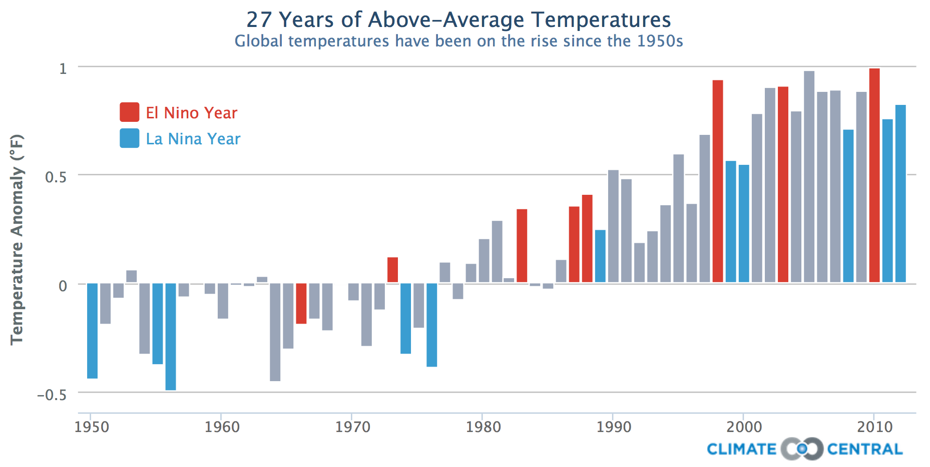

This global temperature change suggests we should look for local temperature changes in Puget Sound. The Climate Impacts Group’s State of Knowledge report shows Puget Sound has experienced a gradual increase in average annual temperature of 1.3**°**F over the past 115 years:



**Figure ES-1. The Puget Sound region warmed by +1.3°F from 1895 to 2014.** The red line shows average annual temperature for the Puget Sound Lowlands climate division, the horizontal black line corresponds to the average temperature for 1950-1999 (50.3**°**F), and the dashed red line is the estimated trend.[6]

Further, one might then wonder what sort of warming trend we might expect in the future. Again, UW’s Climate Impacts Group provides a scientific forecast on page 3 of their executive summary:



Figure ES-2: The Puget Sound region is projected to warm considerably in the 21st century. The graph shows average annual air temperatures projected by climate models, relative to the average for 1950-1999 (horizontal gray line; the average annual temperature for the Puget Sound region is 44**°**F). Thin colored lines show individual climate model projections; thick colored lines show the averages of the models. Data source: Downscaled climate projections developed by Abatzoglou and Brown 2011.[7]

PSE’s Integrated Resource Plan does not consider these current trends that forecast changes in both temperature and hydropower. This means PSE’s IRP is not accounting for possible changes in load and Mid-Columbia power availability and price. There might be reasons to expect higher volatility (and thus need additional winter and possibly even summer peaking capacity), but the average temperature data suggests a lower *average* energy need for the winter, by decreasing heating degree days. PSE could have known this, but didn’t ask the climatologists. While this particular report is “hot off the presses” by utility planning standards, regionally appropriate data like this must be incorporated into future IRP’s from PSE and all Washington state utilities.

While IRP participants repeatedly asked PSE to include forecasted changes from climate change and hydropower changes at multiple IRP Advisory Group meetings and Technical Advisory Group meetings, PSE did not engage with regional climate experts from the University of Washington or Oregon State University to provide an answer. Staff from the Bonneville Power Administration was willing to explore this topic, and clearly the University of Washington was busy producing long-term climate forecasts for core parts of PSE’s service territory. However, PSE had no follow through. Understanding these trends would reduce risk for the region and may well reduce PSE’s resource build by one power plant based on temperature changes. In the 2017 IRP, we implore PSE to do a better job of reaching out to regionally recognized experts. Instead, PSE left a possible tool to help reduce risk off the table.

A 1 or 2 degree difference in average temperature may not sound like much, but this translates into a ~2-3% difference in heating degree days. Further, if climatologists show a 15 degree increase in our coldest daily temperatures over the past century but PSE is modelling the climate using older data, that could reduce heating degree days far more substantially. Sierra Club extrapolates that Colstrip units 1 and 2 were barely economic to dispatch, with benefits exceeding realized costs by about 2% in the 2013 IRP (PSE refused to break out costs on a per unit basis). This very thin margin means a more accurate temperature forecast is incredibly important for predicting load accurately, lowering risks to ratepayers, and ensuring utilities do not over-build capacity or carry unnecessary capacity.

On November 18th 2015, Sierra Club asked the NWPCC to provide assistance with understanding the weather forecasts and hydrological impact of climate change in the region. Council members took extensive notes on our concerns and Council member Karier promised to follow up with Council’s staff.

1. **What about Colstrip?**

The 2013 IRP suggested that Colstrip units 1 and 2 were almost uneconomical **today** with reasonable assumptions about environmental liabilities with the plant, and that Colstrip units 3 and 4 become uneconomic under certain scenarios as early as 2027. Some scenarios even suggested shutting down units 1 and 2 in 2017. While PSE did not do a detailed look at Colstrip in this IRP, we do recognize the value of looking at replacement resources for Colstrip’s power, and appreciate the thought afforded to Montana wind. We also recognize that shutting down Colstrip may require unwinding complex ownership structures, which requires actions and approvals outside the context of this IRP.

However, while the ultimate timing of Colstrip’s closure and replacement will be resolved outside of the current IRP process, this IRP is fundamentally flawed because PSE failed to even attempt to plan for the very likely scenario that Colstrip will not be a part of PSE’s resource mix in the near future. This IRP only considered shutting down Colstrip units 1 and 2 in the year 2026, when previous results pointed to a date of around 2023, and earlier if higher pollution costs are accrued by this plant. This IRP was under-powered by design, and provides no further certainty to when this coal plant will drop out of Puget Sound Energy’s fuel mix. Further, we do not know how much ratepayers will pay to clean up Colstrip’s leaking toxic coal ash ponds.

By avoiding a meaningful Colstrip analysis, PSE also was able to avoid the mounting economic pressure on its co-owner of Units 1 and 2, Talen Energy. As detailed in the report[8] by the Institute for Energy Economics and Financial Analysis (IEEFA), Talen may well be losing money already on its Colstrip assets. Talen previously attempted to sell its share of Colstrip and its Corette coal plant in Billings (175MW) to another Colstrip owner NorthWestern Energy and they ascribed a negative value to Colstrip. The economic pressures on Talen, as documented by IEEFA, were increasing production costs (averaging 7 percent increase for each of the last 11 years), low gas prices, loss of their hydropower units which they bundled with the expensive Colstrip coal to lower their costs, and Talen’s expiring power purchase agreements. These traditional economic pressures – in addition to all of the mounting environmental liabilities – have create a partnership in Units 1 and 2 that leave PSE in a substantially weakened position to maintain the economic viability of these units.

We know that PSE said that a deep Colstrip analysis was to be done in a separate Colstrip proceeding as recommended by the UTC in your acknowledgment letter for the 2013 IRP. But upon repeated requests for this Colstrip proceeding, PSE said no. Then when the Sierra Club and allies finally petitioned for this proceeding, PSE filed its motion to dismiss the petition. PSE cannot have it both ways. A full accounting of Colstrip costs should not be further delayed.

There is a social justice problem demanding a solution as well. Colstrip is an ongoing and increasingly growing environmental catastrophe. The ranchers living near Colstrip are threatened by potentially not being able to use their own groundwater for either humans or cattle. The town of Colstrip Montana must import drinking water from far away because its own groundwater is unfit to drink. The residents in the town are also tied to the power plant as a source of income and tax base. When the power plant shuts down, there must be a coordinated effort by PSE and other owners to help this community in transition. PSE cannot simply pretend the problem is not there and ignore its moral responsibilities and economic liabilities. We need to provide a clear and long-term transition plan for the future.

We believe it is time for an adjudicated proceeding before the UTC on Colstrip’s economics, as the UTC recommended in their comments on PSE’s 2013 IRP. A true cost accounting of the plant’s water pollution, air pollution and carbon pollution will strongly point to a much earlier shutdown, especially for units 1 and 2. PSE should not see this as a hostile act, but as an attempt to protect PSE’s bottom line by ensuring that any expenditures on Colstrip are prudent before PSE spends the capital. This is to provide certainty to ratepayers, PSE, and residents of Colstrip, Montana. We have been consistently clear with our public and private messaging that our desire is not to harm PSE, but to assist PSE in altering its fuel mix very rapidly.

1. **Peakers vs. Combined Cycle**

A continuing theme from the last three IRP’s is confusion over when to build a natural gas peaker vs. a combined cycle plant. We understand a peaker is useful for flexibility, but why would PSE need more than one peaker? The IRP doesn’t articulate what kind of intra-day ramp rate is necessary to serve its peak loads. Perhaps PSE could get by with owning just one peaker, then using CCCT’s or wind for the rest of its gas needs. Between the last several IRP’s, the variance in predictions seems to be much more than what can easily be explained via capital costs. For instance, consider the Colstrip replacement sensitivities from the IRP:

* When Colstrip Units 1 & 2 are retired in 2026, one additional frame peaker is added to

replace the lost capacity (228 MW). Also, 300 MW of wind in Montana is added on top of the

300 MW of Washington wind for the RPS. The Montana wind plants become cost effective

with the lower capital cost for transmission upgrades and the 55 percent capacity credit. [..snip..]

* When all 4 units are retired in 2026, two CCCT units (385 MW each) and one frame peaker

are added to replace capacity and meet growing demand instead of two frame peakers,

along with an additional 300 MW of Montana wind. *The CCCT plants become cost effective*

*when retirements increase market prices, especially the spread between gas prices and power prices.*[9]

Figure 6-28 shows a Mid-C power price difference of approximately $2/MWh between retiring units 1 and 2 vs. all of Colstrip, or about 3%. If some scenarios build CCCT’s, the assumption is they will operate as baseload power. If we assume continuous load growth, it is very hard to understand how a peaker would not be operated as baseload power, if not initially then several years after construction. While PSE’s IRP team seems to recognize that a mix of peakers and CCCT’s is best, the gyrations back and forth between them alternating in every IRP suggests either the costs are nearly identical, or PSE may not be assessing lifetime risks (not costs) adequately.

We suggest that to resolve this knife’s edge price difference, more emphasis be given to the risk of carbon emissions and a future carbon price. In the alternative, PSE’s projections of 3 to 5 methanol plants coming online should give pause to PSE’s gas price forecasts, and suggest a high gas price is more likely. CCCT should provide ratepayers a better value in the future. We are not alone in this assessment. The Northwest Power & Conservation Council’s draft 7th Power Plan recommends replacing retiring coal plants by running *existing* natural gas plants more frequently:

The Council’s modeling found that without additional carbon control policies, carbon dioxide emissions from the Northwest power system are forecast to decrease from about 55 million metric tons in 2015 to around 34 million metric tons in 2035, the result of retiring the Centralia, Boardman, and North Valmy coal plants by 2026; using existing natural gas-fired generation to replace them; and developing about 4,500 average megawatts of energy efficiency by 2035, which should meet all forecast load growth over that time frame.[10]

This strongly suggests PSE should acquire plants that could be run much more frequently. We prefer conservation, load shifting, and energy storage (via batteries, pumped hydro, compressed air, and HVAC ice storage) to new power plants. However, in the unlikely event that demand reduction is insufficient, then we must assume a high carbon price in the future. In this non-preferred world, we believe this risk reduction justifies the higher up front capital cost of CCCT plants over peakers.

1. **Inadequate and Incorrect Solar PV Adoption Projections**

Appendix M contains Cadmus’s PV Technical and Market Potential report, and paints a dark picture of a slow solar adoption rate. Cadmus projects 309 MW of customer solar added to the grid between now and 2035. That corresponds with approximately 15 MW/year between now and then. This number is low. While focusing on the solar Investment Tax Credit (ITC) expiration, it does not adequately capture the current market price of solar installations, the cost reductions coming in solar, nor the growth in utility electric rates. And as of December 2015, the solar ITC has been extended by Congress for 5 years, further rendering Cadmus’ projections out of sync with reality.

Cadmus’s projected PV installation cost is incorrect. Figure 1 (Appendix M, Cadmus report, page 7) shows 2015 installation costs of around $4/W for commercial and $4.50/W for residential. These numbers are higher than prevailing market rates by between 22% and 53%! We have seen quotes from Washington State solar installers from the summer of 2015 in the range of $2.35/W for a large industrial project to $2.94 - $3.65 for residential systems around 8 KW. The reasonableness of these prices is easily verifiable by looking on WholesaleSolar.com, where you can see turnkey bundles of solar modules, inverters & equipment sold to installers for $1.63/W for an 8 KW system[11]. Solar installers then add their costs and margin, based on market conditions and the status of the Washington state solar incentive. On the utility scale side, analysts are also projecting SunEdison will sell solar projects in 2016 for $2.03/W, with a margin of $0.35/W (implying utility scale solar costs of about $1.68/W for material and construction), while SunPower obtained a FY 2015 average sales price of $2.17/W with a higher gross margin around 24%.[12]

Solar PV modules are falling in price at about 10%/year. While balance-of-system costs are not dropping as fast consistently, significant progress is being made. Innovations keep coming in terms of better racking systems with shorter installation time, as well as micro-inverters. SolarCity also cited increased solar module efficiency as a cost reduction, but not by providing cheaper modules. Instead, the more efficient modules will reduce balance-of-system costs by 10%. Cadmus assumes an annual decrease in total system cost of 2.9% for residential and 2.2% commercial (Appendix M, Cadmus Report page 6), but then follows up by saying that “it is likely that installed costs will fall faster than predicted, which would result in a correspondingly higher market potential”. This certainly came true by 2015, and the economics point to continued R&D to further reduce this cost. Continued gains in module efficiency, other technological changes to balance-of-system components, and competition are likely to continue to squeeze costs for solar systems for some time to come.

In addition, the Cadmus report is using a low growth rate for electric costs for both residential & commercial. PSE doesn’t clearly state how much utility costs will grow for customers, but you can make some extrapolations based on Figure 6-28. That figure shows Mid-C prices growing at approximately 4.5%/year. Residential electric costs will probably grow at the same amount. Cadmus is analyzing solar by comparing it with a 3% increase in residential electric rates (see Appendix M, in the Cadmus report in the second half of the appendix page 5, Table 6, “Utility Rate Escalation”). For industrial customers, Cadmus uses 2.5% (see Table 8). We suspect this growth should be closer to the growth in Mid-Columbia prices. Over 20 years, this is an error of about 25% in the cost of residential electric rates.

The Washington State legislature is also considering extending the Washington solar incentive by raising the cap on the state utility tax, to about 2% of the utility tax, at a lower rate. This would further expand the solar industry, and support our Washington solar module and inverter manufacturers. While this has not been passed out of committee yet, there’s a reasonable chance of some action here to support local jobs. Cadmus couldn’t have predicted this policy change, but it raises further doubt about their report.

For a real-world check on Cadmus’s projected 15 MW/yr installation rate, note that Itek Energy produced just shy of 24 MW of solar in 2015. They account for about 97% of the solar installed in this state in many regions, and project Washington installed 24 MW of solar state-wide in 2015. That’s already 60% higher than Cadmus’s annual projection. For 2016, Itek projects producing 30-35 MW of solar modules, although their current run rate is 40 MW/yr[13]. Assuming no growth in solar installation rates, we’re already 2-2.5x higher than Cadmus’s projections for the next 20 years. Clearly policy changes like the ITC and PTC are important, but falling solar costs is the long term driver.

Cadmus’ solar PV costs are too high and don’t change over time in line with current trends. Congress’ solar ITC extension further paves the way for the expansion of the solar industry without a 2 year hiccup in growth, which Cadmus spent copious thought modelling. This report should be viewed as an insufficiently accurate floor on the amount of solar PV PSE’s customers will build. PSE must get a more accurate estimate for the next IRP where the prices reflect reasonable market rates and the report factors in appropriate rate increases for the utility’s customers. As to the current report, they should ask Cadmus for a revision.

1. **Solar Harmonics Concern**

During the course of this IRP, PSE was concerned about solar growth. They brought up an argument that an electrical phenomenon called harmonics could limit the amount of solar deployed on one circuit to something like 10-15% of the customers on that circuit. The Sierra Club contacted Philip Undercuffler, Director of Strategic Platforms for Outback Power Technologies. As you know, Outback Power makes inverters for solar systems, and their staff shared knowledge that resolves PSE’s concern. PSE did acknowledge this and dropped their attempt at doing a solar-limiting study from this IRP, though they may revisit that in the future. We are including Director Undercuffler’s comments here to ensure the UTC staff is versed on this non-issue, and is not surprised if another utility incorrectly raises the same concern in the future.

From Philip Undercuffler, Outback Power Technologies, July 23, 2015

I spoke with our engineering team, and have answers for you – the good news is this is a non-issue.  Decades ago, when the primary inverter used in grid-tie applications was the Trace SW inverter, it might have been a consideration because that inverter apparently did have an issue with 3rd & 5th order harmonics.  The standard for inverters (UL1741) was revised some many years ago to define requirements for harmonics to address those concerns, and to include testing to confirm inverters didn’t present issues with the grid.  At the time, the SW was pulled from the market until it could meet the new standard.

In terms of the utility’s concerns, today’s inverters are substantially different than those SW inverters from long ago, and the current standard ensures that inverters available meet all necessary requirements for harmonics.  In addition, that particular product hasn’t been available on the market for nearly a decade, and the vast majority of solar has been installed long after it was gone.

To the other concerns related to increased concentrations of PV, the grid supporting functions newly enabled in the updates to IEEE1547 and UL1741 really address the issues seen in Hawaii, and have been proven in regions such as Germany to allow instantaneous RE percentages to routinely exceed 50%, with installed capacity being even larger.

1. **No Pathway to Reduced Emissions**

In Paris during November 2015, world leaders agreed to national carbon reduction targets, “intended nationally determined contributions”. While these agreements are a great successor to the Kyoto Protocol, they are not sufficient to reach the internationally agreed goal of limiting climate change to 2**°**C. This suggests a future agreement will require even larger emissions reductions. As a reminder of the scale of the problem, we need a clear picture of where the world’s Paris commitments put us. The modest new pledges in the Paris agreement are not enough:

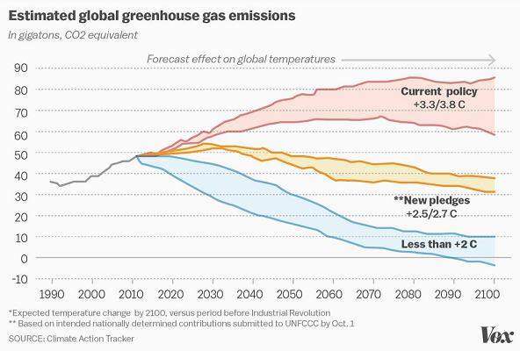[14]

The Northwest Power & Conservation Council’s 7th Power Plan draft lays out several paths for reducing carbon emissions. Moreover, the United States committed in Paris to curb the growth in carbon emissions substantially by 2030. Thought leaders are calling for a reduction of 80% of carbon emissions by 2050. However, PSE’s emissions only meet the Kyoto Protocol style standards in four out of ten scenarios. PSE’s recommended resource build is too dependent on natural gas. To inform regional policy makers, PSE must paint a picture of what it needs to meet these reductions. While PSE may be the utility most dependent on purchases, the Council appears to be recommending we use BPA power for local purposes once contracts expire.

The UTC should ask all of its regulated utilities how they are going to do their part to meet our share of the nation’s carbon emission reductions, such as the following modelled by the NWPCC[15]:

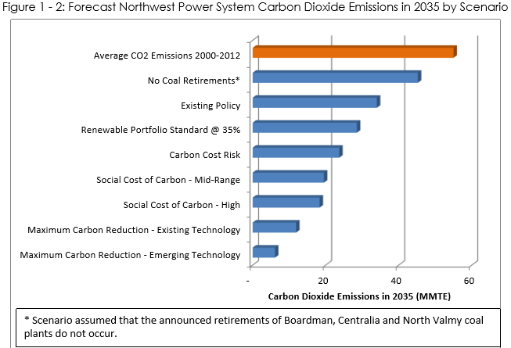

Similarly, King County’s Climate Action Plan calls for eliminating coal by 2025 and replacing it with clean energy. While in some scenarios PSE may retire their coal generation, their current projections are they would replace almost all of the power with natural gas. PSE’s resource plans are not aligned with international, national, regional, nor county level goals.

PSE does not offer ways to meet these emissions goals. PSE modelled the portfolio based on cost, then said how much it will emit. *Emissions goals must drive design of at least one scenario*, to show how close or how far off we are from obtaining the high-level policy goal of limiting catastrophic climate change. This additional scenario captures a future possibility that utilities may be compelled to operate under by future federal, state, and local policies. All utilities need to contemplate and model a policy-driven scenario to understand the costs and risks. The chance of this scenario happening may be low, but it would provide a measure of how much work *may* need to happen and on what time scale. The UTC should require this in all future IRP’s from all utilities.

PSE needs to provide a clear vision of how they will comply. Instead we’re left with the rather unsettling Figures 6-20 and the even more bleak 6-21:

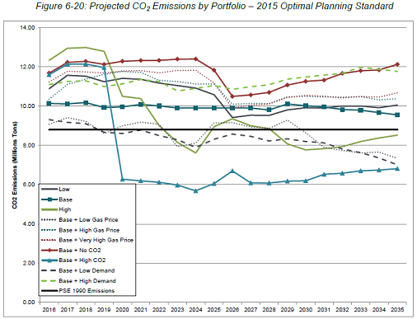

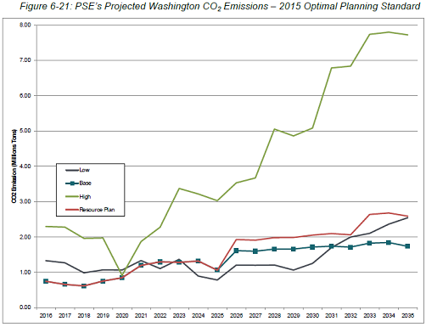

These figures clearly illustrate we need drastic action to reduce CO2 emissions, such as retiring coal and some natural gas plants. PSE does not produce the results that curb and reduce carbon emissions, nor to ensure worldwide temperature increases are constrained to 1.5 or 2 degrees Celsius.

1. **Disconnect from the 7th Power Plan**

The Northwest Power & Conservation Council’s 7th Power Plan draft says in 90% of scenarios, we don’t need to build any new power plants in this region, and suggests it’s possible to contemplate getting to zero carbon emissions by 2050. Yet PSE is proposing building several new gas plants, and treats emissions as an inevitable side effect of a portfolio shaped by costs. There’s a shockingly large disconnect between our regional planning and local planning. Previous similar disparities occurred when comparing the Northwest Energy Coalition’s Bright Future report with PSE’s plans. The 7th Power Plan is the latest very thorough report to suggest our days of building new natural gas plants may have already ended.

NextEra Energy’s CEO Jim Robo recently said that after 2020, there might never be another peaker plant built in the US – all the construction would be energy storage instead. To this end, NextEra Energy is investing $100M in batteries in 2016[16]. To their credit, PSE modelled batteries in this IRP, yet their work shows batteries are completely inconsequential to their energy future. One of these two utilities is working off wrong projections for battery costs and improvements. Note that PSE did not consider batteries installed on the customer side of the meter, where their benefits are measured at the retail rate instead of the wholesale rate.

While PSE is perhaps the utility most leveraged to the spot market in our region and has done a good job with investing in efficiency for years, it is very hard to understand how the regional top-level results differ so vastly from the local results. PSE’s IRP should include some breakdown of these discrepancies, so we can figure out how to diagnose and solve these problems. We hope PSE continues to refine their analysis of energy storage through regional pumped hydro, batteries, compressed air, HVAC ice storage, and other technologies.

Again, we expressed our concern about this disconnect to NWPCC on November 19th, with an assurance that Council staff will follow up on these issues.

1. **Electric Vehicles**

Previous IRP’s included sensitivities around electric vehicle uptake. That was missing from this IRP. Lithium ion battery prices are falling very quickly, and will soon allow EV’s to be priced for the masses. PSE is setting themselves up to be surprised by the following three graphs showing electric vehicles are starting a multi-decade exponential growth path:

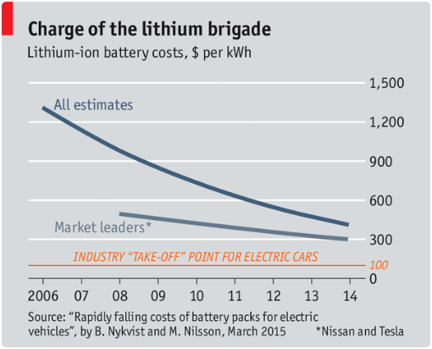[17]

This chart may be understating the case too. Estimates for Tesla’s battery cost range wildly, but are generally around $180-$245/kWh today and may fall to $90-$175/kWh once their Gigafactory ramps up production[18] [19]. Tesla’s CTO notes that lithium ion batteries get better by 7-8% every year. Coupled with building the world’s largest battery manufacturing plant and eliminating intermediaries and commodities market exposure from their supply chain, Tesla’s costs will fall much faster than that.

The following chart shows the economic value proposition for electric vehicles on costs alone, ignoring benefits from reduced pollution, reduced fossil fuel dependence, performance, charging convenience and coolness factors.

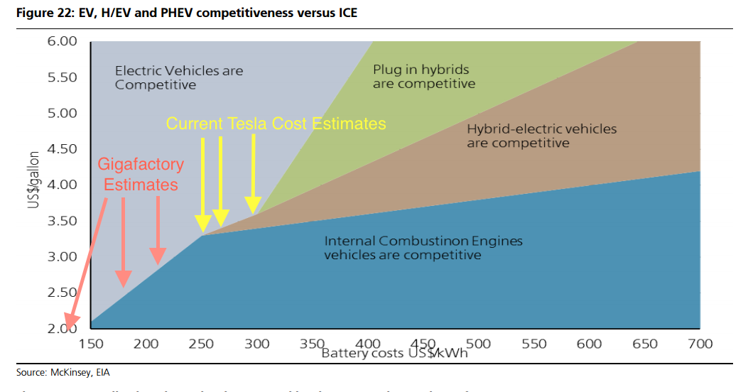[20]

Washington State provides vehicle registration data per model and county. Mapping that to PSE customer ownership, you can estimate how many battery electric vehicles and plug-in electric vehicles are in PSE’s service territory today. With a rudimentary analysis of EV sales projections, here is the projected growth in EV’s within PSE’s service territory over the next few years.

[21]

This represents a significant load increase, depending on when EV’s are charged. PSE should contact the Washington Department of Transportation for updated information on this impact on load.

**A Proposed Roadmap to a Coal-Free Future**

There are hints of a brighter future close at hand. PSE’s current approach to an IRP is via small incremental changes to its existing assets driven by load growth and costs. Nowhere does PSE start from carbon reduction policy goals and plan around that objective. What if PSE envisioned a coal-free future and projected how to get there? Imagine this:

* EV’s are charged off-peak in the most environmentally friendly, low-cost way.
  + Load growth is only driven by population growth, data centers, and indoor agriculture.
* Winter average energy need is lower due to updated climate forecasts. Any higher peak capacity need is purchased from WA utilities with excess hydro, managed with the BPA, and/or satisfied via reduced California power exports and/or imports.
  + PSE acquires ~250 MW of hydro contracts from other WA utilities that suffered reduced load. This allows early retirement of Colstrip units 1 and 2.
* Conservation efforts could keep up with this reduced load growth, keeping load constant.
* Regional utilities and the BPA build pumped hydro, providing intra-day energy storage and cheaper wind integration costs.
  + FERC lists three active pre-permits for pumped hydro in our state for 3.6 GW.[22]
* With the lower BPA wind integration cost, PSE could build another 600 MW of wind either in Montana (near Colstrip or Judith Gap) or in Washington.
* Itek Energy continues growing like crazy, manufacturing 100 MW per year around 2020, almost all installed within WA state. Of that, perhaps 25 MW per year is in PSE’s service territory. PSE gets 5 aMW added annually to its grid at no direct cost to the utility. Neighboring utilities also sell excess solar on the spot market or buy less power themselves.
* PSE implements time-of-use pricing, and creates a market for power arbitrage via behind-the-meter battery storage (like the Tesla PowerWall).
  + This further fuels solar growth as well.
  + Customers arbitrage power, keeping TOU rate spreads low & equitable.
  + Where possible, load shifting is handled via software instead of forcing customer education then conscious behavior changes.
  + Peak capacity requirements decrease, reducing the need for new power plants.
* Colstrip units 1 & 2 retire in Spring 2018, with units 3 & 4 following in 2023. PSE’s 2017 IRP shows replacement peak capacity is unnecessary, due to reduced load, acquired hydro, building 600 MW of wind & a 50 MW battery storage facility in 2023, and customer solar.
* Utility-scale solar prices fall 10% annually, becoming cost-competitive in Eastern WA in 2023. PSE builds 200 MW of solar at their Lower Snake River wind farm for both RECs and energy.
* PSE expands natural gas conservation activities & acquires firm pipeline capacity, but doesn’t pay for expanding gas pipelines.
* PSE refocuses from worrying about market reliance to focusing on distribution system upgrades, improving service reliability in a cost-effective manner with no new peakers.

This may be optimistic, and the numbers may not add up perfectly. But let’s think big. We can design what our future should look like, and work backwards to build that future. Puget Sound Energy could choose to model how to eliminate 100% of their electric carbon emissions by 2050. They could do this voluntarily now, or wait until international agreements or Washington’s carbon pricing ballot initiative force the issue.

**Conclusions**

In conclusion, there’s a lot to be improved upon in the 2017 IRP, often stemming from too much focus on one planning standard change to the exclusion of more creative analysis. PSE and all utilities must include a social cost of carbon in their daily power plant dispatch operations, and provide a credible path to lower emissions by 80% by the year 2050. They underestimate the impact of solar and electric vehicles.

Colstrip remains a primary concern. We must find a way to break the cycle of not confronting the full suite of risks to ratepayers. In order to ensure an orderly transition for PSE, customers and the Colstrip community, we must create certainty by examining the costs and then finally resolving whether continued ratepayer investment is justified. We urge the UTC to move forward with a Colstrip proceeding and the most logical next opportunity is the pending April 1, 2016 rate case.

Thanks for continuing to allow us to participate in this public process. We eagerly look towards shifting PSE’s fuel mix to become less carbon intensive, through retiring their coal plant, expanding renewable energy options, and investing in conservation, energy efficiency and demand response measures.

Brian Grunkemeyer

Energy Committee Chair

Washington State Chapter of the Sierra Club

1. Rifkin, Jeremy. *The Third Industrial Revolution: How Lateral Power is Transforming Energy, the Economy, and the World.* New York: Palgrave MacMillan, 2011. Print.
2. CA ISO duck curve facts, <http://www.caiso.com/Documents/FlexibleResourcesHelpRenewables_FastFacts.pdf>
3. “The Economics of Demand Flexibility: How ‘Flexiwatts’ Create Quantifiable Value for Customers and the Grid”, August 2015, Boulder. <http://www.rmi.org/electricity_demand_flexibility>
4. Mauger, G.S., J.H. Casola, A.K.Snover, et al., 2015. *State of Knowledge: Climate Change in Puget Sound* Climate Impacts Group, University of Washington, Seattle Doi:10.7915/CIG93777D <http://cses.washington.edu/picea/mauger/ps-sok/PS-SoK_2015.pdf>
5. http://www.realclimate.org/images/climcent_sat_enso.png
6. *State of Knowledge: Climate Change in Puget Sound* Climate Impacts Group, University of Washington <http://cses.washington.edu/picea/mauger/ps-sok/PS-SoK_2015.pdf>
7. *State of Knowledge: Climate Change in Puget Sound* Climate Impacts Group, University of Washington http://cses.washington.edu/picea/mauger/ps-sok/PS-SoK_2015.pdf
8. “A Bleak Future for Colstrip Units 1 and 2”, Institute for Energy Economics and Financial Analysis, June 2015. <http://ieefa.org/wp-content/uploads/2015/06/A-BLEAK-FUTURE-FOR-COLSTRIP-UNITS-1-AND-2.pdf>
9. PSE 2015 IRP, Chapter 6, page 52, edited for emphasis.
10. NWPCC 7th Power Plan draft, <https://www.nwcouncil.org/media/7149627/chapter01_summary.pdf>, page 1-3
11. WholesaleSolar.com prices for a 7.92 kW SolarEdge system w/ Suniva 330 W modules, as of November & December 2015. <https://www.wholesalesolar.com/grid-tie-packages>
12. “SunEdison Distressed Debt situation obfuscates high quality business model” http://seekingalpha.com/article/3808966-sunedison-distressed-debt-situation-obfuscates-high-quality-business-model
13. Itek Energy presentation by Dana Hickenbottom at Solar Washington’s January 2016 meeting, <http://solarwa.org/sites/default/files/files/itekPresentationGM2016_1_13.pptx>
14. “How to Think About the Paris Climate Deal”, Dec 2015. <http://rameznaam.com/2015/12/13/how-to-think-about-the-paris-climate-deal/?shared=email&msg=fail>
15. NWPCC 7th Power Plan draft, <https://www.nwcouncil.org/media/7149627/chapter01_summary.pdf>
16. “NextEra to invest 100 million in energy storage technology”, Sept 29, 2015 in Bloomberg <http://www.bloomberg.com/news/articles/2015-09-29/nextera-to-invest-100-million-in-energy-storage-technology>
17. The Economist newspaper, December 24 2015. <http://econ.st/1ZpdbrZ>
18. “How battery costs could plunge below $100/kWh” http://reneweconomy.com.au/2014/battery-storage-costs-plunge-below100kwh-19365
19. Model S Battery pack cost analysis, Tesla Motors Club. http://www.teslamotorsclub.com/showthread.php/17590-Model-S-Battery-Pack-Cost-Per-kWh-Estimate
20. “Importance of Tesla Superchargers, Battery Upgrades, & Electric Car Benefits”, CleanTechnica.com, Jan 2016, <http://cleantechnica.com/2016/01/24/importance-of-tesla-superchargers-battery-upgrades-electric-car-benefits-my-ev-summit-presentation/>
21. Sierra Club analysis, starting from June 2015 WA electric car registration by county and make, <http://www.westcoastgreenhighway.com/pdfs/PEVregistrationbycountybymake.pdf> and <http://www.westcoastgreenhighway.com/pdfs/Map_WAEVRegistrationByCounty.pdf>
22. FERC active pre-permits as of January 2016. Projects are Cold Creek Valley (2 GW), Cascade Pumped Storage (600 MW) and Banks Lake Pumped Storage (1 GW). <http://www.ferc.gov/industries/hydropower/gen-info/licensing/active-pre-permits.xls>