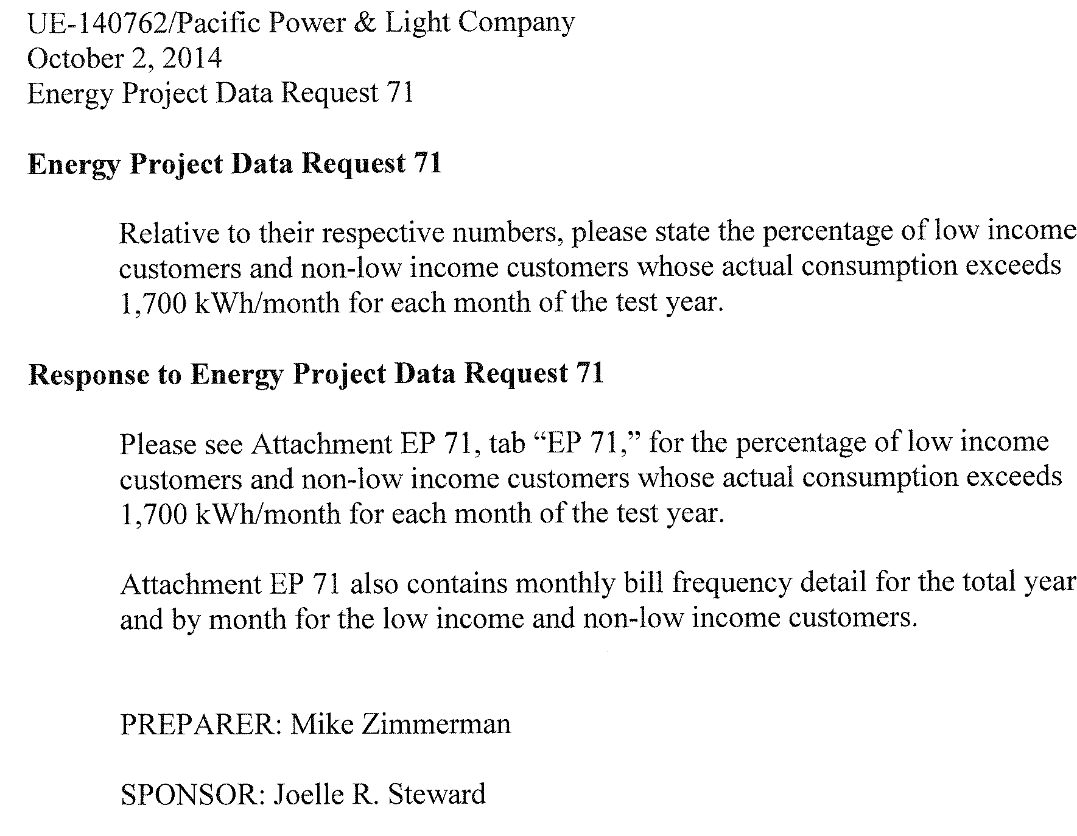

Tab “EP 71” provided below:

|  |  |  |  |
| --- | --- | --- | --- |
| % of Bills with Monthly Consumption over 1,700 kWh | | | |
|  |  |  |  |
| 2013 |  |  |  |
|  | Low-Income (Schedule 17) |  | Non Low-Income (Schedule 16) |
|  |  |
| Month |  |
| January | 63% |  | 51% |
| February | 53% |  | 42% |
| March | 36% |  | 29% |
| April | 15% |  | 14% |
| May | 7% |  | 9% |
| June | 4% |  | 8% |
| July | 9% |  | 17% |
| August | 12% |  | 22% |
| September | 8% |  | 16% |
| October | 5% |  | 8% |
| November | 19% |  | 18% |
| December | 62% |  | 50% |
| Total | 24% |  | 24% |