|  |  |
| --- | --- |
| **Avista Corp.**  1411 East Mission P.O. Box 3727  Spokane, Washington 99220-0500  Telephone 509-489-0500  Toll Free 800-727-9170 |  |

May 1, 2017

Steven V. King

Executive Director and Secretary

Washington Utilities & Transportation Commission

1300 S. Evergreen Park Drive S. W.

P.O. Box 47250

Olympia, Washington 98504-7250

Re: Docket No. UE-160082 – Avista Utilities Quarterly Report on Electric Vehicle Supply Equipment Pilot Program

Dear Mr. King,

On April 28, 2016 the Commission issued Order 01 in Docket UE-160882 approving Avista Corporation’s, dba Avista Utilities (Avista or Company) tariff Schedule 77 for its Electric Vehicle Supply Equipment (EVSE) Pilot Program (program). Within the Order the Commission required Avista to submit quarterly reports on the status of the program beginning on August 1, 2016 and ending on August 1, 2018. The quarterly reports must include the following:

1. For DC Fast Charging stations, Avista shall report the locations and utilization of stations, review and revise the DC fast charging rate, and assess the amount of overall fixed and variable costs recovered through user payments and report its findings to the Commission quarterly, beginning August 1, 2016.
2. For all other services offered under the Electric Vehicle Supply Equipment Pilot Program, Avista shall report participation levels, expenditures, and revenues for each service offered for the duration of the program. We expect the Company to collect and report additional data necessary to provide enough information to accurately evaluate the program’s success by August 1, 2018.

As described in Order 01 the effective date of tariff Schedule 77 was May 2, 2016. The term of the program began with the first residential EVSE installation on July 20, 2016. The following are updates on each element of the program.

Customer participation and feedback on the program remains positive. Many customers are engaged and continue to offer useful feedback and suggestions to improve the program. As of April 21, 2017, the number of applications and installations for the various EVSE categories are as follows:

**Table No. 1**

|  |  |  |  |  |  |
| --- | --- | --- | --- | --- | --- |
|  | **2-Year Goal of Port Installations** | **Applicants** | | **Installations** | |
|  | **Applicants** | **Approved** | **Scheduled** | **# Ports Installed** |
| **Residential SFH[1]** | 120 | 125 | 107 | 20 | 66 |
| **Workplace\Fleet\MUD[2]** | 100 | 104 | 57 | 18 | 19 |
| **Public** | 45 | 48 | 25 | 6 | 1 |
| **DCFC** | 7 | 5* | 2** | 1 | 1 |

*Sites identified

**Sites where site agreement has been signed to move ahead with construction.

Other high-level statistics on charging behaviors are shown in Table No. 2 below.

**Table No. 2**

|  |  |
| --- | --- |
| Daily Avg. No. of Charge Sessions | 61 |
| Daily Avg. kWh Consumed | 332 |
| Sessions Charged to Date | 7,637 |
| kWh Consumed to Date | 49,814 |
| Lbs of CO2 Saved to Date | 97,585 |
| Gallons of Gasoline Saved to Date | 4,981 |

**AC Level 2 Charging Stations – Residential and Commercial**

The EVSE deployed in residential settings continues to perform well. However, on occasion an EVSE may lose Wi-Fi communication signals and require a power reset, which may be carried out by the customer. More rarely, a few problems have occurred requiring a technician’s visit, such as swapping out a failed communications module, board reset, or full replacement of the EVSE. The Company will continue to evaluate the performance and reliability of EVSE deployed in the field, and consider deploying new EVSE that may become available in the market, provided satisfactory demonstration of required specifications, performance, and cost.

The following chart shows the status of residential applications and installations by categories of Battery Electric Vehicle (BEV) Commuter, BEV Non-Commuter, Plug-In Hybrid Electric (PHEV) Vehicle Commuter, and PHEV Non-Commuter.

**Chart No. 1**

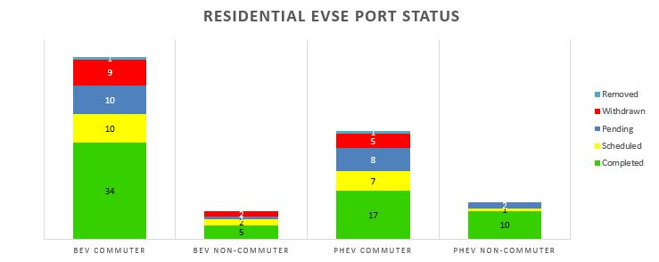

The Company has recently made outreach efforts to achieve greater program participation with residential customers, including bill inserts and engaging auto dealerships. Continued outreach is expected to be necessary through the remainder of the program’s installation period, in order to meet installation targets.

The chart below shows the residential installation cost components by job, ranging from a total of $452 to $3,721. Low costs correspond to installations where an adequate 240V AC circuit is already installed, with higher costs corresponding to a greater number of wall and floor penetrations, total circuit distance, and/or service upgrades.

**Chart No. 2**

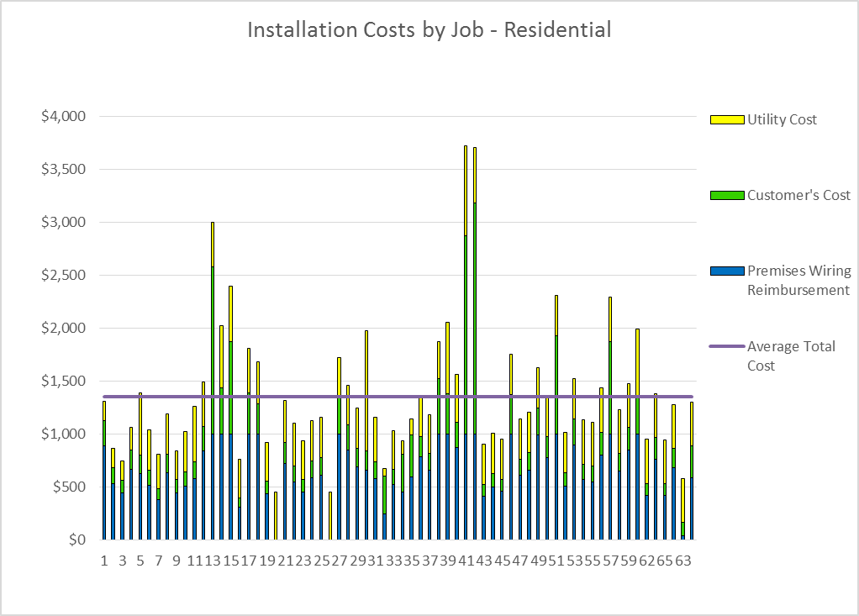

Residential installation cost breakdowns continue to meet expectations as shown by the average costs in the table below, with EVSE installed in 66 customer homes thus far.

**Table No. 3**

**Average cost per component for residential installations:**

|  |  |  |  |  |  |
| --- | --- | --- | --- | --- | --- |
| **Premises Wiring Reimbursement** | **Customer’s Cost** | **Utility Hardware & Installation Cost** | **Total Installation Cost** | **EVSE Cost** | **Total Costs Installation + EVSE** |
| $665 | $308 | $404 | $1,356 | $1,066 | $2,422 |

The following chart shows the status of commercial applications and installations by category[3]:

**Chart No. 3**

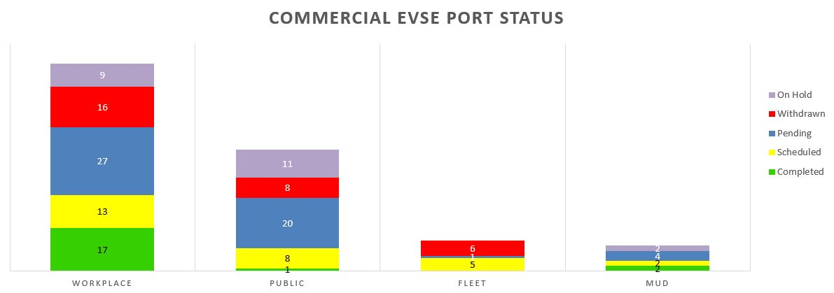

Commercial installation site agreements and scheduling have increased recently, with a corresponding higher rate of commercial AC Level 2 installations, including new installations in fleet, MUD, and public applications. However, as with the residential installations, a strong effort will be required to achieve the targeted levels of workplace and public installations for the program by July 2018.

The cost components of commercial installations at ten different locations are shown below. These EVSE locations are primarily used as workplace charging for employees:

**Chart No. 4**

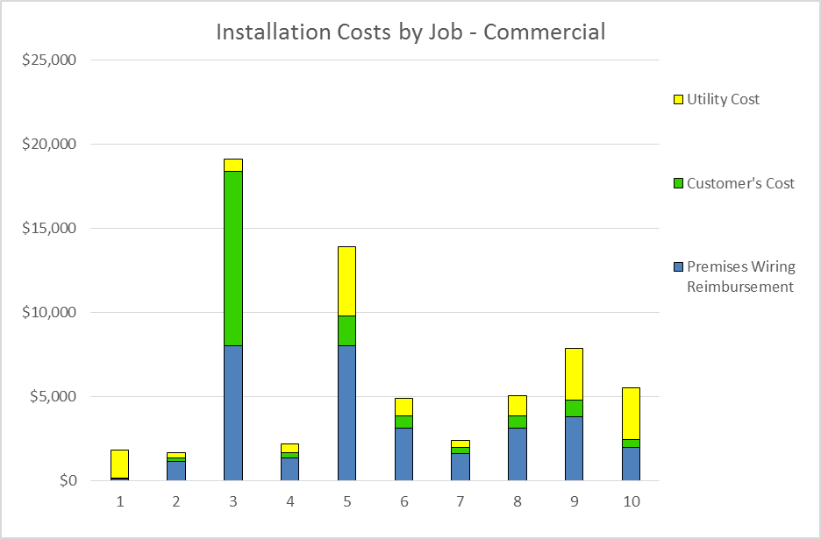

Lower costs correspond to simpler installations avoiding service upgrades and trenchwork, lower cost EVSE, and/or a single port connection. Conversely, higher costs are associated with multiple installed EVSE ports, required upgrades to transformers, supply panels, and/or trench work, especially concrete and asphalt trenching. Average cost breakdowns for commercial EVSE sites are listed in the table below.

**Table No. 4**

|  |  |  |  |  |  |  |  |
| --- | --- | --- | --- | --- | --- | --- | --- |
| **Premises**  **Wiring**  **Reimburse-ment** | **Customer's**  **Cost** | **Utility Hardware & Installation Cost** | **Total**  **Install**  **Cost** | **EVSE**  **Cost** | **Total**  **Cost EVSE + Installation** | **#**  **Ports** | **Total**  **Cost per**  **Port** |
| $3,201 | $1,607 | $1,614 | $6,422 | $4,339 | $10,761 | 2.0 | $4,910 |

**DC Fast Charging (DCFC) Stations**

The first DCFC station in Rosalia, Washington was brought online January 18, 2017, and made available for public use. Remote monitoring continues to show satisfactory status and availability. More information about the Rosalia DCFC is posted online at [www.plugshare.com](http://www.plugshare.com). As expected, the use of the Rosalia DCFC has been limited thus far. Greenlots’ SKY network indicates four charging sessions outside of initial testing on January 18. Although this DCFC’s use will be limited until the travel corridor is completed with DCFC installations in Pullman and Spokane, the relatively high cost of $0.30 per minute of charging compared to gasoline fuel cost may also be a contributing factor. The Company will continue to monitor DCFC use and customer comments. At the present time no change to the DCFC user fee is proposed, however it may be appropriate in the future to change the fee in order to evaluate the correlation of price points with utilization. In order to be competitive in the market and encourage EV adoption, the DCFC user fee should result in an electric fueling cost at or below an equivalent cost to travel using a gasoline vehicle.

DCFC site acquisition and design work is complete for the location at Kendall Yards in Spokane, with installation expected to be completed in June 2017. This desirable location is within one mile of Interstate 90, situated among a number of attractive retail and restaurant venues at Kendall Yards, and is within a reasonable walking distance to the downtown core of Spokane and Riverfront Park. The Kendall Yards location will help enable regional transportation on both the North-South and East-West corridors through Spokane, as well as provide quick public charging for inner city travel within Spokane.

Other installations are expected to be completed in 2017 at the Spokane Transit Authority (STA) Park & Ride in Liberty Lake, and near the WSU Visitor Center in Pullman. A DCFC at a new STA facility located at exit 272 along I-90 is anticipated in early 2018. The Park & Ride facilities were identified as excellent locations given their convenient access to Interstate 90 on both the West and East sides of Spokane County, nearby facilities including restaurants and convenience stores, proximity to three-phase power, as well as a partner in the STA that is able to provide the parking space necessary to facilitate the DCFC. Installation of these five identified locations will provide an electrified north-south corridor between Spokane and Pullman, as well as serving east-west traffic along I-90 in the vicinity of Spokane, and between the Spokane and Coeur d’Alene, Idaho travel corridor.

This leaves two additional stations to complete the seven DCFC proposed for the pilot program. A search for a suitable location on the outskirts of north Spokane is currently underway, which will help to begin to electrify the US-395 corridor and serve customers living in the north Spokane area. The final DCFC location will be determined as the Company gathers more information and lessons learned. Candidate locations under consideration include the Spokane University District, Spokane Valley, Clarkston, Deer Park, Chewelah, and Colville. The Company will continue to consult with the Washington State Department of Transportation on site locations to confirm agreement and alignment with efforts to build out EVSE infrastructure across the state.

Standardized DCFC site design has an operational 50kW DCFC with both CCS and CHAdeMO connectors, and a dual-port AC Level 2 EVSE as a backup. The installations include adequate property easements and/or site agreements for future expansion, with transformer capacity and conduit installed to allow for low-cost expansion of an additional 150kW DCFC capacity.

**Customer Surveys**

Web based customer surveys are carried out post-installation and quarterly thereafter for both residential and commercial customers. These surveys began on July 21, 2016 and will continue through the course of the pilot program. Completion rates as of April 17, 2017 are as follows:

**Table No. 5:**

|  |  |  |
| --- | --- | --- |
| **Customer** | **Post-installation** | **Quarterly** |
| Residential | 72% (49 of 68) | 27% (8 of 30) |
| Commercial | 36% (4 of 11) | 50% (2 of 4) |

Overall satisfaction with the residential installations remains high with 98% of the 49 respondents reporting satisfied or very satisfied:

**Chart No. 5**

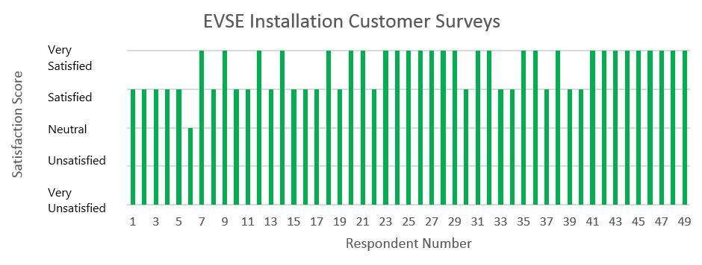

78% of residential customers indicated that they commute to work in their EV. Yet, only 38% of those customers indicated that their employer offers an EVSE at work.

**Chart No. 6**

Thus far, the average commute was 18.3 miles for those that could use an EVSE at work and only slightly higher at 18.8 miles for those that did not have an EVSE available.

**Chart No. 7**

Additional insights from the customer surveys will be reported as a greater number of responses are received.

**Data Analysis, Modeling, and Load Management**

As seen in the chart below, the average daily residential demand from EVs peaks between the hours of 5:00 PM to 8:00 PM.

**Chart No. 8**

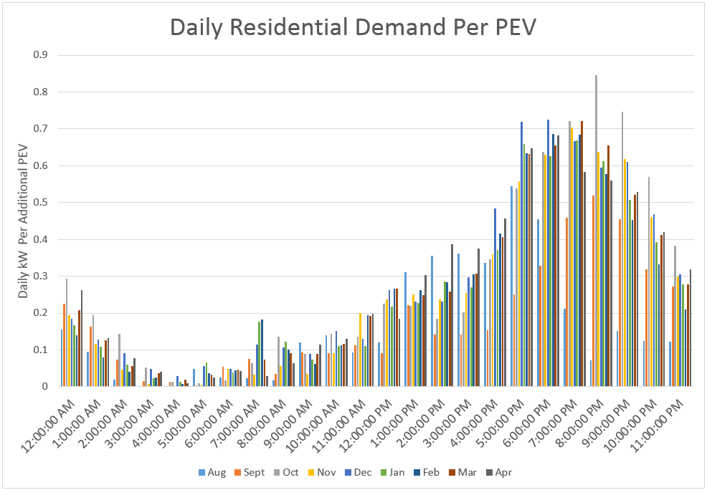

Qualitatively, there were a few accounts of program participants that reduced or stopped driving their EVs with the onset of harsher winter conditions, opting instead to use gasoline vehicles with higher ground clearances. This may result in reduced energy demand from EVs during parts of the winter. Batteries do not perform as well with colder temperatures and may require more kW per mile driven than at other times of the year. The seasonal demand difference appears somewhat significant as both daily EV driver energy and peak demand decreased slightly during Spokane’s colder than average months of January and February.

The charts below present profiles that are representative of participant group charging habits. Chart No. 9 shows commuter profiles. As noted previously, more data is available for the BEV commuter category, followed by PHEV commuters. A relatively low quantity of data is available for both BEV and PHEV non-commuters, therefore some caution is prudent in evaluating comparisons between these different groups.

Commuters with both BEVs and PHEVs had higher average daily demand than non-commuters, with peak times between 6 PM and 9 PM. Note the higher peak of 2 kW to 2.5 kW for BEV commuters, compared to 1.2 to 1.6 kW for PHEV commuters. Also, BEV commuters show greater differences between weekday and weekend charging compared to their PHEV counterparts.

**Chart No. 9**

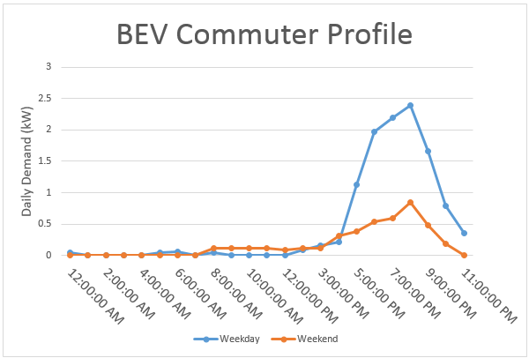

**Chart No. 10**

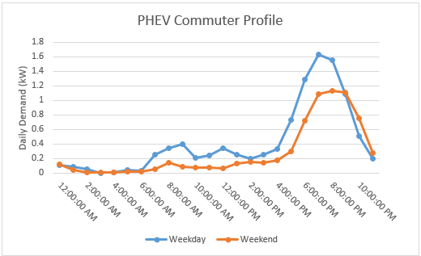

Compared to commuters, non-commuters thus far demonstrate a “flatter” charging profile, with earlier peak times. Weekday and weekend demand for non-commuters are also less pronounced. Somewhat surprisingly, the highest demand peaks for many participants in these driver groups occur on the weekend rather than the weekday. Again, although these insights may prove consistent over time, the lower volume of data for the non-commuter categories does not allow for strong conclusions to be drawn at this time.

**Chart No. 11**

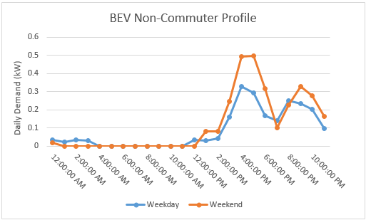

**Chart No. 12**

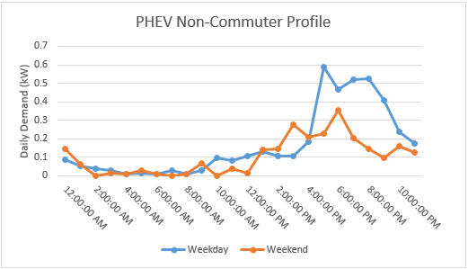

The charts below show daily demand at individual workplaces. Workplace charging peaks during the start of the work day for that business or organization. In the first chart we see a single peak occurring in the morning. In Chart 14, the effect of shift work creates demand peaks during the first shift and gradually declines until the swing shift begins and a second peak occurs.

**Chart No. 13**

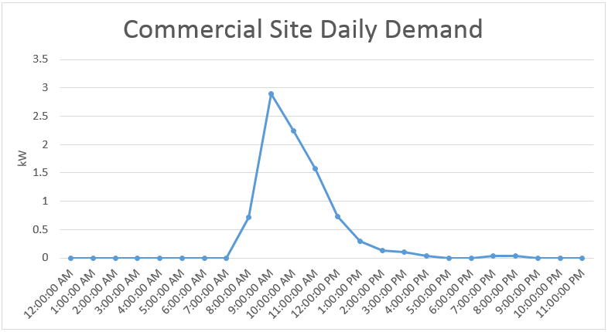

**Chart No. 14**

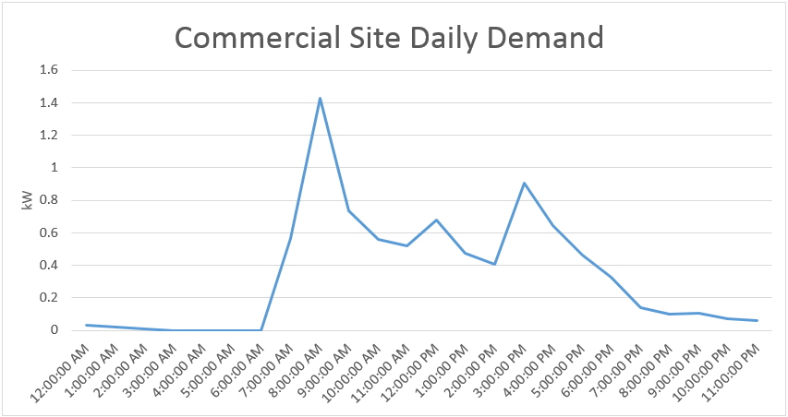

As more data is gathered, additional profiles and analysis will be performed, including the differences in residential demand due to the availability or unavailability of workplace charging.

Analysis of miles driven per kWh is ongoing, requiring correlation of EVSE data and survey responses on odometer readings. This is currently estimated at 3.0 to 3.3 miles driven per kWh.

Given the various load profiles representing uninfluenced charging behaviors, it is appropriate to begin the early phases of load management experimental design. The Company anticipates initial trials of the technology platforms in the next several months, with actual experiments commencing later in 2017.

**Expenditures and Revenues**

Expenditures through April 21, 2017 totaled $725,915. A more detailed breakdown is provided in Attachment A.

Revenues to date are as follows, based on data from Greenlots’ SKY network:

**Table No. 6**

|  |  |  |  |  |
| --- | --- | --- | --- | --- |
| **Type** | **No. of Charging Sessions** | **kWh Consumed** | **Rate** | **Revenue** |
| Residential AC Level 2 | 6,894 | 43,020 | $0.09134/kWh | $3,929 |
| Commercial AC Level 2 | 739 | 5,716 | $0.01162/kWh | $66 |
| DC Fast Charging | 4 | 34 | $0.30/minute | $21 |
| **Total** | 7,637 | 48,770 | - | $4,018 |

Please direct any questions regarding this report to Rendall Farley at 509-495-2823, [rendall.farley@avistacorp.com](mailto:rendall.farley@avistacorp.com), or Shawn Bonfield at 509-495-2782, [shawn.bonfield@avistacorp.com](mailto:shawn.bonfield@avistacorp.com).

Sincerely,

Linda Gervais

Sr. Manager, Regulatory Policy

Avista Utilities

**Attachment A**

**Avista EVSE Pilot Program Expenditures through April 21, 2017**

Expenditures include all costs for both completed EVSE installations and installations in progress, as well as program administrative costs.



1. Single Family Home
2. Multi-Unit Dwelling
3. Completed – EVSE has been installed. Scheduled – EVSE is scheduled to be installed. Pending – customer application is pending full approval. Withdrawn – customer has withdrawn application from program. On Hold – customer application is on hold due to location of requested EVSE.