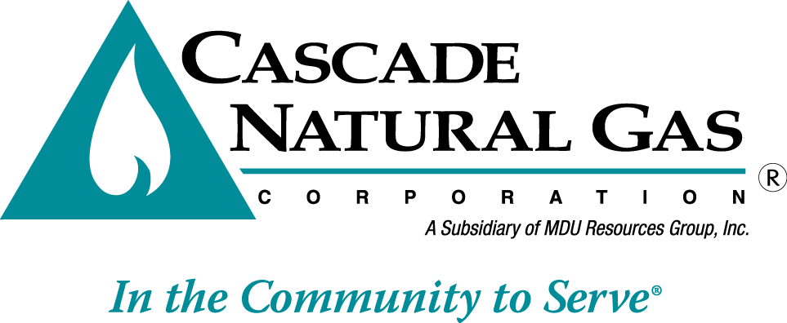

8113 W. GRANDRIDGE BLVD., KENNEWICK, WASHINGTON 99336-7166

TELEPHONE 509-734-4500 FACSIMILE 509-737-9803

[www.cngc.com](http://www.cngc.com)

April 27, 2018

Washington Utilities & Transportation Commission

Mr. Mark L. Johnson, Executive Director & Secretary

P.O. Box 47250

Olympia, WA  98504-7250

RE: Cascade Natural Gas Corporation 2018 Integrated Resource Plan

Dear Mr. Johnson:

Pursuant to WAC 480-90-238, enclosed for filing is Cascade Natural Gas Corporation’s Amended Work Plan for its 2018 Integrated Resource Plan (IRP or Plan). Due to several unforeseen scheduling conflicts, including work associated with the Company’s efforts to comply with the WUTC hedging guidelines under UG-132019. The Company is respectfully requesting to move TAG 2, currently scheduled on May 23rd, to be combined with TAG 3 on July 12, 2018. Cascade has discussed this change with Staff. Staff has indicated support for the modification of the TAG schedule.

If there are any questions regarding this matter, please contact Brian Robertson at (509) 734-4546 or myself at (509) 734-4589.  Alternatively, we may be reached at [brian.robertson@cngc.com](mailto:brian.robertson@cngc.com) and [mark.sellers-vaughn@cngc.com](mailto:mark.sellers-vaughn@cngc.com).

Sincerely,

CASCADE NATURAL GAS CORPORATION

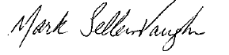

Mark Sellers-Vaughn

Manager, Supply Resource Planning

Enclosures

Cascade Natural Gas Corporation’s (“Cascade” or “the Company”) Amended Work Plan for its 2018 Integrated Resource Plan (“IRP”) is filed pursuant to the Washington Utilities and Transportation Commission (WUTC) IRP rules (WAC 480-90-238).



