June 20, 2014

Steven V. King, Executive Director and Secretary
Utilities and Transportation Commission
1300 S. Evergreen Park Dr. SW
P.O. Box 47250
Olympia, WA 98504-7250

RE: Washington Utilities and Transportation Commission v. Clear Rate Communications, Inc.

Commission Staff’s Response to Application for Mitigation of Penalties UT-140875

Dear Mr. King:

On May 30, 2014, the Utilities and Transportation Commission issued a $1,000 Penalty Assessment in Docket UT-140875 against Clear Rate Communications, Inc. for 10 violations of Washington Administrative Code (WAC) 480-120-382, which requires telecommunications companies to furnish annual reports to the commission no later than May 1 each year.¹

On June 9, 2014, Clear Rate Communications, Inc. wrote the commission requesting mitigation of penalties (Mitigation Request).² In its Mitigation Request, Clear Rate Communications, Inc. does not dispute that the violation occurred. The company states, “The requirement of attaching financial statements was overlooked. We did correct the deficiency when notified by the commission by mailing the missing financial statements on May 15th.”

It is the company’s responsibility to ensure that the regulatory fee is paid and the annual report is filed by the May 1 deadline. On February 28, 2014, Annual Report packets were mailed to all regulated telecommunication companies. The instructions for annual report completion page of
the annual report informed the regulated company that it must complete the annual report form, pay the regulatory fees, and return the materials by May 1, 2014, to avoid enforcement action.

UTC Annual Reports
June 20, 2014
Page 2

On May 19, 2014, Clear Rate Communications, Inc. filed its complete annual report with the regulatory fee payment received on May 5, 2014. The company has been active since May 13, 2011. No prior violations of WAC 480-120-382 are on commission record. Staff supports the company’s request for mitigation as this is the first delinquent annual report filing. Staff recommends a reduced penalty assessment of $200.

If you have any questions regarding this recommendation, please contact Amy Andrews, Regulatory Analyst, at (360) 664-1157, or aandrews@utc.wa.gov.

Sincerely,

Sondra Walsh, Director
Administrative Services

ATTACHMENT A
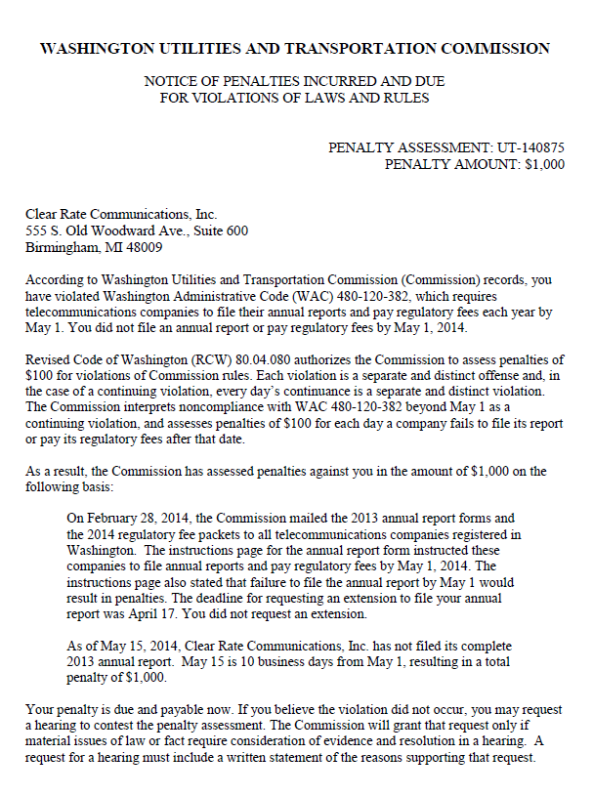

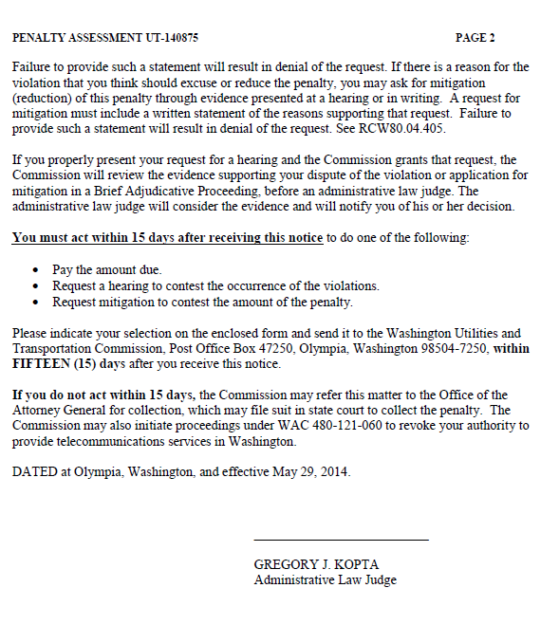

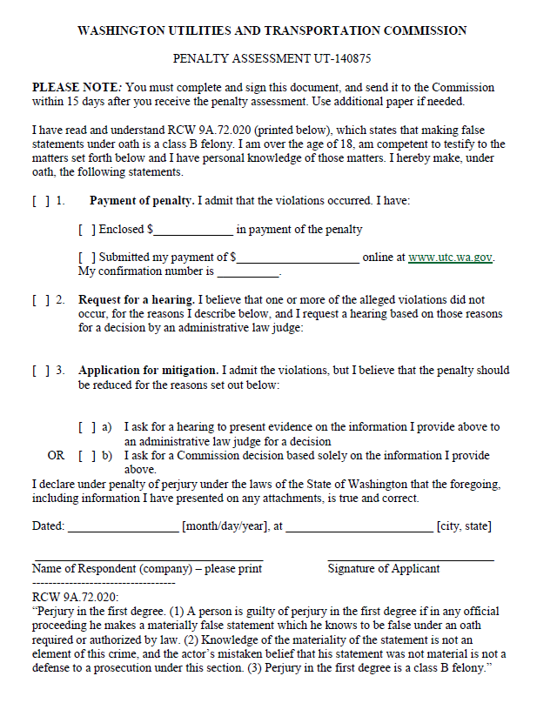
ATTACHMENT B
