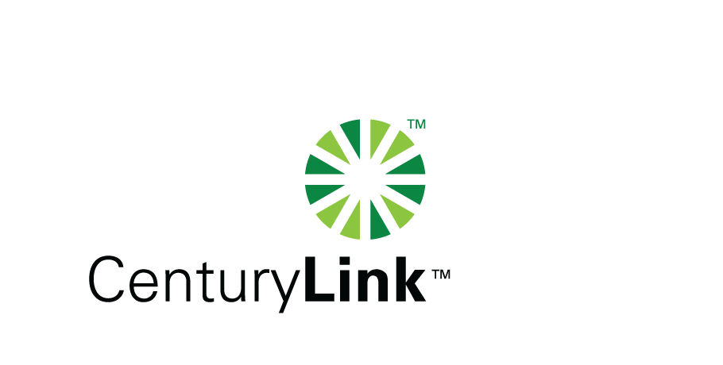

December 9, 2014

Steven V. King, Executive Director & Secretary

Washington Utilities & Transportation Commission

1300 S Evergreen Park Drive, SW

Olympia, Washington 98504-7250

Re: Washington Quality of Service Report

Dear Mr. King:

Attached is the United Telephone Company of the Northwest d/b/a CenturyLink Service Quality Report for the month of November 2014 as required under docket UT-921192.

The trouble reports per 100 access lines objective was met for the month of November.

Should you have any questions, please contact Mark Reynolds at (206) 345-1568 or by e-mail at Mark.Reynolds3@Centurylink.com.

Sincerely,

Mark Reynolds

Enclosures: Installation/Repair Appointments

Service Activation in 5 Days

Trouble Per 100/Access Lines

Switching – Dial Tone Speed in 3 Seconds

Final Trunk Blockage (EAS and Toll)

Out of Service Trouble Cleared in 48 Hours

Not Out of Service Trouble Cleared in 72 Hours

Service Activation Delay 90-180 Days