[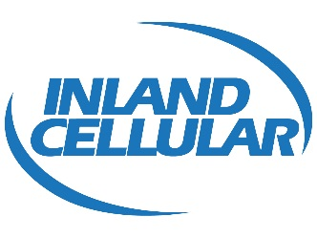](http://inlandcellular.com/)

August 12, 2016

*Via electronic filing*

Mr. Steven V. King, Executive Director and Secretary Washington Utilities and Transportation Commission 1300 South Evergreen Park Drive SW

Olympia, WA 98504-7250

**Re: Docket # UT-160960 - 2016 ETC Certification** - Eligible Telecommunications Carriers' Annual Re-certification on High Cost Fund Support Pursuant to WAC 480-123-060

Dear Mr. King:

Pursuant to WAC 480-123-060, Inland Cellular LLC *(f/ k/ a WA-RSA No. 8*) ("Company''), with a study area code of 529003, hereby requests that the Washington Utilities and Transportation Commission certify to the Federal Communications Commission and the Universal Service Administration Company that the Company has met the requirements of 47 C.F.R. §54.314 for eligibility for continued receipt of federal high-cost funds.

The certifications and reports that are specified in WAC 480-123-060, WAC 480-123-070 and WAC 480-123-080 are enclosed. If you should have any questions, please call me at (509) 649-2500.

Sincerely,

C:\Users\admin\Desktop\Inland Cellular\nathansignature.JPG

Nathan Weis

President and CEO

Inland Cellular, LLC

Enclosures