July 8, 2014

Steven V. King, Executive Director and Secretary
Utilities and Transportation Commission
1300 S. Evergreen Park Dr. SW
P.O. Box 47250
Olympia, WA 98504-7250

RE: Washington Utilities and Transportation Commission v. Starving Students, Inc.

Commission Staff’s Response to Application for Mitigation of Penalties TV-140991

Dear Mr. King:

On June 6, 2014, the Utilities and Transportation Commission issued a $1,000 Penalty Assessment in Docket TV-140991 against Starving Students, Inc. for 10 violations of Washington Administrative Code (WAC) 480-15-480, which requires household goods carrier companies to furnish annual reports to the commission no later than May 1 each year.¹

On June 23, 2014, Starving Students, Inc. wrote the commission requesting mitigation of penalties (Mitigation Request).² In its Mitigation Request, Starving Students, Inc. does not dispute that the violation occurred. The company states, “We had no intention to violate the Revised Code of Washington 81.04.080. As a moving company in business for over 40 years, we have been in compliance of the state law of Washington and we will continue to do so. The report was delayed due to our overwhelming working schedule.”

It is the company’s responsibility to ensure that the regulatory fee is paid and the annual report is filed by the May 1 deadline. On February 28, 2014, Annual Report packets were mailed to all regulated household goods companies. The instructions for annual report completion page of the annual report informed the regulated company that it must complete the annual report form, pay the regulatory fees, and return the materials by May 1, 2014, to avoid enforcement action. The instructions for annual report completion page also informed the company of the opportunity to file for an extension request to submit the report. The company did not file an extension.

UTC Annual Reports
July 8, 2014
Page 2

On May 15, 2014, Starving Students, Inc. filed an incomplete 2013 annual report and paid the regulatory fees and late payment penalty. On June 25, 2014, Starving Students, Inc. submitted the completed 2013 annual report. The company was delinquent in filing the 2012 annual report and received an automatic mitigation to $25 per day. Staff does not support the company’s request for mitigation due to a lack of new compelling information and prior violation of WAC 480-15-480.

If you have any questions regarding this recommendation, please contact Amy Andrews, Regulatory Analyst, at (360) 664-1157, or aandrews@utc.wa.gov.

Sincerely,

Sondra Walsh, Director
Administrative Services

ATTACHMENT A
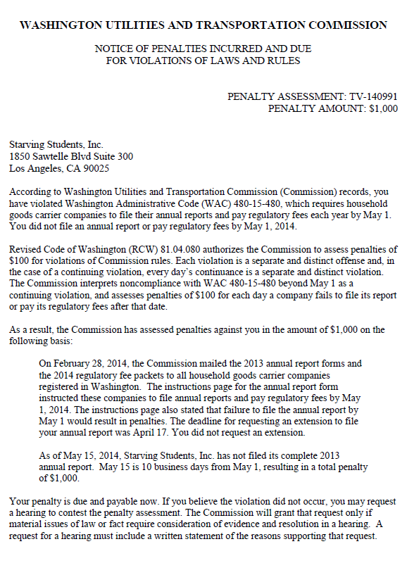

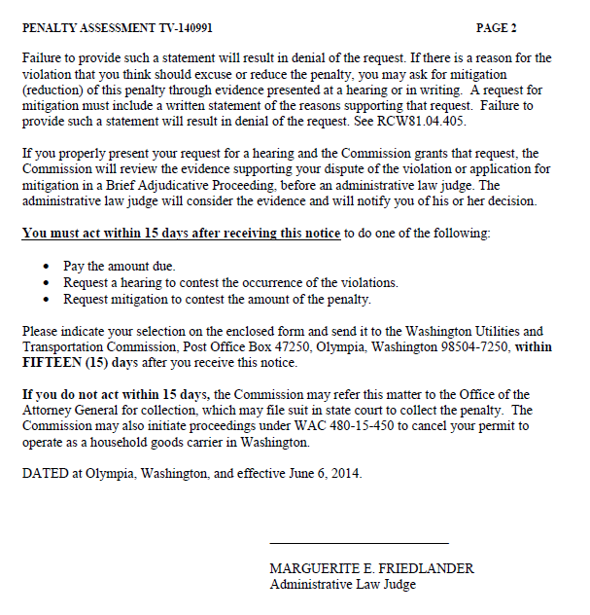

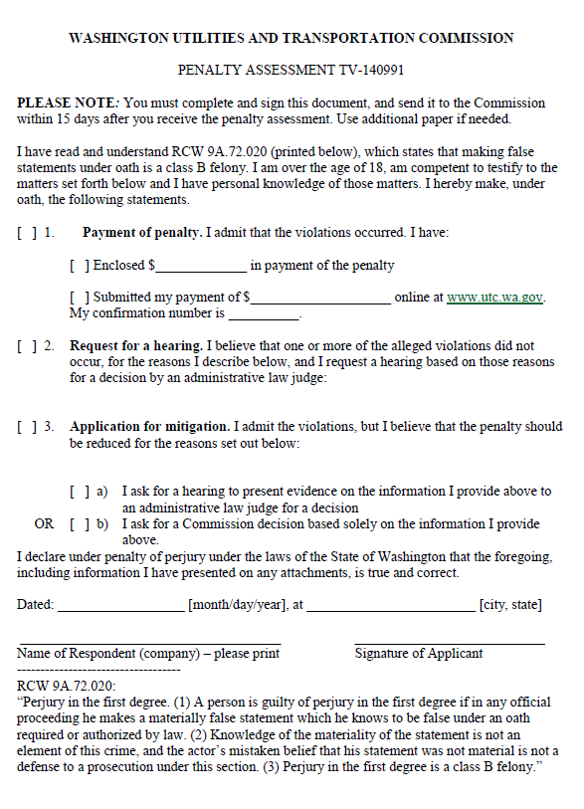

ATTACHMENT B
