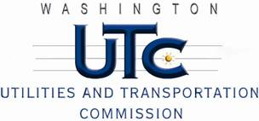

Memorandum

May 20, 2011

To: TR-101764 - File

From: Kathy Hunter, Deputy Assistant Director Transportation Safety

Subject: TR-101764 Central Washington Railroad

Grade Crossing Protective Fund (GCPF) Project at the Intersection of

West Mead Avenue and Central Washington Railroad’s Tracks in the City of Yakima, Washington

On November 4, 2010, the Washington Utilities and Transportation Commission (Commission) awarded a GCPF grant totaling $9,941.83 to install LED lights, replace the system batteries and the mechanical bell with an electronic type at the West Mead Avenue crossing in the City of Yakima. The USDOT number assigned to this crossing is 808195B.

On May 11, 2011, the applicant, Central Washington Railroad submitted a request for reimbursement pursuant to Commission order. On May 12, 2011, Commission staff conducted a site visit and verified that the project is completed according to the specifications outlined in the order approving the grant.

Please close this docket.