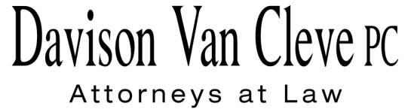

TEL (503) 241-7242 ● FAX (503) 241-8160 ● jog@dvclaw.com

Suite 400

333 S.W. Taylor

Portland, OR 97204

September 11, 2015

### Via Electronic Filing and Federal Express

Mr. Steven V. King

Executive Director & Secretary

Washington Utilities & Transportation Commission

1300 S. Evergreen Pk. Dr. S.W.

P. O. Box 47250

Olympia, WA 98504-7250

Re: Washington Utilities and Transportation Commission v.

Pacific Power & Light Company

**Docket UE-144160**

Dear Mr. King:

Enclosed for filing in the above-referenced docket, please find an original and one copy of the Opening Brief of Boise White Paper, L.L.C.

Thank you for your assistance. If you have any questions, please do not hesitate to contact me.

Sincerely,

*/s/ Jesse O. Gorsuch*

Jesse O. Gorsuch

cc: Service List

##### CERTIFICATE OF SERVICE

I hereby certify that I have this day served the attached Opening Brief of Boise White Paper, L.L.C. upon all parties in this proceeding by sending a copy via electronic mail.

DATED this 11th day of September, 2015.

Davison Van Cleve, P.C.

*/s/ Jesse O. Gorsuch*

Jesse O. Gorsuch

|  |  |  |  |  |  |  |  |  |
| --- | --- | --- | --- | --- | --- | --- | --- | --- |
| |  |  | | --- | --- | | **BRYCE DALLEY**  Pacific Power & Light Co.  825 NE Multnomah STE 2000  Portland, OR 97232  bryce.dalley@pacificorp.com  washingtondockets@pacificorp.com | **DUSTIN TILL**  Pacific Power & Light Co.  825 NE Multnomah St. STE 1800  Portland, OR 97232  Dustin.Till@pacificorp.com | | **JOHN LOWE**  Renewable Energy Coalition  12050 SW Tremont Street  Portland, OR 97225  jravenesanmarcos@yahoo.com  **IRION SANGER**  Sanger Law, P.C.  1117 SE 53rd Avenue  Portland, OR 97215  irion@sanger-law.com | **CHRISTOPHER M. CASEY**  Washington Utilities & Transportation Commission  Assistant Attorney General  1400 S. Evergreen Park Drive SW  PO Box 40128  Olympia, WA 98504-7250  ccasey@utc.wa.gov | |  |  | |  |  | |