

|  |  |
| --- | --- |
| **Avista Corp.**  1411 East Mission P.O. Box 3727  Spokane. Washington 99220-0500  Telephone 509-489-0500  Toll Free 800-727-9170 |  |

|  |  |
| --- | --- |
|  |  |

**VIA: Electronic Mail**

August 2, 2012

David Danner

Executive Director and Secretary

Washington Utilities & Transportation Commission

1400 S. Evergreen Park Dr. SW

P.O. Box 40128

Olympia, WA 98504-0128

RE: Docket No. UE-100176 – Avista Matrix Response

Dear Mr. Danner,

The Commission invited additional comments by the close of business August 2, 2012. A list of issues was developed with interested parties following the Open Meeting on July 27, 2012.

Attached for filing with the Washington Utilities and Transportation Commission (UTC) is Avista Utilities response to the list (matrix).

If you have any concerns or questions, please contact Bruce Folsom at (509) 495-8706 or via e-mail at [bruce.folsom@avistacorp.com](mailto:bruce.folsom@avistacorp.com).

Sincerely,

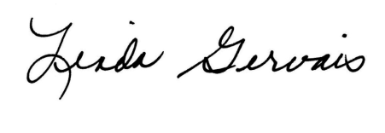

Linda Gervais

Manager, Regulatory Policy

Avista Utilities

509-495-4975

[linda.gervais@avistacorp.com](mailto:linda.gervais@avistacorp.com)

Attachment