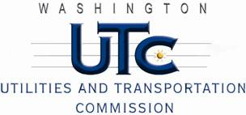

Memorandum
September 11, 2012

To: TR-111528 - File

From: Betty Young, Compliance Investigator, Transportation Safety

Subject: TR-111528 Eastern Washington Gateway Railroad (EWG)
Grade Crossing Protective Fund (GCPF) project to improve safety 79 passive crossings and 22 signalized crossings

On October 3, 2011, the Washington Utilities and Transportation Commission (Commission) awarded Eastern Washington Gateway Railroad (EWG) a GCPF grant in the amount of $24,444.16 to improve safety at 79 passive mainline crossings and 22 signalized crossings maintained by EWG. The estimated project cost exclusive of labor was $49,532.18, with EWG paying for all costs exceeding $24,444.16.

On September 11, 2012, the applicant, EWG, submitted a request for reimbursement for work pursuant to Commission order. Commission staff conducted a site visit of a sampling of the crossings and verified that the project was completed according to the specifications outlined in the order approving the grant.

Please close this docket.

