Polly L. McNeill

DID: (206) 676-7040

Email: *pollym@summitlaw.com*

May 7, 2015

***Via Email and Federal Express***

Washington Utilities and Transportation Commission

1300 S. Evergreen Park Dr. SW

PO Box 47250

Olympia, WA 98504-7250

360-664-1160

**Re: Docket No. TG-143889 – WUTC v. Waste Management of Washington d/b/a Waste Management of Spokane**

Dear Judge Kopta:

On behalf of Waste Management of Washington, Inc. d/b/a Waste Management of Spokane, this letter is to confirm that the Company will not be filing a request to recover its attorney fees and costs incurred in this general rate filing.

As we discussed on our call of last Friday, May 1, 2015, the Commission Staff have indicated that they would support a request by the Company to recover the significant attorney fees and costs incurred by WMW in responding to the County’s petition for intervention and in preparing for the mediation and hearing that were scheduled for this matter, subject to an audit of those expenses.

However, the Company will not pursue recovery of its fees and costs in favor of an expeditious resolution of the pending rate case. WMW wishes to preserve for the record that it would be permitted to recover its legal expenses in this matter subject to an audit by WUTC Staff and Commission approval, but that it has declined to do so at this time and will instead be requesting that the temporary rates be put in place on a permanent basis without further adjustment and without further proceeding.

Thank you for including this letter in the record for this docket matter.

Sincerely,

SUMMIT LAW GROUP PLLC

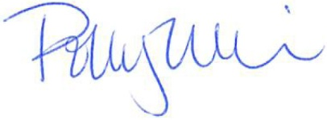

Polly L. McNeill

cc: Julian Beatty

P. Stephen DiJulio