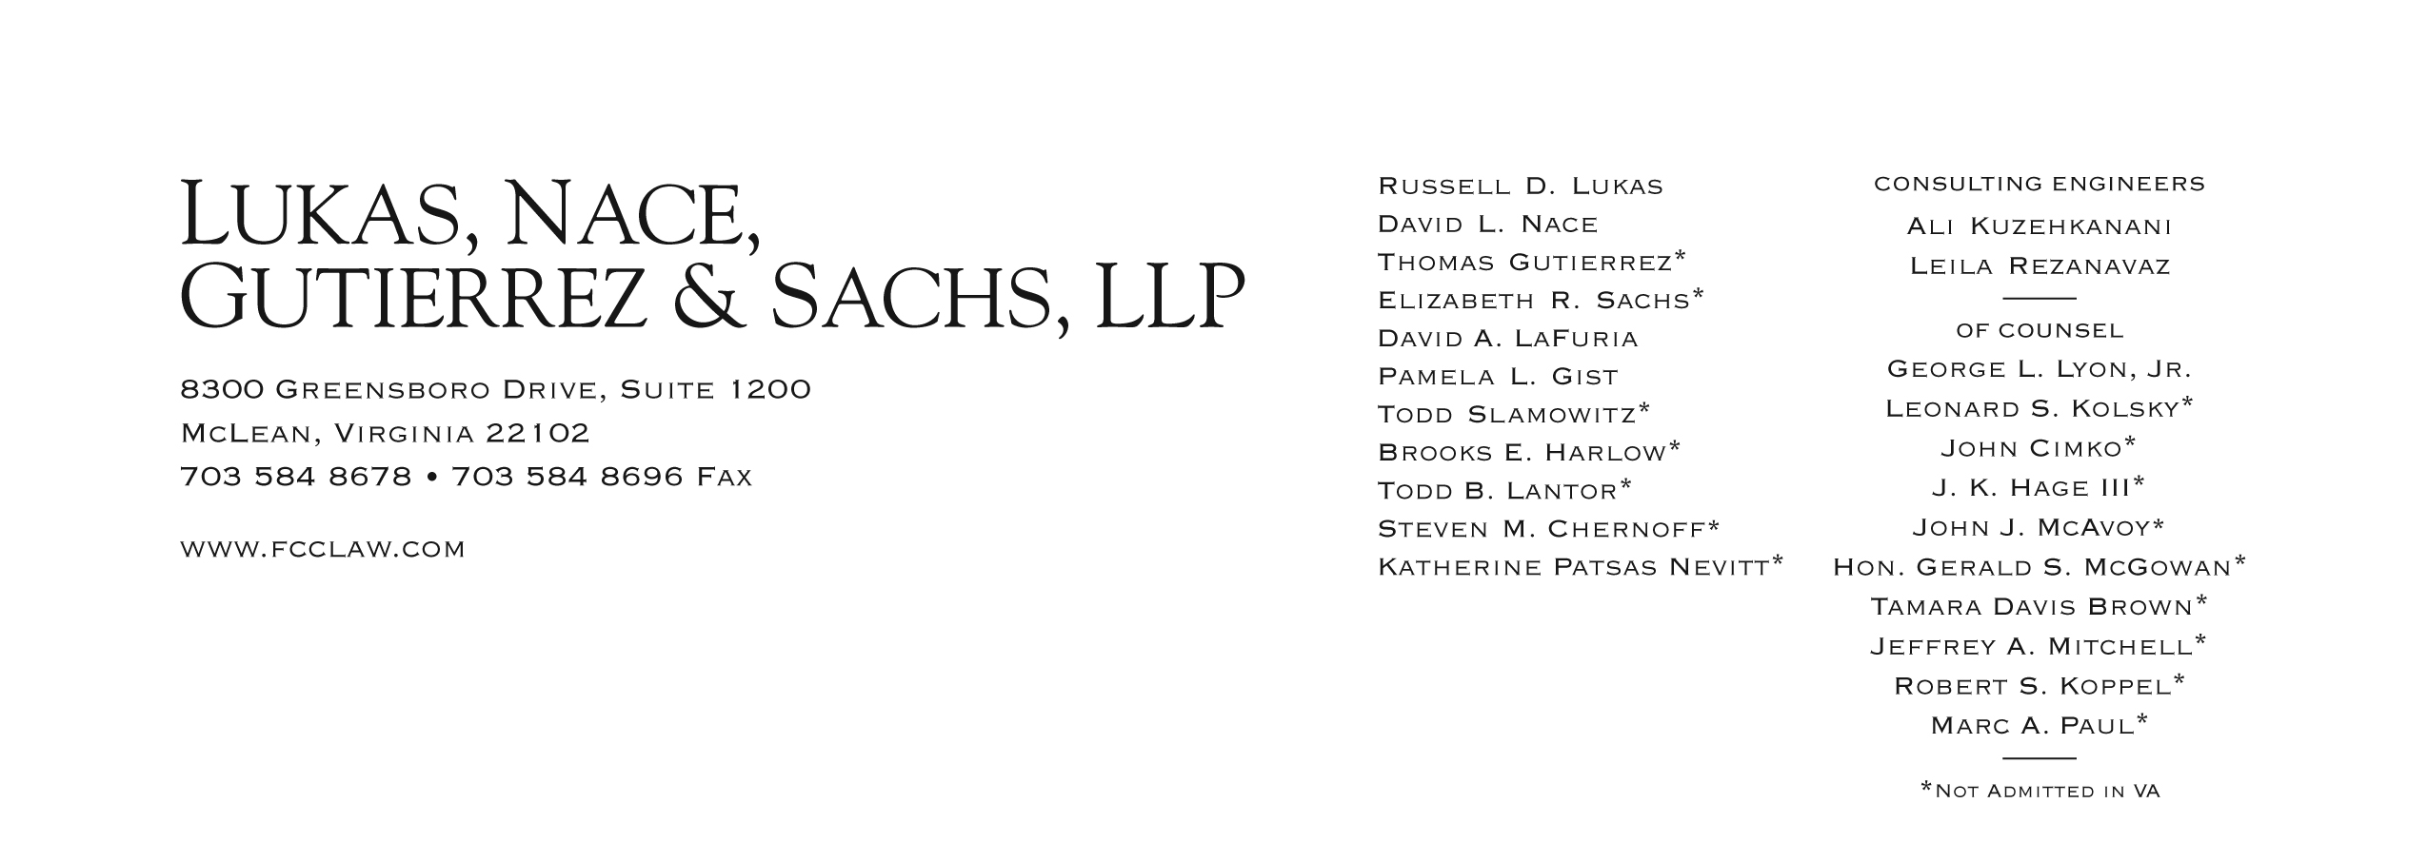

Brooks E. Harlow

(703) 584-8680

bharlow@fcclaw.com

May 21, 2012

*VIA Web Portal*

David W. Danner

Executive Director and Secretary

Washington Utilities and Transportation Commission

1300 S. Evergreen Park Drive S.W.

Post Office Box 47250

Olympia, Washington 98504-7250

Re: Docket No. UT-120541 Rulemaking to Consider Modifications to, or Elimination of, WAC 480-120-251

Comments of Dex One Corporation

Dear Mr. Danner:

Enclosed, for filing, are the Comments of Dex One Corporation in the above-referenced proceeding.

If you have any questions, please do not hesitate to contact the undersigned.

Very truly yours,

Brooks E. Harlow, P.C.



*cc via email*

John Cupp

Simon ffitch