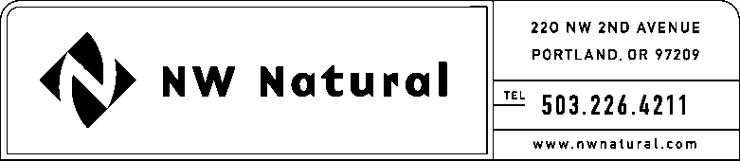

# **ONITA R. KING**

Rates & Regulation

Tel: 503.721.2452

Fax: 503.721.2516

Email: ork@nwnatural.com

June 30, 2015

***VIA ELECTRONIC FILING***

Steven V. King, Executive Director and Secretary

WASHINGTON UTILITIES &

TRANSPORTATION COMMISSION

1300 S Evergreen Park Drive, SW

### Post Office Box 47250

Olympia, Washington 98504-7250

**Re: Request for Extended Effective Date**

**UG-151326 / NWN WUTC Advice No. 15-04**

**General Rule 9: Appliance Inspection and Adjustment Services**

Northwest Natural Gas Company, dba NW Natural (“NW Natural” or the “Company”), respectfully requests that the effective date of the above-referenced advice filing be extended to July 31, 2015.

Please address correspondence on this matter to me with copies to the following:

eFiling

Rates & Regulatory Affairs

NW Natural

220 NW Second Avenue

### Portland, Oregon 97209

Telecopier: (503) 721-2516

Telephone: (503) 226-4211, x3589

eFiling@nwnatural.com

Sincerely,

NW NATURAL

*/s/ Onita King*

Onita R. King

Rates and Regulation