**CenturyLink**

1600 7th Avenue, Room 1506

Seattle, Washington 98191

(206) 345-1568

Facsimile (206) 343-4040

**Mark S. Reynolds**

VP Regulatory & Legislative Affairs

Western Region

June 21, 2013

Steven King

Acting Executive Director and Secretary

1300 S. Evergreen Park Dr. S.W.

P.O. Box 47250

Olympia, Washington 98504-7250

Re: UT-133011  Access Recovery Charge (ARC) and Connect America Fund (CAF)-ICC recovery annual certifications to the Federal Communications Commission pursuant to 47 C.F.R. § 51.915 for price cap carriers and 47 C.F.R. § 51.917 for rate-of-return carriers.

*Annual reporting requirement for CAF ICC recipients pursuant to 47 C.F.R. 54.304(c)(1)*

Dear Mr. King:

The Federal Communications Commission (FCC) Report and Order released November 18, 2011 in WC Docket No. 10-90, et al. (USF/ICC Transformation Order) and associated FCC rules (47 C.F.R. 54.304(c)(1)), require price cap carriers to file data establishing the amount of a price cap carrier’s annual eligible CAF ICC funding. The attached letter reflects the anticipated CAF ICC support and Access Recovery Charge Revenue amounts for CenturyLink Operating Companies together with Qwest Corporation d/b/a CenturyLink QC (CenturyLink) as submitted to the FCC for 2013.

If you have questions concerning this filing, please contact Gary Kepley at 913-345-7572.

Sincerely,

Mark Reynolds

Attachment

**CenturyLink**

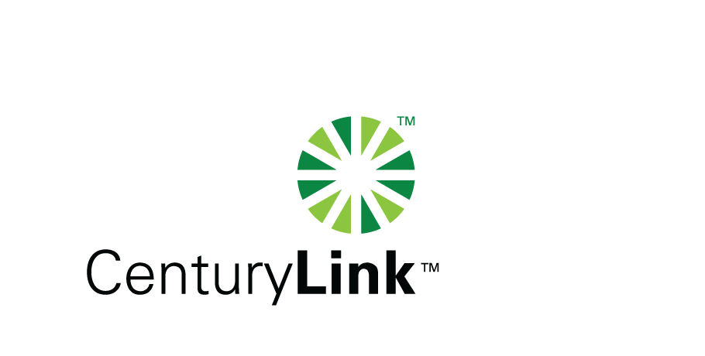Gary Kepley

5454 West 110th Street

Overland Park, KS 66211

Tel: 913-345-7572 Fax: 913-345-6756

E mail: Gary.Kepley@CenturyLink.com

June 18, 2013

The Federal Communications Commission (FCC) Report and Order released November 18, 2011 in WC Docket No. 10-90, et al. (USF/ICC Transformation Order) and associated FCC rules (47 C.F.R. 54.304(c)(1)), require price cap carriers to file data establishing the amount of a price cap carrier’s annual eligible CAF ICC funding. The information presented below reflects the anticipated CAF ICC support and Access Recovery Charge Revenue amounts for CenturyLink Operating Companies together with Qwest Corporation d/b/a CenturyLink QC (CenturyLink) as submitted to the FCC for 2013.

|  |  |  |
| --- | --- | --- |
| Holding Company Eligible Recovery | Holding Company Maximum ARC Revenues | Maximum CAF ICC Support |
| $153.697,466 | $147,890,128 | $5,807,338 |

Please call me at 913-345-7572 if you have any questions regarding this filing.

Sincerely,

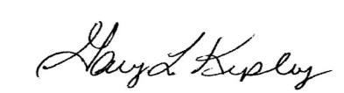

Gary Kepley

Director – Regulatory Operations