|  |  |
| --- | --- |
| CNG-Color-300dpi | 8113 W. GRANDRIDGE BLVD., KENNEWICK, WASHINGTON 99336-7166 TELEPHONE 509-734-4500 FACSIMILE 509-737-7166  www.cngc.com |

December 14, 2015

Mr. Steven V. King

Executive Director and Secretary

Washington Utilities & Transportation Commission

P.O. Box 47250

Olympia, WA 98504-7250

**RE: UG-060256, Cascade Natural Gas’s Conservation Plan**

Dear Mr. King:

As an informational filing, Cascade Natural Gas Corporation (“Company”) submits in the subject docket its 2016 Washington Conservation Plan, which provides an overview of the Company’s Washington conservation programs, the technical potential for savings, and program costs.

Any questions regarding this filing may be directed to Monica Cowlishaw at (360) 788-2357.

Sincerely,

Michael Parvinen

Director, Regulatory Affairs

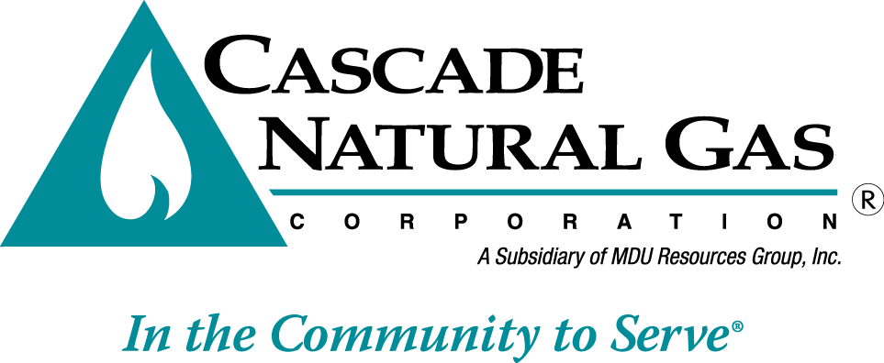Attachment