BEFORE THE WASHINGTON UTILITIES AND
TRANSPORTATION COMMISSION

IN RE: APPLICATION OF  MILLER SCHMER, INC. D/B/A  SEATTLE EXPRESS  FOR PERMANENT AUTO  TRANSPORTATION AUTHORITY | DOCKET TC-111306  PROTEST AND REQUEST FOR ADJUDICATIVE PROCEEEDING AND HEARING OF  SHUTTLE EXPRESS

  - Shuttle Express, Inc. d/b/a Shuttle Express (“Shuttle Express” or “Protestant”) protests the above captioned application of Seattle Express (“Applicant”) under WAC 480-30-032. Shuttle Express requests that the WUTC commence an adjudicative proceeding and set this application for hearing for the reasons identified in this protest.
  - The Protestant is:

Shuttle Express
800 S.W. 16th Street
Renton, WA 98057
Phone: (425) 981-7070
Attn: John Rowley, Jr.
  - The name and address of Shuttle Express’ attorney is:

Brooks E. Harlow
Lukas, Nace, Gutierrez & Sachs, LLP
8300 Greensboro Drive, Suite 1200
McLean, VA 22102
Phone: (703) 584-8680
Facsimile: (703) 584-8696
Email: bharlow@fcclaw.com
  - Shuttle Express is an auto transportation company operating under the authority issued by the WUTC in Permit C-975. See attachment. Under this certificate, Shuttle Express has the authority to provide door to door and scheduled service within the city of Seattle. Shuttle Express operates a fleet of approximately 100 vans and 15 buses.
  - Shuttle Express believes that a grant of Applicant’s application is not in the public interest and is not required by the public convenience and necessity. Applicant requests authority to provide passenger service between Cruise line terminals 66 and 91 and the Sea-Tac Airport. Shuttle Express already provides satisfactory service along this route. There is no public need for the Applicant’s proposed, duplicative service, as Shuttle Express’s existing equipment is not fully utilized and is available to provide additional service should the need and opportunity arise.
  - If the WUTC sets this matter for hearing, Shuttle Express will appear, submit evidence and present witnesses at the hearing in support of this protest.
  - Respectfully submitted this 31st day of August, 2011

LUKAS, NACE, GUTIERREZ & SACHS, LLP

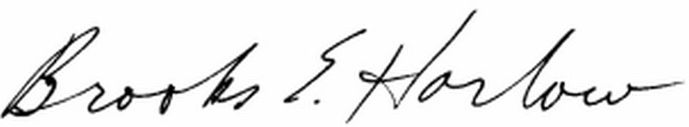

Brooks E. Harlow
WSB No. 11843

Attorney for SHUTTLE EXPRESS, INC.

