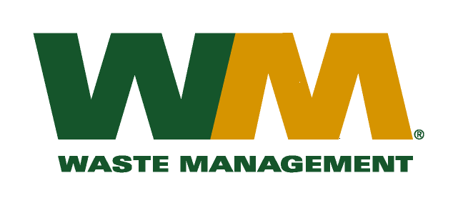

June 29, 2010
Washington Utilities and Transportation Commission
Chandler Plaza Building
1300 S. Evergreen Park Drive SW
P.O. Box 47250
Olympia, WA. 98504-7250
Dear Sirs:
Subject: Waste Management of Spokane, a division of Waste Management of Washington, Inc. (G-237); Tariff # 16 (Docket # TG-101120)
As our revised tariff pages reflect an increase in the current commodity credit and therefore results in a reduction to the customers’ bill it is unnecessary that we request LSN treatment in the above-referenced docket. Therefore, we hereby withdraw our LSN request.
If you have any questions or need additional information, please contact me at (425) 814-7840.
Very truly yours,

Michael A. Weinstein
Senior Pricing Manager, Pacific Northwest Market Area

cc: Marco Gonzales
Joe Krukowski
Clerk of the Board, Spokane County Chair

