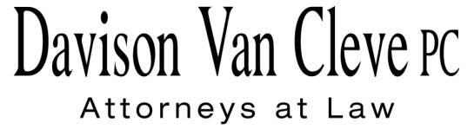

TEL (503) 241-7242 ● FAX (503) 241-8160 ● tcp@dvclaw.com

Suite 400

333 S.W. Taylor

Portland, OR 97204

July 14, 2015

### Via E-mail and Federal Express

Mr. Steven V. King

Executive Director & Secretary

Washington Utilities & Transportation Commission

1300 S. Evergreen Pk. Dr. S.W.

P. O. Box 47250

Olympia, WA 98504-7250

Re: Washington Utilities and Transportation Commission v.

Pacific Power & Light Company

**Docket UE-144160**

Dear Mr. King:

This letter is to inform the Washington Utilities and Transportation Commission and parties to the above-referenced docket that Boise White Paper, L.L.C. (“Boise”) does not intend to file a responsive policy declaration in this matter. Boise reserves its right to file a cross-answering policy declaration and to otherwise participate fully in the remainder of the proceeding.

Thank you for your assistance. If you have any questions, please do not hesitate to contact me.

Sincerely,

*/s/ Tyler C. Pepple*

Tyler C. Pepple

cc: Service List

##### CERTIFICATE OF SERVICE

I hereby certify that I have this day served the attached Letter upon all parties in this proceeding, as shown below, by sending a copy via electronic mail.

DATED this 14th day of July, 2015.

Davison Van Cleve, P.C.

*/s/ Tyler C. Pepple*

Tyler C. Pepple

|  |  |  |  |  |  |  |  |  |
| --- | --- | --- | --- | --- | --- | --- | --- | --- |
| |  |  | | --- | --- | | **BRYCE DALLEY**  Pacific Power & Light Co.  825 NE Multnomah STE 2000  Portland, OR 97232  bryce.dalley@pacificorp.com | **DUSTIN TILL**  Pacific Power & Light Co.  825 NE Multnomah St. STE 1800  Portland, OR 97232  Dustin.Till@pacificorp.com | | **SALLY BROWN**  Washington Utilities & Transportation Commission  Assistant Attorney General  PO Box 40128  Olympia, WA 98504-0128  sbrown@utc.wa.gov  **JOHN LOWE**  Renewable Energy Coalition  12050 SW Tremont Street  Portland, OR 97225  jravenesanmarcos@yahoo.com | **CHRISTOPHER M. CASEY**  Washington Utilities & Transportation Commission  Assistant Attorney General  1400 S. Evergreen Park Drive SW  PO Box 40128  Olympia, WA 98504-7250  ccasey@utc.wa.gov  **IRION SANGER**  Sanger Law, P.C.  1117 SE 53rd Avenue  Portland, OR 97215  irion@sanger-law.com | |  |  | |  |  | |