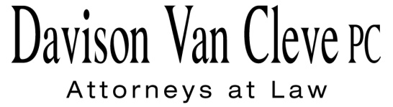

TEL (503) 241-7242 ● FAX (503) 241-8160 ● haa@dvclaw.com

Suite 400

333 SW Taylor

Portland, OR 97204

September 28, 2015

***Via E-Mail and Federal Express***

Mr. Steven V. King

Executive Director and Secretary

Washington Utilities & Transportation Commission

1300 S. Evergreen Pk. Dr. S.W.

P. O. Box 47250

Olympia, WA 98504-7250

Re: WUTC v. Avista Utilities

**Dockets UE-151148**

Dear Mr. King:

Enclosed for filing in the above-captioned proceedings, please find the original and six (6) copies of the Industrial Customers of Northwest Utilities’ Protective Order Signatory Pages for Jesse E. Cowell and Bradley G. Mullins.

Thank you for your assistance. If you have any questions, please do not hesitate to contact our office.

Sincerely,

*/s/ Rainbow Wainright*

Rainbow Wainright

Enclosures

cc: Service List

**CERTIFICATE OF SERVICE**

I hereby certify that I have this day served the attached **Protective Order Signatory Pages of ICNU** upon all parties of record in this proceeding, as shown below, by sending a copy via electronic mail and by mailing a copy via First Class U.S. Mail, postage pre-paid.

DATED in Portland, Oregon, this 28th day of September 2015.

Davison Van Cleve, P.C.

*/s/ Rainbow Wainright*

Rainbow Wainright

|  |  |
| --- | --- |
| **AVISTA CORPORATION**  David. J. Meyer  Kelly O. Norwood  PO Box 3727  1411 E. Mission Ave,  MSC-27 Spokane, WA 99220-3727 david.meyer@avistacorp.com  kelly.norwood@avistacorp.com  **WASHINGTON UTILITIES & TRANSPORTATION COMMISSION** Patrick Oshie  Assistant Attorney General PO Box 40128 Olympia, WA 98504-0128  poshie@utc.wa.gov | **OFFICE OF THE ATTORNEY GENERAL – PUBLIC COUNSEL**  Simon ffitch  Lisa W. Gafken  800 Fifth Avenue, Suite 2000  Seattle, WA 98104-3188  simonf@atg.wa.gov  Lisaw4@atg.wa.gov |