**Eligible Telecommunications Carriers’ annual recertification on High Cost Fund pursuant to WAC 480-123-060, 070 and 080**

August 4th, 2015

Mr. Steven King, Executive Secretary

Washington Utilities and Transportation Commission

1300 South Evergreen Park Drive SW

Olympia, WA 98504-7250

Re: Amendment to UT-151346 Annual ETC Certification

Dear Mr. King:

Pursuant to WAC 480-123-070, The Toledo Telephone Co., Inc. (“Company”) has with this filling enclosed the 2015 NECA 1 report.

Sincerely,

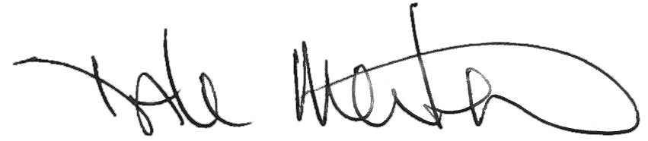

Dale Merten

Chief Operating Officer