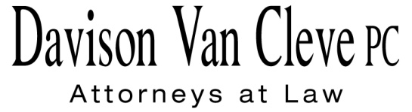
TEL (503) 241-7242 ● FAX (503) 241-8160 ● mail@dvclaw.com
Suite 400
333 SW Taylor
Portland, OR 97204

May 24, 2011

Via Email and U.S. Mail

David Danner
Executive Director and Secretary
Washington Utilities and Transportation Commission
PO Box 47250
1300 S Evergreen Park Drive, SW
Olympia, WA 98504-7250

Re: In the matter of WUTC v. PacifiCorp
Docket No. UE-100749

Dear Mr. Danner:

The Industrial Customers of Northwest Utilities (“ICNU”) submits this letter regarding PacifiCorp’s (or the “Company”) renewable energy credit (“REC”) tracking mechanism compliance filing regarding the Washington Utilities and Transportation Commission’s (the “Commission” or “WUTC”) final order (“Final Order”) in Docket No. UE -100749. The Commission directed PacifiCorp to make certain REC-related filings within 60 days of the Final Order (May 24, 2011). The Commission did not explain the specific process to review the Company’s filing but stated that other parties may file alternative proposals. Final Order ¶ 208. The Commission did not set a specific date for filing alternative proposals. Id.

PacifiCorp plans to make its REC compliance filing today. PacifiCorp’s filing should include both a REC tracking proposal and a REC sales report. In addition, ICNU was informed that the Commission Staff intends to make an alternative REC compliance filing and has been provided a draft version of the Staff proposal.

ICNU is not planning on making an alternative REC proposal at this time, but reserves the right to make a different proposal after completing its review of the Company’s and Staff’s proposals. ICNU has been provided draft REC filings but has been unable to complete its review of the reasonableness and accuracy of the either filing as they are just being filed. Any review of the REC filings may require the use of the discovery process to obtain REC-related information and documents in the sole possession of the Company.

ICNU requests that the Commission allow the parties a reasonable opportunity to review the REC tracking proposals and to file comments or make alternative proposals.
ICNU understands that PacifiCorp has agreed that it will not argue that ICNU should be required to file an alternative proposal contemporaneous with the Company’s filing. ICNU suggests that the Commission convene a prehearing conference to set a schedule to address issues related to REC tracking proposal and REC sales report.

Thank you for your consideration of these REC issues.

Sincerely yours,

/s/ Irion A. Sanger
Irion A. Sanger

cc: Service List

