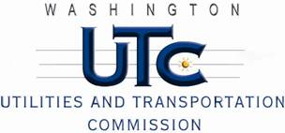

Memorandum

June 28, 2011

To: TR-101809 - File

From: Kathy Hunter, Deputy Assistant Director Transportation Safety

Subject: TR-101809 Thurston County Public Works

Grade Crossing Protective Fund (GCPF) Project for Signage near the Old Highway 99 Railroad Under-crossing in Thurston County, Washington

On December 16, 2010, the Washington Utilities and Transportation Commission (Commission) awarded a GCPF grant totaling $14,000 to replace and install additional signage near the Old Highway 99 railroad under-crossing in Thurston County. On June 15, 2011, Thurston County Public Works amended their GCPF application and requested an extension of time to complete the project. On June 21, 2011, the Commission granted the amendment and extension of time.

On June 28, 2011, the applicant, Thurston County Public Works submitted a request for reimbursement pursuant to Commission Order - 02. Along with the request for reimbursement, Thurston County Public Works provided photos of the installed signage. The project is completed according to the specifications outlined in the order approving the amended grant.

Please close this docket.