ALTERNATE EXHIBIT 7

CORPORATE OPERATIONS EXPENSE ADJUSTMENT CERTIFICATE

I, Richard J Weaver, an officer of Westgate Communications LLC dba WeavTel, with personal knowledge and responsibility, under penalty of perjury, hereby certify that no corporate operations adjustment to existing high-cost loop and interstate common line support mechanisms, as required by the Federal Communications Commission, applied to the Company for 2014 and 2013.

Date this 31st day of July, 2015.

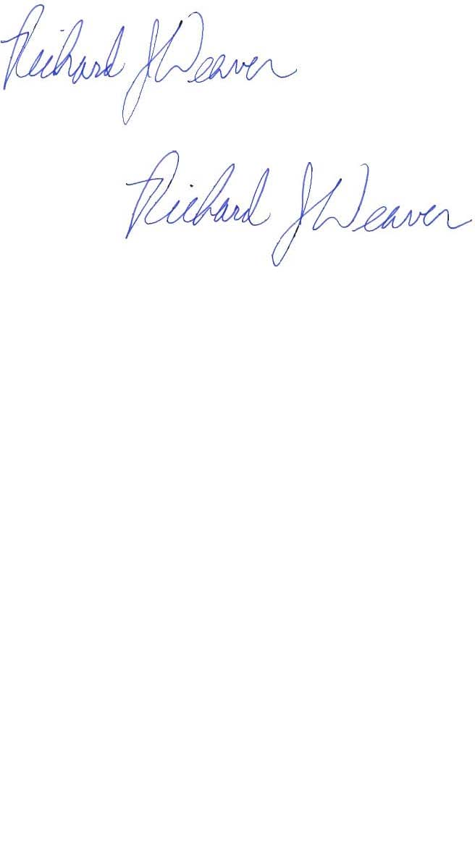

Richard J. Weaver

General Manager

EXHIBIT 8

FINANCIAL ACCOUNTING CERTIFICATE

I, Richard J. Weaver, an officer of Westgate Communications LLC dba WeavTel, with personal knowledge and responsibility, based upon my discussions with the outside consultants retained by the Company to handle such matters, under penalty of perjury, state that the Company complies with state and federal accounting, cost allocation and cost adjustment rules pertaining to incumbent local exchange companies.

Dated this 31st day of July, 2015.



Richard J. Weaver

General Manager

EXHIBIT 9

CONTINUED OPERATIONS CERTIFICATE

I, Richard J. Weaver, an officer of the Company, under penalty of perjury, hereby certify that if the Company receives Program support, the Company will continue to provide communications services pursuant to its tariffs on file with the Commission throughout its service territory in Washington for which the company is seeking and receives Program support during the entirety of 2016.

Dated this 31st day of July, 2015.



Richard J. Weaver

General Manager