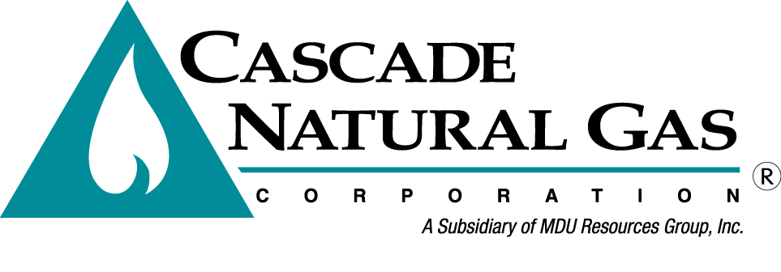
8113 W. GRANDRIDGE BLVD., KENNEWICK, WASHINGTON 99336-7166
TELEPHONE 509-734-4500 FACSIMILE 509-737-9803
www.cngc.com

December 22, 2017

Washington Utilities & Transportation Commission
Mr. Steven King, Executive Director & Secretary
P.O. Box 47250
Olympia, WA 98504-7250

RE: Cascade Natural Gas Corporation’s 2016 Integrated Resource Plan Quarterly Update 2
(Docket UG-160453)

Dear Mr. King:

On July 24th, 2017 Cascade Natural Gas Corporation (Cascade or Company) received a letter from the Washington Utilities and Transportation Commission (WUTC or Commission) acknowledging that the Company’s 2016 Integrated Resource Plan (IRP or Plan) met the minimum planning requirements of Washington Administrative Code 480-90-238. This acknowledgement was contingent upon Cascade providing three quarterly progress reports regarding the issues raised by the WUTC in its letter, as well as providing an update on Cascade’s Two-year Action Plan. Enclosed for filing is Cascade’s first quarterly update.

Cascade believes that this document fully complies with the conditions set forth in the WUTC letter, and greatly appreciates the opportunity to share its progress in enhancing the Company’s ever evolving IRP process. If there are any items within this update that the Commission would like further elaboration on, Cascade would be happy to conduct a workshop with any Commission Staff members who wish to be present.

If there are any questions regarding this matter, please contact Brian Robertson at (509) 734-4546 or myself at (509) 734-4589. Alternatively, we may be reached at brian.robertson@cngc.com and mark.sellers-vaughn@cngc.com.

Sincerely,
CASCADE NATURAL GAS CORPORATION
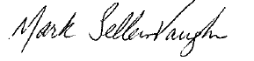
Mark Sellers-Vaughn
Manager, Supply Resource Planning

