August 12, 2014

Steven V. King, Executive Director and Secretary
Utilities and Transportation Commission
1300 S. Evergreen Park Dr. SW
P.O. Box 47250
Olympia, WA 98504-7250

RE: Washington Utilities and Transportation Commission v. Comtech 21, LLC

Commission Staff’s Response to Application for Mitigation of Penalties UT-140876

Dear Mr. King:

On May 29, 2014, the Utilities and Transportation Commission issued a $1,000 Penalty Assessment in Docket UT-140876 against Comtech 21, LLC for 10 violations of Washington Administrative Code (WAC) 480-120-382, which requires telecommunications companies to furnish annual reports to the commission no later than May 1 each year.¹

On August 11, 2014, Comtech 21, LLC Communications, Inc. wrote the commission requesting mitigation of penalties (Mitigation Request).² In its Mitigation Request, Comtech 21, LLC does not dispute that the violation occurred. The company states, “Short staff, never had a violation before”.

It is the company’s responsibility to ensure that the regulatory fee is paid and the annual report is filed by the May 1 deadline. On February 28, 2014, Annual Report packets were mailed to all regulated telecommunication companies. The instructions for annual report completion page of
the annual report informed the regulated company that it must complete the annual report form, pay the regulatory fees, and return the materials by May 1, 2014, to avoid enforcement action.

On May 12, 2014, Comtech 21, LLC filed an incomplete 2013 annual report. On May 12, 2014, commission staff contacted the company via email to notify the company of the required information³. On May 23, 2014 the company filed the missing information and the annual report was considered complete. The company has been active since 2004. Comtech 21, LLC was

UTC Annual Reports
August 12, 2014
Page 2

previously delinquent in filing the 2012 annual report. Additionally, the company failed to respond within the 15 days to request mitigation as required by the penalty assessment. Staff does not support the company’s request for mitigation due to past violation and failure to respond within 15 days of the penalty assessment being received.

If you have any questions regarding this recommendation, please contact Amy Andrews, Regulatory Analyst, at (360) 664-1157, or aandrews@utc.wa.gov.

Sincerely,

Sondra Walsh, Director
Administrative Services

ATTACHMENT A
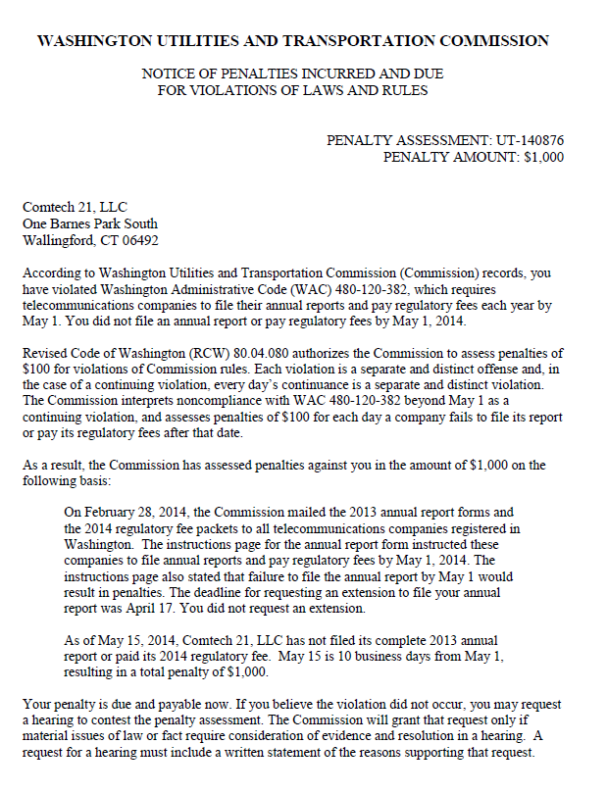

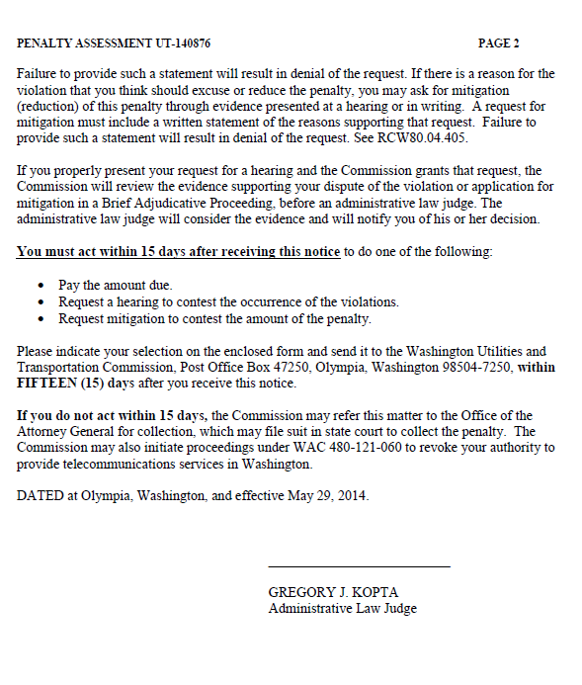

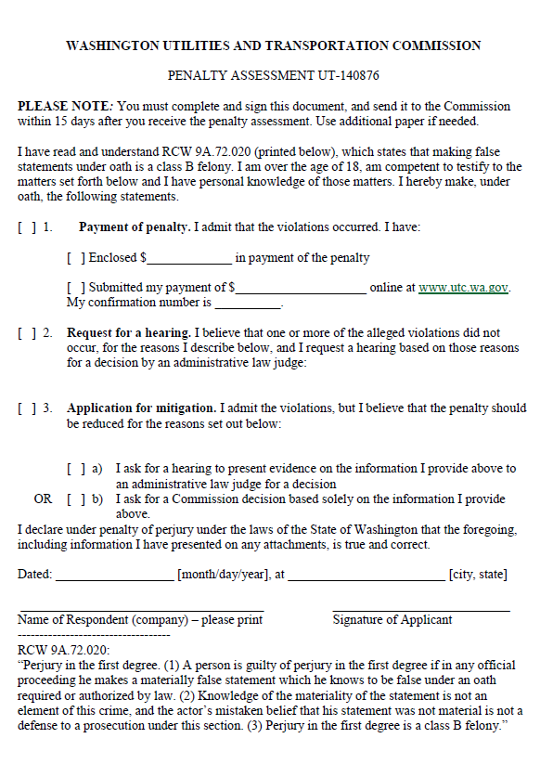

ATTACHMENT B
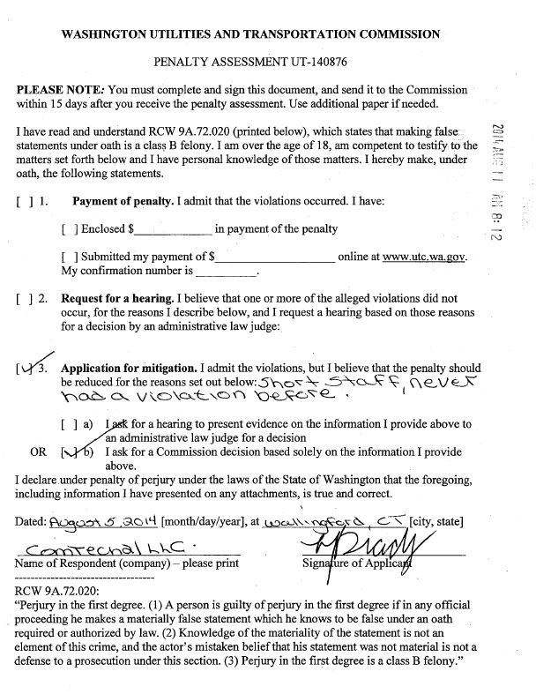

ATTACHMENT C
