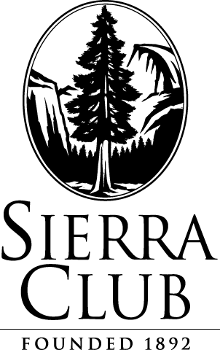

August 24, 2015

**Via Electronic Filing and U.S. Mail**

Attn: Steven King, Executive Director and Secretary

Washington Utilities and Transportation Commission

1300 S. Evergreen Park Drive S.W.

P.O. Box 47250

Olympia, WA 98504-7250

Re: Docket UE-151592 Sierra Club and Washington Environmental Council’s Opposition to Puget Sound Energy’s Motion to Dismiss

Please find enclosed an original and 12 copies of the above captioned Opposition. This filing has been e-filed with the Commission and served upon parties electronically and via U.S. mail.

Please let me know if you have any questions. Thank you.

Respectfully submitted,

*/s/ Alexa Zimbalist*

|  |
| --- |
| Alexa Zimbalist  Legal Assistant  Sierra Club Environmental Law Program  85 Second St., 2nd Floor  San Francisco, CA 94105  (415) 977-5649  alexa.zimbalist@sierraclub.org |

cc: Service List

85 Second Street, Second Floor San Francisco, CA 94105-3441 TEL: (415) 977-5649 FAX: (415) 977-5793 www.sierraclub.org