|  |  |
| --- | --- |
| CNG-Color-300dpi | 8113 W. GRANDRIDGE BLVD., KENNEWICK, WASHINGTON 99336-7166 TELEPHONE 509-734-4500 FACSIMILE 509-737-7166  www.cngc.com |

December 12, 2016

Mr. Steven V. King

Executive Director and Secretary

Washington Utilities & Transportation Commission

P.O. Box 47250

Olympia, WA 98504-7250

**RE: UG-161253, Cascade Natural Gas’s Conservation Plan Cover Letter**

Dear Mr. King:

On November 30, 2016, Cascade Natural Gas Corporation (Cascade or Company) filed its 2017 Conservation Plan. The Company herewith resubmits its 2017 Conservation Plan in its entirety under this new cover letter in order to clarify that the Plan is filed in compliance with the terms established in Docket No. UG-152286 and is not an informational filing as stated in the initial filing.

Any questions regarding this filing may be directed to Monica Cowlishaw at (360) 788-2357.

Sincerely,

Michael Parvinen

Director, Regulatory Affairs

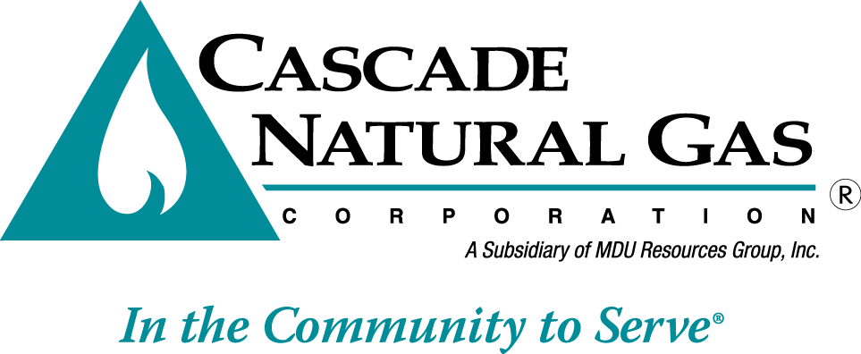Attachment