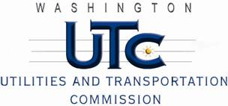

Memorandum

March 8, 2013

To: TR-120037 - File

From: Kathy Hunter, Deputy Director, Transportation Safety

Subject: TR-120037 – Sound Transit

Grade Crossing Protective Fund (GCPF) project related to Sound Transit’s Commuter Rail Lakewood Extension Safety Education Outreach Campaign

On February 23, 2012, the Washington Utilities and Transportation Commission (Commission) awarded Sound Transit a GCPF grant in the amount of $20,000 to fund a portion of Sound Transit’s project related to their Commuter Rail Lakewood Extension Safety Education Outreach Campaign. The estimated project cost was $128,000 with Sound Transit responsible for all costs exceeding $20,000.

On March 4, 2013, Sound Transit submitted a request for reimbursement for work pursuant to Commission order. Enclosed with the reimbursement request are copies of educational materials related to the project, thus confirming that the project was completed according to the specifications outlined in the order approving the grant.

Please close this docket.