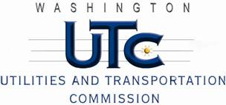

Memorandum

June 10, 2011

To: TR-101525 - File

From: Kathy Hunter, Deputy Assistant Director Transportation Safety

Subject: TR-101525 Union Pacific Railroad

Grade Crossing Protective Fund (GCPF) Project to Upgrade 13 Railroad Crossings with LED Lights

On September 24, 2010, the Washington Utilities and Transportation Commission (Commission) awarded a GCPF grant in the amount of $20,000 to install LED lights at 13 railroad crossings. The list of crossing upgraded is included as Appendix A, in Order 01.

On June 10, 2011, the applicant, Union Pacific Railroad submitted a request for reimbursement pursuant to Commission order. On June 9, 2011, Commission staff randomly selected six crossings from the list of 13 upgraded crossings and conducted site visits. Staff verified that the project is completed according to the specifications outlined in the order approving the grant. Inspecting six of the 13 upgraded crossings is adequate sampling to determine compliance to Commission order.

Please close this docket.